A STUDY ON INFORMAL MARKET CLUSTER ACTIVITIES CONCENTRATING AROUND MENDI MARKET AREA: IS RELOCATION THE BEST OPTION?

Undiri Kima and Agung Sugiri

Diterima: 23 Januari 2015 Disetujui: 20 Februari 2015
Abstract: The market provides a means of survival for the local and urban communities. The local farmers, local artisans, and other informal sectors find the market as their source of income and food and a place of relaxation. They find the market as a place where they meet friends. The article seeks to understand and analyze how informal sectors cluster groups agglomerate in and around the Mendi Local Market (LM) area of Papua New Guinea. This research has made particular reference to Street Vendors (SV) who are operating their daily activities in and along the market corridor and exert their influences to the LM and the public. The study provides the scenario to understand the impact of the social relations of the informal street vendors and their daily associated influences on LM. This article seeks to trace and to understand how informal market clusters are operating and concentrating around the local market. The conclusion suggests that the relationships of the informal sector, street vendors, and local market should be promoted through an appropriate inclusive policy and regulatory environment.
Keywords: Informal Sector, Local Market, Street Vendors

Introduction
Kavan (2013: 2), citing Eugenio (2001); defines the urban informal sector as “a sub-set of the total informal sector as well of the total urban sector”. In the context of Papua New Guinea (PNG), the urban informal sector is described as livelihood activities which include micro-enterprises or tiny livelihood activities selling, distributing, producing or manufacturing goods and providing services, either regularly, occasionally or on a needs basis and being carried out in prescribed or un-prescribed markets or areas, such as streets, roadsides, in front of supermarkets or offices, at bus stops, and in yards of houses. These activities can be owned by one or two persons, a family or a group of people. The informal sector in PNG has expanded rapidly in the post-independence period, particularly in rural areas. It is because of rapid population growth but slow economic growth. Papua New Guinea has a population of 7.167 million people and has a land mass area of 462,840 km2 (SendMoneyPacific, n.d), with twenty-two provinces and over 800 plus native languages. It is diverse in culture and custom that makes societies cluster and so intact that bonded family and ethnic groups from generations. Even today such bonding is been exercised both in rural and urban areas, thus leads to agglomeration of SV cluster groups operating around the LM in Mendi.
Mendi market is the main LM arena of the capital town of Southern Highlands Province (SHP). The market was formed in the early 1990s and has taken its shape to be where it is now. From the research, information and data been acquired; some scenes were video, audio recorded and one on one interview. The case study is an ideal scene for a town that is rich in natural resources and yet poorly managed and developed. The market operates under Mendi Urban Local Level Government Council (MULLGC). Making land space available is of a significance to the development and operations of the LM. The LM provides the means for the local and urban communities. The local farmers, local artisans, and other informal sectors find the market as their source of income, food source and a place of relaxation. They find the market as a place where they meet new friends, colleagues and interact with communities.
Furthermore, the research was an investigation into distraction and disturbances that may be caused by the informal street vendors clustering around the market area impacting on the LM activities and the public. The research was more empirical rather than theory based, with in-depth knowledge and information learned from others through personal experience, observation, and questionnaires. However, quite often the null hypothesis is not the best approach, rather, actual research hypothesis is. Moreover, what works in one situation or for one condition might be ineffective or even dangerous in another, or when combined with other measures. Common sense approaches may overlook the impact of external factors that may contribute to what is observed. However, it is not possible to make generalizations about that stated situation till this study is fully carried, and a wider perception can be understood.

Problem Statement of the study
The SVs operate within and along the LM corridors; finding their way to make a living daily. In doing so, they are clustering into groups as friends, relatives and tribesman from the same village and extended relationships, thus occupying land that could be allocated to a better land use. Such attitudes of cluster groups were practiced in past in their villages but now, been used to survive in urban areas. Associated problems are:
- The working conditions and occupational hazards like they face unique kinds of livelihood risks because of the legal, physical, and socio-cultural environment in which they work.
- Land Identification (LI), was an essential independent variable and seen as a commodity, wealth, and prestige. Since there are no proper and legal registers of the identified land, such situation has given hopes to the opportunists, SVs and money people to claim land. They do it either by negotiations, force, purchase or other means, formal or informal, acquisition to have user rights to the land. Such practice has encouraged the building up of unplanned settlements and the SVs that are agglomerating along the LM corridor.
- The other problem was the Papua New Guinea’s Land Disputes Settlement Act 1975. The 20 years of independence saw a steady decline in official interest in the fate of Papua New Guinea’s land dispute settlement Act to protect the interest of the land.
- Lawlessness has taken its grip into the society making it vulnerable to opportunist claiming the land by chances wherever possible.

Research Objectives
The main research question of the study is; How should the problem of informal market clusters, especially breeding of the Street Vendors to agglomerate within and along the local market corridor be addressed? The objectives are mainly in terms of hypotheses tests, as follows: to understand the relationship of Mendi Urban Spatial Plan and land allocation; to know if location of the SV affects the LM activities/operations; to understand and know if ethnicity contributes to squatter inclusion; to know if Street Vendors activities affect the Local Market activities/operations; to understand whether the SV has an effect on the LM activities/operations; to analyze if the SV threat is affecting the LM activities/operations; to know if income opportunities within the study area is attracting SVs; to know if SV attracts certain age groups; to know if the SV activities contribute to population growth; and to understand if the SV associated problems are affecting the LM activities/operations. Final objectives are: to assess land quality and infrastructure availability of the market and to propose and forecast future market development scenarios.

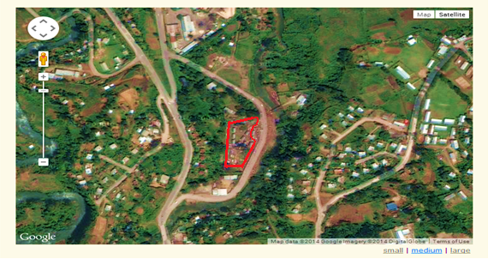



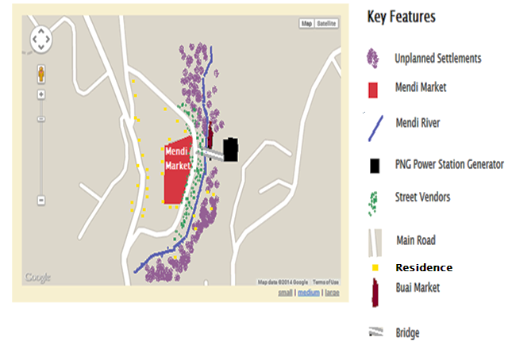

Source: http://www.maplandia.com/papua-new-guinea/southern-highlands/mendi/
Figure 1: Satellite map of Mendi Local Market

Research Methodology
The research approach is quantitative, and the data and information are analyzed numerically, descriptively and using inferential statistics. Scope of the inquiry is defined as specific questions and hypotheses that reflects targeted population within the study area with understanding and observing the participants’ thoughts and feelings. Such provides an advancement in knowledge and tools to carry out research, tools to look at things in life objectively, and it develops a critical attitude, disciplined thinking to observe objectively with understanding. The survey questionnaire administered to all 73 participants. Thus, an overall sample size was from street vendors. The questionnaire is designed to supplement the data collected from the focus groups and subset populations by collecting information on the household profile and income sources of the SV; information on the activities of the SV; and linkages between the informal economy and the formal economy. The questionnaires were administered one on one interviewed. It took approximately 90 minutes for each respondent to complete the questionnaire.
Sampling is about subset of the population selected for the study (Nalzaro, 2012). Cluster sampling was used due to time and cost limitations. The study used Probability Technique sampling by using Cluster (Area) Random Sampling for the for my research. This sampling method is much easier to understand as long as we know our targeted population and the type of cluster sample we want to group. Following is the participating stakeholders.

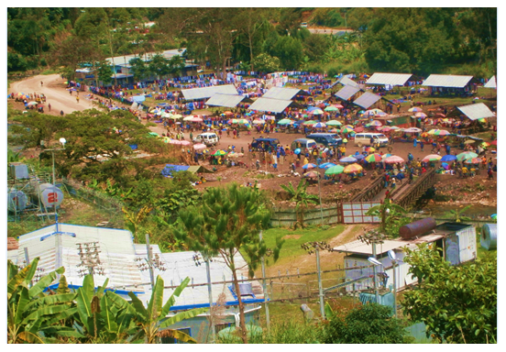

Source: Observation by Undiri Kima (July, 2014)
Figure 2: Spatial view of the Mendi Market

Table 1: Showing the cluster against number of respondents and % composition
Cluster group |  | Number of respondents | % Composition
1 | Local farmers | 9 | 12
2 | Street vendors | 29 | 40
3 | Public servants | 11 | 15
4 | Residents | 8 | 11
5 | Public | 7 | 10
6 | Squatter Settlers | 9 | 12
Total |  | 73 | 100

Literature Review
Informal sector influence contributes to its causes and effects in global and local paradigm. With such understanding of global and local perspective, we can have a clear picture and understanding of the IS with particular reference to SV. Different location and places have different kinds of influence and experiences regarding IS and its activities linking the working conditions of open spaces, institutional settings and public domains. Considering the influences, taking into consideration not only bad but good as well.

Theoretical background, definition, and a brief explanation
There are many contributing variables involved in triggering SVs to behave the way they are. The followings are operational definitions derived from the research. ILO defines the informal sector (IS) as, “all economic activities by workers and economic units that are in law or in practice not covered or insufficiently covered by formal arrangements (Chen, 2004)". Salley Roever (2010: 2), defines Street Vendor (SV), include all those selling goods or services in public spaces. Local Market (LM) local market as a place to purchase locally produce goods and services knowing who will buy the product, where they are located and how far they will travel to obtain the product is essential for this type of sales approach (The Law Dictionary, n.d).
FAO (2003) affirms that “market linkages” is often referred to in the literature on rural development. What precisely does it mean? The term ‘linkage’ obviously implies a physical connection between the producer and the ultimate consumer. Linkages also involve financial transactions, the selling and buying of goods. Having in mind, the theoretical background of informal street vending and functional role it plays within a community, a society or municipality either through formal or informal aspects.
Therefore, sphere of the local market scenario gives an overview of the research analogy. From the literatures of IS, LM, and SV, it was evident they correlate and show a significant relationship, and on that note, the concept of Sphere of linkage was developed (see Figure 3).

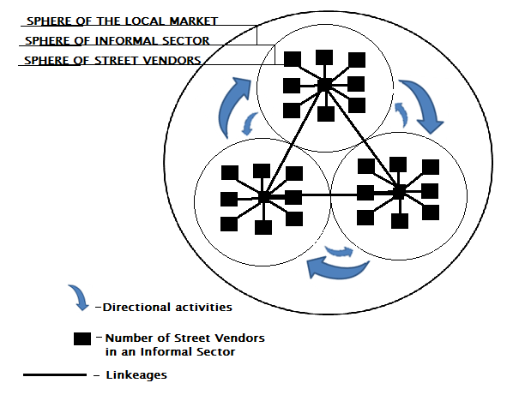

Figure 3. Sphere of Local Market, Informal Sector, and Street Vendor linkages

Weaknesses in Governance and Institutions in PNG

Asian Development Bank (ADB), Diagniostic Studies (2012) in PNG states:
Weak governance and institutions undermine all economic activity, delivery of public services, credibility of the state, and efforts to improve the population’s well-being. Although PNG has comprehensive laws and institutions, their functioning and outcomes are seen to be weak in comparison with other major economies in Southeast Asia and the Paciﬁc (the region). Of particular concerns are the low levels of government effectiveness, poor law and order situation, and weak control of corruption. In addition, the land administration and difﬁcult access to formal land titles also constrain private investment and infrastructure development.
The study was conducted in Mendi, the main town of SHP with an estimated population of 90,000 people according to the PNG Census in 2009. It is a resource rich town where people transit now and then either as workers in the public, private sectors. opportunists or as settlers in the burgeoning settlements. It is estimated 60,000 people, more than half of the population of Mendi live in rural areas and the remaining 30,000 live in the urban areas many located in some of the wastelands such as hillsides, river banks. A research by ILO (2011: p. 20) done in PNG tells that the living standards in these settlements was usually poor and comprised makeshift residences of cardboard boxes and discarded material. These settlements lacked clean water supply and sanitation facilities, social facilities, and other basic services.
Mendi is no different to that scenario. Recently due to changes in trend of developments in communities and societies have become much aware the importance of money in their life, thus create a cash society. In doing so, they are migrating to urban areas in search of a better life. Such experiences are not only happening in Mendi district but the nation as a whole.

Overview of Street Vendors in Mendi
During the research, much been learned and observed the way SV cluster groups are; how they happen to be where they are now; what is really attracting them to migrate. There are different types of SV operating in Mendi town like the bus stop vendors, town vendors, school vendors, special event vendors, market vendors and sport field vendors. Scope of the study is focused on LM of Mendi and the SV cluster groups operating along the corridor of the market. SV has been operating along the LM corridors, for the past years finding the location appropriate and comforting. They seem to enjoy the environment of the LM as they interact with themselves, the public and the local farmers.

Table 2: Comparative Analysis of Global and PNG paradigm of Informal Sector (SV)
Features |  | Global | Papua New Guinea (Local)
1 | Employees | Hired | Family, relatives, friends provide labors
2 | Legal Group | Legal & Formal | Informal
3 | Function as group or individual | Operate as individuals, group or association. | Ethnicity combination, relatives, and wantoks, mostly individuals.
4 | Economical | a. Employment  b. Income | a. Employment (informal sectors only)  b. Income
5 | Level of Skill | Multiple training  (cooking, food safety) | Informal training, from experiences, observations & informal training.
6 | Government funded Banks | Government provided bank grants and loan. | No funding from government
7 | Government Budget | Included in the government gazetted budget. | Not included in government budget
8 | License to operate | Registered street vendor must have a license. | Not registered and thus operate without a license.
9 | Structure | More structured | Not structured
10 | Personal Hygiene | Required personal hygiene by health inspectors. | Not applicable (depending on the SV personal code of ethics).
11 | Type of Dwelling | House in the city. | House in settlement and in the city
12 | Type of sale | Sale at fixed & static site. | Itinerant or semi-itinerant  vending and mobile.
13 | Status of activity | legal | illegal

General Description of Informal Sectors and street vendors
ILO defines the informal sector as “all economic activities by workers and economic units that are in law or in practice not covered or insufficiently covered by formal arrangements” (Chen 2004).
National Policy on Street Vendors (2004) defines street vendor as a person who offers goods or services for sale to the public without having a permanently built structure but with a temporary static structure or mobile stall (or head-load). There are other definitions in various, journals, reports of other research about informal sector and street vendors, but within the jurisdiction of my study, This study uses the combined definition of Chen (2004) and the National Policy (2004). From the definition, we understand that SV operates or functions within informal sectors. Therefore, SV can be seen as economic units operating individually or in groups. Further discussions would agree that street vending cannot be exhaustive without reference to the informal sector, since many people perceive street vending as a manifestation, offshoot, spillover and often, prodigal subset of the urban informal sector. The term informal sector itself is a chameleon, a genre that eludes explicit characterization.

Analysis

We use the SPSS software to analyze the research data. Chaleunvong (2009) states that SPSS is one of the most popular statistical packages, which can perform highly complex data manipulation and analysis with simple instructions. Blumenthal (2010) states that SPSS is good for organizing and analyzing data. With SPSS, we can rearrange data, calculate new data and conduct a variety of statistical analyses.

- Significance of Mendi Urban Spatial Plan with Land Allocation
The data was analyzed using a chi-square goodness of fit test. ( x² = 26.095, df = 4, p= 0.000). The alternate/research hypothesis was rejected. The null hypothesis was accepted. Therefore, there is strong evidence of statistically significant in relationship/association between land and Mendi Urban Spatial Plan. There is no spatial policy for land use plans, and settlers, opportunists, and migrants are illegally occupying and claiming the rights to the land.
- Is the location of SV affecting the local market
The data was analyzed using a chi-square goodness of fit test ( x² =0.948, df=3, p=0.814). The null hypothesis was rejected The alternate/research hypothesis was accepted. There is no strong evidence of statistically significant in relationship/association between street vendors occupying land close to the market. The daily activities of the street vendors do not affect the daily operations of the market.
- Squatter Inclusion the result of Ethnicity
The data was analyzing using a chi-square goodness of fit test (x² =8.037, df=15, p=0.922). The null hypothesis was rejected. The alternate/research hypothesis was accepted. There is no strong evidence of statistically significant in relationship/association between squatter inclusion and ethnic group occupying land close to the market. The land was claimed forcefully. In other words, the stated variables are independent. Occupying the land by ethnic groups close to the LM, whichever way does not affect the distribution of land within the market vicinity.
- Are SV activities affecting the LM activities/operations:
The data was analyzing using a chi-square goodness of fit test (x² =8.460, df=3, p=0.037). The null hypothesis was accepted. The alternate/research hypothesis was rejected. There is a strong evidence of statistically significance in relationship/association between SV activities affecting the main market activities/operations. The daily activities of the street vendors do have a significant relationship in the operations of the main market.
- Is SV attraction (pull factors) the cause of Population Growth within the Study Area:
The data was analyzing using a chi-square goodness of fit test (x² = 2.232, df= 9, p= 0.987). The null hypothesis was rejected The alternate/research hypothesis was accepted. There is no strong evidence of statistically significance in relationship/association between attraction (pull factors) and population growth. All factors, as named, do not have a significant difference to the population growth of the street vendors within the study area. Build up of the population was caused by other contributing factors.
- Is SV Threat affecting LM activities:
The data was analyzing using a chi-square goodness of fit test. (x² = 3.113, df= 2, p= 0.211). The null hypothesis was rejected The alternate/research hypothesis was accepted. There is no strong evidence of statistically significance in relationship/association between SV threat affecting the LM activities.
- Income opportunities attracting SV (unplanned settlements)
The data was analyzed using a chi-square goodness of fit test (x²⁼7.733, df=9, p=0.561^{).} The null hypothesis was rejected. The alternate/research hypothesis was accepted. There is no strong evidence of statistically significance in relationship/association attracting street vendors to move to town in search of income opportunities. The income does not have a significant difference to unplanned settlements build up, other factors are contributing to the growth of unplanned settlements.
- Is the land occupied by unplanned squatter affecting the market scenarios The data was analyzed using a chi-square goodness of fit test. (x² =6.304, df=2, p=0.043). The alternate/research hypothesis was rejected. The null hypothesis was accepted. There is a strong evidence of statistically significance in relationship/association between illegally land been occupied and market activities. The land plays a major role in the functioning of the market operations.
- Respondent age group and SV
The data was analyzed using a chi-square goodness of fit test. (x² =9.002, df=6, p=0.173). The null hypothesis was rejected. The alternate/research hypothesis was accepted. There is no strong evidence of statistically significance in relationship/association between age group and street vending. The street vendor’s pull factors do not affect any particular age group into street vending.
- Is SV informal activities cause of population growth
The data was analyzed using a chi-square goodness of fit test ( x² =41.501, df=9, p=0.000). The alternate/research hypothesis was rejected. The null hypothesis was accepted. There is a strong evidence of statistically significance in relationship/association between SV activities and population growth within the study area. SV activities increases yearly and thus attracting more and more SV cluster groups to agglomerate within the LM vicinity and its corridors.
- Is SV associated problems affecting and LM activities/operations
The data was analyzed using a chi-square goodness of fit test (x² =0.361, df=3, p=0.948). The null hypothesis was rejected. The alternate/research hypothesis was accepted. There is no strong evidence of statistically significance in relationship/association between SV activities and LM activities within the study area. In other words, the variables are independent.

Conclusion
The research was carried out to explore the relationship and understanding that may exist between the informal street vendors, LM and the unplanned build up of settlement areas that may or may not hinder public peace and future development within the market vicinity. The study provides a case scenario to understand the impact of the social interactions of informal street vendors towards LM and to know and understand the relationships amongst IS, SV, LM within the study area. Increasing of SV along the LM corridor was seen as a result of improper management of public offices, giving advantages to SV to capitalize and occupy land. Also, inclusion of the unplanned settlements are caused by other factors like the informal local casinos, SV informal activities, and lawlessness. After the analysis, it was found that, relocating of the SV is not an option or the solution to make free the congestion and LM space and land use. With clear knowledge in mind, it has been taken into consideration the significance of IS, making particular reference to SV, taking into consideration, that no presence of the Mendi urban spatial plan for land use allocation results in opportunists, SV, immigrants and squatters claiming the land unlawfully.
Government interventions are so weak and ineffective that delivery of services and protecting the interest of the land for future development are not seen as a priority. Weak governance of administering the law to the designated provinces and districts are not functional, the end result is people claiming and occupying land without formal arrangements. In my view, the Informal Development Sector Act 2004 provides the best opportunity for the thousands of unemployed people in the country to become meaningfully engaged in economic activities. The informal sector has the capacity to accommodate the thousands of school leavers exiting the education system every year. It provides the best option for those who out of frustration and hopelessness have turned to crime and other anti-social activities, to earn an honest living and contribute as productive members of society.

References
Asian Development Bank Diastic Studies, (2012). (Online), Available at: http://www.nicta.gov.pg/public_inquiries/Retail%20Service%20Determination%20Papers/Digicel%20Response%20ADB%20PNG%20-%20critical%20development%20constraints.pdf
Businessdictionary, (2014). Local market. Available at: http://www.businessdictionary.com/definition/local-market.html
Chaleunvong, K. (2009). Introduction to SPSS, (Online), Available at: http://www.gfmer.ch/Activites_internationales_Fr/Laos/Introduction_SPSS_Chaleunvong_Laos_2009.htm
Food and Agriculture Organization of the United Nations, (2003). The informal food sector, “Food in Cities” Collection, No. 4, Rome
Blumenthal, E. (2010). Introduction to SPSS 16.0, University of Washington, USA, (Online), Available at: http://julius.csscr.washington.edu/pdf/spss.pdf
Google maps. (n.d). Mendi Map-Satellite Images of Mendi, (Online), Available at: http://www.maplandia.com/papua-new-guinea/southern-highlands/mendi/
International Labour Organization, (2011). Child Labour in Papua New Guinea, ILO Publications, Fiji.
Independent State of Papua New Guinea, (1975). Land Disputes Settlement Act 1975, (Online), Available at: http://isearch.searchcompletion.com/WebSearchResultsCSE.aspx?silvan=1&si=41460&st=bs&tid=2933&ver=7.1&ts=1381716350057.000008&tguid=41460-2933-1414306087860- 728812-b5678&q=papua+new+guinea+land+dispute+settlement+act+1975
Philip, K.S. (2013). Informal Sector In Port Moresby and Lae, Papua New Guinea: Activities and Government Response, University of Canberra, Australia, p.2, (Online),-Available at: file:///C:/Users/V5-431/Desktop/recent%20found%20references/INFORMAL%20SECTORS%20IN%20PORT%20MORESBY%20AND%20LAE.pdf
Nalzaro, L.M. 2012, The Research Process-more available at: http://www.slideshare.net/ludymae/chapter-2overview-of-research-process
Chen, M.A. (2004), Rethinking the Informal Economy: Linkages with the Formal Economy and the Formal Regulatory Environment. Finland, Havard University, (Online), Available at: http://wiego.org/sites/wiego.org/files/publications/files/Chen-Rethinking- Informal_WIDER_paper.pdf
National Policy on Street Vendors, (2004). (Online), Available at: http://www.karmayog.com/hawkers/npusv.htm
Roever, S. (2010). Livelihood Profile: Street Vendor, (Online), Available at: file:///C:/Users/V5- 431/Desktop/InformalEconomyToolkit_sectorprofiles.pdf
SendMoneyPacific, (n.d). Community information-Papua New Guinea, (Online), Available at: http://www.sendmoneypacific.org/communities/papua-new-guinea.html
The Law Dictionary, (n.d). What is local market? 2nd ed, (Online), Available at: http://thelawdictionary.org/local-market/

Papua New Guinea University of Technology, Lae, Papua New Guinea
Universitas Diponegoro, Semarang, Indonesia Korespondensi: ukima.bogasi@gail.com; agung.sugiri@undip.ac.id

