MAKING LIQUID SOAP FROM COOKING OIL PURIFICATION RESULTS WITH SUGARCANE WASTE ADSORBENT
Ghina Sovia, M. Nurrohmat Fauzi, Rashinta Rizka, Satya Pramudika, Vita Paramita, Mohamad Endy Yulianto
Departemen Teknologi Industri, Sekolah Vokasi, Universitas Diponegoro,
Jl. Prof. Soedarto Tembalang Semarang, Indonesia
Email: ghinasovia@gmail.com
Abstract
Cooking oil is high enough economic value. Cooking oil is generally used to cook, but its uses are also many other than for cooking needs, such as skin beauty, lubricants and others. In the condition which the longer time, the price of cooking oil is higher than before, making some society to think creative by recycling the oil which has been used cooking oil. According to the research, it is know that sugarcane waste have strong adsorption potency to water content, and free fatty acid content that found in used cooking oil. The variable of this research are the rinsing time and the amount of sugarcane waste used. The best condition reaches to 40 gr sugarcane waste with the decrease water content reach 0.0050%; the rinse of sugarcane waste in 2x24 hours with free fatty acid intensity adsorption up to 0.23%

Keywords: Sugarcane Waste, The Used Cooking Oil, Adsorption

INTRODUCTION
Cooking oil is very important for human life, where cooking oil is one of the basic needs that is used to process food ingredients. The use of cooking oil in Indonesia as a frying media is now increasing every year.
For reasons of economize, some people now replace it with used cooking oil, because the current condition of cooking oil the prices is getting higher. In fact, there are many dangers behind the use of used cooking oil which in the long run can cause disease.
Sugarcane waste is one of the recycling technologies to process used cooking oil into usable oil. Which is, sugarcane waste is an absorbent material (adsorbent).
The purpose of this research is to research the process of refining used cooking oil in other to can be reused as a suitable cooking oil, which is in accordance with the level of analysis of suitable cooking oil for the process of making liquid soap and also to compare the final analysis level after processing using sugarcane waste adsorbent.
METODOLOGY
In this research the equipments used for the process of oil purification and soap making include dropper pipette, glass funnel, digital balance, plastic bottles, watch glass, measuring cylinder, stopwatch, beaker glass, erlenmeyer flask, clamp and stative, burette, spoon of reagents, volumetric flask, stirring bar, thermometer, magnetic stirrer, separating funnel, hotplate, pycnometer, desiccator,porcelain bowls, pH meter, oven.
The materials used include used cooking oil, sugarcane waste, aquadest, NaOH, KOH, indicator PP (Phenolphthalein), glycerine, and alcohol 96%.The process of this research is divided into two stages, namely oil purification and making liquid soap.
The process of purification of used cooking oil is purposed to disappear the dark and smell and also to reduce the level of free fatid acid in used cooking oil to make material of soap.
The pocess of making a soap uses purified oil that has low level of FFA.
The procedure of purification of used cooking oil is with 500 ml constant variable of used cooking oil in every trial, 5 gr; 20 gr; 40 gr free variable of dregs of sugarcane waste with 6 hours; 24 hours; 48 hours soaking duration.
The procedure of making a soap from used cooking oil is first, oil is poured into erlenmeyer and then adding KOH solution then it is heated and stied with magnetic stirrer for 80 minutes and then adding glycerine and alcohol 96% then stired for 5 minutes and adding aquadest and stired for 5 minutes. Liquid soap that has been cooled before, then adding color and perfume in it, and keep stiring for 5 minutes.
RESULT AND DISCUSSION
a. Analysis Results Used Oil Adsorption Analysis with Sugar Cane Adsorbent
A good oil has a characteristic odorless, transparent yellow and clear. FFA level of 0.3%. Next is, the frying oil obtained from the seller of fried foods around Tembalang is purified using an adsorption process. The oil obtained has a bad small that from fried food and the colour is dark yellow.
Oxidation occurs more quickly at high temperature heating and oil contact with air. Meanwhile, the hydrolysis process occurs due to the presence of a number of water in oil by repeated heating at high temperatures can cause the ester bond to break and make free fatty acids are formed (Nasir, et al., 2014).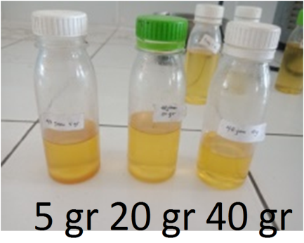
Figure 1. Results of variable adsorption of 6 hours soaking.
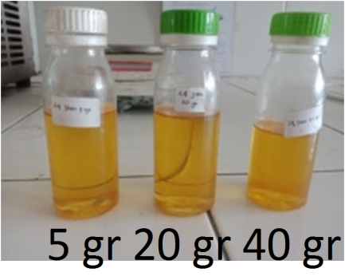
Figure 2. Results of variable adsorption of 24 hours soaking.

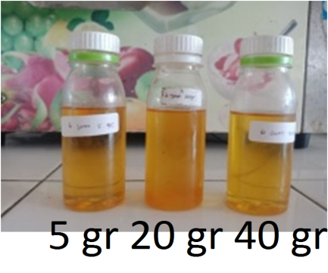
Figure 3. Results of variable adsorption of 48 hours soaking.

The use of adsorbents in the adsorption process is physical absorption. Contact between the surface of the granules under certain conditions is the cause, for example temperature and time. Adsorbent absorption increases maximally with higher temperatures and longer contact times so that the ability of adsorbents to absorb impurities (colloids) is better and oil color is more clearer (Rosita and Widasari, 2009).

b. Analysis Results Comparative Analysis of FFA Levels with Soaking Time
Soaking time can increase the adsorption capacity of sugarcane waste so that it can release free fatty acids in used cooking oil.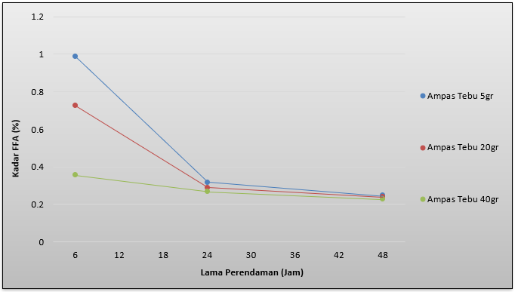
Figure 4. Analysis Results Comparison of FFA Levels with Soaking Time.
The results of the analysis were obtained from waste cooking oil-free fatty acids without the addition of sugarcane waste is 1.3%. Cooking oil with high free fatty acids can be caused because the oxidation and hydrolysis process (Nurbasnawati, 2015).
Based on the results of research after adding sugarcane waste can reduce free fatty acid lower up to 0.23%. The free fatty acid levels obtained still meet the requirements of the Indonesian National Standard (SNI), the cooking oil acid number is less than 0.3% (Dahlan, et al., 2013).
Optimal adsorption in this study was obtained at 48 hours with 40 gr sugarcane waste adsorbent. Reduce free fatty acids that occur due to sugarcane waste which can dissolve in free fatty acids. This happens because sugarcane waste contains cellulose which is more electronegative (alkaline) and polar hydroxyl groups (bases) and can be used with carboxylic acid groups (-COOH) of free fatty acids which is electropositive (acid) and polar (Rahayu et al., 2014).
In a research by Suryani (2009) the reduction of free fatty acids with activated charcoal with corn cobs activated in 0.5 N NaOH solution was able to reduce the used fatty acids free of used cooking oil by 18.40%. In addition, in a study by Aisyah et al. (2010) the neutralization process can reduce levels of used fatty acids free of used cooking oil from 0.35% to 0.16%, using activated carbon of Moringa fruit pods using NaCl.

c. Analysis of Making Liquid Soap
In the research of making liquid soap by using oil purification variable with the lowest FFA content, that is 48 hours soaking time and 40 gr sugarcane waste.

Table 1. Analysis of Making Liquid Soap
Parameter | Result Analysis | SNI | Journal
Water level | 2,04% | <15% | 13,73%
pH | 13 | 9-11 | 9
Density | 1,004 | 1,01-1,10 | 1,08
Liquid soap from the research results obtained by the water content that is in accordance with SNI namely <15%. The pH and Density have not fulfilled SNI namely 9-11 and 1.01-1.10. From the recapitulation results, it can be concluded that liquid soap didn’t fulfill SNI standards.
In the comparison of making soap with making soap in previous studies with used cooking oil by Wahyu Putri, et al in 2011 they obtained soap that had fulfilled SNI when compared with this study. Research by Wahyu Putri et al is more accurate because the levels are close to SNI compared with soap in this study.

CONCLUSION
1. Sugarcane waste is a fiber that can be used as an adsorbent to absorb impurities present in oils such as FFA (Free Fatty Acid in used cooking oil).
2. Percentage of FFA levels in used cooking oil can reduce it to 0.23%, which means that oil that has been reduced by FFA levels can be reused.
3. The duration of oil soaking affects the oil yield obtained from oil purification. From the research results obtained, the optimal time for soaking is 2x24 hours.
4. Many adsorbents (sugarcane waste) that are used affect the FFA levels of oil obtained. The more adsorbents, the lower of the FFA level. In the research results that 40 grams of adsorbent (sugarcane waste) is the most effective in reducing oil FFA levels.
5. From our results we found the water content in the making of 2.04% liquid soap, pH 13 and density 1,004 gr/ml.
BIBLIOGRAPHY
Aisyah, S., Yulianti, E & Fasya, A.G. 2010. Penurunan Angka Peroksida dan Asam Lemak Bebas (FFA) pada Proses Bleaching Minyak Goreng Bekas oleh Karbon Aktif Polong Buah Kelor (Moringa Oliefera Lamk) dengan Aktivasi NaCl. Alchemy. Vol. 1. No. 2.
Dahlan, M.H., Siregar, H.P & Yusra, M. 2013. Penggunaan Karbon Aktif dari Biji Kelor dapat Memurnikan Minyak Jelantah. Jurnal Teknik Kimia. Vol. 19. No. 3.
Fradiani Rosita, Alinda and Arum Widasari, Wenti. 2009. PENINGKATAN KUALITAS MINYAK GORENG BEKAS DARI KFC DENGAN MENGGUNAKAN ADSORBEN KARBON AKTIF. In: "Seminar Tugas Akhir S1 Jurusan Teknik Kimia UNDIP 2009", Jurusan Teknik Kimia UNDIP.
Nasir, N.S.W., Nurhaeni & Musafira. 2014. Pemanfaatan Arang Aktif Kulit Pisang Kepok (Musa Normalis) Sebagai Adsorben Untuk Menurunkan Angka Peroksida dan Asam Lemak Bebas Minyak Goreng Bekas. Online Jurnal of Natural Science. Vol.3. No. 1.
Nurbasnawati, H. 2015. Penetapan Kadar Asam Lemak Bebas dan Bilangan Peroksida pada Minyak Goreng yang digunakan Pedagang Gorengan di Jalan A.W Sjahranie Samarinda. Jurnal Ilmiah Manuntung. Vol.1 No. 1.
Putri, Wahyu. 2011. Pembuatan Sabun Cair dari Minyak Goreng Bekas (jelantah). Laporan Tugas Akhir Departemen Teknik Kimia Universitas Sebelas Maret, Surakarta.
Rahayu, L.H., Purnavita, S & Sriyana, H.Y. 2014. Potensi Sabut dan Tempurung Kelapa sebagai Adsorben untuk Meregenerasi Minyak Jelantah. Akademi Kimia Industri “Santo Paulus” Semarang.Vol. 10. No. 1.
Suryani, A.M., 2009. Pemanfaatan Tongkol Jagung untuk Pembuatan Arang Aktif sebagai Adsorben Pemurnian Minyak Goreng Bekas. Skripsi Departemen Kimia Institut Pertanian Bogor. Bogor.

