Failure Analysis Of Water Pump Shaft

Didik Ariwibowo¹, Sulthonul Putra², Seno Darmanto¹, Juli Mrihardjono¹, Wiji Mangestiyono¹

¹Mechanical Design Engineering, Industrial Technology Departement Vocational School of Diponegoro University Jl. Prof. Soedarto, SH. UNDIP, Tembalang, Semarang, 50275, Indonesia
²Undergraduate Student of Mechanical Design Engineering, Industrial Technology Departement Vocational School of Diponegoro University Jl. Prof. Soedarto, SH. UNDIP, Tembalang, Semarang, 50275, Indonesia

e-mail :didik.ariwibowo@live.undip.ac.id

Abstract- A water pump shaft for utility water raw material was failed. The shaft was broken into two parts. While in dismantling, the sand was found in chamber between bearing and shaft. There was also a bolt in the impeller. According to reports, the pump has been repaired and since there was no replacement shaft but the shaft was reused in reverse position. There was no inspection of the shaft when it was disconnected by operational reasons. The failure analysis of the broken-shaft was performed to investigate the cause of the failure. Two inspection and analysis were perfomed those are visual inspection and material identification and analysis. When material analysis of the shaft was carried out there was difference between examination and data specification of the shaft.The material identification indicate that the material was AISI SS 304 whereas specification data states SS 316. Both materials have similar tensile stress, so the difference was not the contributor of the failure. The present of foreign material was consider as the cause of the failure. The foreign material caused to stucked on rotation of shaft and increasing in tensile of the shaft over its ultimate strength.
Keywords – vertical pump, tensile stress, ultimate strength, material identification
Submission:xxxxxxxxx Correction:xxxxxxxxx Accepted: xxxxxxxxx
Doi: http://dx.doi.org/xx.xxxxx/xxxxx.x.x.xxxx.x-x
[How to cite this article: Ariwibowo, D., Putra S., Darmanto, S.,Mrihardjono(2019). Faulire Analysis of Water Pump Shaft. Journal of Vocational Studies on Applied Research, x(x), xx-xx.doi:http://dx.doi.org/xx.xxxxx/xxxxx.x.x.xxxx.x-x]

1. Introduction
Well pump is used to pump ground water that used for process, boiler feed water, and human consumable water. Water contains a lot of iron (Fe), Manganese (Mn), and other minerals. The pump has to deliver water with capacity of 150 m³/hr and head about 84 meters. By the characteristic of water to be delivered and location, a vertical centrifugal pump was chosen for that requirements.
The vertical pump used at a typical well was design with stainless steel materials. The construction of the pump and details of pump specification can be seen at Fig. 1 and Table 1, subsequently [1].
On November, the pump failed. An information stated that the pump was stop working. After being brought to the shop and initial inspection, it was found that pump shaft broken to near half of the length of the pump shaft, and some impeller parts were damaged at side of the blade. Further more foreign particles such as sand and new pebbles and bowl bolts casing inside the pump was found.
Based on the information, cause effect analysis was carried out to investigate failure of the shaft.
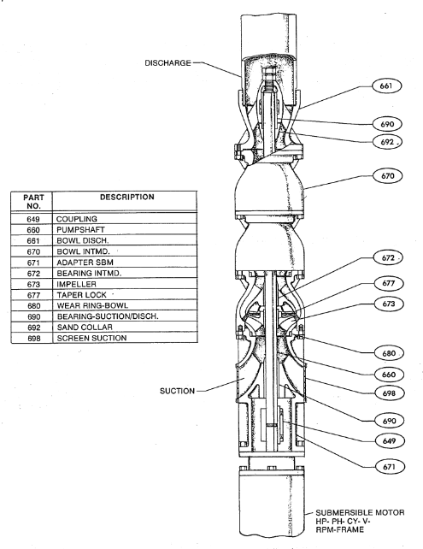
Figure 1. Vertical Centrifugal Pump

Table 1. Specification of Vertical Centrifugal Pump
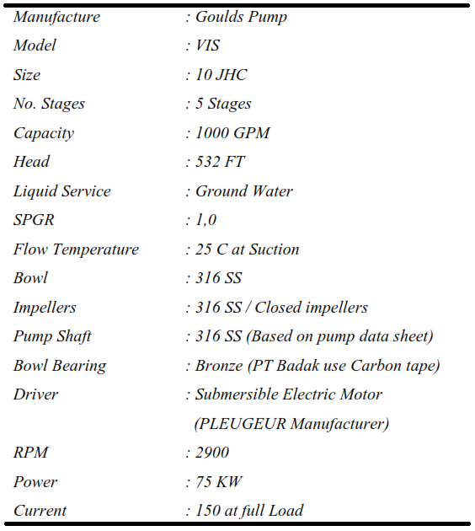

2. Analysis Procedure
The procedure to investigate the failure of pump shaft was performed in the steps below [2, 3]:
1. Visual inspection and examination
2. Material Identification
Visual inspection was performed by taking a picture of the failure part of shaft and analysis the form of the broken. The geometry and modes of crack were identify and analyze. In the Material identification step, pump shaft was examine by Olympus Alloy Analyzer that shows the chemical composition of shaft materials. The identified material was used to know its strength of the material, the strength to whitstand tensile occurs in shaft.

3. Results and Discussion
3.1. Visual Inspection and Analysis
Visual inspection was carried out to analyze the modes of failure. One of the picture can be seen at Fig.2. This leading to hypotheses that shaft failed in torsion loading condition. The figure shows that there is a crack initiation. This mode of failure was consider that shaft sustained a rotational load that cause the tensile stress over its ultimate strength. This initial crack was mis-inspection. From historical maintenance data, the shaft was not checked for it.
The cause of the over tensile strength was of the foreign material, those are sand and bolt in pump chamber. The bolt that found in the chamber and damage of impeller can be seen at Fig.4. The rotation of shaft was stucked by the bolt, cause tensile stress increased in the shaft over its tensile strength. The initial crack extents until shaft broken. Besides the stucked, imbalance that cause of bolt exerted in impeller could also be contributor of shaft failure. It can also be seen that their direction of initial crack and failure was different. This is caused by maintenance activity that change the vertical position of the shaft This failure phenomena is similar to that in pump shaft failure studied by some researcher [2, 3, 4, 5].
Figure 2 also shows that the fracture plane was perpendicular to the longitudinal plane of the shaft. It was indicated that crack propagation occurred under induced flexural fatigue loading.

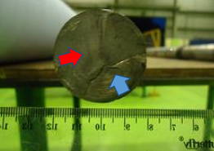

Figure 2. Modes of failure: a. initial crack portion (lower arrow), and b. failure portion (upper arrow)

There are three portion area of the failure, portion that large plastic deformation occurs (large portion), portion of brittle fracture, and portion of rotational bending fatigue charactaeristic. A large portion of the failure surface was flattened and smeared off. This surface condition was considered due to a repeated grinding agains the fracture surface with mating part while the motor runs after complete fracture. The fatigue occurs because of pump operation over 40000 hours without preventive maintenance.
Figure 2 shows that there also was a fatigue zone. The fatigue zone can be described as follows: a smooth rubbed, and velvety appearance, the presence of waves known as "clam-shells" or "oyster-shells", "stop marks" and "beach marks," and the herringbone pattern or granular trace which shows the origin of the crack, as seen at Fig3. In general, stop marks indicate the variations in the rate of crack propagation due to variations in stress amplitude in a cyclic application varying with time.

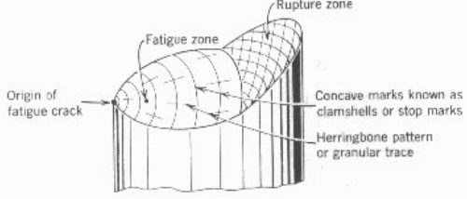
Figure 3. Failure zone

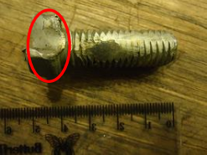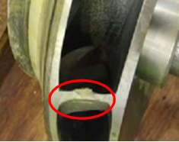

Figure 4. Bolt in pump chamber and damage of impeller

Another cause of failure was worn out of shaft at bearing location, that can be seen at Fig. 4. This wear cause the shaft cross section area reduced and lack to withstand tensile stress. The stress is a high stress level of induce fluctuating stresses that exerts from a start and stop cycle mode of operation. The shaft experiences cyclic flexural load and torsional load during pumping operation. At this location, an excessive plastic deformation could be induced and severe localized stress occurs. This would lead to fatigue crack [8]. The mass of shaft is an factor that induce cyclic flexural stress. This stress is distributed uniformly along the length of the shaft between the bearing supports. At the bearing support, reduced cross section area induces a local stress gradient then this stress could be the contributor to failure of the shaft. The fillet corner was too sharp to withstand the stress concentration for longer duration.

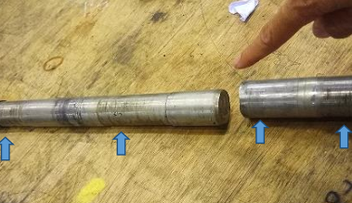

Figure 4. Shaft cross section area reduction caused by wearing out of bearing bushing

Vibratory stress was also suspected as a shaft failure contributor. The existence of sand and bolt in pump chamber could generate vibration. This will induced a vibratory stress subjected to the shaft.
Unbalanced forces which result from foreign material exist in pump chamber could results in large amplitude vibrations. Impellers may shift due to the decrease in residual stresses that are created when the impeller is cooled and contracted around the shaft. Shaft vibrations and flexing tend to result in the impeller cocking or bowing the shaft, which removes it from its original balance along its centerline [9].

3.2. Material Identification
As specification, pump shaft conform to stainless steel SS 316. This material has mechanical properties of yield strength of 21 kg/mm².
Material identification was carried out by using alloy analyzer. The identification can be seen at Table 2.

Table 2. Material Identification
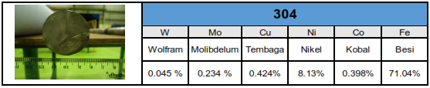

The table shows that material identification was stainless steel SS 304. The specification of shaft is SS 316. Both two materials were compare chemically and mechanically. The comparison can be seen at Table 3 and Tabel 4.

Table 3. Material Comparison between SS 304 and SS 316
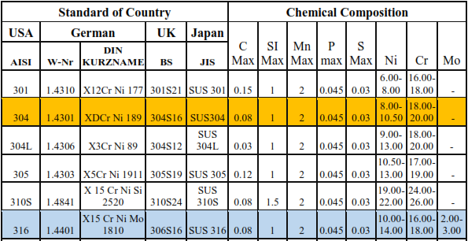

Table 3 shows that chemical composition of SS 304 and SS 316 is similar. The shaft was made of stainless steel which is a recommended material for such applications[ The change of shaft by SS 304 was accepted. It is also for the mechanical properties. The two materials have a same yield strength, that is 21 kg kg/mm².

Table 4. Mechanical Properties Comparison between SS 304 and SS 316
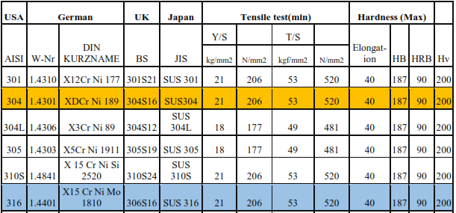

3.3. Excessive Power
Other main causes of pump failure that could cause excessive power consumption. This could be cause of the liquid that is being pumped has a viscosity that is more than what the pump was designed for. The factors was due to sand and bolt exist in pump chamber. This could lead the shaft to misalign in the pump, and the impeller is touching the case.

4. Conclusion
- The mode of failure was consider that shaft sustained a rotational load that cause the tensile stress over its ultimate strength..
- Shaft with material of stainless steel SS 304 could be interchangeable with SS 316, in material properties identification point of view.
- The existence of sand and bolt in pump chamber could generate vibration. This will induced a vibratory stress subjected to the shaft.

5. Acknowledgment
This work was supported in part by Vocational School of Diponegoro University.

References
- Goulds Pump, Installation, Operation, and Maintenance Book. Goulds Pump Vertical Division.
- Heinz P. Bloch, Fred K. Geitner, 1997, Machinery Failure Analysis and Troubleshooting 3rd Ed., Gulf Publishing Company, 1997
- Heinz P. Bloch, 2004, Root Cause Analysis of Five Cost Centrifugal Pump Failure, Montgomery, Texas
- Dr. Juergen Weinert, 1998, Pumps: Failure Modes Failure Modes and
Ways to Investigate the Cause, Wiesbaden, Germany
- Farabirazy Albiruni, 2005, Failure of A Vertical Ammonia Transfer Pump Shaft, Technical Bureau of Inspection, PT. Pupuk Kalimantan Timur, Tbk., Bontang, Klimantan Timur, Indonesia
- Roman Celin, Franc Tehovnik, Vodopivec, Borut Zuzek, 2013, Impeller-Blade Failure Analysis, Institute of Metal and Technology, Lepi pot 11, 1000 ljubljana, Slovenia
- OM Prakash and R.K. Pandey, 1995, Failure Analysys of The Impellers of A Feed Pump, Engineering Failure Analysis, Vol.3, No.1, pp. 45-52, 1996.
- http://dx.doi.org/10.5772/intechopen.70672
- Karassik, Igor J., J. P. Messina, P. Cooper, and C. C. Heald, Pump Handbook (3rd Edition). New York: McGrawHill, 2001.

