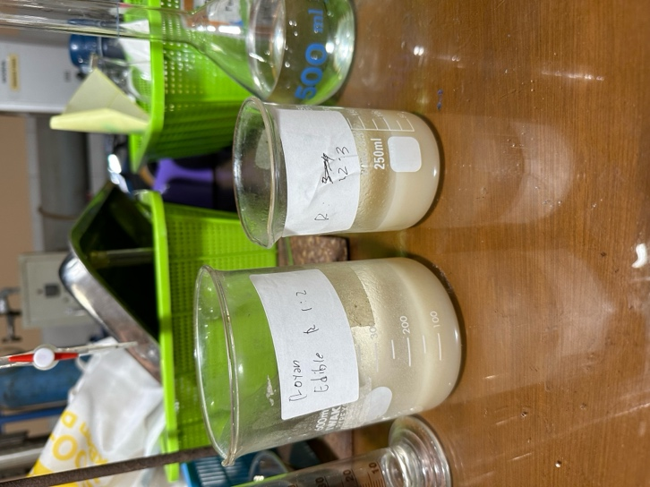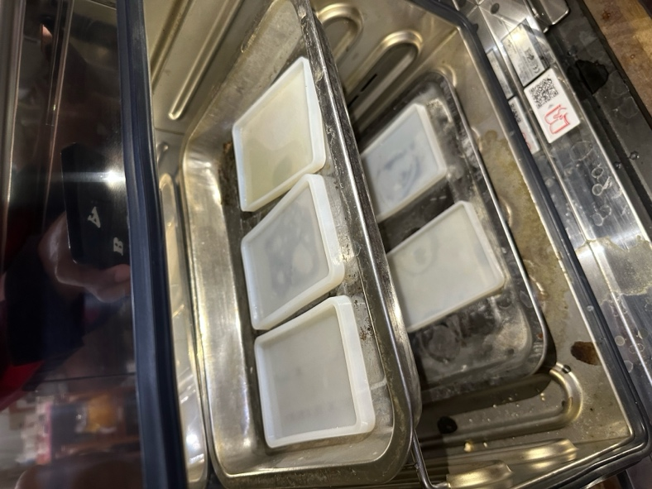LAMPIRAN

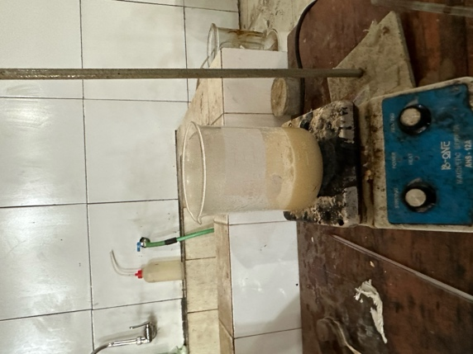Proses pemanasan edible film Larutan edible film

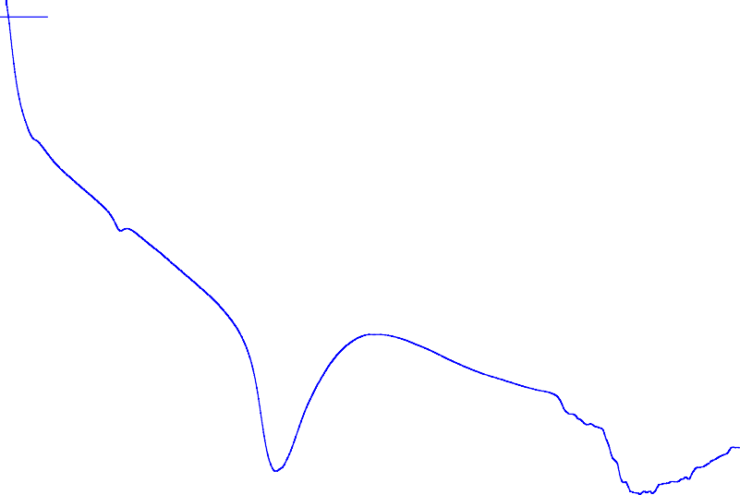

Thermal Analysis Result

Start

End

-5.00

Peak Onset Endset

Heat

Start End Peak

Onset

Endset Heat

102.33C

160.53C

124.28C

114.17C

144.50C

-647.14mJ

-230.30J/g

-4.58mW

-1.63mW/mg

Height

60.62C

67.19C

64.75C

61.58C

66.56C

-5.03mJ

-1.79J/g

-0.23mW

-0.08mW/mg

Height

100.00

200.00

300.00

Temp [C]

Proses pengadukan larutan edible film

