Declaration of interests

Manuscript title:

Aktivitas Fisik Lansia Untuk Mengontrol Hemodinamik Melalui Kombinasi Senam Tera Dan Senam Pernapasan (SETAPA) Pada Lansia Dengan Hipertensi

☒ The authors declare that they have no known competing financial interests or personal relationships that could have appeared to influence the work reported in this paper.

Purwokerto, September 20, 2023
On behalf of all authors
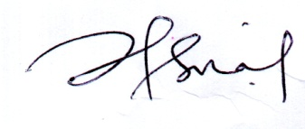
Dr. Isna Hikmawati, S.KM.,M.Kes(Epid)
Corresponding author

