Declaration of interests

Manuscript title:

Health Education Using Menarche Media Islamic Flashcard About Menarche Against Student Levels Of Knowledge And Anxiety

☒ The authors declare that they have no known competing financial interests or personal relationships that could have appeared to influence the work reported in this paper.

Purwokerto, Agustus 29, 2023
On behalf of all authors
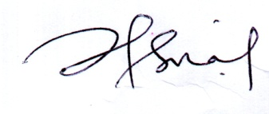
Dr. Isna Hikmawati, S.KM.,M.Kes(Epid)
Corresponding author
Email: isnahikmawati@ump.ac.id
Afiliation : Universitas Muhammadiyah Purwokerto

