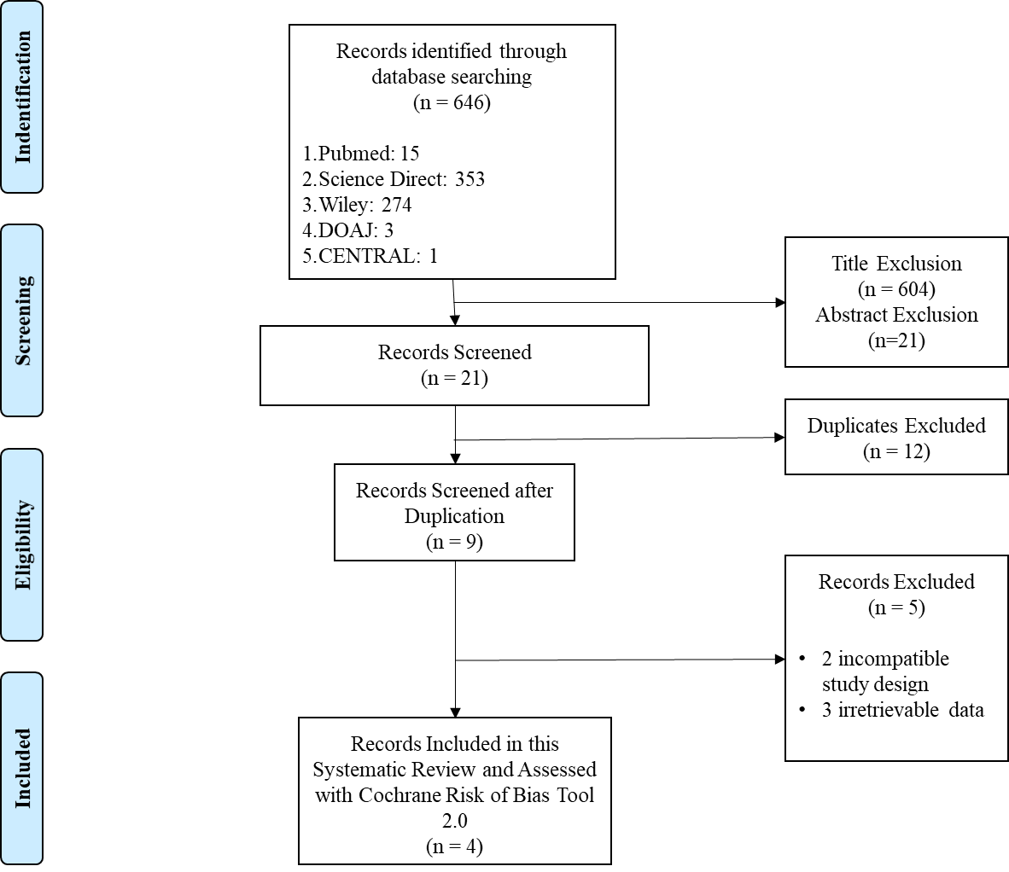

Figure 1. PRISMA Flow Chart Diagram of Search Strategies

