Journal of Physics and Its Applications



Journal of Physics and Its Applications
Journal homepage : https://ejournal2.undip.ac.id/index.php/jpa/index

The Effect of Laser Ablation Time On The Concentration of Gold Nanoparticle Colloids

Salsa Dila Nisa Pratiwi¹, Ali Khumaeni², Iis Nurhasanah³

¹Master of Physics Department, Faculty of Science and Mathematics, Diponegoro University, Jl. Prof. Soedharto, SH., Tembalang, Semarang 50275, Indonesia
²Physics Department, Faculty of Science and Mathematics, Diponegoro University, Universitas Diponegoro, Jl. Prof. Soedharto, SH., Tembalang, Semarang 50275, Indonesia
³Research Centre for Laser and Advance Nanotechnology, Faculty of Science and Mathematics, Diponegoro University, Jl. Prof. Soedharto, SH., Tembalang, Semarang 50275, Indonesia
Corresponding author: khumaeni@fisika.fsm.undip.ac.id

A R T I C L E I N F O

Article history:

Received: -
Accepted: -
Available online: -

Keywords:

Gold
Nanoparticle
Laser Ablation
Absorbance
Consentration

A B S T R A C T


The use of gold nanoparticles is being studied more widely, including in the medical, electronics and sensor fields. Nanoparticles with high concentration and purity can be produced using the pulsed laser ablation method. This study aims to increase the concentration of gold nanoparticle colloids linearly with increasing ablation time using Nd: YAG Laser. The colloid concentration test parameters based on The concentration of AuNPs colloids with 10 minutes, 15 minutes, and 25 minutes ablation time is 5.17; 8.50; and 20.12 mg/L. It can be concluded that the longer ablation time succeeded in increasing the absorbance value and ultimately increasing the concentration of gold nanoparticle colloids. Nanoparticle colloid concentration can be further investigated using synthesis methods other than pulsed laser ablation.

1. Introduction

Gold is a chemical element with the symbol Au and atomic number 79. It is a solid, yellow, shiny metal that is stable in air and water without oxidation. Current technological developments are capable of producing gold in the form of particles measuring less than 100 nanometers (nm). The results of nanotechnology are called nanoparticles [1]. Nanomaterials have very different physical and chemical properties from their bulk materials, such as being more stable in terms of thermal, electronic, magnetic, catalytic, optical, and mechanical strength.
At the nanoscale, gold is known as gold nanoparticles, which can be produced in the form of powder, colloid, or particles dissolved in water. Colloids are a mixture that lies between a true solution and a coarse suspension. Solution and colloid particles cannot be separated physically (by filtration), while coarse suspensions can be filtered [2]. Technological developments that enable understanding the physical and chemical properties of nanoparticles have attracted researchers to use gold nanoparticles in broader studies, including in the medical, electronics, and sensor fields [3]. Nanoparticles can be produced through various methods, one of which is synthesis using pulsed laser ablation. The results of the synthesis of each metal have different characteristics depending on the metal used.
Gold nanoparticles have a spherical shape with quite diverse diameter variations depending on the increase in laser energy [4]. The color change when using gold metal changes from transparent to purplish red in aquadest medium and the longer ablation time produced a darker color of gold nanoparticle colloids [5]. This color change aligns with previous research. Gold nanoparticles have a characteristic absorption peak at a wavelength ranging from 535 to 546 nm, depending on the ablation time. The longer ablation time, the higher absorbance value [6].
Previous research on the absorbance of gold nanoparticles was shown by Noor et al. In their study, the optical absorption spectra of the Au-NPs in THF with different Pulse Laser Ablation time ranging from 7 to 30 minutes shows absorption peaks at 535, 539, 541 and 546 nm are referred to the localized surface plasmon resonance properties of Au-NPs clusters. It can be observed that the intensity of these peaks are proportional to Pulse Laser Ablation time while the Pulse Laser Ablation time is indirectly proportional to the wavelength of the observed peaks. This authenticates the size decrement of Au-NPs with the increment of PLA time. The breaking of bigger cluster of Au-NPs to smaller particles are in good agreement with previous study and the absorption spectra confirmed that the Au-NPs were formed in the THF [6].
Based on the Lambert Beer law, the higher the concentration of gold nanoparticles, the higher the absorbance value. This study aims to increase the concentration of gold nanoparticle colloids linearly with increasing ablation time using an Nd:YAG Laser (New Wave Research, Polaris II, 20 Hz). Variations in ablation time from 5 to 25 minutes with a 5 minute time interval. Hypothesis of this research is the longer the ablation time, the higher the concentration.

2. Methods

The steps of the methods in this study are shown in Fig. 1. Each step addresses aimed at ensuring that the synthesis and characterization process can prove the hypothesis. First, prepare the research tools and materials for the synthesis. Washing of gold plate is carried out to free the material from impurities. Next, synthesis and characterization of gold nanoparticles. Finally, relationship between concentration and ablation time was generated based on absorption spectra UV-Visible spectrum and colloid concentration in Atomic Absorption Spectroscopy.

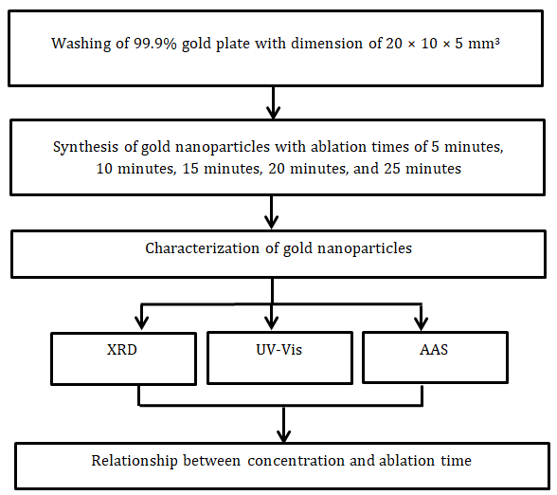
Fig. 1: Overview methodology

2.1. Synthesis of Gold Nanoparticles With Pulse Laser Ablation
The ablation uses a Nd: YAG Laser (New Wave Research, Polaris II, 20 Hz) wavelength 1064 nm, energy 45mJ, and pulse width 7 ns. The gold nanoparticle synthesis process begins when a pulsed Nd:YAG laser is focused on a gold metal sample in aqueous medium. The laser is fired for 5, 10, 15, 20, and 25 minutes to increase the concentration of gold nanoparticle colloids. The set up experiment is shown in Figure 2.

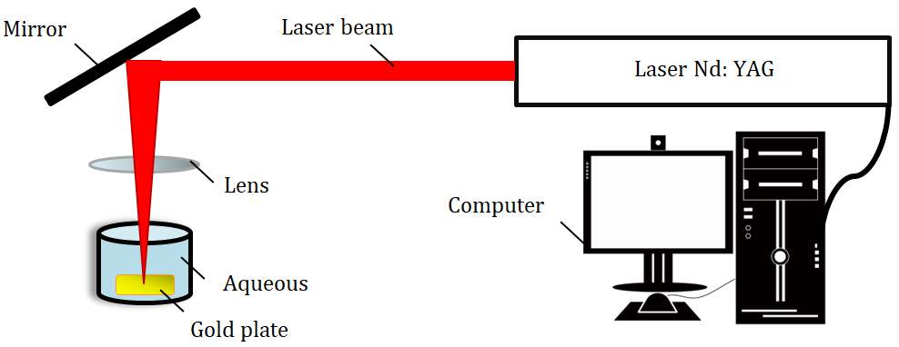
Fig. 2: Set up experiment tools for gold nanoparticle synthesis

The gold plate was synthesized in aqueous medium, it was immersed in 10 mL of aqueous. Next, it was ablated using a Nd:YAG laser beam with pulse duration of 7 ns and energy of 45 mJ/pulse. The ablation of gold plate was performed in the range of 5 to 25 minutes with 20 Hz repetition rate. The ablation process is carried out using a laser beam directed at the sample by deflecting the beam using a mirror towards a convex lens which is then focused on the sample so that nanoparticles are formed.

2.2. Characterization of Gold Nanoparticles
The first step of characterizing nanoparticle colloids was UV-Visible Light Spectroscopy (UV-Vis), which was used to obtain the absorbance spectrum value of the nanoparticle colloids by inserting 3.5 mL of gold nanoparticle colloid into a cuvette. UV-Vis spectrophotometry uses the working principle according to the Lambert-Beer Law which states that molecules in a sample can absorb light at certain wavelengths and the effect of the light path on reducing light intensity decreases exponentially with the path length. This relationship fulfills the following equation
$I=I_{0 }exp\left(-α.L\right)$ (1)
$A=ε.L.c$ (2)
I is the intensity of light transmitted through the sample, I₀ is the intensity of incident light, L is path length, A is absorbance, ɛ is molar extinction coefficient, c is concentration of sample, and α is the absorption coefficient [7].
Next, the crystal phases of gold nanoparticles can be identified by conducting an X-Ray Diffraction (XRD) test. The XRD method utilizes the diffraction properties of X-rays to determine the crystal structure formed in the synthesis of gold nanoparticles. When X-rays hit the sample, the rays will be scattered in a certain pattern. The results of the XRD test produce a diffraction pattern in the form of a diffractogram that shows the intensity of the diffracted X-rays at various angles. Constructive interference produces diffraction peaks that are detected according to Bragg's Law, where the diffraction rays detected by the diffractometer from X-rays that reinforce each other because they are in the same phase. Mathematically, this relationship is expressed through the following equation
$nλ=2d.sinθ$ (3)
n is the diffraction order, λ is the X-ray wavelength, d is the distance between crystal planes, and θ is the diffraction angle or Bragg angle [8].
After the characterization was declared successful, an Atomic Absorption Spectroscopy (AAS) test was conducted to obtain the concentration or content of gold in aqueous medium. The AAS test mechanism involves atomizing the sample solution to be analyzed using a flame or graphite furnace at high temperatures, allowing the elements to decompose into free atoms. These atoms are then irradiated with a light beam from a hollow cathode lamp containing the element to be analyzed. The free atoms of the elements absorb radiation at a specific wavelength specific to each element. This radiation absorption is then measured using a detector, and its intensity is proportional to the element's concentration in the sample. By measuring the absorption and comparing it with a calibration curve, the element's concentration in the sample can be determined. The sensitivity is good, with a detection limit of mg/L for flame AAS and lower with a detection limit of μg/L for electrothermal/furnace AAS. Therefore, the AAS method is used to determine the concentration/content of metals in synthesis of gold nanoparticles [9]. The analysis carried out in this study was to analyze the morphology, absorbance spectrum, and the effect of ablation time on gold nanoparticles.

3. Results and Discussion

Figure 3 shows colloidal gold nanoparticles produced by pulsed laser ablation of 99.9% pure gold in distilled water. The formation of Au nanoparticles can be visually observed by the color change in the aqueous medium from clear to purplish red. This color change is similar to the study by Deepak et al. (2019).
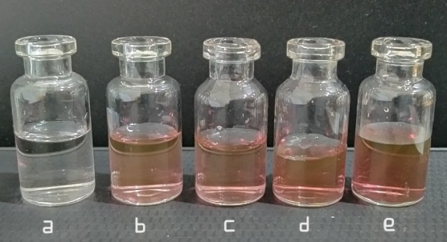
Absorbance (a.u)
Fig. 3: Gold nanoparticle colloids with synthesis time variations a) 5 minutes; b) 10 minutes; c) 15 minutes; d) 20 minutes; and e) 25 minutes
On the ablation process, observed visually that the longer the ablation time, the darker the color of the colloid, which indicates that the gold content in the aquades medium is higher. Next, the synthesized gold nanoparticles were characterized using a UV-Vis spectrophotometer to determine the optical characteristics of gold nanoparticles in aqueous medium. The blue shift absorption peak in gold nanoparticles indicates a shift in the absorption spectrum towards shorter wavelengths due to an increase in the energy band gap size, indicating a decrease in the nanoparticle size below 10 nm. This decrease in size causes the Laser Surface Plasmon Resonance absorption peak to shift to the UV region, then producing a strong optical signal absorption in the ultraviolet spectrum region, thus referred to as a blue shift [10] which is in line with Figure 4.
Intensity (a.u)
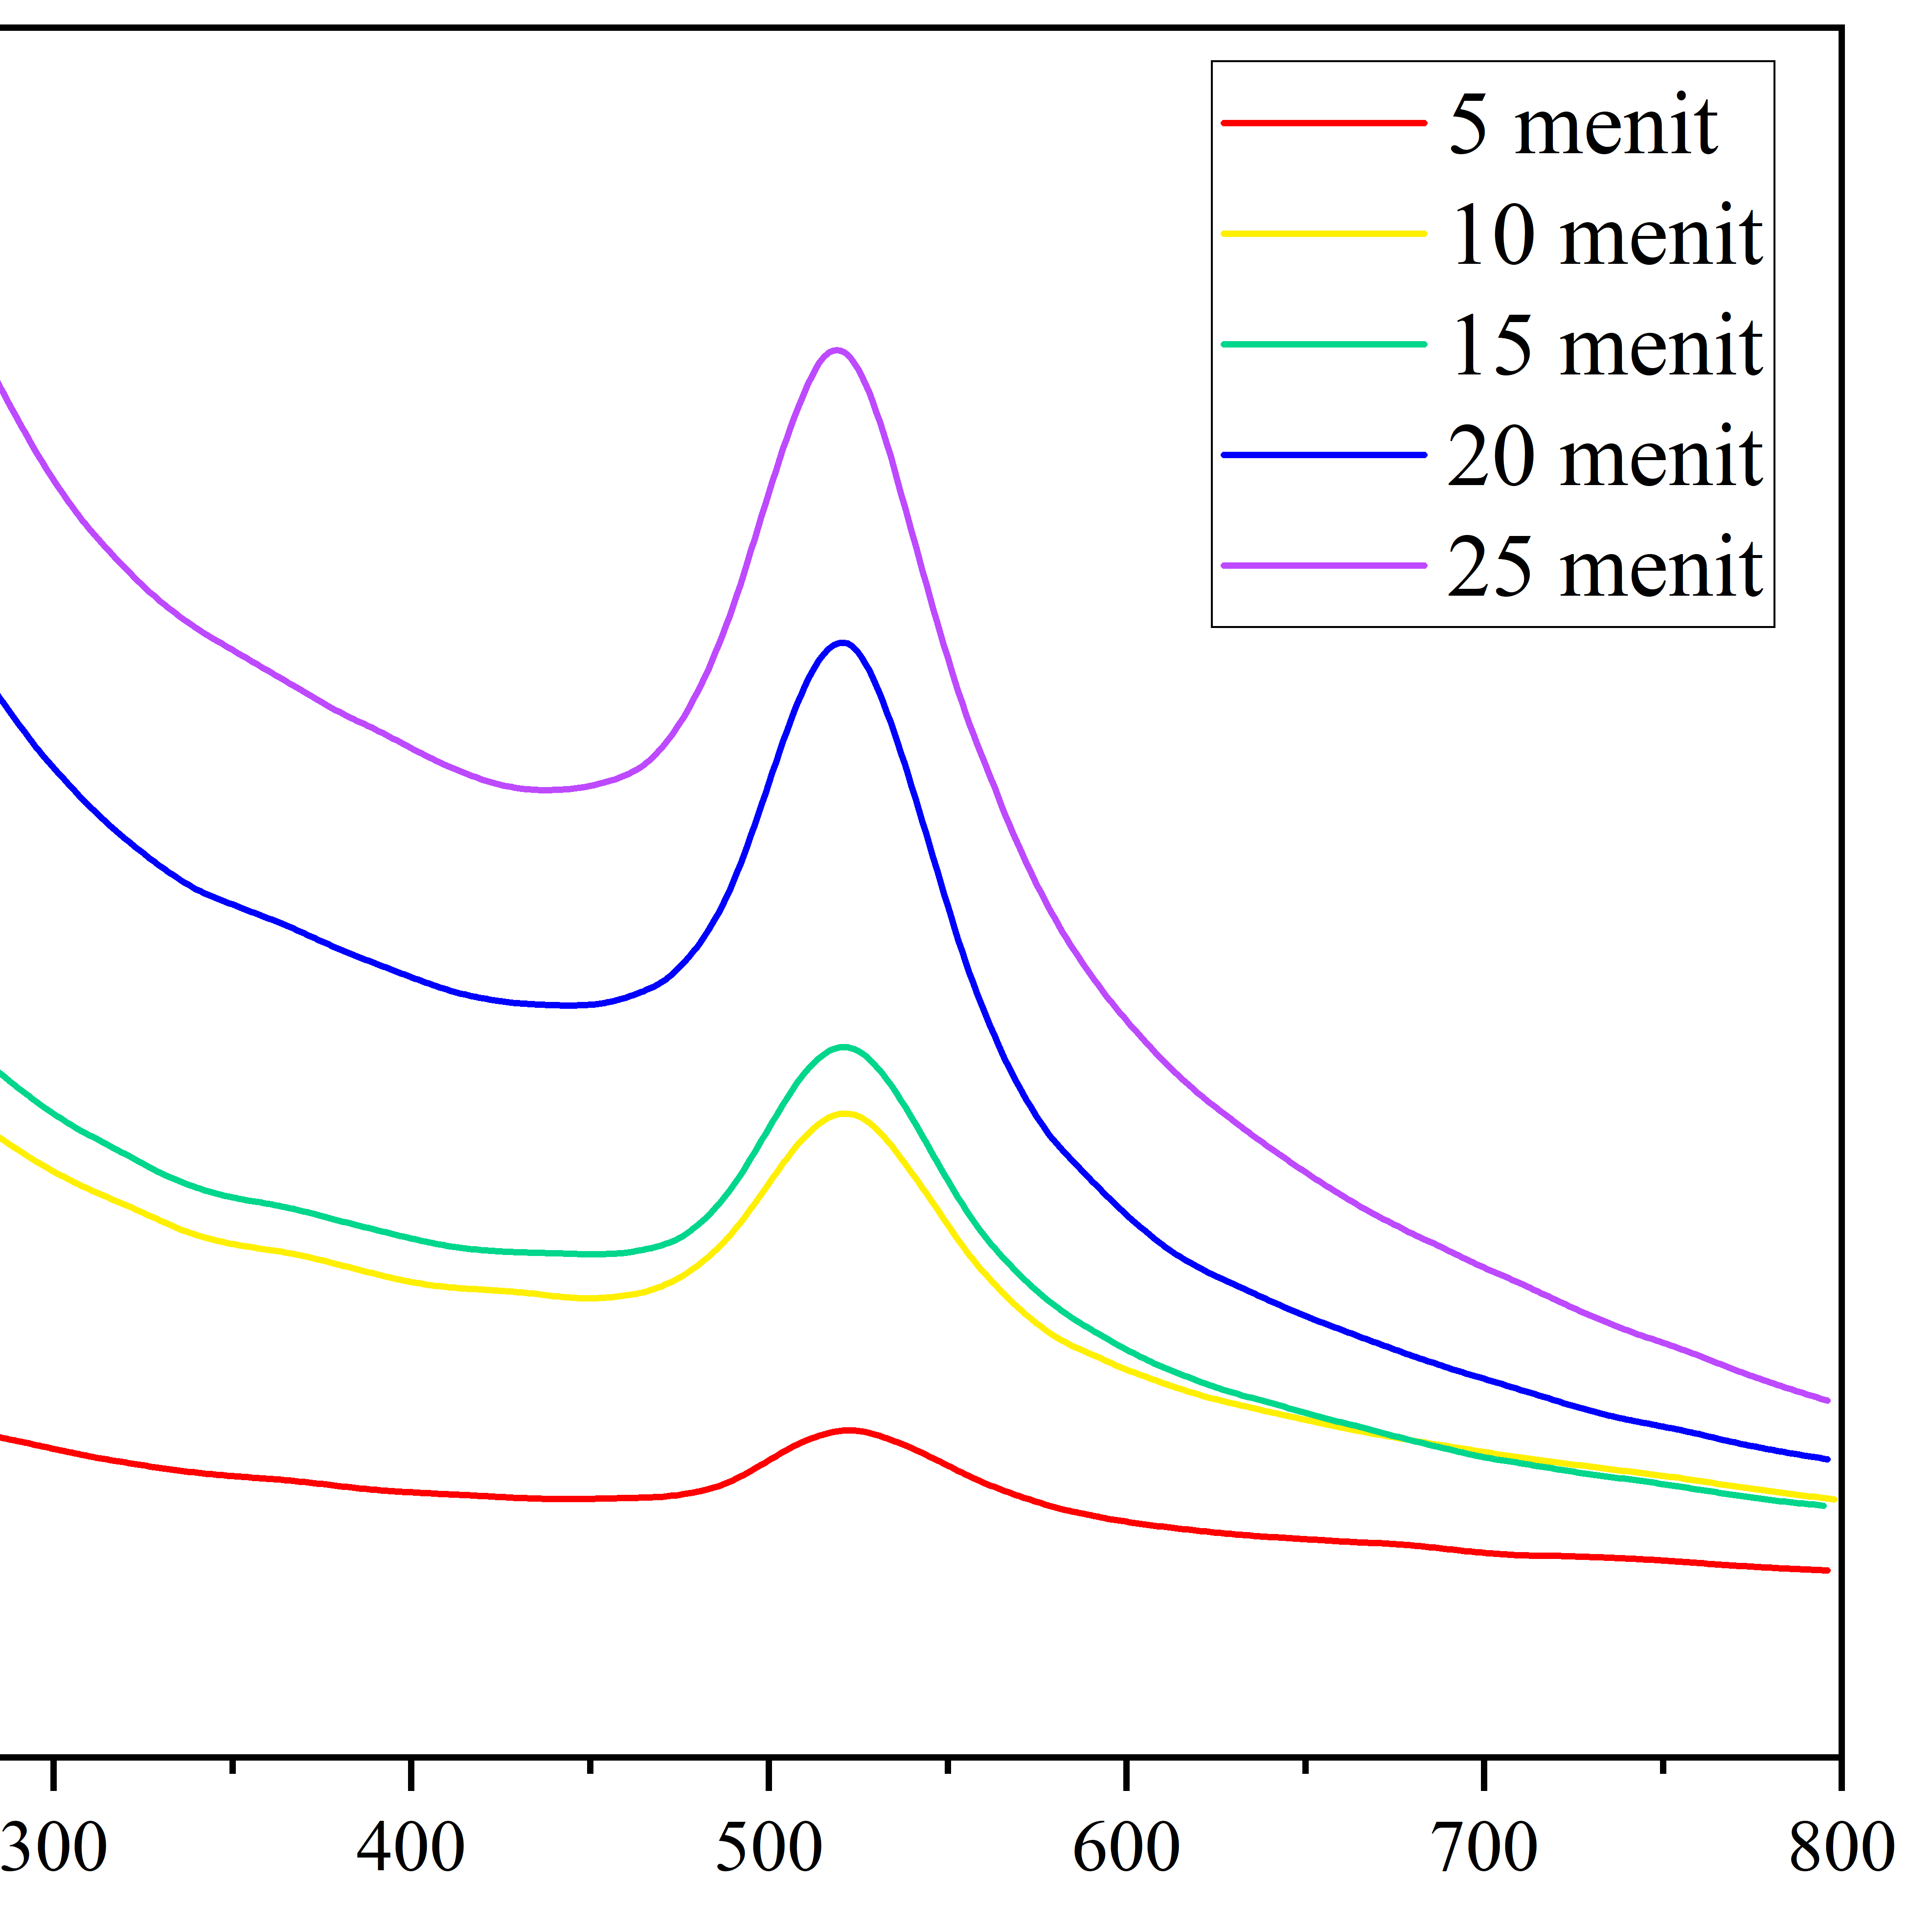
5 minutes
10 minutes
15 minutes
20 minutes
25 minutes
Absorbance (a.u)
Wavelength (nm)

Fig. 4: UV-Vis absorbance spectrum of gold nanoparticle colloids with variations in ablation time of 5, 10, 15, 20, and 25 minutes
Figure 5 shows a linear relationship between ablation time and absorbance value. The longer the ablation time, the higher the nanoparticle concentration, resulting in a higher absorbance value. This is consistent with the Lambert-Beer Law, which states that the higher the concentration of gold nanoparticles, the higher the absorbance value. Furthermore, the absorbance value at 15 minutes of ablation time indicates that the ablation linearity is not the same as the ablation time. This can occur because the ablation affects the metal surface.

Ablation time (minute)

Fig. 5: Graph of the relationship between ablation time and absorbance value
X-ray diffraction analysis provides information on the formation of the crystal structure of gold nanoparticles during the ablation process. The diffraction pattern of the sample ablated for 25 minutes shows sharp peaks. These peaks in the diffraction pattern indicate the presence of a crystalline structure in the gold nanoparticles. The following is a colloidal diffractogram of gold nanoparticles shows in Figure 6.
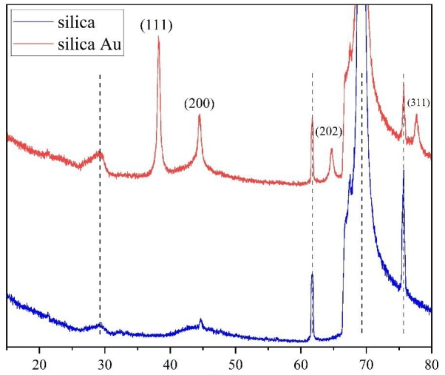
2θ (˚)

Fig. 6: Colloidal diffractogram of gold nanoparticles on silica substrate
Characterization of gold nanoparticles using XRD in Figure 6 shows that the resulting diffractogram shows quite sharp peaks which prove that gold nanoparticles have been formed. This is indicated by the 2θ values ​​of gold nanoparticles, respectively, namely 38.24; 44.48; 64.67; and 77.64 which are close to the standard gold diffractogram of JCPDS Data No. 04-0784, namely 37.82; 44.06; 64.42; and 77.53 [11]. These peaks are marked with miller index, namely (111), (200), (202), and (311) [12]. The agreement between the diffraction pattern and the existing reference shows that the gold nanoparticle crystals are Face Center Cubic (FCC).

Table 1: Gold nanoparticle concentration for 10, 15, and 25 minutes ablation time
Ablation Time | Au concentration (mg/L)
10 minutes |  | 5,170
15 minutes |  | 8,502
25 minutes |  | 20,120

The concentration of gold nanoparticles in aqueous medium with varying ablation times showed different results at each 5-minute interval. The initial hypothesis of the study was that the longer the ablation time, the higher the concentration. This occurs because more gold nanoparticles are formed due to the longer ablation time performed by the laser. The initial hypothesis is proven in Table 1 and align with equation 2 which prove the higher the absorbance, the higher the concentration.

4. Conclusion
This study successfully increased concentration by increasing the laser ablation time on the gold plate. The pulsed laser ablation method using an Nd: YAG Laser (New Wave Research, Polaris II, 20 Hz) wavelength 1064 nm, energy 45mJ, and pulse width 7 ns effectively fired a laser beam at the target and produced more nanoparticles for longer ablation times. However, some imperfections were observed in the 15 minutes ablation time as shown in the UV-Vis absorbance spectrum because ablation on metals with different surfaces will result in different amounts of nanoparticle ablation. But it was still detected through AAS that the 15 minute time ablation still increase the concentration. As a result, it can also be concluded that from minute to minute, variations in the ablation time succeeded in increasing the absorbance value and ultimately increasing the concentration of gold nanoparticle colloids.

Acknowledgment
The authors declare that no specific funding to complete this research.

References
- Abdullah, M., Khairurijal, “Karakterisasi Nanomaterial: Teori, Penerapan, dan Pengolahan Data,” Bandung: CV. Rezeki Putera Bandung (2010)
- Hardani, Pertiwi, A.D., Hartanto, Indri, K. D, “Buku Ajar Farmasi Fisika,” Yogyakarta : Samudra Biru (2021)
- Nengsih, S., Ali Umar, A., Salleh, M.M., & Oyama, M, “Detection of Formaldehyde in Water : A Shape-Effect On The Plasmonic Sensing Properties Of The Gold Nanoparticle,” Sensor 12:10309-10325 (2012)
- Khumaeni, A., Sutanto, H., Budi, W.S, “The Role of Laser Irradiance, Pulse Repetition Rate, and Liquid Media in the Synthesis of Gold Nanoparticles by the Laser Ablation Method using an Nd:YAG Laser 1064 nm at Low Energy,” International Journal of Technology. Volume 10(5), pp. 961-969 (2019)
- Deepak B Thimiri Govinda Raj, Niamat Ali Khan, Srisaran Venkatachalam, Sivakumar Arumugam, Selvamani Palaniswamy, “Synthesis of Hybrid Gold Nanoparticle (AuNP) Functionalized Superparamagnetic Nanoparticles (SPMNPs) for Efficient Coupling of Biomolecules,” Methods Mol Biology 2125:73-75 (2020)
- Noor Zirwatul Ahlam Naharuddin, Amir Reza Sadrolhosseini, Muhammad Hafiz Abu Bakar, Nizam Tamchek, and Mohd Adzir Mahdi, “Laser Ablation Synthesis of Gold Nanoparticles in Tetrahydrofuran,” Opt. Mater. Express 10, 323-331 (2020)
- Mantele W, Deniz E, “UV-VIS absorption spectroscopy: Lambert-Beer reloaded. Spectrochim Acta A Mol Biomol Spectrosc,” 173:965-968 (2017)
- Lindawati, L., Mursal, M., & Afdhal, A, “Determination of Mineral Contents in Meukek Marble Using XRD and SEM-EDS Analysis,” In IOP Conference Series : Materials Science and Engineering. Vol 506, No. 1, p.012023. IOP Publishing (2019)
- Maharani, E., Briliana, H., Putri, E., Faraditta, F., & Azzhaffirah, A, “A Comprehensive Review on Atomic Absorption Spectroscopy: Principles, Techniques, and Applications,” Jurnal Ilmiah Wahana Pendidikan page 20-29 (2024)
- Oliveira, L. C., Lima, A. M. N., Thirstrup, C., and Neff, H. F, “Surface Plasmon Resonance Sensors : A Materials Guide to Design, Characterization, and Usage,” Springer:978-3030174859 (2019)
- Larayetan, Rotimi & Ojemaye, Mike & Okoh, Omobola & Sadimenko, Alexander & Okoh, Anthony, “Synthesis, Characterization, Antimalarial, Antitrypanocidal and Antimicrobial Properties of Gold Nanoparticle,” Green Chemistry Letters and Reviews. 12. 61-68. 10.1080/17518253.2019.1569730 (2019)
- Roddu. A.K., Wahab. A. W., Ahmad. A., Taba. P., Sutapa. I. W, “Theoretical Analysis Properties of Gold Nanoparticles Resulted by Bioreduction Process,” 1463(1), 012008 (2020)

