Journal of Physics and Its Applications, x(x) xxxx, Pages: xx‐xx

Journal of Physics and Its Applications
Journal homepage : http:/www.

Detection of Altered Rock Zones by Applying the Essential Analyses of the Magnetic Method: A Case Study from the Lainea Geothermal Site, Southeast Sulawesi

La Hamimu¹, Al Rubayin², Suryawan Safar³, Laode Ihksan Juarzan⁴, Indrawati⁵

1Department of Geophysical Engineering, Halu Oleo University, Email: lahamimu@uho.ac.id
2Department of Geophysical Engineering, Halu Oleo University, Email: alrubaiyn@uho.ac.id
3Department of Geological Engineering, Halu Oleo University, Email: suryawan_tambang@uho.ac.id
4Department of Geophysical Engineering, Halu Oleo University, Email: juarzan.ode@uho.ac.id
5Department of Geophysical Engineering, Halu Oleo University, Email: indrawati@uho.ac.id

A R T I C L E I N F O

Article history:

Received
Accepted
Available online

Keywords:

Essential analyses
Magnetic method
Total Magnetic Intensity (TMI)
Euler deconvolution
Altered rock zones

A B S T R A C T


The essential analyses in the magnetic method are fundamental approaches of geophysical studies that should be commonly applied for interpreting the magnetic data. In this study, the essential analyses of the magnetic method incorporated several fundamental techniques such as analytic signal processing, upward continuation technique, horizontal gradient method (HGM), tilt angle derivative (TDR), and Euler deconvolution. These techniques were successfully applied to process the field data acquired from the Lainea geothermal site, South Konawe District, Southeast Sulawesi Province, Indonesia. The results of the magnetic data processing were then analyzed to characterize the anomaly sources. This analysis is applied to the total magnetic intensity (TMI). Based on the application of all essential stages in processing and analysis of magnetic data, it was found that signal analysis and Euler deconvolution were effective and efficient in analyzing the magnetic anomaly source. Furthermore, from the TMI map it can be verified that a positive anomaly trend corresponding to the main fault and formation distribution. The HGM implementation can accurately detect the edge boundary of the body anomaly in the form of the altered rock. Here, there are several magnetic lineation paths trending in the north-south (N-S), northeast-southwest (NE-SW), and northwest-southeast (NW-SE) directions. The combined results of TDR and Euler deconvolution can completely show the detection of edge and depth of the anomaly. In particular, the altered rock zones can be specifically found at Boroboro fault, Windo fault, Kaindi fault, Laindi fault, and Lainea fault. A contact anomaly indicating rock intrusion was detected at a depth of 1300–1500 m, which may be associated with the development of altered rock zones.

1. Introduction

Potential field is an essential method in the geophysical exploration employed to explore natural resources based on the geologic structure involving the mapping of several magnetic parameter such as a dip, boundary, area, etc. [1]. The Magnetic data interpretation has the variously complexity level from one dimensional (1D) simple model to 3D modeling with aim to perform a fully characterization of the anomaly sources ([2]). In the perspective of inverse modeling, optimization process including the fitting of observation data and calculation data can produce an estimation anomaly sources model having un-unique solution [3].
Some of techniques have been developed to characterize the anomaly sources. According to Saada [4], the analytic signal (AS), tilt angle derivative (TDR), Euler deconvolution (ED) are common techniques for characterizing the sources of anomaly. The application of these techniques can characterize the anomaly model both edge detection and the depth of anomaly sources ([4], [5], [6], [7], [1]).
In this work, analytic signal, tilt angle derivative, and Euler deconvolution are implemented on the field data of magnetic anomaly measured at Lainea geothermal site with aim to represent the anomaly sources characterization. Lainea is one of place having the potential geothermal located in Southeast Sulawesi Province, eastern part of Indonesia. This site performs several spots of hot spring manifested at earth’s surface as well as the altered rock [8].
In our previous study, we have been quantitatively investigated the geological structure employing the application of the geomorphic method. This method integrates the analysis of morphotectonics by joining data of digital elevation model (DEM) and lithology type. Here, the activity of tectonic is manifestly classified by using index of activity called relative tectonic activity index (RTAI). This index can be generally produced from the geological and geomorphological structures [9].
Based on the results obtained from the analysis of the RTAI, it is classifiably found that there are classes of the tectonic activity presented in the area of study that is high tectonic activity, medium tectonic activity, and low tectonic activity. According to Hamimu et al., (2022), the high activity of tectonic at the Lainea geothermal site covering two watersheds with total area of ± 20.5 km². The medium tectonic and low tectonic activities are respectively covering five watersheds with total area of ± 40.9 km² and two watersheds with total area of ± 12.8 km². Basically, the tectonic locations having a class of high activity should certainly generate the high possibility of seismic hazards due to the propagation of the geological structures.

2. Brief Review of the Geology of Research Area
Research area in this study is the part of Southeast arm of Sulawesi composed of several types of rock. The distribution of rocks in this study area is shown in Fig. 1.

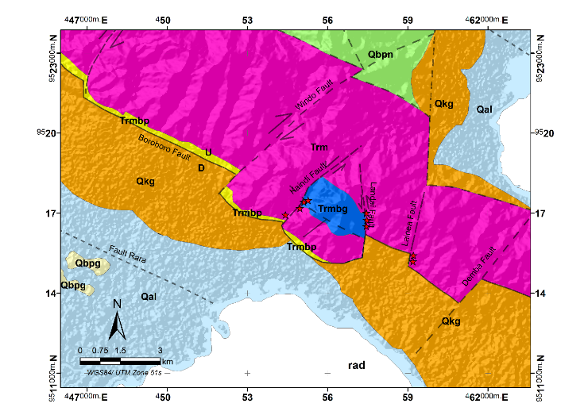
Fig. 1 Regional geological map consisting of Metamorphic Rock Unit (Trm), Meta-Limestone Unit (Trmbg), Meta-Sandstone Unit (Trmbp), Non-carbonate Sandstone Unit (Tbpn), Limestone Sandstone Units (Tbpg), Conglomerate Rock Unit (Qkg) ) and Alluvium deposits (Qal). ([10]).

As can be seen in this figure, there are a number of rock unit can be found in this region ([10]), that is
- Rock unit of metamorphic (Trm) consist of several types of lithology that is quartzite, up rock, schist and phyllite.
- Rock unit of meta-limestone (Trmbg) located around the sloping area. The rock unit at this sloping is typically classified as the metamorphic limestone.
- Rock unit of meta-sandstone (Trmbp) distributed in the southern part of the metamorphic unit, good-naturedly layered with the quartzite type insertion.
- Rock unit of non-carbonate sandstone (Tbpn) with a lithological type of the sandstones. This type is characterized by the inserted black claystone.
- Rock unit of the limestone-sandstones (Tbpg) consists of interchanging of the coarse sandstone with fine sandstone and contains the Mollusca fossils.
- Rock unit of the conglomerate (Qkg) composed on the conglomerate and sandstone. In particularly, the grain size of the composition is in form the boulder-crust.
- Rock units of Alluvium are composed of the clay, gravel, blocks, and sand.
At the Lainea research area, it is also can be found the geothermal potential trending southeast around the structure zone. In term of the geological structure, the research area has three groups of faults. According to the brief review of Hamimu et al., (2022), based on their direction, the main groups of faults presented in this area namely:
- The faults of Boro-boro, Aonope, Andinete, Putemata, and Sibingguru that is grouped in the faults trend of northwest-southeast (NW-SE) .
- The faults of the Windo, Wolasi, Hariri, Demba, Kaindi, and Anggowila that is classified in the faults trend of southwest-northeast (SW-NE).
- The faults of Lainea, Rara, and Landai that is classed in the north-south (N-S) fault direction.

3. Method

3.1. Magnetic Data
Magnetic ground survey is carried out at the site of Lainea geothermal in November 2020. The measurement of field data used two instruments of Proton Precession Magnetometer 19-T with a resolution of 0.1 nT. The first instrument is operated to measure the magnetic field at base station that could be used to calculate the temporal variation of the magnetic field. The last instrument is employed to measure the magnetic field at the observation point. Furthermore, the data resulted from measurement at field are corrected from temporal variation or diurnal correction with aim of calculating total magnetic intensity (TMI).
The TMI anomaly is then obtained by applying the reduction of theoretical magnetic field. This reduction is generally based on the international geomagnetic reference field or IGRF ([11]). In addition, the implementation of the reduced to pole (RTP) technique is carried out by using the Oasis Montaj’s software ([12]). The last process is applied to produce the position correction of TMI anomaly so that it is accurately above the anomaly ([1]).

3.2. Separation of the Residual-Regional Using Upward continuation.
Upward continuation technique is applied on the TMI anomaly RTP to filter the shallow source that is produced from deeply source or regional source. This technique is most frequently applied in analyzing the magnetic anomaly ([2]). Procedure of the Upward continuation is accomplished up to altitude of 1000 m. In this altitude, the trend of anomaly map is relatively not modified. Here, the Geosoft program ([12]) is utilize for visualizing the map of upward continuation. Thereafter, this map is straightforward employed to extract the residual map from the TMI anomaly map.

3.3. Horizontal Gradient Magnitude (HGM)
Horizontal Gradient Magnitude (HGM) is one of computational approach that is very useful for mapping a fault location ([5]). Principally, HGM define strongly interaction of two types of rock having the magnetization different ([13]). This method generates the highly anomaly and reflects the location from anomaly source. HGM(x,y) from a magnetic field M(x,y) is empirically formulated as follow ([14])
$$\text{HGM}\left(\text{x,y}\right)\text{=}\sqrt{{\left(\frac{\text{∂M}}{\text{∂x}}\right)}^{\text{2}}\text{+}{\left(\frac{\text{∂M}}{\text{∂y}}\right)}^{\text{2}}}\text{ (1)}$$

where $\frac{\text{∂M}}{\text{∂x}}$ and $\frac{\text{∂M}}{\text{∂y}}$ are the first derivative of magnetic field toward variable of x and y axes, respectively. The asymptotic function of HGM peaked on magnetic contact with three assumptions that is (Ngoh et al., 2017):
- The Magnetic field and the source of magnetization are in vertical direction
- The magnetic contact is a vertical contact
- Having the thick coating
To prevent the multiple phenomena from thin body, this method should be applied on the RTP magnetic field ([5]). Moreover, Geosoft program ([12]) is used to calculate the first derivative using equation (1) produced from the map of RTP total magnetic intensity RTP.

3.4. Tilt Angel Derivative (TDR)
Improvement of the signal analysis method to determine the location and vertical magnetic contact without a priori information can be perfectly carried out by using the first horizontal amplitude gradient from the angle of inclination ([15], [16]). This method is very interesting to use because it is fundamental and practical to be implemented ([2]). The tilt angel derivative (TDR) or tilt angle of a magnetic field M(x,y) of Miller and Singh (1994) is formulated as follows:
$$\text{θ}\text{=}{\text{tan}}^{\text{-1}}\left[{\frac{\text{∂M}}{\text{∂z}}}/{\frac{\text{∂M}}{\text{∂h}}}\right]\text{ (2)}$$
where $\frac{\text{∂M}}{\text{∂z}}$ is the first derivative of magnetic field toward variable of z axes and $\frac{\text{∂M}}{\text{∂h}}$ is the HGM(x,y).
The average distance between contour angles of 0° and angles of +45° or -45° is the depth of the anomaly ([7]). The results of the TDR technique can point out the location of the source of TMI anomaly as well as make equal the contrast for high and low anomalies ([16]). Tilt angel derivative yielding a zero value (it means close or exactly to the anomaly source) can be used to detect the edge of the source ([15]) Process of the tilt derivative is carried out using the Geosoft program ([12]).

3.5. Euler Deconvolution
The Euler deconvolution is one of techniques that can be used to interpret magnetic data automatically and fast ([4]). This technique is applied to calculate the depth of anomaly object ([2]). This Calculations using the GMsys-3D program ([12]). The technique of Euler deconvolution is based on the equation of the Euler homogeneity.
This homogeneity equation relates the magnetic field and its gradient components for the source location, with the degree of homogeneity N being considered as a structural index ([17]). The structural index is a rating measure of the change in the field with distance. The magnetic field which is the interface and contact has a structural index N = 0 ([2], [4]). In this study the Euler deconvolution technique was applied to calculate the depth of anomaly objects with windows size 10. The depth solution is estimated in the range of 750-1500m with a depth tolerance of 15%.

4. RESULTS AND DISCUSSION
The RTP map of the total magnetic intensity anomaly shows the negative and positive of magnetic magnitudes ranging from -117 nT to 47 nT (Fig. 2).

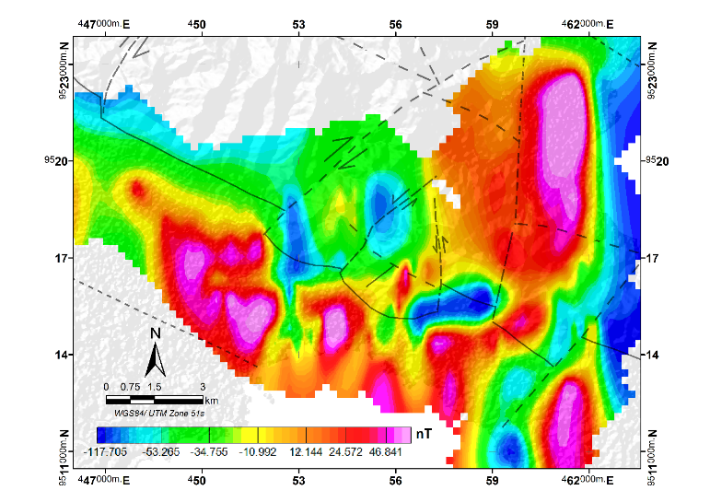
Fig. 2. The RTP map from the total magnetic intensity anomaly of the Lainea. The color gradation shows the magnitude of TMI (nT) and the black line shows faults.

The part of the positive anomaly is observed in the lower area trending in the NW - SE direction and in the upper right area trending in the N-S direction. These areas correspond to the distribution of Quaternary rock unit, namely Conglomerate Rock Units (Qkg) and Alluvium Deposits (Qal). In contrast, the negative or low anomaly area shows the distribution of Metamorphic rock unit (Trm). This area shows correspondingly the boundary lineation of high and low anomalies which be consistent to the Boro-boro fault, the Lainea fault and the Demba fault. Around this lineation, there are three areas having low anomaly closure. The first area is located in the center part with hot springs enclosing the appearance point of the hot spring. In this area, coming out of the hot spring manifestation (Kaendi, Awomolo, Rampant and Lainea) is a geothermal reservoir zone ([8]). This could indicate that the two low anomaly closure areas located in the slightly center part to the north direction should be interpreted as the altered rock zones. Further analysis of this anomaly is investigated using continuation technique and the magnetic derivative analysis.
The results of the upward continuation at an altitude of 1000m indicate a regional anomaly map (Fig. 3) which is a source of deep anomalies. The lifting height of 1000m is correspondingly expected as regional depth. The altered rock zone is no longer visible at this depth. The trend of positive and negative anomalies corresponds to the direction of the main fault in the study area. The map in the Fig. 3 is then subtracted from the map of RTP to produce a map of shallow source as illustrated in Fig. 4. The residual map shows more evidently three altered rock zones close to the main fault in the research area.

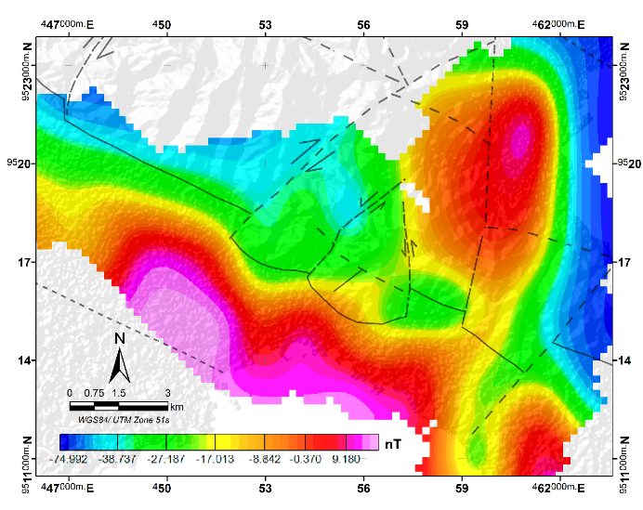
Fig. 3. Map of the upward continuation of the total magnetic intensity at altitude of 1000m. The color gradation shows the magnitude of TMI (nT) and the white polygon shows the altered zone.

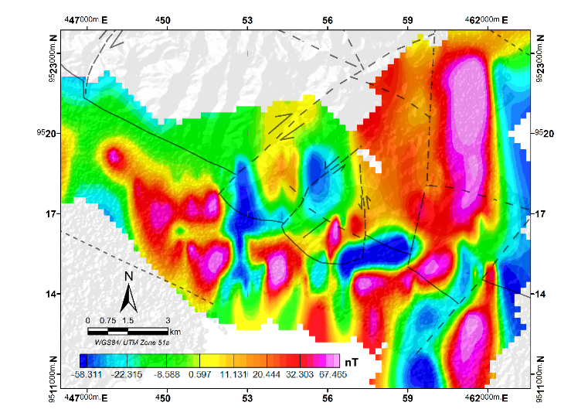
Fig. 4. The map of total magnetic intensity residual. The color gradation shows the magnitude of TMI (nT) and the white polygon shows the altered zone.

The edges of the altered rock zone shown on the HGM map (Fig. 5) are more obviously than those on the RTP map of total magnetic intensity.

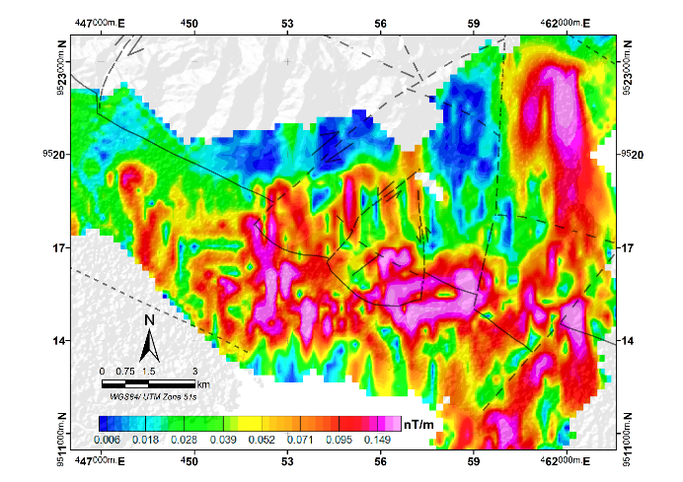
Fig. 5. The map of Horizontal Gradient Magnitude (HGM). The white line shows the peak magnitude of the HGM and the black line shows the fault.

Here, the peak magnitude shows several anomalies denoting the altered rock and fault zones. In the middle part of the map, the closure peak magnitude indicates an altered rock contact edge. This indication is only observed on the eastern part and is not visible on the two altered rock zones as shown on the residual RTP map (Fig. 4). Another anomaly is a number of magnitude lineation indicating faults. The lineation is trending in the NE -SW direction (correlating to the Demba fault), the N-S trend, as well as the NW-SE trend.
Further analysis is carried out by joining the results of the Euler deconvolution and the tilt derivative filter solutions (Fig. 6).

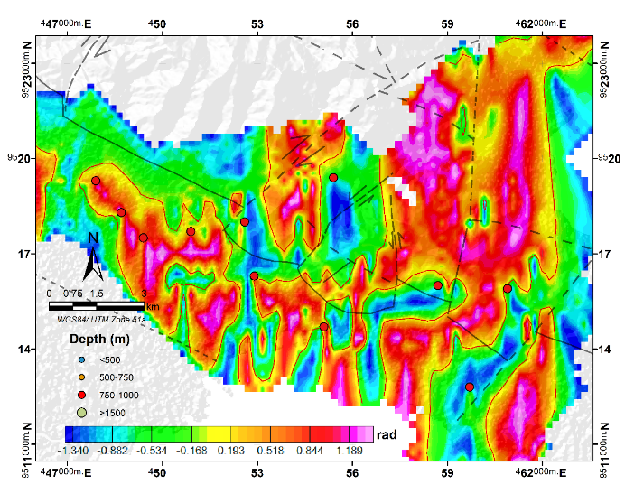
Fig. 6. The map of tilt derivative of the total magnetic field of RTP and the solution of index 0 structural 3D-Euler. Color gradations show angle magnitude (rad), black lines indicate faults

The TDR analysis shows the availability of faults, which appear in the form of magnetic lineation, as well as the boundary edges of the anomaly sources denoted by the zero TDR contour. The zero contour is shown with a red line separating the magnetic susceptibility with a positive value marked a red-pink gradient and a negative value marked a green-blue gradient. The distribution of positive values ​​is exactly over the source corresponding to unaltered rock. The overlap of TDR with the Euler deconvolution solution indicates that the edge of the body anomaly between the two filters correspond to each other. In addition, the TDR map shows correspondingly a distribution of negative values ​​indicating the distribution of the altered rock zones from a more extensive residual map (Fig. 4). These zones can be specifically found at around the faults of Boro-boro, Windo, Kaindi, Laindi as well as the Lainea fault. In general, the correlation with the Euler deconvolution solution for the structure index 0 shows that there is a contact anomaly indicating the rock intrusion. This intrusion can prospectively produce the altered rock zone at a depth of 1300-1500m.
Finally, the results of magnetic anomaly data analysis obtained from this study can consistently confirm the manifestation of the geothermal system at Lainea. The hot spring source at the Lainea’s geothermal system has an intrusive or plutonic rock characteristics with the depth estimation of 1250-1500 meters ([8]).

5. Conclusion
Application of the signal analysis method and Euler deconvolution was effectively and efficiently in analyzing the magnetic anomaly data. The main fault and the distribution of formation is properly confirmed by using an analysis the positive anomaly trend obtained from TMI map. The HGM implementation can completely verify the edge detection of the body anomaly in the form of the altered rock and there are several magnetic lineation paths trending in the N-S, NE-SW, and NW-SE directions. The join results of TDR and Euler deconvolution can show the detection of edge and depth of the anomaly. In particular, the altered rock zones can be specifically found at Boro-boro fault, Windo fault, Kaindi fault, Laindi fault, and also Lainea fault. A contact anomaly indicating the rock intrusion can prospectively produce the altered rock zone at a depth of 1300-1500m.

Acknowledgment
We would especially like to thank the Halu Oleo University for supporting financial and facility. This article is fully funded by internal Basic Research Program of Halu Oleo University.

References
- Eldosouky, A. M. & Saada, S. A. Source edge detection (SED) of aeromagnetic data: synthetic examples and a case study from Haimur area, south Eastern Desert, Egypt. Arabian Journal of Geosciences, 13, 626 (2020).
- Hinze, W. J., Von Frese, R. R., Von Frese, R. & Saad, A. H. Gravity and magnetic exploration: Principles, practices, and applications, Cambridge University Press. (2013).
- Hinze, W. J., Von Frese, R. R., Von Frese, R. & Saad, A. H. Gravity and magnetic exploration: Principles, practices, and applications, Cambridge University Press (2013).
- Yudistira, T. & Grandis, H. Interpretasi Gravitasi dan Magnetik Menggunakan Metode Sinyal Analitik dan Dekonvolusi Euler-3D. Prosiding HAGI, Yogyakarta (1998).
- Saada, S. A. Edge detection and depth estimation of Galala El Bahariya Plateau, Eastern Desert-Egypt, from aeromagnetic data. Geomechanics and Geophysics for Geo-Energy and Geo-Resources, 2, 25-41 (2015).
- Grauch, V. J. S. & Ruleman, C. A. 2013. Identifying Buried Segments of Active Faults in the Northern Rio Grande Rift Using Aeromagnetic, LiDAR, and Gravity Data, South-Central Colorado, USA. International Journal of Geophysics, 2013, 1-26. (2013)
- Sultan Araffa, S. A., Monteiro Santos, F. A. & Arafa-Hamed, T. Delineating active faults by using integrated geophysical data at northeastern part of Cairo, Egypt. NRIAG Journal of Astronomy and Geophysics, 1, 33-44 (2012).
- Lahti, I. & Karinen, T. Tilt derivative multiscale edges of magnetic data. The Leading Edge, 29, 24-29 (2010)
- Zarkasyi. A. Survei Magnetotellurik (MT) dan Time Domain Electro Magnetic (TDEM) Daerah Panas Bumi Lainea, Provinsi Sulawesi Tenggara. In: WIDODO, S., ed. Prosiding Hasil Kegiatan Pusat Sumber Daya Geologi, Pusat Sumber Daya Geologi (2014).
- Hamimu, L., Asfar, S., Arisona, Ngkoimani, L. O., Silvara, Irawati. & Rubaiyn, A. Quantitative Analysis of Relative Tectonic Activities of Geothermal Areas of Lainea, South Konawe District, Southeast Sulawesi Province, Indonesia, International Journal on Advanced Science Engineering Information Technology (IJASEIT), Vol. 12, No. 5, (2022).
- Hadi, M. N., Kusniadi, D. & Widodo, S. Laporan Akhir Penyelidikan Terpadu Geologi dan Geokimia Daerah Panas Bumi Lainea. Pusat Sumberdaya Geologi, Badan Geologi (2010).
- Reynolds, J. M. An introduction to applied and environmental geophysics, John Wiley & Sons. (2011).
- Montaj, O. Geosoft mapping and application system Inc, Suit 500, Richmond St. West Toronto, ON Canada N5SIV6 (2007).
- El All, E. A., Khalil, A., Rabeh, T. & Osman, S. Geophysical contribution to evaluate the subsurface structural setting using magnetic and geothermal data in El-Bahariya Oasis, Western Desert, Egypt. NRIAG Journal of Astronomy and Geophysics, 4, 236-248. (2015)
- Cordell, L. & Grauch, V. Mapping basement magnetization zones from aeromagnetic data in the San Juan Basin, New Mexico. The utility of regional gravity and magnetic anomaly maps. Society of Exploration Geophysicists. (1985).
- Miller, H. G. & Singh, V. Potential field tilt—a new concept for location of potential field sources. Journal of applied Geophysics, 32, 213-217 (1994).
- Verduzco, B., Fairhead, J. D., Green, C. M. & Mackenzie, C. New insights into magnetic derivatives for structural mapping. The leading edge, 23, 116-119 (2004).
- Thompson, D. Euldoph: A new technique for making computer-assisted depth estimates from magnetic data. Geophysics, 47, 31-37 (1982).

