**Journal of Physics and Its Applications**, x(x) xxxx, Pages: xx-xx



Journal of Physics and Its Applications

Journal homepage : <https://ejournal2.undip.ac.id/index.php/jpa/index>

**Study of Potential Land Subsidence in East Aceh Region Based on Sediment Characterization Using Logging Data**

Tarmizi1*, Layna Miska1, Muhammad Syukri2, Zahratul Maghfirah1, Tika Hapsari3, Dian Darisma1, and Ikhlas4

*1Department of Geophysical Engineering, Universitas Syiah Kuala*

*2Department of Physics, Universitas Syiah Kuala*

*3Department of Geological Engineering, Universitas Syiah*

*4Aceh Energy and Mineral Resources Service*

\**Corresponding author: tarmizi_hasyem@usk.ac.id*

A R T I C L E I N F O

*Article history:*

Received

Accepted

Available online

*Keywords:*

Subsidence

Sediment

Logging Data



A B S T R A C T



Observations to determine subsidence potential were conducted in East Aceh, based on sediment characterization using logging data. The study encompassed 9 measurement sites representing 9 villages from 9 sub-districts. The data used obtained from the Aceh Energy and Mineral Resources Service (ESDM). This data is processed to obtain the resistivity value of the subsurface sediment layer. The measurement results were then depicted in 1D profile illustrating the cross-section of subsurface lithology for each measurement point. Subsequently, several measurement points were correlated to generate a 2D bottom image representing two regions, referred to as cross-section A-A' and cross-section B-B'. The correlation outcomes revealed that cross-sectional area A-A', spanning approximately ±50 km from east to west through Cot Geulumpang Village, Java Village, Kuala Lawah Village, Bukit Seroja Village, and Rantau Panjang Village, shows a shallow surface layer consisting mostly of sand and sandy clay soil. The sand layer in this area exhibited a medium to fine size with a configuration of round-shaped particles containing quartz and shell minerals, forming a soft sediment layer. The structure and type of sediment in this area indicate the potential for land subsidence. Conversely, cross-section B-B', extending for about ±15 km through Bukit Seroja Village, Beurandang Village, and Alue Hitam Village, revealed a sedimentary structure dominated by clay, suggesting a low or almost non-existent potential for land subsidence.

**1. Introduction**

Along with the high level of exploitation of underground resources, land subsidence has become a hot issue. Land subsidence can occur suddenly or gradually due to the movement of materials on the earth's surface [1]. This phenomenon can cause losses in the form of infrastructure damage, flooding, and other social and economic impacts for the community [2]. Land subsidence can occur naturally or as a side effect of human activities. Factors causing land subsidence include excessive water exploitation, mining, building loads, tectonic activity, geological cycles, and sedimentation [3]. Land subsidence can occur when porous rocks lose cement such as clay that fills the pores or the groundwater level drops close to a pumping well due to excessive groundwater pumping [4]. Numerous researchers used a strategy for hydrogeological investigation by applying electromagnetic, resistivity, and other geophysical methods [5][6][7]. One way to determine the possibility of land subsidence in an area is by characterizing the sediments in the region. The research area is adjacent to the coast, which is quite vulnerable to land subsidence, because coastal areas are very vulnerable to environmental pressures, both from the land and from the sea [8]. Land subsidence has occurred in East Aceh district, more precisely the subsidence of infrastructure on the Peureulak-Lokop-Border of Gayo Lues road segment l on January 2022 [9].

Sedimentation is the process of settling suspended material due to gravity. Sedimentation can occur directly or indirectly causing the change of sediments into sedimentary rocks. Sedimentation activities can occur through physical, chemical and biological processes. Sediments come from fragments of rock fragments, minerals, and organic materials that settle in sedimentation basins which in a long time will experience rocking [10]. The deposition process is assisted by wind, water, gravity, and so on. The sedimentation process that occurs continuously forms layers on the earth's surface [11].

The process of transporting sediment-forming materials can occur in three ways, namely suspension, bed load, and saltation. Suspension occurs due to the flow of water and wind that transports sedimentary material with a very small size. Bed load occurs because the force acting exceeds the moment of inertia of the material, causing the flow or movement of the material. While saltation is the fall of material due to the force of gravity [12].

The final destination for the transportation of sedimentation material is called a basin. The basin is lower than the surrounding area and is the place where deposition or sedimentation occurs. The process of sedimentation that occurs continuously results in differences in the subsurface structure or crust of the Earth. Each region has a different subsurface structure or formation depending on the sedimentation process that takes place over millions of years. This sedimentation process determines the subsurface characteristics of an area. Determination of subsurface characteristics can be done using the Electrical Well Logging method. Both geophysical and geological methods that have been integrated by this researcher as a spatial analysis with an approach to sedimentation and groundwater studies i.e in Krueng Aceh was done by [13].

Electrical well logging is a geophysical method to determine subsurface structures by utilizing the physical properties of rocks. The physical properties referred to here are the conductivity and electrical potential of rocks. Each type of rock has a different type of resistance or resistivity that causes different electrical conductivity [14]. The resistivity value of a rock depends on the effective porosity, permeability, salinity, and hydrocarbons in the rock pores. The same type of rock does not necessarily have the same resistivity value but is in a certain range of values. The following is an example of material classification based on the range of resistivity values.

Table : Resistivity Value of Rocks and Minerals [15].

|  |  |
| --- | --- |
| Material | Resistivity (Ωm) |
| Sandstone | 500 – 10000 |
| Sand | 20 - 2000 |
| Clay | 1 – 1000 |
| Ground water | 0,5 - 300 |
| Sea water | 0,2 |
| Dry gravel | 600 - 10000 |
| Alluvium | 10 – 800 |
| Gravel | 100 - 600 |

The electrical well logging method can provide an overview of the vertical subsurface structure so that characterization of each subsurface sediment layer can be done. Measurements are made by flowing electric current into the subsurface through 2 electrodes [16].

According to [17][18], East Aceh area was formed by the quaternary and pre-quaternary rock, recognized as alluvium deposited along the coast of East Aceh which includes the area Peureulak, Idi Rayeuk, Idi, and parts of Simpang Ulim sediments. Westward from the coast, the study area is located in the Idi and Julu Rayeu formations. The alluvium deposited consists of gravels, sands, and clays. The Idi formation is distinguished by limestone and semi-consolidated sands, then the Julu Rayeu formation consists of rhytmic sandstones, lignitic clays, and mudstones.

**2. Methods**

The data acquisition process was carried out with 9 borehole sites in several sub-districts in East Aceh District as shown in Fig 1. Table 2 provides information on the borehole sites and the areas that were traversed.

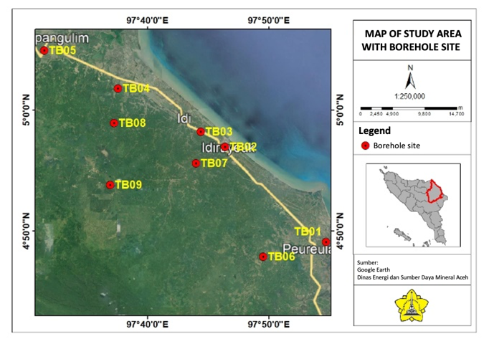

**Fig 1:** Borehole sites map.

Table : List of borehole points in the study area

|  |  |  |  |
| --- | --- | --- | --- |
| Drill  Point | District | Village | Depth Wells (m) |
|
| TB01 | Peureulak | Cot Geulumpang | 130 |
| TB02 | Idi | Jawa | 124 |
| TB03 | Idi Rayeuk | Kuala Lawah | 100 |
| TB04 | Julok | Bukit Seroja | 102 |
| TB05 | Pantai Bidari | Rantau Panjang | 123 |
| TB06 | Rantau Peureulak | Pulo Blang | 108 |
| TB07 | Darul Ihsan | Pantaiyan Timur | 111 |
| TB08 | Nurul Salam | Beurandang | 121 |
| TB09 | Indra Makmur | Alue Hitam | 83 |

The data used in this research is borehole data, where cutting of material fragments from the well wall eroded by the drill bit is carried out as supporting data in determining the type of rock. The data acquisition process was carried out by the Aceh Energy and Mineral Resources Service (ESDM). Drilling was carried out at a depth of 0 to 135 m, and resistivity measurements using the Naniura ND 112 P instrument. The data processing begins with inputting electrical well logging data in the form of resistivity logs, SP logs, and cutting data using Logplot 2007 software so that the results are obtained in the form of cross sections and lithology descriptions as well as resistivity curves and SP (Spontaneous Potential) curves. The principle of log SP is to measure the electrical potential between the depth in the drill hole and the ground voltage at the surface [19]. Numerous research applications on log SP have been applied to groundwater investigation [20][21][22][23]. Furthermore, logging and cutting data in the form of 1D rock layer cross sections are analyzed so that the character of the sedimentary deposits of the study area can be determined. While the permeability of the layer is reviewed by analyzing the response of the resistivity log curve and SP log.

To obtain a comprehensive picture of the subsurface conditions of the study area, correlation between measurement points was carried out using

Rockwork 16 software to obtain a 2D model of the lithology of the study area.

**3. Result and Discussion**

Based on the results of data processing using Logplot 7 software, a lithology cross-section of 9 measurement sites is obtained as shown in the following figure:

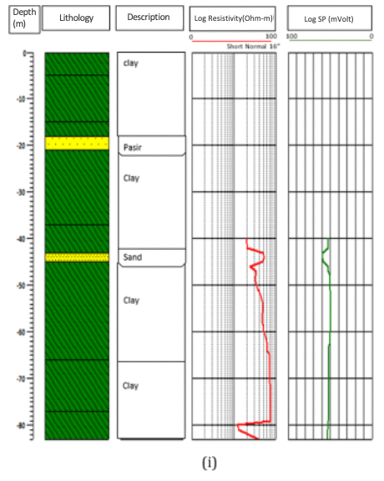

Fig 2. Lithologic cross-section of 9 measurement points

Based on the response of log resistivity and log SP curves, the type of subsurface layer of the research area is obtained as shown in Fig 2. The subsurface sedimentary structure of the East Aceh Regency area is a mixture dominated by a clay layer. The clay layer has a high resistivity value because it traps water.

Correlation between measurement points was carried out and a lithological cross-section of 2 passes was obtained as follows:

1. Cross-section A-A'

This cross-section is the result of correlation forming a ± 50 km long track that stretches from east to west through Cot Geulumpang Village, Java Village, Kuala Lawah Village, Bukit Seroja Village and Rantau Panjang Village. This track covers 5 sub-districts which in this study are called points TB01 to TB05. The 2D cross-section of the correlation results is presented in Fig 3 as follows:

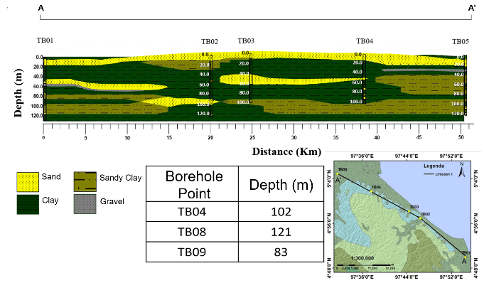

**Fig 4:** Lithology cross section A-A'.

Fig 3 shows that the sedimentary structure of cross-section A-A' consists of a mixture of clay, sandy clay, and sand layers. The ground surface to a depth of ±18 m along this area is dominated by sand. In some areas, the sand layer is on the surface while in other areas the surface layer is in the form of passive clay and the sand layer inserts underneath. Sand layers are also visible at a depth of 85 m to 100 m with a thickness of about 15 m stretching between points TB01 and TB02 along 9 km.

The sand layer of this area is relatively medium to fine in size with a rounded particle arrangement containing quartz and shell minerals. The characteristics of the sand layer in this area indicate that these sediments originated from the marine sedimentation process, forming soft deposits and sediments. This soft sediment character allows for subsidence.

Clay layers are underlain at depths of 18m - 43m, 80m - 100m, and 120m -125m with thicknesses of 25m, 20m, and 5m respectively.

1. Cross section B-B'

This cross-section is the result of correlation with a ±15 km long track through Bukit Seroja Village, Beurandang Village, and Alue Hitam Village which in this study are called points TB04, TB08, and TB09. The lithological cross-section of this area is shown in Fig 4 as follows:

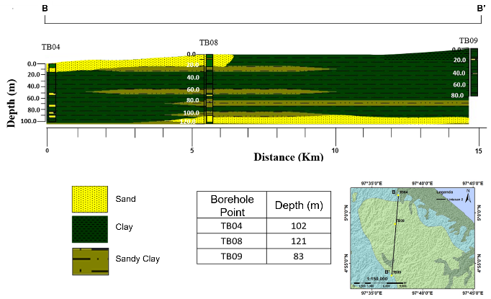

**Fig 5:** Lithology cross-section B-B’.

Fig 4 shows that the sedimentary layer structure representing these 3 sub-districts is similar to cross-section A-A' which is composed of a mixture of clay, sandy clay, and sand layers. However, part of the surface of this area consists of sand layers and the other part is clay. The sand layer of this area is also identified as the result of marine sedimentation with relatively coarse to fine particle sizes and contains quartz and shell minerals.

The subsurface layer of the area is entirely dominated by clay with a thickness of up to 70m. These characteristics indicate low or almost no potential for subsidence. A layer of passive clay inserts into the subsurface sedimentary structure of the area with an average thickness of 5m.

1. **Conclusion**

The results showed the potential for land subsidence in part of the study area. The potential for land subsidence is seen in the A-A' cross-section area which includes Cot Geulumpang Village, Jawa Village, Kuala Lawah Village, Bukit Seroja Village, and Rantau Panjang Village with the surface layer dominated by medium to fine-grained sand that forms soft sediments. Cross section B-B' extends for ±15 km through Bukit Seroja Village, Beurandang Village, and Alue Hitam Village, dominated by a clay layer with a thickness of up to 70 m. These sedimentary characteristics make the B-B' cross-section area minimal or even no potential for land subsidence.

**Acknowledgment**

The authors would like to thank the Aceh Energy and Mineral Resources Agency for supporting data and implementation of this research.

**References**

[1] D. G. Zeitoun and E. Wakshal, *Land Subsidence Analysis in Urban Areas*. 2013. [Online]. Available: http://link.springer.com/10.1007/978-94-007-5506-2

[2] B. Tirta, D. Waryono, and Sawarendro, “Penurunan Muka Tanah (Land Subsidence) dan Dampaknya terhadap Strategi Pengelolaan Air di Kota Semarang, Provinsi Jawa Tengah,” *Pertem. Ilm. Tah. ke-40 HATHI, Bandar Lampung*, no. August, 2023.

[3] B. Setyadi and R. Rustadi, “Analisis Penurunan Muka Tanah dengan Small Baseline Subset Differential SAR Interferograms di Kota Bandar Lampung,” *JGE (Jurnal Geofis. Eksplorasi)*, vol. 5, no. 2, pp. 116–129, 2020, doi: 10.23960/jge.v5i2.27.

[4] J. H. Kim, M. J. Yi, S. H. Hwang, Y. Song, S. J. Cho, and J. H. Synn, “Integrated geophysical surveys for the safety evaluation of a ground subsidence zone in a small city,” *J. Geophys. Eng.*, vol. 4, no. 3, pp. 332–347, 2007, doi: 10.1088/1742-2132/4/3/S12.

[5] N. B. Christensen and K. I. Sorensen, “Surface and borehole electric and electromagnetic methods for hydrogeological investigations,” *Eur. J. Environ. Eng. Geophys.*, vol. 3, no. 1, pp. 75–90, 1998.

[6] U. Hamzah, R. Yaacup, A. R. Samsudin, and M. S. Ayub, “Electrical imaging of the groundwater aquifer at Banting, Selangor, Malaysia,” *Environ. Geol.*, vol. 49, no. 8, pp. 1156–1162, 2006, doi: 10.1007/s00254-005-0160-6.

[7] S. Uhlemann, O. Kuras, L. A. Richards, E. Naden, and D. A. Polya, “Electrical resistivity tomography determines the spatial distribution of clay layer thickness and aquifer vulnerability, Kandal Province, Cambodia,” *J. Asian Earth Sci.*, vol. 147, no. March, pp. 402–414, 2017, doi: 10.1016/j.jseaes.2017.07.043.

[8] R. Pujiastuti, Suripin, and Syafrudin, “Pengaruh Land Subsidence terhadap Genangan Banjir dan Rob di Semarang Timur,” *J. Media Komun. Tek. Sipil*, vol. 21, no. 1, pp. 1–12, 2015.

[9] S. Hendri, “Tim Geologi Teknik PUPR Aceh Survei Struktur Tanah di Jalan Amblas,” *Aceh.tribunnews.com*, Feb. 23, 2022.

[10] K. O. Usman, “Analisis Sedimentasi Pada Muara Sungai Komering Kota Palembang,” *J. Tek. Sipil dan Lingkung.*, vol. 2, no. 2, pp. 209–215, 2014.

[11] D. Piranto, I. Riyantini, M. U. Kurnia, and D. J. Prihadi, “Karakteristik sedimen dan pengaruhnya terhadap kelimpahan gastropoda pada ekosistem mangrove Di Pulau Pramuka,” *J. Perikan. dan Kelaut.*, vol. X, no. 1, pp. 20–28, 2019.

[12] C. Asdak, “Hidrologi dan Pengelolaan Daerah Aliran Sungai,” *Gadjah Mada Univ. Press*, 2007.

[13] I. Rusydy *et al.*, “Integration of borehole and vertical electrical sounding data to characterise the sedimentation process and groundwater in Krueng Aceh basin, Indonesia,” *Groundw. Sustain. Dev.*, vol. 10, no. 7, p. 100372, 2020, doi: 10.1016/j.gsd.2020.100372.

[14] S. Vebrianto, *Eksplorasi Metode Geolistrik: Resistivitas, Polarisasi Terinduksi, dan Potensial Diri*. Malang: Universitas Brawijaya Press, 2016.

[15] W. M. Telford, L. P. Geldart, and R. E. Sheriff, “Applied Geophysics,” *Cambridge University Press*, vol. Cambridge. pp. 535–537, 1990.

[16] A. Harsono, “Aplikasi Well Logging Dalam Evaluasi Formasi,” *Schlumberger Oilfields Serv.*, pp. 69–89, 1997.

[17] W. Keats *et al.*, “Geologic Map of The Lhokseumawe Quadrangle, Sumatra,” 1981.

[18] N. . Cameron *et al.*, “Geologic Map of The Langsa Quadrangle, Sumatra,” 1981.

[19] Petrogorv, *Complete eBook for Employment on Offshore Drilling Platforms*. Petrogorv International, 2020.

[20] T. A. Fadlly and T. Harmawan, “Identifying Changes Of Groundwater Potential With The Interpretation Of Self-Potential,” vol. 13, no. 2, pp. 32–38, 2021.

[21] N. F. I. D and A. Setyawan, “Identifikasi Aliran Air Injeksi Di Lapangan Talang Jimar Region Sumatra Menggunakan Metode Spontaneous Potential,” vol. 15, no. 3, 2012.

[22] N. Widiastuti, N. Nurhasanah, and J. Sampurno, “Pendugaan Potensi Air Bawah Permukaan Menggunakan Metode Self Potential di Kelurahan Sungai Jawi Kota Pontianak,” *Prism. Fis.*, vol. V, no. 2, pp. 61–67, 2017.

[23] H. Siswoyo, S. Harganto, F. S. H. Kusuma, R. Hisbulloh, and A. B. Pratama, “Penyelidikan Potensi Air Tanah pada Lahan Pertanian Di Desa Bono Kecamatan Pakel Kabupaten Tulungagung dengan menggunakan Metode Potensial Diri,” vol. 14, no. 2, pp. 112–118, 2018.