**Journal of Physics and Its Applications**, x(x) xxxx, Pages: xx‐xx

Journal of Physics and Its Applications

Journal homepage : http:/www.

**Morphological, Crystallinity, and Functional Group Analysis of Coconut Shell-Based Activated Carbon with Carbonization Temperature Variations for Supercapacitor Electrode Potential**

Sheilla Rully Anggita1, Arinda Yukashima Putri Prahesti2, Tasya Salsabila Azizah3 and Arsini4

*1Physics Department, UIN Walisongo;* [*sheillarully@walisongo.ac.id*](mailto:sheillarully@walisongo.ac.id)

*2Physics Department, UIN Walisongo;* [*Arinda_yukashima_putri_p_2008026004@walisongo.ac.id*](mailto:Arinda_yukashima_putri_p_2008026004@walisongo.ac.id)

*3Physics Department, UIN Walisongo;* [*2108026035@student.walisongo.ac.id*](mailto:2108026035@student.walisongo.ac.id)

*4 Physics Education Department, UIN Walisongo;* [*arsini@walisongo.ac.id*](mailto:arsini@walisongo.ac.id)

A R T I C L E I N F O

*Article history:*

Received

Accepted

Available online

*Keywords:*

Morphology

Crystallinity

Functional Group

Active Carbon

Coconut Shell

A B S T R A C T



Supercapacitors are one of the electrical energy storage technologies whose capacity capabilities continue to be developed. Coconut shell activated carbon has great potential as the main material for supercapacitor electrodes to increase the capacity of supercapacitors. Coconut shell carbon powder is carbonized at a temperature of 400-700°C, then chemically activated with a 3M KOH activator solution for 24 hours. The activated carbon powder is filtered and rinsed with distilled water (H2O) until the pH approaches ±7 and is oven-dried at a temperature of 120°C for 4 hours. This activated carbon will be applied as an electrode in a supercapacitor. Tests of coconut shell activated carbon carried out are SEM, XRD; and FTIR tests. The morphological results of all samples have formed pores that are evenly distributed, the higher the carbonization temperature, the more the pore structure develops. The results of the XRD test showed that all samples were amorphous graphite carbon structures and the level of crystallinity increased as the carbon temperature increased. The results of the FTIR test showed that all samples had aromatic C=C groups and C-O groups.



**1. Introduction**

The dwindling availability of fossil fuels has encouraged many researchers to develop energy storage systems from renewable and environmentally friendly natural resources [1]. Supercapacitors are rapidly gaining interest because they have high power density with less environmental impact [2]. In addition, supercapacitors have the advantages of fast charging in the order of seconds, large capacity with capacitance values ​​exceeding 100F, and charging cycles with a longer life compared to conventional capacitors [3][4][5]. Supercapacitors have two important material components, namely electrodes and electrolytes [6]. The composition of supercapacitors consists of two electrodes, electrolytes and separated by a separator [7]. Electrodes are very important devices in supercapacitor energy storage media because they can react directly to electrolytes [3][8]. Electrolyte ions store energy by forming an electrical layer on the surface of the active electrode material [9].

The material commonly used in the formation of electrodes is carbon-based material. Carbon materials are interesting to be studied as materials because of the advantages of several properties such as high electrical conductivity and surface area [10], abundant availability of materials, low prices, easily controlled pores and stable physical and chemical properties [11]. In its development, electrodes are often made with activated carbon because of its porous texture [8], has a high surface area [12], good electrochemical properties [13], high absorption capacity [14], is cost-effective, low inorganic compounds and is easy to obtain because it is made from natural materials that are certainly abundantly available [15]. Activated carbon has a porous surface structure resulting in a high surface area which is beneficial for making electrodes [5]. The high surface area of ​​activated carbon results in more electrons being absorbed on the electrode so that it will increase its capacitance [3]. The porous structure of activated carbon is important for ions to migrate and occupy the carbon pores repeatedly to form a layer at the electrode-electrolyte interface in electrochemical energy storage devices such as supercapacitors [8].

One of the materials that is widely available in nature and can be used as activated carbon with a high carbon content is coconut shell [12]. Coconut shells have a fairly high carbon content of 74.3% [16]. In addition to having a high carbon content, coconut shells are organic materials consisting of cellulose, hemicellulose, and lignin [17]. The higher the lignin, hemicellulose, and cellulose content, the better the activated carbon produced [18]. Carbonization of lignin will affect the width of the diameter and the number of pores. Increasing the carbonization temperature results in more lignin decomposition that evaporates. This lignin decomposition that evaporates will be beneficial for the manufacture of activated carbon because it opens the gaps between the aromatic charcoal sheets, thus increasing its adsorption capacity [19]. Increasing the adsorption capacity on the electrode will increase the supercapacitor capacitance.

Pore formation in activated carbon is not only influenced by the carbonization temperature, but also by the type of activator. KOH is an activator solution that can produce a larger pore diameter and surface area than other activators [20]. The nature of KOH activator which has strong basic properties, is able to absorb water vapor (hygroscopic) and is able to remove impurities in carbon is very suitable for use as a carbon activator that can produce a more porous surface [21]. This study aims to study the effect of carbonization temperature of activated carbon from coconut shells with carbonization of 400˚C - 700˚C activated by KOH on the morphology, structure, and functional groups as a candidate for supercapacitor electrodes

**2. Methods**

The materials used in this study were cleaned coconut shells, 3 M KOH solution, distilled water, filter paper, and pH indicator paper. The tools used were a furnace, oven, mortar & pestle, 40 mesh sieve, magnetic stirrer & hotplate, and scales. The process of making activated carbon powder as an electrode is divided into 4 stages:

1. Material Preparation Process

Coconut shells that will be used as raw materials for making activated carbon are crushed into small pieces and cleaned of dirt and coconut fibers, then dried in the sun for 3 days until dry.

1. Carbonization Process

The dried shells are then carbonized using a furnace. The coconut shells are furnaced at temperatures of 400 ˚C [22], 500 ˚C [23], 600˚C, dan 700 ˚C [18] for 2 hours.

1. Grinding Process

The resulting carbon is then ground until crushed using a mortar and pestle and then sieved using a 40 mesh sieve.

Table 1. Samples of Active Carbon of Coconut Shell

|  |  |
| --- | --- |
| Sampel | Suhu |
| KA 400 | 400˚C |
| KA 500 | 500˚C |
| KA 600 | 600˚C |
| KA 700 | 700˚C |

1. Activation Process

To have a large surface area of ​​activated carbon, an activation process is carried out using a KOH solution with a concentration of 3M. Activated Carbon is mixed with an activator with a ratio of 1:1 and stirred at a temperature of 80 ˚C for 1 hour. Furthermore, it is heated in an oven at a temperature of 130 ˚C for 4 hours [24]. Activated Carbon is then continued with a washing process with distilled water until the pH is neutral (approaching 7). Activated Carbon is then dried using an oven at a temperature of 120˚C for 4 hours [24]. Table 1 is the name of the sample of activated carbon powder.

**3. Result and Discussion**

Seen from the results of the Scanning Electron Microscope (SEM) in Figure 1 shows that all samples of coconut shell activated charcoal with a carbonization temperature of 400°C - 700°C have formed pores spread throughout the surface. The formation of these pores is caused by the evaporation of lignin components in the coconut shell material, so that the evaporation of lignin changes the surface structure into a new structure that is more porous [19]. Other research also states that lignin evaporation occurs starting at a temperature of 400°C. [25][26]. The increase in pore size occurs when the carbonization temperature increases. Figure 1 shows that the pore size and number of pores increase. Using *imageJ* software, the number of pores can be calculated in table 2.

Table 2. Number and area of ​​pores use imageJ analysis

|  |  |  |  |
| --- | --- | --- | --- |
| sample | total of pore | total area | %area |
| KA 400 | 48 | 93129 | 8.934 |
| KA 500 | 77 | 270112 | 26.014 |
| KA 600 | 66 | 161368 | 15.450 |
| KA 700 | 54 | 170154 | 16.387 |

As seen in table 2, the increase in carbonization temperature from 400°C to 500°C shows that the number of pores increases from 48 to 77 pores. This also has an impact on the percentage of total pore area which also increases from 8.934% to 26.014%. This shows that the increase in carbonization temperature has an impact on the increasing number of substances that evaporate so that the surface of the previously closed carbon pores will open and increase the absorption capacity [27]. Increasing the carbonization temperature causes substantial transformations in the morphology of the charcoal surface due to the increase in surface roughness, which may be due to the increased rupture of the biomass structure due to the release of more volatile matter as the heating temperature increases. Therefore, there is a significant development of pores on the charcoal surface at 500°C. The presence of pores on the surface of activated charcoal is considered to be conducive to the movement of electrolyte ions and reduce the diffusion resistance [17].

The decrease in the number of pores in KA600 and KA700 compared to KA500 can be caused by more small pores than large pores based on the SEM image results. The large number of small pores makes small pores undetectable by *imageJ* software so that the number of pores detected is only large pores. This is what causes a decrease in the number of pores, which also has an impact on the level of roughness and surface area. The formation of these pores plays a very important role in increasing the specific area of ​​carbon. The pores formed aim to intercalate electrolyte ions into the carbon material so as to increase the capacitance of the capacitor [28]. This porous structure is very beneficial as an electrode because the more pores formed can increase the diffusion process and increase the transfer process of electrolyte ions. Many pores can increase the surface area which will attract more functional groups attached to the carbon surface, thereby increasing the adsorption properties of carbon [29].

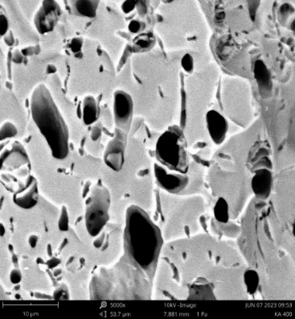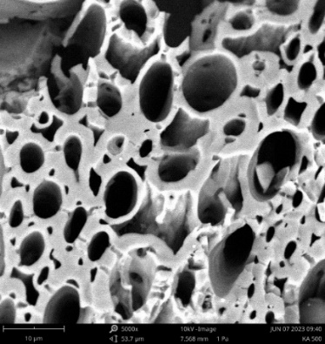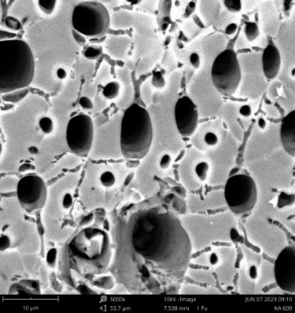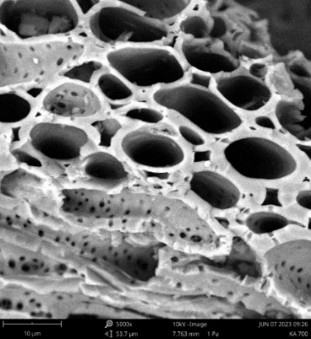

Figure 1. Morphology of active carbon of coconut shell (a) KA400 (b) KA500 (c) KA600 and (d) KA700

**a**

**b**

**c**

**d**

The FTIR spectrum results of coconut shell activated carbon in Figure 2 show the same peak at a wavelength of 1565.38 cm-1, then the wave decreases with a peak at a wavelength of 526.62 cm-1. The peak at a wavelength of 1565.38 cm-1 shows that it is in the range (1475-1600) cm-1 which is the aromatic group C=C [30]. Previous research also found the presence of aromatic C=C complex groups in the range (1400-1600) cm-1 [31]. The same thing was also found in the aromatic group at a wavelength range that was close, namely a wavelength of 1599.02 cm-1. The absorption peak at a wavelength of 1599.02 cm-1 shows the stretching vibration of the C=C bond in the benzene ring framework [17]. Aromatic compounds exhibit a number of absorption bands in the infrared spectrum, many of which have no diagnostic value. The C=C stretching band for aromatic rings typically appears between 1600 and 1450 cm−1 [30].

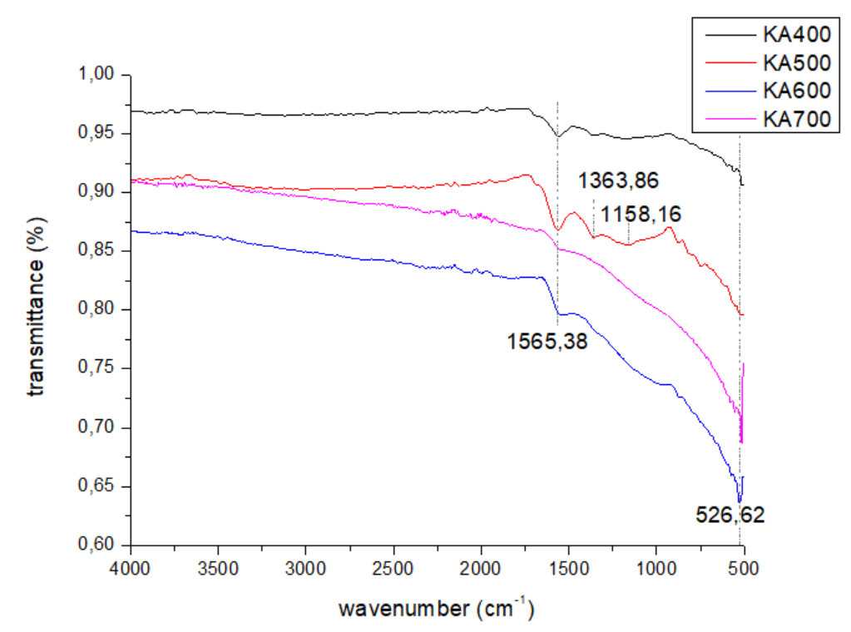

Figure 2. FTIR spectrum of active carbon coconut shell

In the KA400 and KA500 samples, there is a low band peak at a wavelength of 1158.16 cm-1 which indicates the C-O group. The C-O group based on correlation data is in the wavelength range of 1000-1300 cm-1 [30]. Previous research had results that were close to this research, which found the C-O group with a wavelength that was close, namely a wavelength of 1150 cm-1 [31]. Previous research had results that were close to this research, which found the C-O group with a wavelength that was close, namely a wavelength of 1150 cm-1 [17]. As the mass of the atoms bound to carbon increases, the reduced mass (µ) increases, and the vibration frequency decreases (the wave number becomes smaller), where at a wavelength of 1200 cm-1 it has a C-C group, then at a wavelength of 1100 cm-1 it has a C-O group [30]. The results of this study indicate that the emergence of a peak at a wavelength of 1158.16 indicates that the mass of carbon-bound atoms is increasing. The presence of C-O groups is very beneficial for supercapacitor electrodes. This is because the high content of oxygenated functional groups may be beneficial for supercapacitor electrodes by increasing the wettability of the carbon surface, and by taking part in faradaic reactions, thereby increasing the specific capacitance [10].

In this study, XRD was used to analyze the changes in crystal structure according to the carbonization process. Figure 3 shows the XRD graph of KA400-KA700 samples at a carbonization temperature of 400℃-700℃, which appears to have a peak at the same 2θ angle as the amorphous structure. It can be seen from the graph that the peak with the highest intensity is at an angle of about 24°-25° similar to the peak (002) and there is a peak with a lower intensity at an angle of about 43°-45° similar to the peak (100). Previous studies have shown similar results where the carbon peaks at peaks 002 and 100 are graphite carbon crystallites [17][32][9]. Peak 002 from the research results shows that there is a broadening of the graphite carbon crystallite (C). Peak (002) is related to the small dimensions of the crystallites which are perpendicular to the aromatic layer [32]. This peak broadening can also be caused by a transition in the polymer (non-graphite) structure to a carbon crystallite graphite structure [9].

The components in coconut shells consisting of hemicellulose, cellulose, and lignin are thermally decomposed at different temperature ranges. Therefore, after carbonization, some components have not decomposed into carbon. This is what affects the crystallinity of the resulting carbon. The remaining lignin components in the sample greatly contribute to the amorphous nature of the observed peaks [33]. Therefore, in this study, the XRD peaks of carbon were produced which maintained the broad amorphous peaks.

The broad peak between 20°-30° indicates the presence of amorphous carbon in the sample, which indicates that the carbonization temperature used may not be sufficient to induce crystallization of amorphous carbon or produce graphitic carbon structure. This indicates that lower crystallinity is formed due to the absence of nitrogen gas during carbonization [33]. At the wide peak between 40°-50°, as in table 3, it can be seen that as the carbonization temperature increases, the peak intensity becomes higher, marked by the high FWHM value. This situation indicates that there may be a change in the amorphous carbon structure as a function of temperature. The weak peak at an angle of 40° can be referred to as a characteristic reflection originating from the (100) plane in disordered carbon materials [33].

Tabel 3. Crystallinity of coconut shell activated carbon variation of carbonization temperature

|  |  |  |  |  |
| --- | --- | --- | --- | --- |
| Sample | 2θ | FWHM | total area of crystalline peak | % index crystallinity |
| KA400 | 24,73 | 13,53 | 16304,15 | 49,64 |
| 44,67 | 0,84 | 371,06 |
| KA500 | 24,07 | 12,78 | 21545,04 | 72,76 |
| 44,73 | 9,31 | 5944,17 |
| KA600 | 24,47 | 14,60 | 25956,85 | 79,51 |
| 44,71 | 9,53 | 6583,57 |
| KA700 | 24,19 | 14,77 | 25679,79 | 83,14 |
| 44,47 | 8,08 | 8321,58 |

In this case, according to table 3, it can be seen that the % level of crystallinity index increases with increasing carbonization temperature. This increase in intensity indicates that it has a layered structure of aromatic graphite carbon structure with better crystallinity [32]. At a carbonization temperature of 400°C, a graphite carbon crystal structure with a crystallinity index of 49% has begun to form, then the graphite crystal structure grows with increasing carbonization temperature. The highest crystallinity of 83% was obtained with a carbonization temperature of 700℃, marked by an increase in peak intensity by forming a sharper curve, thus increasing the FWHM value and increasing its crystallinity [9].

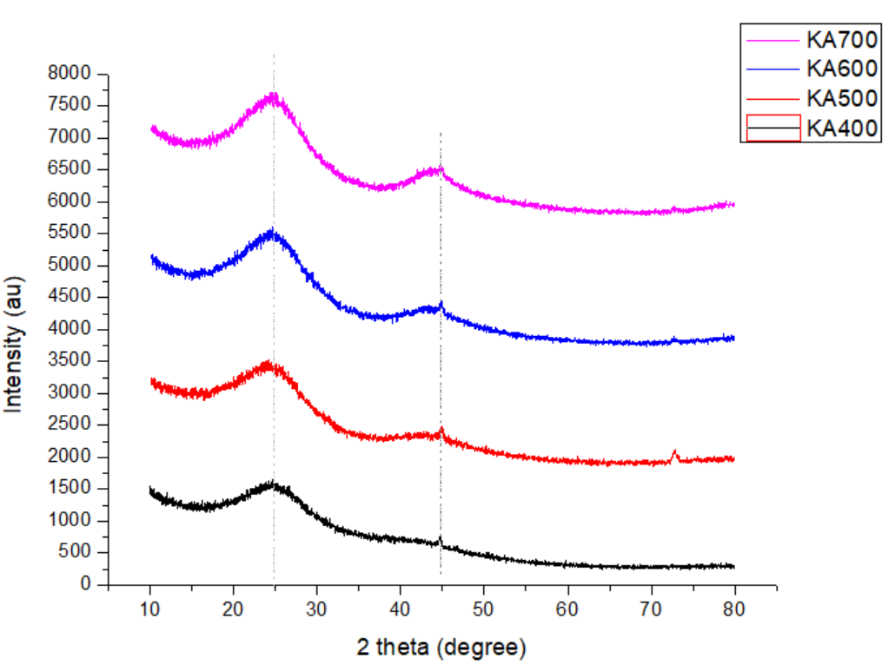

Figure 3. XRD pattern of active carbon coconut shell

At higher carbonization temperatures, carbon materials tend to achieve higher crystallization rates. Increased thermal energy leads to further enhanced reactions because more energy is available to support the breaking and formation of new chemical bonds. For this reason, structural changes in amorphous coconut shell carbon as carbonization temperatures are increased result in higher crystallization rates [33]. In general, as the carbonization temperature increases, the resulting graphite carbon crystal structure grows. This shows that coconut shells contain cellulose, where cellulose has a crystalline structure. This crystalline nature is very beneficial in the manufacture of activated carbon because the ideal carbon structure generally has a relatively large degree of crystallinity [34].

**4. Conclusion**

Based on the results of the research that has been conducted, it can be concluded that the results of the Scanning Electron Microscope (SEM) showed that the morphology of all coconut shell activated carbon samples with a carbonization temperature of 400°C - 700°C had formed pores that were spread throughout the surface. In the KA400 sample, pores were formed that were evenly distributed. Then there was pore development when the carbonization temperature increased. This porous structure is very beneficial as an electrode because the more pores formed can increase the diffusion process and increase the transfer process of electrolyte ions. The FTIR spectrum results of coconut shell activated carbon were obtained at a wavelength of 1565.38 cm-1, then the wave decreased with a peak at a wavelength of 526.62 cm-1. The peak at a wavelength of 1565.38 cm-1 indicates the aromatic group C=C. In the KA400 and KA500 samples there is a low band peak at a wavelength of 1158.16 cm-1 indicating the C-O group. The presence of the C-O group is very beneficial for supercapacitor electrodes, because the high content of oxygenated functional groups may be beneficial for supercapacitor electrodes. KA400-KA700 samples at carbonization temperature of 400℃-700℃ appear to have peaks at the same 2θ angle as the amorphous structure. The presence of these peaks indicates the graphite structure of carbon crystallites. The intensity of the peaks (002) and (100) increases with increasing carbonization temperature. The increase in % linear crystallinity index with increasing carbonization temperature, this indicates that the higher the temperature, the more the graphite crystal structure of the resulting carbon grows.

**References**

[1] P. Saini, “A Historical Review of Electrode Materials and Electrolytes for Electrochemical Double Layer Supercapacitors and Pseudocapacitors,” *Indian J. Pure Appl. Phys.*, vol. 61, no. 4, pp. 268–290, 2023, doi: 10.56042/ijpap.v61i4.69622.

[2] A. Mendhe and H. S. Panda, “A review on electrolytes for supercapacitor device,” *Discov. Mater.* , vol. 3, no. 1, 2023, doi: 10.1007/s43939-023-00065-3.

[3] G. Sriram, M. Kurkuri, and T. H. Oh, “Recent Trends in Highly Porous Structured Carbon Electrodes for Supercapacitor Applications: A Review,” *Energies*, vol. 16, no. 12, pp. 1–36, 2023, doi: 10.3390/en16124641.

[4] G. Zhang, Y. Chen, Y. Chen, and H. Guo, “Activated biomass carbon made from bamboo as electrode material for supercapacitors,” *Mater. Res. Bull.*, vol. 102, no. 2010, pp. 391–398, 2018, doi: 10.1016/j.materresbull.2018.03.006.

[5] N. Kumar, S. Bin Kim, S. Y. Lee, and S. J. Park, “Recent Advanced Supercapacitor: A Review of Storage Mechanisms, Electrode Materials, Modification, and Perspectives,” *Nanomaterials*, vol. 12, no. 20, 2022, doi: 10.3390/nano12203708.

[6] Z. S. Iro, C. Subramani, and S. S. Dash, “A brief review on electrode materials for supercapacitor,” *Int. J. Electrochem. Sci.*, vol. 11, no. 12, pp. 10628–10643, 2016, doi: 10.20964/2016.12.50.

[7] L. F. Aval, M. Ghoranneviss, and G. B. Pour, “Graphite nanoparticles paper supercapacitor based on gel electrolyte,” *Mater. Renew. Sustain. Energy*, vol. 7, no. 4, pp. 1–11, 2018, doi: 10.1007/s40243-018-0136-6.

[8] M. N. Mohd Iqbaldin, I. Khudzir, M. I. Mohd Azlan, A. G. Zaidi, B. Surani, and Z. Zubri, “Properties of coconut shell activated carbon,” *J. Trop. For. Sci.*, vol. 25, no. 4, pp. 497–503, 2013.

[9] H. M. Lee, D. C. Chung, S. C. Jung, K. H. An, S. J. Park, and B. J. Kim, “A study on pore development mechanism of activated carbons from polymeric precursor: Effects of carbonization temperature and nano crystallite formation,” *Chem. Eng. J.*, vol. 377, no. January, p. 120836, 2019, doi: 10.1016/j.cej.2019.01.115.

[10] P. Dulyaseree *et al.*, “Effect of Carbonization Temperature on Physical Properties and Specific Capacitance of Activated Carbon Derived from Banana Stem and Its Application as Supercapacitor Electrodes,” *Curr. Appl. Sci. Technol.*, vol. 23, no. 2, pp. 1–9, 2023, doi: 10.55003/cast.2022.02.23.002.

[11] X. H. Duan, C. Srinivasakannan, K. Bin Yang, J. H. Peng, and L. B. Zhang, “Effects of heating method and activating agent on the porous structure of activated carbons from coconut shells,” *Waste and Biomass Valorization*, vol. 3, no. 2, pp. 131–139, 2012, doi: 10.1007/s12649-011-9097-z.

[12] K. Chopngam, M. Luengchavanon, M. Khangkhamano, K. Chetpattananondh, and W. Limbut, “Coating Activated Carbon from Coconut Shells with Co3O4/CeO2 for High-Performance Supercapacitor Applications: An Experimental Study,” 2021. doi: 10.5281/zenodo.7049126.

[13] J. Y. Hwang, M. Li, M. F. El-Kady, and R. B. Kaner, “Next-Generation Activated Carbon Supercapacitors: A Simple Step in Electrode Processing Leads to Remarkable Gains in Energy Density,” *Adv. Funct. Mater.*, vol. 27, no. 15, 2017, doi: 10.1002/adfm.201605745.

[14] A. R. Hidayu and N. Muda, “Preparation and Characterization of Impregnated Activated Carbon from Palm Kernel Shell and Coconut Shell for CO2 Capture,” *Procedia Eng.*, vol. 148, pp. 106–113, 2016, doi: 10.1016/j.proeng.2016.06.463.

[15] Z. U. Nisa, L. K. Chuan, B. H. Guan, F. Ahmad, and S. Ayub, “A Comparative Study on the Crystalline and Surface Properties of Carbonized Mesoporous Coconut Shell Chars,” *Sustain.*, vol. 15, no. 8, pp. 1–15, 2023, doi: 10.3390/su15086464.

[16] D. Tamado *et al.*, “Sifat Termal Karbon Aktif Berbahan Arang Tempurung Kelapa,” *Semin. Nas. Fis.*, pp. 73–81, 2013.

[17] U. F. Hassan, A. A. Sallau, E. O. Ekanem, A. Jauro, and A. M. Kolo, “Effect of carbonization temperature on properties of char from coconut shell,” *Int. J. Adv. Chem.*, vol. 9, no. 1, pp. 34–39, 2021, doi: 10.14419/ijac.v9i1.31433.

[18] H. Nurdiansah and D. Susanti, “Pengaruh Variasi Temperatur Karbonisasi dan Karbon Aktif Tempurung Kelapa dan Kapasitansi Electric Double Layer Capacitor,” *J. Tek. Pomits*, vol. 2, no. 1, pp. 13–18, 2013.

[19] G. Pari, K. Sofyan, W. Syafii, Buchari, and H. Yamamoto, “KAJIAN STRUKTUR ARANG DARI LIGNIN (Study on Charcoal Structure of Lignin),” *J. Penelit. Has. Hutan*, vol. 24, no. 1, pp. 9–20, 2006.

[20] E. Taer, R. Taslim, A. W. Putri, A. Apriwandi, and A. Agustino, “Activated carbon electrode made from coconut husk waste for supercapacitor application,” *Int. J. Electrochem. Sci.*, vol. 13, no. 12, pp. 12072–12084, 2018, doi: 10.20964/2018.12.19.

[21] A. Prayogatama and T. Kurniawan, “Modifikasi Karbon Aktif dengan Aktivasi Kimia dan Fisika Menjadi Elektroda Superkapasitor,” *J. Sains dan Teknol.*, vol. 11, no. 1, pp. 47–58, 2022.

[22] Y. N. Fidiyanti, L. Rohmawati, N. P. Putri, and W. Setyarsih, “Analisis Nilai Kapasitansi Spesifik Pada Elektroda Karbon Aktif/PVDF,” *Sains Mat.*, vol. 4, no. 2, 2016.

[23] H. R. Suryadi *et al.*, “Pengaruh jenis aktivator terhadap nilai kapasitansi elektroda karbon dari tempurung kelapa - The influence of activator types on the capacitance value of carbon electrodes from coconut shell,” *J. Aceh Phys.Soc*, vol. 11, no. 2, pp. 52–58, 2022, doi: 10.24815/jacps.v11i2.23789.

[24] H. R. Suryadi *et al.*, “The influence of activator types on the capacitance value of carbon electrodes from coconut shell,” *J. Aceh Phys. Soc.*, vol. 11, no. 2, pp. 52–58, Apr. 2022, doi: 10.24815/jacps.v11i2.23789.

[25] S. Hartanto and Ratnawati, “SAWIT DENGAN METODE AKTIVASI KIMIA,” *Sains Mater. Indones.*, vol. 12, no. 1, pp. 12–16, 2010.

[26] J. Katesa, S. Junpiromand, and C. Tangsathitkulchai, “Effect of Carbonization Temperature on Properties of Char and Activated Carbon from Coconut Shell,” *Suranaree J. Sci. Technol*, vol. 20, no. 4, pp. 269–278, 2013.

[27] Aulia, Aprilianda, F. S. Arsyad, and A. Johan, “Temperature carbonization effect on the quality of activated carbon based on rubber seed shell,” *J. Phys. Conf. Ser.*, vol. 1282, no. 1, 2019, doi: 10.1088/1742-6596/1282/1/012043.

[28] A. N. Huda, I. Lestari, and S. Hidayat, “Pemanfaatan Karbon Aktif Dari Sekam Padi Sebagai Elektroda Superkapasitor,” *J. Ilmu dan Inov. Fis.*, vol. 06, no. 02, pp. 102–113, 2022.

[29] R. Novitra, H. Aziz, and E. Taer, “Supercapactors based on active carbon from spent arabica coffee ground using NaOH activators,” *J. Aceh Phys. Soc.*, vol. 11, no. 1, pp. 33–40, 2022, doi: 10.24815/jacps.v11i1.22227.

[30] D. L. Pavia, G. Lampman, G. S. Kriz, and J. R. Vyvyan, *Introduction to Spectroscopy*, vol. Vol. 32, no. 1. 2009. doi: 10.3917/popu.p1977.32n1.0034.

[31] M. S. Islam, B. C. Ang, S. Gharehkhani, and A. B. M. Afifi, “Adsorption capability of activated carbon synthesized from coconut shell,” *Carbon Lett.*, vol. 20, no. 1, pp. 1–9, 2016, doi: 10.5714/CL.2016.20.001.

[32] V. Purwandari, S. Gea, and B. Wijosentono, “Analisa XRD Terhadap Perubahan Struktur Dan Kristalinitas Karbonisasi Batubara Sawahlunto – Sijunjung Sumatera Barat,” *Talent. Conf. Ser. Sci. Technol.*, vol. 2, no. 1, pp. 88–91, 2019, doi: 10.32734/st.v2i1.321.

[33] Y. W. Yap *et al.*, “Influence of Carbonization Conditions and Temperature Variations on the Characteristics of Coconut Shell Carbon,” *Int. J. Nanoelectron. Mater.*, vol. 17, no. 3, pp. 381–387, 2024, doi: 10.58915/ijneam.v17i3.1130.

[34] G. Pari, “PENGARUH SELULOSA TERHADAP STRUKTURKARBON ARANG BAGIAN I: PENGARUH SUHU KARBONISASI,” *J. Penelit. Has. Hutan*, vol. 29, no. 002, pp. 33–45, 2011.