
Jurnal Epidemiologi Kesehatan Komunitas x (x), 20xx, x-x

JEKK
Spatial Risk Model for Mapping Tuberculosis (TB) Hotspot Areas in West
Lombok Regency

Mega Sara Yulianti^{1*}, Muhamad Sadli¹, Muhammad Syukri², Warni Farida³, Lia Apriani⁴
¹Faculty of Public Health , Nahdlatul Ulama University of West Nusa Tenggara (NTB), Jln. Pendidikan No. 6, Mataram City, NTB
² Faculty of Public Health, Nahdlatul Ulama University of West Nusa Tenggara (NTB), Jln. Pendidikan No. 6, Mataram City, NTB 83125, Indonesia
³ Faculty of Public Health, Jambi University, Jl. Letjend Soeprapto No. 33, Telanaipura, Jambi 36122, Indonesia
⁴ Student, Nahdlatul Ulama University of West Nusa Tenggara (NTB), Jln. Pendidikan No. 6, Mataram City, NTB 83125, Indonesia
⁵ Student, Nahdlatul Ulama University of West Nusa Tenggara (NTB), Jln. Pendidikan No. 6, Mataram City, NTB 83125, Indonesia 83125, Indonesia

ABSTRACT
Background: Tuberculosis (TB) remains a major global public health concern, and identifying TB hotspots is essential for effective disease control. Conventional approaches often overlook the spatial component that plays a critical role in TB transmission, highlighting the need for more precise and area-based surveillance methods. This study aims to identify spatial risk patterns using a geo- targeting approach and to map hotspot areas to support more sustainable precision control strategies. Methods: This study employed a quantitative approach integrating spatial ecological analysis with a case–control design. A total of 1,658 registered tuberculosis (TB) cases were geocoded and analyzed to identify spatial clustering patterns. Based on the identified hotspot and non-hotspot areas, a case–control survey involving 226 respondents (113 cases and 113 controls) was subsequently conducted to assess environmental, socioeconomic, and behavioral determinants. Data were collected through structured interviews, household environmental observations, and secondary health records, and were analyzed using spatial statistical methods and multivariable logistic regression.
Result: Significant spatial clustering of tuberculosis (TB) was identified, with hotspots in Gerung, Lembar, Kuripan, and Sekotong, West Lombok. Higher TB risk was associated with high household humidity (OR 5.40), low income (OR 5.42), low education (OR 4.26), and elevated indoor temperature (OR 2.87). Inverse associations were observed for smoking, infrequent health-facility visits, and male sex, likely reflecting information bias rather than true protection.
Conclusion: Integrating spatial hotspot mapping with epidemiological assessment enables precise identification of tuberculosis (TB) transmission risk. In West Lombok, hotspot areas were associated with high household humidity, low income, low education, and elevated indoor temperature. These findings support geo-targeted, area-based TB interventions focusing on housing improvement, socioeconomic support, and education-based risk communication, providing a practical framework for sustainable precision public health strategies.

Keywords: Hotspot, Geo-Targeting, Spatial Analysis, Tuberculosis, Risk Factors.

Copyright © 2024 by Authors, Published by the Master Program of Epidemiology, School of Postgraduate Studies, Universitas Diponegoro, Semarang, Central Java, Indonesia. This is an open- access article under the CC BY-SA License (https://creativecommons.org/licenses/by-sa/4.0).

*Corresponding author, megasara74@gmail.com

Introduction
Tuberculosis (TB) is an infectious disease that remains one of the major causes of death worldwide¹. In Indonesia, TB is still categorized as an urgent public health problem due to its high incidence and the significant burden of morbidity and mortality it causes². According to the World Health Organization (WHO), Indonesia ranks second after India among countries with the highest TB burden, with an estimated 1,060,000 cases in 2023³. This situation shows that TB is not only a medical issue but also a social and public health development concern⁴. The persistence of TB transmission is related to various risk factors that worsen its spread within communities⁵Although several national programs, such as the National Strategy for TB Elimination and the Directly Observed Treatment, Short-course (DOTS) approach, have been implemented, the incidence of TB in Indonesia has not shown a significant decline⁶. This condition indicates the presence of gaps in early detection and spatial risk mapping, which are still too general in nature⁷.
Various studies have shown that the high incidence of TB is influenced by social and environmental factors such as population density, housing quality, air ventilation, lighting, and household sanitation^{8,9,10}. These factors increase the risk of TB transmission in the community, as demonstrated by spatial studies that have found a significant association between population density and TB incidence^{11,1}. Most spatial studies on tuberculosis in Indonesia have been conducted in large urban areas such as Jakarta and Surabaya, focusing primarily on population density and environmental quality in residential areas^{12,13}. However, based on the existing literature, studies that integrate socio-environmental analysis with spatial approaches in semi-rural areas, such as West Lombok Regency, remain very limited.
West Lombok Regency continues to face a relatively high burden of TB cases. According to data from the District Health Office Dinas Kesehatan in 2024¹⁴, a total of 1,658 TB cases were reported among adults, and 322 TB cases were identified among children aged 0-14 years. When classified by sex, TB cases were more prevalent among males (61.9%, or 1,026
cases) compared to females (38.1%, or 632 cases). These data indicate that although TB is more dominant among adults and males, the number of cases in children remains significant, reflecting ongoing active transmission within the community. However, the existing data have not yet been optimally utilized to analyze the spatial patterns of TB distribution. To date, no study has mapped high-risk (hotspot) areas or examined their relationship with environmental and social factors in West Lombok Regency.
Along with the advancement of epidemiological methods, spatial analysis has become an important approach in understanding the distribution of infectious diseases, including TB¹⁵. Various studies have demonstrated that spatial mapping can identify areas with high case density (hotspots) that are closely associated with environmental and social factors^{16,17}. This spatial approach supports more precise, area-based control efforts, allowing interventions to be focused on high-risk regions. Geo-targeting refers to the utilization of spatial data to direct health interventions accurately toward areas with the highest disease burden¹⁸. Consequently, geo-targeting enables TB control programs to be implemented in a more precise, efficient, and sustainable manner. However, research that develops spatial risk models based on geo-targeting, particularly in West Lombok Regency, remains very limited. This limitation has resulted in a lack of scientific basis for decision-making in TB control programs at the district level. Therefore, this study aims to develop a spatial risk model based on geo-targeting that integrates social and environmental factors in mapping TB hotspot areas as a foundation for precise and sustainable TB control. The findings of this research are expected to make a substantial contribution to strengthening TB elimination programs in West Lombok Regency.

Methods
This study employed a quantitative approach integrating two complementary designs: a spatial ecological study and a case–

control study. The research was conducted in West Lombok Regency, West Nusa Tenggara Province, covering 20 primary health centers (puskesmas) as the defined catchment areas. Data collection was carried out from August to September 2025.
In the spatial ecological component, the study population comprised all 1,658 Tuberculosis (TB) cases recorded in the 2024 West Lombok District Health Office Profile. All cases with complete address information were analyzed using a total sampling technique and mapped through a geocoding process in QGIS 3.34. Spatial analysis was performed using GeoDa 1.20, applying the Moran’s I test to assess global spatial autocorrelation and the Getis-Ord Gi* statistic to identify hotspot and non-hotspot areas. The results were presented in the form of distribution maps, cluster maps, and TB hotspot maps.
The subsequent stage involved a case–control study comprising 226 respondents, consisting of 113 cases and 113 controls, selected using a purposive sampling technique based on their residence within hotspot and non-hotspot zones. Inclusion criteria included tuberculosis patients aged ≥15 years with complete residential addresses, residing within the study area, and willing to participate. Primary data were collected through structured interviews using a questionnaire and direct observation of household environmental conditions.
The variables assessed included environmental, socioeconomic, and health service access factors. Environmental factors comprised lighting, ventilation, and housing density. Lighting was defined as the availability of adequate natural or artificial light inside the house, ventilation referred to the presence of sufficient air circulation openings, and housing density was measured as the ratio of household members to floor area and classified according to national healthy housing standards. Socioeconomic factors included household income categorized based on the regional minimum wage, education level defined as the highest formal education attained, and occupation classified by employment status. Access to health services was assessed through distance to the nearest health facility and frequency of healthcare utilization, categorized based on accessibility and visit patterns.
Secondary data were obtained from the West Lombok District Health Office, as well as administrative maps sourced from the Geospatial Information Agency (BIG) and the Regional Development Planning Agency (Bappeda). Statistical analyses were conducted using licensed IBM SPSS Statistics version XX. Descriptive analysis was performed to summarize the distribution and characteristics of the study variables. Bivariate analysis using the Chi-square test was applied to assess the association between independent variables and tuberculosis incidence. Variables with a p-value < 0.25 in the bivariate analysis were included in the multivariate logistic regression model to identify dominant risk factors while controlling for potential confounding variables. The results were presented as adjusted odds ratios (AORs) with 95% confidence intervals.
This study obtained ethical approval from the Health Research Ethics Committee of Nahdlatul Ulama University of West Nusa Tenggara (NTB) with approval number 102/LP2M/UNU/2025. All participants were provided with a clear explanation of the study objectives and signed an informed consent form prior to participation. The confidentiality of respondents’ identities was strictly maintained, and all data were used solely for research purposes.

Result
This study analyzed tuberculosis (TB) case data from 20 primary health centers (Puskesmas) covering 122 villages across West Lombok Regency. All TB data were processed using Microsoft Excel and subsequently analyzed with GeoDa version 1.20 (open- source software) employing the Moran’s Index Analysis method. The analysis began with the construction of thematic maps of TB case distribution, aimed at illustrating the proportional spread of TB cases based on each health center’s catchment area.

Description of the Study Area
The study area comprised 122 villages within the catchment areas of 20 primary health centers (Puskesmas) in West Lombok Regency. Figure 1 presents the map of the study location, which serves as the spatial reference framework for all subsequent analyses in this study.

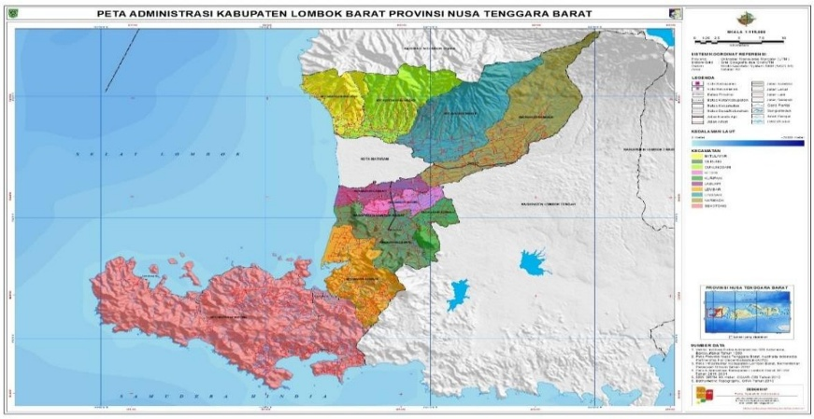
Figure 1. Map of West Lombok Regency

This study analyzed tuberculosis (TB) case data obtained from the 20 Puskesmas across all
122 villages. Spatial data processing was performed using Microsoft Excel for data cleaning and GeoDa 1.20 for spatial analysis. Thematic maps of TB case distribution were generated to illustrate the variation in TB burden among Puskesmas catchment areas. Global and local spatial autocorrelation analyses (Moran’s I and LISA) were then conducted to identify the presence and pattern of clustering of TB cases.

Spatial Distribution Pattern Analysis Global Moran’s Index Analysis
Global spatial autocorrelation was assessed using Moran’s I to evaluate the overall

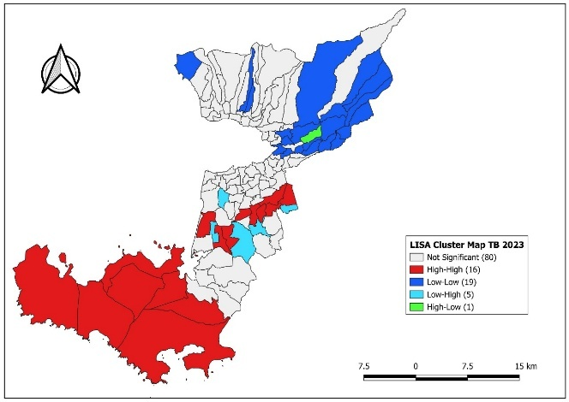
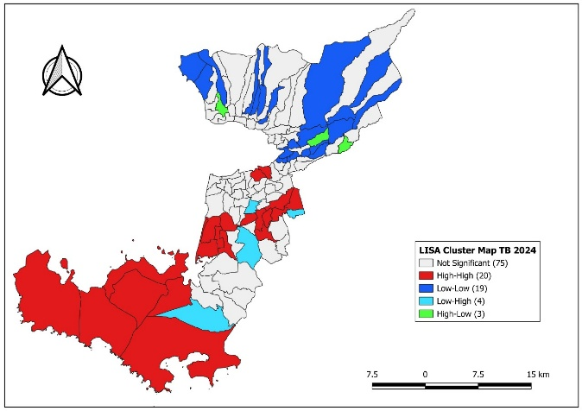
Year 2023
Year 2024

distribution pattern of tuberculosis (TB) Incidence across West Lombok Regency. A Queen Contiguity spatial weight matrix was applied to define neighborhood relationships based on shared boundaries between Puskesmas catchment areas. The analysis indicated notable spatial variation in TB incidence between regions.
Moran’s I values for both 2023 and 2024 demonstrated statistically significant positive Spatial autocorrelation, confirming that TB cases were not randomly distributed but tended to form spatial clusters. Higher-incidence areas, as visualized in the thematic maps (Figure 2 and 3), appeared concentrated in specific zones, suggesting the influence of environmental and socio-economic conditions on spatial clustering.

Figure 2. Spatial distribution map of Tuberculosis (TB) cases in West Lombok Regency in 2023 and 2024 with the result of Global Spatial Autocorrelation analysis using Moran’s I Index.

The Global Moran’s I analysis showed significant spatial clustering of tuberculosis (TB) cases in West Lombok Regency for both study years. In 2023, the Moran’s I value was 0.459 (p < 0.001), indicating non-random spatial aggregation of cases. The clustering pattern strengthened in 2024, with an increased Moran’s I value of 0.521 (p < 0.001). These findings confirm the presence of statistically significant spatial concentrations of TB cases across specific areas in the regency.

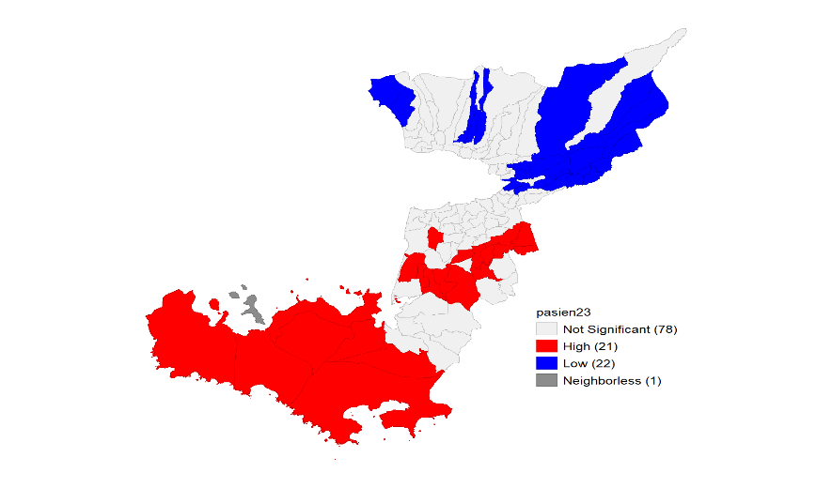
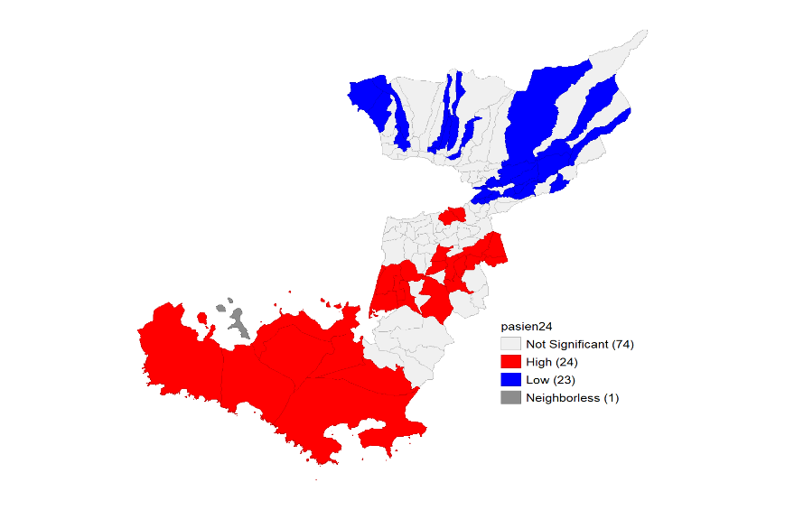
Year 2023
Year 2024

Local Cluster Analysis (Hotspot Analysis)
Local cluster analysis using the Getis-Ord Gi* statistic identified statistically significant hotspot and lowspot areas of TB incidence across West Lombok Regency. The resulting hotspot map shows villages with high TB concentration surrounded by similarly high-incidence areas, as well as low- incidence clusters (coldspots).

Figure 3. Hotspot and Coldspot Map of Tuberculosis (TB) in West Lombok Regency, 2023 and 2024

Based on the hotspot analysis using the Getis-Ord Gi* statistic, as shown in Figure 3, the identification of TB hotspot areas across 122 villages in West Lombok

Regency revealed several locations with statistically significant clustering of high TB incidence (hotspots). The following areas were identified as primary hotspot zones:

Table 1. Tuberculosis (TB) Hotspot Areas in West Lombok Regency, 2023
High (highspot) | Low (lowspot) | Neighborless
1. Babussalam | 1. Batu Kumbang | Gili Gede Indah
2. Batu Putih | 2. Batu Layar Barat
3. Dasan Geres | 3. Batu Mekar
4. Gerung Utara | 4. Dasan Tereng
5. Giri Tembesi | 5. Dopang
6. Jagaraga | 6. Golong
7. Jembatan Gantung | 7. Grimax Indah
8. Jembatan Kembar | 8. Jeringo
9. Jembatan Kembar Timur | 9. Keru
10. Kedaro | 10. Lebah Sempage
11. Kuripan | 11. Lembuak
12. Kuripan Timur | 12. Lingsar
13. Kuripan Utara | 13. Mekar Sari
14. Lembar | 14. Narmada
15. Pelangan | 15. Pakuan
16. Sekotong Barat | 16. Peresak
High (highspot) | Low (lowspot) | Neighborless
17. Sekotong Tengah | 17. Peteluan Indah
18. Suka Makmur | 18. Sedau
19. Taman Baru | 19. Selat
20. Tempos | 20. Senggigi
21. Buwun Mas | 21. Sesaot
 | 22. Suranadi

Table 1. Tuberculosis (TB) Hotspot Areas in West Lombok Regency, 2024
High (highspot) | Low (lowspot) | Neighborless
- Babussalam | - Batu Kumbang | Gili Gede Indah
- Bagik Polak | - Batu Layar Barat
- Batu Putih | - Batu Mekar
- Beleke | - Bengkaung
- Bengkel | - Dasan Tereng
- Dasan Geres | - Dopang
- Gerung Utara | - Gegerung
- Giri Tembesi | - Grimax Indah
- Jagaraga | - Jeringo
- Jembatan Kembar | - Keru
- Jembatan Kembar Timur | - Lebah Sempage
- Kebon Ayu | - Lembuak
- Kedaro | - Mekar Sari
- Kuripan | - Mekarsari
- Kuripan Timur | - Narmada
- Kuripan Utara | - Peresak
- Lembar | - Peteluan Indah
- Lembar Selatan | - Ranjok
- Pelangan | - Sandik
- Sekotong Barat | - Selat
- Sekotong Tengah | - Senggigi
- Taman Baru | - Sesaot
- Tempos | - Suranadi
- Buwun Mas

The results of the Getis-Ord Gi* analysis in 2024 revealed that out of 122 villages examined, 24 villages (19.67%) were identified as statistically significant highspot areas. These highspot areas represent villages with a high incidence of tuberculosis (TB) that are surrounded by other villages also exhibiting high TB incidence, forming a distinct spatial cluster. Conversely, the analysis also identified 23 villages as lowspot areas, characterized by a low concentration of TB cases, while the remaining villages showed no statistically significant spatial clustering.
Factor Risk Analysis
A total of 1,658 tuberculosis (TB) cases were reported in West Lombok Regency in 2024. Most cases were male (61.9%) and the majority occurred among adults aged ≥15 years (80.6%). The detailed distribution of case

characteristics is presented in Table 3.
Table 3. Characteristics of Tuberculosis (TB) Cases in West Lombok Regency, 2024
Category | Variables | n | %
Sex | Male | 1.026 | 61,9%
 | Female | 632 | 38,1%
Age Group | Child (0–14 years) | 322 | 19,4%
 | Adult (≥15 years) | 1.336 | 80,6%
Total Cases |  | 1.658 | 100,0%

Following the spatial analysis, 22 villages were identified as TB hotspot areas based on statistically significant high clustering of TB incidence using the Getis-Ord Gi* statistic. These villages were selected as sampling sites for the case group to represent populations residing in areas with higher TB transmission risk. Villages classified as lowspot areas, characterized by significantly lower TB incidence clustering, were selected as control locations to allow comparison between populations with differing levels of transmission risk. A total of 226 respondents were included in the study, consisting of 113 cases and 113 controls. Table 4 summarizes the sociodemographic and environmental characteristics of respondents, including education level.occupation, household income, comorbidities, frequency of healthcare visits, temperature, humidity, and housing density.

Table 4. Characteristics of Case and Control Respondent
Variables | Case |  | Control |  | Total
Variables | n | % | n | % | n | %
Education
No formal education | 21 | 18,6 | 18 | 15,9 | 39 | 17,3
Completed Elementary School / Equivalent | 28 | 24,8 | 7 | 6,2 | 35 | 15,5
Completed Senior High School (SMA/SMU/MAN) / Equivalent | 10 | 8,8 | 2 | 1,8 | 12 | 5,3
Completed Diploma I / II (D1/D2) | 2 | 1,8 | 4 | 3,5 | 6 | 2,7
Completed Diploma III / IV (D3/D4) | 0 | 0,0 | 3 | 2,7 | 3 | 1,3
Completed Bachelor’s Degree (S1) | 4 | 3,5 | 15 | 13,3 | 19 | 8,4
Type of Occupation
Unemployed / Housewife | 25 | 22,1 | 34 | 30,1 | 59 | 26,1
Student / Pupil / Equivalent | 4 | 3,5 | 15 | 13,3 | 19 | 8,4
Farmer / Breeder / Fisherman | 22 | 19,5 | 8 | 7,1 | 30 | 13,3
Trader | 11 | 9,7 | 9 | 8,0 | 20 | 8,8
Laborer | 33 | 29,2 | 20 | 17,7 | 53 | 23,5
Entrepreneur / Self-employed | 2 | 1,8 | 13 | 11,5 | 15 | 6,6
Civil Servant / Military / Police / Teacher | 9 | 8,0 | 6 | 5,3 | 15 | 6,6
Others | 7 | 6,2 | 8 | 7,1 | 15 | 6,6
Income Level
<Rp.5.00.000 | 28 | 25.0 | 19 | 16.8 | 47 | 20.9
Rp. 1000.000 | 60 | 53.6 | 39 | 34.5 | 99 | 44.0
<Rp. 2.000.000 | 13 | 11.6 | 18 | 15.9 | 31 | 13.8
Rp. 2.000.000-Rp.4.000.000 | 9 | 8.0 | 19 | 16.8 | 28 | 12.4
Rp. 4.000.000-Rp.7.000.000 | 2 | 1.8 | 17 | 15.0 | 19 | 8.4
>Rp.7.000.000 | 0 | 0.0 | 1 | 0.9 | 1 | 0.4
Type of Comorbid Disease
Diabetes Mellitus | 5 | 4.4 | 4 | 3,5 | 9 | 4,0
Hypertension | 3 | 2,7 | 5 | 4,4 | 8 | 3,5
Asthma | 5 | 4,4 | 2 | 1,8 | 7 | 3,1
Heart Disease | 3 | 2,7 | 1 | 0,9 | 4 | 1,8
No comorbidity | 97 | 85,5 | 101 | 89,4 | 198 | 87,6
Frequency of Health Facility Visits
Rarely | 66 | 58,4 | 101 | 89,4 | 167 | 73,9
Moderately | 30 | 26,5 | 12 | 10,6 | 42 | 18,6
Frequently | 17 | 15,0 | 0 | 0,0 | 17 | 7,5
Temperature
Mean | 31,42 |  | 30,70 |  | 31,06
Median | 31,10 |  | 30,70 |  | 30,85
Std Deviasi | 2,32 |  | 2,48 |  | 2,42
Minimum | 25,0 |  | 24,5 |  | 24,5
Maksimum | 36,4 |  | 36,4 |  | 36,4
Humidity
Mean | 57,55 |  | 53,67 |  | 55,62
Median | 57,00 |  | 55.00 |  | 56,00
Std Deviasi | 4,64 |  | 8,41 |  | 7,03
Minimum | 49,0 |  | 0,00 |  | 0,0
Maksimum | 67,0 |  | 65,00 |  | 67
Variables | Case |  | Control |  | Total
Variables | n |  | % |  | n
Density
Mean | 11,59 |  | 13,72 |  | 12,65
Median | 10,00 |  | 12,00 |  | 10,50
Std Deviasi | 5,71 |  | 6,52 |  | 6,21
Minimum | 6,00 |  | 5,60 |  | 5,60
Maksimum | 42,00 |  | 50,00 |  | 50,00

Based on Table 4, there were clear differences in the sociodemographic characteristics between case and control respondents. The case group tended to have lower educational attainment, with elementary school being the most frequent level completed, whereas the control group showed a higher proportion of respondents with university education. Occupational patterns also differed, where many TB cases were employed in labor-intensive jobs such as laborers and farmers, while the control group was dominated by unemployed individuals, housewives, and students.
Income distribution showed that most TB cases had low monthly income (< IDR

1,000,000), whereas the control group exhibited a more diverse income structure with a greater proportion earning higher income. Comorbid conditions were uncommon in both groups, with the majority reporting no chronic diseases.
Differences were also observed in healthcare-seeking behavior. Most TB cases had infrequent or moderate visit patterns, while nearly all respondents in the control group reported infrequent healthcare visits. Environmental characteristics showed slightly higher mean temperature and humidity in the case group compared to controls, whereas the control group had higher housing density.

Bivariate Analysis Results

Table 4. Association Between Independent Variables and Tuberculosis Incidence Based on the Chi-Square Test
Variables | Case |  |  | Control |  |  | Total |  |  | P value | OR (95% CI)
Variables | n | % | n |  | % | n |  | %
Age
Productive (15-50) | 70 | 61,9 | 63 |  | 55,8 | 133 |  | 58,8 | 0,658 |  | 1,29  (0,76-2,19)
Not Productive (>50) | 43 | 38,1 | 50 |  | 44,2 | 93 |  | 41,2 |  |  | 1,29  (0,76-2,19)
Sex
Male | 40 | 35,4 | 63 |  | 55,8 | 103 |  | 45,6 | 0,003 |  | 0,43  (0,25-0,74)
Female | 73 | 64,6 | 50 |  | 44,2 | 123 |  | 54,4 |  |  | 0,43  (0,25-0,74)
Housing Density
Not Eligible | 36 | 31,9 | 15 |  | 13,3 | 51 |  | 22,6 | 0,001 |  | 3,05  (1,56-5,98)
Eligible | 77 | 68,1 | 98 |  | 86,7 | 175 |  | 77,4 |  |  | 3,05  (1,56-5,98)
Humidity
Not Eligible | 41 | 36,3 | 12 |  | 10,6 | 53 |  | 23,5 | <0,001 |  | 4,79  (2,35-9,756)
Eligible | 72 | 63,7 | 101 |  | 89,4 | 173 |  | 76,5 |  |  | 4,79  (2,35-9,756)
Temperature
Not Eligible | 65 | 57,5 | 50 |  | 44,2 | 115 |  | 50,9 | 0,062 |  | 1,70  (1,00-2,88)
Eligible | 48 | 42,5 | 63 |  | 55,8 | 111 |  | 49,1 |  |  | 1,70  (1,00-2,88)
Education Level
Basic Education | 60 | 53,1 | 27 |  | 23,9 | 87 |  | 38,5 | <0,001 |  | 3,60  (2,04-6,36)
Higher Education | 53 | 46,9 | 86 |  | 76,1 | 139 |  | 61,5 |  |  | 3,60  (2,04-6,36)
Employment Status
Unemployed | 35 | 31,0 | 49 |  | 43,4 | 84 |  | 37,2 | 0,074 |  | 0,58  (0,34-1,01)
Employed | 78 | 69,0 | 64 |  | 56,6 | 142 |  | 62,8 |  |  | 0,58  (0,34-1,01)
Variables | Case |  | Control |  |  | Total |  |  | P value
Variables | n | % | n |  | % | n |  |  | n |  | %
Income Level
≤UMR | 102 | 90,3 | 73 |  | 64,6 | 175 |  | 77,4 | <0,001 |  | 5,08  (2,44-10,56)
≥UMR | 11 | 9,7 | 40 |  | 35,4 | 51 |  | 22,6 |  |  | 5,08  (2,44-10,56)
Smoking Habit
Smoker | 60 | 53,1 | 89 |  | 78,8 | 149 |  | 65,9 | <0,001 |  | 0,30  (0,17-0,54)
Non-Smoker | 53 | 46,9 | 24 |  | 21,1 | 77 |  | 34,1 |  |  | 0,30  (0,17-0,54)
History of Contact
History of contact with TB patient | 98 | 86,7 | 105 |  | 92,9 | 203 |  | 89,8 | 0,187 |  | 0,49  (0,20-1,22)
No history of contact | 15 | 13,3 | 8 |  | 7,1 | 23 |  | 10,2 |  |  | 0,49  (0,20-1,22)
Comorbidity
With comorbidity | 94 | 83,2 | 97 |  | 85,8 | 191 |  | 84,5 | 0,71 |  | 0,81  (0,39-1,68)
Without comorbidity | 19 | 16,8 | 16 |  | 15,5 | 35 |  | 15,5 |  |  | 0,81  (0,39-1,68)
Distance to Health Facility
Far | 2 | 1,8 | 0 |  | 0,0 | 2 |  | 0,9 | 0,x47 |  | 2,01  (1,78-2,30)
Near | 111 | 98,2 | 113 |  | 100 | 224 |  | 99,1 |  |  | 2,01  (1,78-2,30)
Frequency of Visit
Rarely | 66 | 58,4 | 101 |  | 89,4 | 167 |  | 73,9 | <0,001 |  | 0,16  (0,82-0,33)
Moderate | 47 | 41,6 | 12 |  | 10,6 | 59 |  | 26,1 |  |  | 0,16  (0,82-0,33)

The bivariate analysis identified several variables that were significantly associated with tuberculosis incidence. Respondents living in households that did not meet housing density standards had more than three times higher odds of having TB (OR = 3.05; 95% CI: 1.56–5.98; p = 0.001). Similarly, non-compliant humidity levels were strongly associated with TB, with cases being almost five times more likely to live in high-humidity environments (OR = 4.79; 95% CI: 2.35–9.76; p < 0.001). Individuals with only primary education were also more likely to develop TB, with a more than threefold increase in risk compared to those with higher education (OR = 3.60; 95% CI: 2.04–6.36; p < 0.001). Low-income respondents (≤UMR) showed the strongest association, having over five times higher odds of being TB cases (OR = 5.08; 95% CI: 2.44–10.56; p <0.001). In contrast, sex and smoking status showed significant statistical differences between groups but did not reflect increased TB risk. Male respondents were more common
in the control group (p = 0.003; OR = 0.43), and smoking was also more prevalent among controls (p < 0.001; OR = 0.30). These findings suggest that although statistically significant, these variables do not represent direct risk factors for TB in this population. Other variables including age group, temperature, employment status, history of TB contact, comorbidity, distance to health facilities, and frequency of health facility visits did not show statistically significant associations with TB incidence.

Multivariate analysis
Multivariate analysis was conducted to assess the effect of each risk factor on the occurrence of tuberculosis while simultaneously controlling for the influence of other variables. A summary of the results from this analysis is presented in Table 5.

Table 5. Multivariate Analysis Results
Variables | B | Adjusted OR | 95%CI | P value
Gender | -1.39 | 0.24 | 0.11-0.53 | <0.001
Housing Density | 0.88 | 2.42 | 0.95-6.11 | 0.062
Humidity | 1.68 | 5.40 | 1.97-14.75 | 0.001
Temperature | 1.05 | 2.87 | 1.37-6.02 | 0.005
Education Level | 1.45 | 4.26 | 1.92-9.48 | <0.001
Family Income | 1.69 | 5.42 | 1.98-14.81 | 0.001
Smoking Habit | -1.68 | 0.18 | 0.07-0.432 | <0.001
Frequency of Visit | -1.93 | 0.14 | 0.05-0.36 | <0.001
Employment Status | -0.56 | 0.57 | 0.26-1.23 | 0.152
The multivariate analysis included ten variables that met the inclusion criteria based on the bivariate screening (p < 0.25), namely sex, housing density, humidity, temperature, education level, employment status, family income, smoking habits, history of TB contact, and frequency of health visits. In the final model, seven variables remained statistically significant (p < 0.05). High humidity was identified as the strongest risk factor, increasing the likelihood of TB by more than fivefold (Adjusted OR = 5.40; 95% CI: 1.97–14.75), followed by low family income (Adjusted OR = 5.42; 95% CI: 1.98–14.81) and low education level (Adjusted OR = 4.26; 95% CI: 1.92–9.48). Elevated temperature also showed a significant association, nearly tripling the risk of TB (Adjusted OR = 2.87; 95% CI: 1.37–6.02). Conversely, smoking habits (Adjusted OR = 0.18; 95% CI: 0.07–0.43), sex (Adjusted OR = 0.24; 95% CI: 0.11–0.53), and frequency of health visits (Adjusted OR = 0.14; 95% CI: 0.05–0.36) demonstrated a protective effect in the model. Housing density showed an increased risk tendency (Adjusted OR = 2.42), although the association was not statistically significant (p = 0.062). Employment status also remained non-significant (p = 0.152) but was retained in the final model due to its influence (>10% change) on the estimates of other variables.

Discussion
This study indicates that the burden of tuberculosis (TB) in West Lombok Regency predominantly affects the adult population and tends to be higher in males compared to females. This pattern aligns with the Global Tuberculosis Report WHO 2023²⁰ which states that globally, TB incidence among adult males is nearly twice that of females. Previous studies also support this finding, reporting that new TB cases occur more frequently in males than in females.^{21,22} These differences are generally associated with behavioral risk factors, such as smoking, alcohol consumption, and occupational exposure, which increase the likelihood of Mycobacterium tuberculosis infection.^{19,20} In addition, socio-economic determinants, including nutritional status, access to health services, and living conditions, further enhance the vulnerability of this population group.²⁵
Spatial analysis in this study shows that clustering of TB cases intensified from 2023 to 2024, indicating that case distribution is not random but concentrated in specific areas. This finding aligns with previous studies²⁶ showing that TB cases tend to form clusters, with spatial autocorrelation related to population density, socioeconomic disadvantage, body height, and distance between patients’ homes.²⁷ Another study²⁸ also found a higher concentration of TB cases in regions with low socioeconomic conditions, suggesting that local environmental and socioeconomic characteristics in West Lombok likely reinforce ongoing transmission patterns.
Univariate and multivariate analyses revealed that environmental and socioeconomic factors play a dominant role in shaping TB transmission dynamics. This is in line with the social epidemiology model²⁹ which emphasizes interactions between structural determinants and individual behaviors. Notably, non-optimal humidity and temperature emerged as strong predictors of TB risk in this study. These findings are consistent with previous research³⁰ demonstrating that monthly average temperature and relative humidity significantly affect TB notification rates, with increased risk observed at temperatures of 16.3–17.3 °C (peak at 16.8 °C, OR = 1.18; 95% CI: 1.02–1.35) and humidity levels around 69% (OR = 1.06; 95% CI: 1.01–1.11).
Educational and income disparities also contributed significantly to TB burden, where respondents with primary-level education and incomes below the regional minimum wage (UMR) faced greater barriers to early diagnosis and treatment adherence. This aligns with the social determinants of health framework explaining that low education limits understanding of TB prevention, while poverty restricts access to adequate nutrition essential for immune function.³⁰ Supporting evidence includes a study in Georgia reporting poorer treatment outcomes among low-income TB patients (OR = 6.18; 95% CI: 1.83–20.94)³¹. and a study in Washington State showing that areas with low socioeconomic status have substantially higher TB incidence (incidence ratio 10.4:1).³²
These findings highlight the importance of community-based interventions combining TB education with economic support. A study³³ showed that economic assistance in the form of monthly vouchers could improve treatment adherence, although the effect was limited by low compliance. Peer-led community approaches have also demonstrated effectiveness in improving case detection and reducing stigma.³⁴ In the Indonesian context, the findings indicate that income levels at or below the regional minimum wage (UMR) represent not merely a correlational factor but an independent causal determinant that warrants targeted redistributive policies. A multisectoral approach involving the health, social, and economic sectors is therefore essential to address the social inequalities that exacerbate the TB burden.
Interestingly, the multivariate analysis revealed that smoking behavior, male gender, and low visit frequency appeared to have a protective association with tuberculosis (TB) incidence. Such results are counterintuitive and deviate from established epidemiological evidence. The seemingly protective effect of smoking (OR = 0.18) is most likely explained by information bias during questionnaire responses—particularly the tendency of former smokers to classify themselves as non-smokers. This misclassification may distort risk estimates and generate a reversed statistical association. These findings contradict a substantial body of literature demonstrating that smoking increases susceptibility to TB infection, accelerates progression from latent to active disease, and worsens clinical outcomes.^{5,35} Moreover, a recent study published in Pathogens³⁶ further confirmed that both active and passive smoking serve as independent risk factors for TB infection, disease reactivation, greater pulmonary lesion severity, and TB-related mortality. Therefore, the observed protective association in this study is more plausibly explained by information bias or residual confounding rather than a genuine biological effect.
In addition, the lower proportion of males in the case group (OR = 0.24) may also be interpreted as an indication of underdiagnosis among women due to social and cultural factors, such as stigma surrounding TB, domestic responsibilities, and limited access to healthcare facilities. This finding is consistent with the study by³⁷ which reported up to a 40% diagnostic disparity and highlighted gender inequities in access to TB diagnosis and treatment services.
Meanwhile, the seemingly protective effect of infrequent healthcare visits (OR = 0.14) likely reflects better baseline health conditions among the control group rather than negligence in seeking medical care. In resource-limited settings, reactive visits among TB cases often indicate delayed treatment, which contributes to prolonged infectious periods and increased community transmission of TB.³⁸ Therefore, interpretation of this finding should consider behavioral, social, and health system factors as contextual determinants that shape the observed patterns of TB risk in the population.
Variables such as housing density and employment status, which were not statistically significant in the multivariate model despite their promise in the univariate analysis, indicate potential mediation by dominant environmental factors. High housing density may be more relevant to community level TB transmission rather than isolated household exposure an insight that enriches the understanding of transmission dynamics in rural Indonesia, contrasting with the predominantly urban focus reported in previous studies.²⁰ The overall implication underscores the need to strengthen the End TB Strategy through integrated interventions that combine environmental control such as based humidity ventilation improvement and socioeconomic empowerment (SES). Such integrated measures could potentially reduce the national TB burden by 15–25% if implemented comprehensively.³⁹
Nevertheless, this study has several limitations. The retrospective case–control design is prone to recall bias, particularly in assessing contact history and healthcare visits. The relatively small sample size (n = 226) may also limit the statistical power, especially for subgroup analyses such as comorbid conditions. In addition, environmental measurements were based on cross-sectional data, which may not adequately capture temporal variations in climatic factors. Future research should employ a prospective design integrated with spatial modeling (GIS) to validate the influence of climatic determinants and incorporate immunological biomarkers to explore underlying biological mechanisms. Such an approach would enhance the evidence base and support the development of more adaptive, evidence-informed national TB control policies.
An additional limitation relates to the imbalance in the distribution of respondents between the case and control groups. The case group included a higher proportion of female participants, whereas the control group was predominantly male. Given that smoking behavior is more prevalent among males, this disproportionality may have influenced the observed inverse associations for sex and smoking variables. Consequently, the effects of gender and smoking on tuberculosis incidence may be partially driven by sample composition rather than true protective effects, potentially leading to residual confounding and biased risk estimation.

Conclusion
This study concludes that tuberculosis (TB) incidence in West Lombok Regency is strongly influenced by environmental and socioeconomic determinants, particularly humidity, temperature, education level, and household income. These findings confirm that TB transmission in the region is spatially clustered and shaped by local contextual factors rather than occurring randomly. The results advance current knowledge by demonstrating the importance of integrating spatial epidemiology with social determinants to identify high-risk areas and vulnerable population groups more precisely.
The study also highlights the need for targeted interventions, especially those combining health education, socioeconomic support, and environmental control strategies, to strengthen TB prevention and control efforts. Despite paradoxical findings in several variables, such as smoking behavior and visit frequency, these inconsistencies are likely attributable to information bias and underline the importance of improved data accuracy in future studies.
To build upon these findings, future research should employ prospective designs, incorporate temporal environmental monitoring, and integrate immunological or biomarker-based assessments to better understand the biological mechanisms involved in TB transmission. Expanding spatial modeling using more granular geospatial data will also enhance the precision of TB risk prediction and support more effective, evidence-informed policy formulation in high-burden regions.

Acknowledgement
The author would like to express sincere gratitude to the Health Office of West Lombok Regency, all primary healthcare center (Puskesmas) staff, and the community members who participated in this study. The author also greatly appreciates the technical and administrative support provided by the Institute for Research and Community Service (LPPM), Nahdlatul Ulama University of West Nusa Tenggara (UNU NTB).
Furthermore, the author acknowledges the research funding support from the Ministry of Education, Research, and Technology (Kemendikbudristek) through the Beginner Lecturer Research Grant (PDP) scheme, which made the implementation of this study possible.

References
1. Rosady DS, Zulfa NRA, Pratama SB. Epidemiologic Spatial Analysis of a Tuberculosis Incidence in Bandung City in 2021. Glob Med Heal Commun. 2024;12(1):31–6.
2. Meutya Zahra Eriansyah, Anggraeni Dian Ciptaningrum, Afifah Thaliah Putri Priyono, Almeria Annisa Putri, Riswandy Wasir. Evaluation of Tuberculosis Control Strategy and Challenges in Indonesia After Pandemic COVID-19. Int J Heal Sci. 2025;5(2):28–37.
3. World Health Organization. Global Tuberculosis Report 2022 [Internet]. Geneva; 2022. Available from: https://www.who.int/publications/i/item/9789240061729
4. Helmy H, Kamaluddin MT, Iskandar I, Suheryanto. Investigating Spatial Patterns of Pulmonary Tuberculosis and Main Related Factors in Bandar Lampung, Indonesia Using Geographically Weighted Poisson Regression. Trop Med Infect Dis. 2022;7(9).
5. Lönnroth K, Jaramillo E, Williams BG, Dye C, Raviglione M. Drivers of tuberculosis epidemics: The role of risk factors and social determinants. Soc Sci \& Med. 2009;68(12):2240–6.
6. Kementerian Kesehatan Republik Indonesia. Laporan Tim Kerja Tuberkulosis: Global TB Report 2024 (Laporan Kinerja 2024). Jakarta: Kementerian Kesehatan RI; 2024.
7. Aglen SSS. Issues and Challenges in the Detection of Suspected Tuberculosis Cases in Paal X Public Health Center, Jambi City. Electron J Sci Environ Heal Dis E-SEHAD. 2024;5(2).
8. Arulmohi M, Vinayagamoorthy V, R. DA. Physical Violence Against Doctors: A Content Analysis from Online Indian Newspapers. Indian J Community Med. 2017;42(1):147–50.
9. Fahdhienie F, Mudatsir M, Abidin TF, Nurjannah N. Risk factors of pulmonary tuberculosis in Indonesia: A case-control study in a high disease prevalence region. Narra J. 2024;4(2).
10. Lestari H. Review article Analysis of Tuberculosis Risk Factors and Prevention Efforts in Coastal Areas of Indonesia : 2025;2(1):101–11.
11. Ribeiro FKC, Pan W, Bertolde A, Vinhas SA, Peres RL, Riley L, et al. Genotypic and spatial analysis of mycobacterium tuberculosis transmission in a high-incidence urban setting. Clin Infect Dis. 2015;61(5):758–66.
12. Khodijah S, Prabawa A. Spatial Analysis of Risk Factors for Tuberculosis Incidence in South Jakarta City in 2022. Media Publ Promosi Kesehat Indones. 2024;7(6):1518–24.
13. Setiyowati E, Khamidah K, Khamariyah N, Setianto B, Hatmanti NM, Bistara DN, et al. Environmental factors determine the occurrence of pulmonary tuberculosis. 1856;7642.
14. Dinas Kesehatan Kabupaten Lombok Barat. Profil Kesehatan Kabupaten Lombok Barat Tahun 2024 [Internet]. 2024. Available from: https://ppid.lombokbaratkab.go.id/fileppid/Profil_Dikes_Lombok_Barat_2024.pdf
15. Elliott P, Wartenberg D. Spatial epidemiology: Current approaches and future challenges. Environ Health Perspect. 2004;112(9):998–1006.
16. Cudahy PGT, Andrews JR, Bilinski A, Dowdy DW, Mathema B, Menzies NA, et al. Spatially targeted screening to reduce tuberculosis transmission in high-incidence settings. Lancet Infect Dis. 2019;19(3):e89–95.
17. Shaweno D, Karmakar M, Alene KA, Ragonnet R, Clements ACA, Trauer JM, et al. Geospatial clustering and modelling provide policy guidance for tuberculosis control. Sci Rep [Internet]. 2021;11(1):12345. Available from: https://www.nature.com/articles/s41598-021-91250-0
18. Teibo TKA, Andrade RL de P, Rosa RJ, Tavares RBV, Berra TZ, Arcêncio RA. Geo-spatial high-risk clusters of Tuberculosis in the global general population: a systematic review. BMC Public Health [Internet]. 2023;23(1):1–10. Available from: https://doi.org/10.1186/s12889-023-16493-y
19. World Health Organization. Global Tuberculosis Report 2023 [Internet]. Geneva; 2023 Nov. Available from: https://www.who.int/teams/global-tuberculosis-programme/tb-reports/global-tuberculosis-report-2023
20. Avenda SM, Anggraini R. Analisis Spasial Kasus Tuberkulosis (TB) di Kabupaten Lampung Barat Tahun 2023. An-Nadaa J Kesehat Masy. 2024;11(2):122.
21. Sari IK, Setyowati M. Pemetaan Persebaran Pasien Kasus Tuberkulosis Paru Kota. Detect J Inov Ris Ilmu Kesehat. 2024;(3):65–78.
22. Lönnroth K, Jaramillo E, Williams BG, Dye C, Raviglione M. Tobacco and tuberculosis: a qualitative systematic review and meta-analysis. Int J Tuberc Lung Dis [Internet]. 2010;14(10):1269–81. Available from: https://www.ingentaconnect.com/content/iuatld/ijtld/2010/00000014/00000010/art00001
23. Indah Kartika Sari, Maryani Setyowati. Pemetaan Persebaran Pasien Kasus Tuberkulosis Paru Kota Semarang Tahun 2021 Di RSUD Dr. Adhyatma, MPH. Detect J Inov Ris Ilmu Kesehat. 2024;2(3):65–78.
24. Bates MN, Khalakdina A, Pai M, Chang L, Lessa F, Smith KR. Risk factors for tuberculosis in older adults: a systematic review and meta-analysis. Clin Infect Dis [Internet]. 2013;57(10):1431–43. Available from: https://academic.oup.com/cid/article/57/10/1431/289557
25. Tuntun M, Aminah S, Yusrizal CH. Distribution pattern and spatial analysis of factors for tuberculosis (TB) cases in Bandar Lampung City in 2022. Bali Med J. 2023;12(1):50–8.
26. Ilmu J, Bhakti K, Medika S, Sulistyo A, Nariswaria NH, Rohman H. Pemetaan Penyakit Tuberkulosis Dengan Sistem Informasi Geografis Di Wilayah Bantul Mapping of TuberkulosisDisease with Geographic Information System in Bantul Region. J Ilmu Kesehat Bhakti Setya Med. 2022;7(tuberkulosis):26–37.
27. Nidoi J, Muttamba W, Walusimbi S, Imoko JF, Lochoro P, Ictho J, et al. Impact of socio-economic factors on Tuberculosis treatment outcomes in north-eastern Uganda: a mixed methods study. BMC Public Health. 2021;21(1):1–16.
28. Organization WH. WHO consolidated guidelines on tuberculosis. Module 4: Treatment [Internet]. Geneva: World Health Organization; 2022. Available from: https://www.who.int/publications/i/item/9789240063129
29. Xu M, Li Y, Liu B, Chen R, Sheng L, Yan S, et al. Temperature and humidity associated with increases in tuberculosis notifications: a time-series study in Hong Kong. Epidemiol Infect. 2020;149:e8.
30. Carter DJ, Glaziou P, Lönnroth K, Siroka A, Floyd K, Weil D. The impact of social protection and poverty elimination on global tuberculosis incidence: A statistical modelling analysis. Lancet Glob Heal. 2018;6(5):e514--e522.
31. Djibuti M, Mirvelashvili E, Makharashvili N, Magee MJ. Household income and poor treatment outcome among patients with tuberculosis in Georgia: A cohort study. BMC Public Health. 2014;14(1):1–7.
32. Oren E, Koepsell T, Leroux BG, Mayer J. Area-based socio-economic disadvantage and tuberculosis incidence. Int J Tuberc Lung Dis. 2012;16(7):880–5.
33. Lutge E, Lewin S, Volmink J. Economic support to improve tuberculosis treatment outcomes in South Africa: A qualitative process evaluation of a cluster randomized controlled trial. Trials. 2014;15(1):1–12.
34. Shenoi S V., Kyriakides TC, Dokubo EK, Guddera V, Vranken P, Desai M, et al. Community-based referral for tuberculosis preventive therapy is effective for treatment completion. PLOS Glob Public Heal [Internet]. 2022;2(12):1–13. Available from: http://dx.doi.org/10.1371/journal.pgph.0001269
35. World Health Organization. Global Tuberculosis Report 2024. Geneva, Switzerland; 2024.
36. Feldman C, Theron AJ, Cholo MC, Anderson R. Cigarette Smoking as a Risk Factor for Tuberculosis in Adults: Epidemiology and Aspects of Disease Pathogenesis. Pathogens. 2024;13(2):1–16.
37. Skouvig Pedersen O, Butova T, Miasoiedov V, Feshchenko Y, Kuzhko M, Niemann S, et al. Sex differences in risk factors for unsuccessful tuberculosis treatment outcomes in Eastern Europe from 2020 to 2022: a multi-country retrospective cohort study. Lancet Reg Heal - Eur [Internet]. 2025;55:101354. Available from: https://doi.org/10.1016/j.lanepe.2025.101354
38. Mhalu G, Weiss MG, Hella J, Mhimbira F, Mahongo E, Schindler C, et al. Explaining patient delay in healthcare seeking and loss to diagnostic follow-up among patients with presumptive tuberculosis in Tanzania: a mixed-methods study. BMC Health Serv Res. 2019;19(1):1–15.
39. Kussainova A, Kassym L, Kussainov A, Orazalina A, Smail Y, Derbissalina G, et al. Impact of Social Determinants of Health on the Incidence of Tuberculosis in Central Asia. 2026;1–15.

