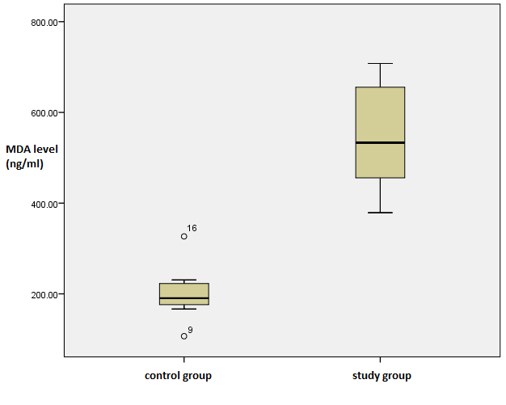

Figure 1. Box plot MDA level

