The results of microscopic observation showed that there is less number of ingested M. tuberculosis and less formation of vacuoles and giant cell macrophages (Figure 1).
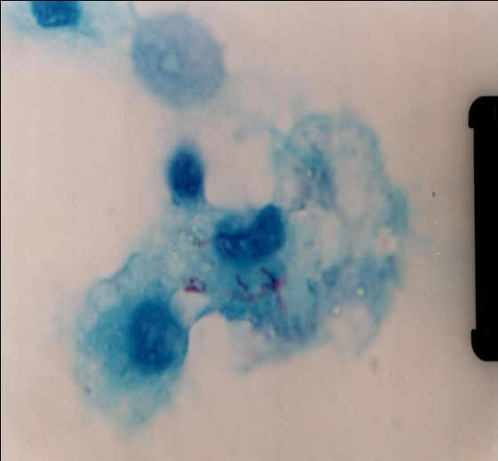

Figure 1. Macrophages of TB-DM patients ingested M. tuberculosis (NIKON Eclipse E600 light microscope, magnification of 1700X)

