Rapid PCR-RFLP Screening of CYP21A2 Variants: Bridging Molecular Diagnostics in a Low-Resource Setting
Irene Astrid Larasati¹, Nani Maharani^{2,4}, Agustini Utari^{3,4}, Tri Indah Winarni^{4*}
¹Magister of Biomedical Science Majoring in Genetic Counseling Program, Faculty of Medicine Universitas Diponegoro, Semarang, Indonesia.
²Department of Pharmacology and Therapy, Faculty of Medicine, Universitas Diponegoro, Semarang, Indonesia.
³Department of Pediatrics, Division of Pediatric Endocrinology, Faculty of Medicine Universitas Diponegoro, Semarang, Indonesia.
⁴Center for Biomedical Research, Faculty of Medicine Universitas Diponegoro, Semarang, Indonesia.

*Corresponding author

Short Running Title: Rapid PCR-RFLP Screening of CYP21A2

ABSTRACT
Background: The 21-hydroxylase deficiency (21OHD) accounted for the majority of autosomal recessive inherited congenital adrenal hyperplasia (CAH) cases. A genetic test could offer a more thorough diagnostic approach because of the wide range of disease’s severity, but it was challenging in a resource-limited setting.
Objective: To apply a simple and cost-effective rapid molecular screening for detecting the most common CYP21A2 variants causing salt-wasting (SW) CAH.
Methods: DNA extraction was conducted using a salting out method from a venous blood sample taken from 49 CAH patients without prior genetic testing. A PCR-RFLP approach was utilized using primer sets specifically designed to anneal to the CYP21A2. Specific restriction enzymes were selected to cleave the DNA sequence, differentiating the wild and mutant type, i.e, the p.Arg357Trp, p.Gln318Ter, IVS2-13A/C>G, and exon 6 cluster. Samples positive for those mutation types detected from DNA sequencing, used as positive controls.
Results: The most common variant was IVS2-13A/C>G, detected in 26 out of 27 patients. Only 6.1% of 49 patients were found to have the p.Gln318Ter variant. Both the p.Arg357Trp and exon 6 cluster carried inconclusive results. All patients detected with the IVS2-13A/C>G and p.Gln318Ter had a phenotype of SW CAH.
Conclusion: The PCR-RFLP was an advantageous method for identifying CYP21A2 variants in a low-resource setting. Nevertheless, the use of multiplex ligation-probe dependent amplification (MLPA) and Sanger sequencing offered a comprehensive analysis to discover novel variants that could help with patients' diagnosis and treatment.

Keywords:
Congenital adrenal hyperplasia, CYP21A2, PCR, RFLP, developing country

INTRODUCTION
Congenital adrenal hyperplasia (CAH) (CAH; OMIM #201910) is a group of genetic conditions characterized by an enzymatic defect in adrenal steroidogenesis. In 95% of cases, the condition is caused by pathogenic variants in the CYP21A2 gene resulting in 21-hydroxylase deficiency (21OHD) leading to cortisol, and aldosterone deficiency in the most severe type, and excessive androgen production.¹ Phenotypically, 21OHD encompasses a spectrum of the most severe salt-wasting (SW) to the least severe non-classic (NC) type. The incidence rate of classic CAH is 1 to 10,000 to 18,000 live birth according to the newborn screening (NBS) data.²

According to the CAH Registry by the Indonesian Pediatric Society, there was a 536.2% increase in the number of CAH cases in Indonesia from 2009 to 2020, with females dominating male cases (female-to-male ratio=303:136).³ Many CAH individuals were late-diagnosed due to the absence of an NBS program, which had barely been started in early 2025 in Indonesia. Individuals with CAH were referred to a pediatric endocrinologist only after frequent episodes of vomiting, dehydration, weight faltering, and weight loss without improvement after treatment, and the presence of virilization aided in the diagnosis of female CAH. However, the number of males with CAH was underrepresented, which was most likely caused by the absence of genital ambiguity and misdiagnosis of adrenal crisis as gastroenteritis.^{4,5} Timely diagnosis is crucial to prevent the lethality of the adrenal crisis. With the beginning of CAH NBS in Indonesia, medical laboratories should improve their capacity and capability, particularly in the measurement of 17-hydroxyprogesterone (17OHP) and genotyping of the CYP21A2.

The CYP21A2 (GenBank NG_007941.3; Ensembl ENSG00000231852; AllianceGenome HGNC:2600) has a highly homologous pseudogene, the CYP21A1P, in which both are located in a human leukocyte antigen (HLA) class III on the short arm of chromosome 6 (6p21.3), where a high frequency of gene recombination occurs.⁶ Hence, genotyping the gene, interpreting the results, and providing a comprehensive genetic counseling required a thorough knowledge of the genetics of CAH. The genetic test could provide a reliable diagnosis, particularly in terms of inconclusive results after cosyntropin stimulation test, and benefit for genetic counseling, i.e, phenotype prediction, prognosis, carrier detection, and family planning.⁷ Due to a lack of resources, the CYP21A2 genetic test using multiplex ligation-probe dependent amplification (MLPA) and Sanger sequencing could not be conducted in Indonesia. Therefore, we aimed to conduct a cost-effective, simple, and reliable method suitable for any laboratory with conventional PCR and gel electrophoresis using Polymerase Chain Reaction-Restriction Fragment Length Polymorphism (PCR-RFLP) in the leading CAH center in Indonesia to detect the most common point variants causing the most severe SW CAH. This method was suitable to be applied in a resource-limited setting, thus we could provide timely, comprehensive diagnosis when the CAH NBS becomes a national program.

MATERIALS AND METHODS
This was an experimental cross-sectional study conducted in a genetics research laboratory in Semarang, Indonesia. The study was conducted from November 2023 to June 2024.

The participants of this study were individuals with CAH without prior genetic test who were diagnosed by pediatric endocrinologists at a tertiary and secondary hospital in Semarang, Indonesia. The diagnosis of CAH was made based on the clinical characteristics, i.e., vomiting, diarrhea, dehydration, hyperpigmentation, and virilization in females, and biochemical measurement of 17OHP and electrolytes, i.e., sodium and potassium. Participants were approached during their routine follow-up and offered their participation in the study. Parents or caregivers of younger participants (<18 years) provided written consent to or not to participate in the study after receiving and understanding the information given by the research team.

The participant’s blood was drawn from a cubital venous vessel by trained laboratory technicians. The blood was stored inside an EDTA tube in a -80°C. A salting-out method was utilized to extract the DNA. DNA concentration and purity were measured using NanoVue Plus Spectrophotometer (GE Healthcare Technologies, Inc., Chicago, IL) by calculating the DNA samples' absorbance at 260 nanometers (A260) and the ratio of absorbance at 260 and 280 nanometers (A260/A280), respectively. A A260/280 ratio at ≥1.80 was considered as the value of pure DNA.

The PCR process was carried out using the GeneAmp PCR System 9700 (Thermo Fisher Scientific Inc., Waltham, MA). Two rounds PCR amplification was utilized for the IVS2-13A/C>G variant, in which the first round was targeted to specifically amplify the exon 1, exon 2, and the intron 2 site of the CYP21A2 gene using a set of LR-F/B2 primers, and the second round was aimed to amplify the intron 2 using a set of 7/8 primers, producing fragment sizes of 1,118 bp and 155 bp, respectively. The other variants, i.e., the Exon 6 cluster (E6 cluster; a compound missense variant named p.[Ile236Asn; Val237Glu; Met239Lys], p.Gln318Ter, and p.Arg357Trp, were amplified using a set of long-range PCR primers, i.e., C1/LR-R, producing a fragment size of 2,610 bp. The site of the primer's annealing was displayed in Figure 1. Some of the primers used in the study were based on a previous study by Zhang et al.⁸

The mixture of each sample for the first round of PCR included 8.2 μl of H₂O, 10 μl of PCR mix, 0.4 μl of forward primer, 0.4 μl of reverse primer, and 2 μl of DNA (100 ng). The PCR settings for the IVS2-13A/C>G variant were 1 cycle of initial denaturation at 94°C for 5 minutes, followed by 30 cycles of denaturation at 94°C for 20 seconds, annealing at 60°C for 30 seconds, extension at 72°C for 1 minute, and concluded with a final extension at 72°C for 5 minutes. The PCR settings for the E6 cluster, p.Gln318Ter, and p.Arg357Trp were 1 cycle of initial denaturation at 94°C for 5 minutes, followed by 30 cycles of denaturation at 94°C for 20 seconds, annealing at 59.3°C for 30 seconds, extension at 72°C for 1 minute, and a final extension at 72°C for 5 minutes.

The mixture for the second round of PCR comprised 8.2 μl of H₂O, 10 μl of PCR mix, 0.4 μl of forward primer (primer 7), 0.4 μl of reverse primer (primer 8), and 1 μl of DNA (100 ng). The PCR settings for this process involved 30 cycles of denaturation at 94°C for 30 seconds, annealing at 58°C for 30 seconds, and extension at 72°C for 30 seconds.

A product check was conducted after each round of PCR using the 1.5% and 2.5% agarose gel electrophoresis for sequences larger and smaller than 1000 bp, respectively. Gel electrophoresis was run for 35 minutes at 120 V.

Prior to the RFLP analysis, an in-silico analysis using a restriction analyzer tool (https://molbiotools.com/restrictionanalyzer.php) was conducted utilizing the CYP21A2 (NG_007941.3) sequence retrieved from the human genome assembly GRCh38/hg38 (unpublished data).

The reaction mixture for RFLP was comprised of 0.5 μl of buffer Tango, 0.5 μl of 10x PCR buffer, 0.5 μl of restriction enzyme, 8.5 μl of H2O, and 10 μl of PCR product. Digestion process was conducted for 2 hours at a temperature of 37°C. To visualize the fragments, a 1.5% or 2.5% agarose gel electrophoresis was operated for 40 minutes at 110 V to effectively separate the DNA fragments based on their length. Each restriction enzyme's specific site was displayed in Table 1.

Ethical approval was issued before the commencement of the study (No. 072/EC/KEPK/FK-UNDIP/II/2024). Data were presented descriptively as frequencies and percentages. No statistical analysis was conducted in the study.

RESULTS
Among 49 SW-CAH patients, the two most common pathogenic variants causing SW-CAH were identified, including IVS2-13A/C>G and p.Gln318Ter. The most frequent variant was IVS2-13A/C>G, which was detected in 26 out of 27 patients tested (96.3%). The p.Gln318Ter was only detected in 3 patients from a total of 49 patients (6.1%).

The positive result of RFLP analysis of the IVS2-13A/C>G variant produced 4 DNA fragments at around 150 bp, 180 bp, 300 bp, and 450 bp, whereas the fifth fragment was visible in the negative result at around 650 bp as can be seen in Figure 2.

Post-digested DNA products using the PstI enzyme visualized several fragments. The positive result showed an additional fragment at approximately 1,000 bp, which was not present in the negative result. (See Figure 3)

Analysis of the post-digested DNA product using AciI of p.Arg357Trp displayed no band in either positive or negative controls. Several DNA samples showed fragments approximately 500 bp, 300 bp, 200 bp, and 100 bp. (See Figure 4)

There was no DNA fragment visualized on the positive control (number 2), although two fragments were visualized on the negative control (number 22). The samples exhibited different fragment sizes, as shown in Figure 5.

Genotype-Phenotype Correlation
Among the 49 patients analyzed in the study, the p.Gln318Ter variant was found in 3 individuals. However, the IVS2-13A/C>G variant was found in 96.3% of 27 patients as displayed in Table 2. One patient had a heterozygous mutation of the IVS2-13A/C>G and p.Gln318Ter.

A group classification based on the prediction of 21-hydroxylase residual enzymatic activity exhibited 3 (6.1%) individuals with p.Gln318Ter variant categorized into the Null group. This group had no remaining enzymatic activity. No patient was identified in group B and C. (See Table 4)

DISCUSSION
A rapid molecular analysis for detecting the four most common CYP21A2 variants causing SW CAH was performed in the main CAH center in Indonesia. The analysis utilized sets of primers designed for long-range PCR, combined with the specific digestion enzyme used in the RFLP. The primers, i.e, B2 and C1, comprised the sequence absent in the pseudogene, such as the 8 bp deletion in exon 3 (E3Δ8bp; c.332_339del; p.Gly111fs; rs387906510), ensured the amplification of the CYP21A2.⁹ Nevertheless, the Del and E3Δ8bp could not be distinguished due to the location of both PCR primers in exon 3. A previous study conducted in 62 other Indonesian CAH patients displayed that the E3Δ8bp variant was found only in 1 allele, and the Del variant was found in none among 124 alleles analyzed.¹⁰

Among the four-point pathogenic variants with clinical manifestation of SW CAH detected using the PCR-RFLP method, which were IVS2-13A/C>G, p.Gln318Ter, p.Arg357Trp, and the exon 6 cluster. The intron 2 splice and p.Gln318Ter variants were successfully identified because of larger-sized fragments visualized on the UV-illuminator. However, the p.Arg357Trp could hardly be identified due to the insignificant fragment size differences between the wild and mutant types, i.e., 189 and 30 bp in the wild type and 219 bp in the mutant type, despite a higher agarose gel concentration at 2.5% and lower Voltage and shorter duration had been implemented. The application of the 100 bp + 3k marker in the study made the interpretation of DNA fragments smaller than 200 bp difficult. The approach applied relied solely on the visualization of DNA bands using a UV-illuminator. Conversely, previous studies utilizing a similar method successfully recognized the variant because of the use of Southern Blot and direct sequencing to confirm the deletions or gene conversion and base substitution, respectively.^{8,9,11}

The exon 6 cluster yielded inconclusive results due to the absence of DNA fragments of the positive control after digestion by a specific restriction enzyme, DraIII. The unavailability of the product after the digestion by a restriction enzyme did not rule out the possibility of contamination. Preceding studies by Yokoyama et al.⁹ and Zhang et al.⁸ performed PCR product purification prior to the RFLP procedure. During the process, primers, reagents, and other contaminants that possibly could obstruct the subsequent process were removed.^{12,13} Excess magnesium could chelate away the restriction enzyme, and frequently, the PCR reagents would inhibit the restriction enzymes. Hence, contamination prevention was necessary and justified.¹⁴

The most frequent variant identified among 27 SW CAH patients was the IVS2-13A/C>G, which was found in 26 (96.3%) patients. This variant was classified into group A with merely 0-1% residual enzymatic activity and predicted phenotype of SW or SV. Only 6.1% of 49 patients were identified with the p.Gln318Ter (Null group). However, the preceding study conducted in the center displayed the p.Arg357Trp to be the most prevalent (41/62) variant found in the CAH patients.¹⁰ In comparison, the intron 2 splice was commonly found in the Chinese, Indian, and Cuban populations,^{15–18}, and the Del in Germans and Austrians, Dutch, Polish, and Chilean populations.^{19–22} These variants resulted in less than 2% enzymatic activity, thus producing extremely low levels of cortisol and aldosterone. Detection of these variants could aid in the genetic counseling process, encompassing the phenotype prediction, course of CAH, carrier detection, family planning, and management of the condition.²³

Due to its complexity, genotyping the CYP21A2 required a combination of molecular analysis techniques to be able to detect complex structural rearrangements, copy number variations (CNVs), insertions/deletions, and single-nucleotide variants (SNVs). RFLP is a simple and specific method to detect variations in the DNA sequence, including SNPs and in/del. A thorough understanding of the sequence is a requirement; thus, an appropriate restriction enzyme could cleave the sequence at a specific restriction site accurately. Because of its cost-effectiveness and requirement for basic instruments, RFLP was a favored method to be applied as an early diagnosis in a resource-limited setting, such as Indonesia.²⁴ Two of the most common point variants, i.e., IVS2-13A/C>G and p.Gln318Ter, causing the most severe SW were successfully detected using this quick, simple, and reliable approach, enabling prompt diagnosis and management of the long-life treatment course of CAH. Additionally, this method was highly reliable due to the consistent results demonstrated across time and locations. By combining it with PCR using specifically designed primers, this procedure could yield high reproducibility.²⁵

Despite its usefulness, RFLP lacked in some aspects. This method was time-consuming and labor-intensive due to the multiple steps involved to yield the results. RFLP could not fully identify human whole genome variation since it was limited to analyzing a particular variant at a specific restriction site.²⁶ Therefore, this method was unsuitable for detecting novel variants because it relied on prior knowledge of restriction enzyme sites within the DNA sequence. This disadvantage was critical in clinical settings where the identification of novel variants could influence diagnosis and treatment. Furthermore, RFLP required a large quantity and quality of DNA, which could be challenging to collect from specific sample types or in situations when there was a shortage of samples.²⁷ Considering that up until now there had been more than 200 pathogenic variants known to cause CAH, there is a better and more advanced technique to do a molecular analysis in CYP21A2.²⁸

Presently, the multiplex ligation-probe dependent amplification (MLPA) and Sanger sequencing are the most frequent methods used for the CYP21A2 genotyping. The MLPA was a high-throughput and less expensive procedure that could simultaneously detect CNVs in 40 target locations, utilizing the probe amplification and producing the results in less than 24 hours. Moreover, MLPA required a small amount of DNA (20-50 ng) and the utilization of standardized software to improve diagnostic accuracy and reduce human error.²⁹ To identify point mutations, Sanger sequencing provided comprehensive details on individual gene sequences. Integration of these methods would allow a more thorough understanding of the genetic basis of the disease, such as 21OHD, in which a single method alone might not identify all mutations. Currently, MLPA and Sanger sequencing have been applied in many laboratories as a gold-standard method for CAH molecular analysis.³⁰

The establishment of a PCR-RFLP technique as a rapid molecular screening for the most common variants of SW CAH shed light on the accessibility of genetic analysis of the CYP21A2. Early genetic counseling could be provided to the patient and the family, thus they would be more prepared to deal with and adjust to the course of CAH. In the era of precision medicine, a genetic analysis of the CYP21A2 gene could provide personalized management to the patients. A genetic counselor played an important role in assisting the patient in the journey of acceptance, adaptation, and connecting them to healthcare professionals and support groups.^{31,32} Hence, patients and their families could benefit from enhanced risk perception, positive risk behaviors, better knowledge, and a sense of personal control.³³

The PCR-RFLP method was simple and cost-effective, with the prerequisite of a thermocycler, an electrophoresis system, and specific restriction enzymes that are easily accessible in genetic laboratories in a developing country. Nevertheless, a prior knowledge of the CYP21A2 gene remains mandatory.

Despite the utilization of the primer set of a previous study, the discrepancy between the most common variant found within the same population, i.e., the p.Arg357Trp, and the disproportionate number of patients found to carry the intron 2 splice, warrants further examination of this variant to confirm the result.⁸ Thus, it was not possible to make a final decision for this variant. The CYP21A2 variants involved complex gene rearrangements and various SNVs, and it is possible that novel variants would be found in the future. Therefore, incorporating direct sequencing is the only approach to detect new or rare variants completely.³⁴

CONCLUSION
The PCR-RFLP was an applicable method for detecting the most common variants of the CYP21A2 gene causing SW CAH in a resource-limited setting because of the accessibility of the equipment and materials used. The two most common variants causing SW CAH were successfully detected, i.e., IVS2-13A/C>G and p.Gln318Ter. Nevertheless, a more advanced molecular technique, such as MLPA combined with Sanger sequencing, is recommended due to its ability to discover novel variants in CAH patients, thereby enabling correct diagnosis, early and personalized treatment, and genetic counseling.

ACKNOWLEDGMENTS
The authors would like to express gratitude to the CAH patients for participating in the study, the lab technicians at the Center for Biomedical Research (CEBIOR), Faculty of Medicine Universitas Diponegoro, for assisting in the research process, and Pendidikan Magister menuju Doktor untuk Sarjana Unggul (PMDSU) scholarship by the Ministry of Higher Education, Science, and Technology of the Republic of Indonesia for providing the financial support for the study.

REFERENCES

1. Claahsen - van der Grinten HL, Speiser PW, Ahmed SF, et al. Congenital Adrenal Hyperplasia—Current Insights in Pathophysiology, Diagnostics, and Management. Endocr Rev. 2022;43(1):91-159. doi:10.1210/endrev/bnab016

2. Speiser PW, Arlt W, Auchus RJ, et al. Congenital Adrenal Hyperplasia Due to Steroid 21-Hydroxylase Deficiency: An Endocrine Society* Clinical Practice Guideline. J Clin Endocrinol Metab. 2018;103(11):4043-4088. doi:10.1210/jc.2018-01865

3. Armstrong K, Benedict Yap A, Chan-Cua S, et al. We All Have a Role to Play: Redressing Inequities for Children Living with CAH and Other Chronic Health Conditions of Childhood in Resource-Poor Settings. Int J Neonatal Screen. 2020;6(4):76. doi:10.3390/ijns6040076

4. Adriaansen BPH, Utari A, Westra D, et al. 46,XX males with congenital adrenal hyperplasia: a clinical and biochemical description. Front Endocrinol. 2024;15. https://www.frontiersin.org/journals/endocrinology/articles/10.3389/fendo.2024.1410122

5. Utari A, Faradz SMH, Ediati A, et al. Challenges in the treatment of late-identified untreated congenital adrenal hyperplasia due to CYP11B1 deficiency: Lessons from a developing country. Front Endocrinol. 2022;13:1015973. doi:10.3389/fendo.2022.1015973

6. Yang M, White PC. Genetics and Pathophysiology of Classic Congenital Adrenal Hyperplasia Due to 21-Hydroxylase Deficiency. J Clin Endocrinol Metab. 2025;110(Supplement_1):S1-s12. doi:10.1210/clinem/dgae535

7. Maher JY, Gomez-Lobo V, Merke DP. The management of congenital adrenal hyperplasia during preconception, pregnancy, and postpartum. Rev Endocr Metab Disord. 2023;24(1):71-83. doi:10.1007/s11154-022-09770-5

8. Zhang B, Lu L, Lu Z. Molecular diagnosis of Chinese patients with 21-hydroxylase deficiency and analysis of genotype–phenotype correlations. J Int Med Res. 2017;45(2):481-492. doi:10.1177/0300060516685204

9. Yokoyama Y, Teraoka M, Tsuji K, et al. Rapid screening method to detect mutations in CYP21, the gene for 21-hydroxylase. Am J Med Genet. 2000;94(1):28-31. doi:https://doi.org/10.1002/1096-8628(20000904)94:1<28::AID-AJMG6>3.0.CO;2-F

10. Faradz SMH, Listyasari N, Utari A, et al. Lessons Learned from 17 Years of Multidisciplinary Care for Differences of Sex Development Patients at a Single Indonesian Center. Sex Dev. Published online September 12, 2023:1-11. doi:10.1159/000534085

11. Asanuma A, Ohura T, Ogawa E, et al. Molecular analysis of Japanese patients with steroid 21-hydroxylase deficiency. J Hum Genet. 1999;44(5):312-317. doi:10.1007/s100380050167

12. Shvartsman E, Richmond MEI, Schellenberg JJ, et al. Comparative analysis of DNA extraction and PCR product purification methods for cervicovaginal microbiome analysis using cpn60 microbial profiling. PloS One. 2022;17(1):e0262355. doi:10.1371/journal.pone.0262355

13. Pedersen LMI, Stangegaard M, Mogensen HS, Morling N. Purification and concentration of PCR products leads to increased signal intensities with fewer allelic drop-outs and artifacts. Prog Forensic Genet 14. 2011;3(1):e347-e348. doi:10.1016/j.fsigss.2011.09.036

14. Smith PJ, Ballantyne J. Simplified Low-Copy-Number DNA Analysis by Post-PCR Purification. J Forensic Sci. 2007;52(4):820-829. doi:10.1111/j.1556-4029.2007.00470.x

15. Espinosa Reyes TM, Collazo Mesa T, Lantigua Cruz PA, Agramonte Machado A, Domínguez Alonso E, Falhammar H. Genotype-Phenotype Correlation in Patients with Congenital Adrenal Hyperplasia due to 21-Hydroxylase Deficiency in Cuba. Int J Endocrinol. 2021;2021:9316284. doi:10.1155/2021/9316284

16. Liu Y, Zheng J, Liu N, et al. The spectrum of CYP21A2 gene mutations in patients with classic salt wasting form of 2l-hydroxylase deficiency in a Chinese cohort. Mol Genet Genomic Med. 2020;8(11):e1501. doi:10.1002/mgg3.1501

17. Wang X, Wang Y, Ma D, et al. Neonatal Screening and Genotype-Phenotype Correlation of 21-Hydroxylase Deficiency in the Chinese Population. Front Genet. 2021;11. https://www.frontiersin.org/journals/genetics/articles/10.3389/fgene.2020.623125

18. Khajuria R, Walia R, Bhansali A, Prasad R. The spectrum of CYP21A2 mutations in Congenital Adrenal Hyperplasia in an Indian cohort. Clin Chim Acta. 2017;464:189-194. doi:10.1016/j.cca.2016.11.037

19. Riedl S, Röhl FW, Bonfig W, et al. Genotype/phenotype correlations in 538 congenital adrenal hyperplasia patients from Germany and Austria: discordances in milder genotypes and in screened versus prescreening patients. Endocr Connect. 2019;8(2):86-94. doi:10.1530/EC-18-0281

20. Stikkelbroeck NMML, Hoefsloot LH, de Wijs IJ, Otten BJ, Hermus ARMM, Sistermans EA. CYP21 Gene Mutation Analysis in 198 Patients with 21-Hydroxylase Deficiency in The Netherlands: Six Novel Mutations and a Specific Cluster of Four Mutations. J Clin Endocrinol Metab. 2003;88(8):3852-3859. doi:10.1210/jc.2002-021681

21. Kurzyńska A, Skalniak A, Franson K, Bistika V, Hubalewska-Dydejczyk A, Przybylik-Mazurek E. Molecular analysis and genotype-phenotype correlations in patients with classical congenital adrenal hyperplasia due to 21-hydroxylase deficiency from southern Poland — experience of a clinical center. Hormones. 2022;21(2):241-249. doi:10.1007/s42000-022-00348-z

22. Fardella CE, Poggi H, Pineda P, et al. Salt-Wasting Congenital Adrenal Hyperplasia: Detection of Mutations in CYP21B Gene in a Chilean Population1. J Clin Endocrinol Metab. 1998;83(9):3357-3360. doi:10.1210/jcem.83.9.5071

23. Arriba M, Ezquieta B. Molecular Diagnosis of Steroid 21-Hydroxylase Deficiency: A Practical Approach. Vol 13.; 2022. https://www.frontiersin.org/articles/10.3389/fendo.2022.834549

24. Hashim HO, Al-Shuhaib MBS. Exploring the Potential and Limitations of PCR-RFLP and PCR-SSCP for SNP Detection: A Review. J Appl Biotechnol Rep. 2019;6(4):137-144. doi:10.29252/JABR.06.04.02

25. Chial H. DNA fingerprinting using amplified fragment length polymorphisms (AFLP): No genome sequence required. Nature Education. 2008. Accessed June 26, 2024. https://www.nature.com/scitable/topicpage/dna-fingerprinting-using-amplified-fragment-length-polymorphisms-39051/

26. Yang W, Kang X, Yang Q, Lin Y, Fang M. Review on the development of genotyping methods for assessing farm animal diversity. J Anim Sci Biotechnol. 2013;4(1):2. doi:10.1186/2049-1891-4-2

27. Sakari SL, Jimson S, Masthan KMK, Jacobina J. Role of DNA profiling in forensic odontology. J Pharm Bioallied Sci. 2015;7(Suppl 1):S138-141. doi:10.4103/0975-7406.155863

28. Neocleous V, Fanis P, Phylactou LA, Skordis N. Genotype Is Associated to the Degree of Virilization in Patients With Classic Congenital Adrenal Hyperplasia. Vol 9.; 2018. https://www.frontiersin.org/articles/10.3389/fendo.2018.00733

29. Fu X, Shi Y, Ma J, et al. Advances of Multiplex Ligation-dependent Probe Amplification Technology in Molecular Diagnostics. BioTechniques. 2022;73(4):205-213. doi:10.2144/btn-2022-0017

30. Yuan D, Cai R, Mao A, et al. Improved genetic characterization of congenital adrenal hyperplasia by long-read sequencing compared with multiplex ligation-dependent probe amplification plus Sanger sequencing. J Mol Diagn. Published online June 24, 2024. doi:10.1016/j.jmoldx.2024.05.009

31. Radu M, Moldovan R, Băban A. Families with complex needs: an inside perspective from young people, their carers, and healthcare providers. J Community Genet. 2022;13(3):293-302. doi:10.1007/s12687-022-00586-z

32. Higgs E, Wain KE, Wynn J, et al. Measuring quality and value in genetic counseling: The current landscape and future directions. J Genet Couns. 2023;32(2):315-324. doi:10.1002/jgc4.1657

33. Madlensky L, Trepanier AM, Cragun D, Lerner B, Shannon KM, Zierhut H. A Rapid Systematic Review of Outcomes Studies in Genetic Counseling. J Genet Couns. 2017;26(3):361-378. doi:10.1007/s10897-017-0067-x

34. Krone N, Arlt W. Genetics of congenital adrenal hyperplasia. Best Pract Res Clin Endocrinol Metab. 2009;23(2):181-192. doi:10.1016/j.beem.2008.10.014

FIGURE CAPTIONS
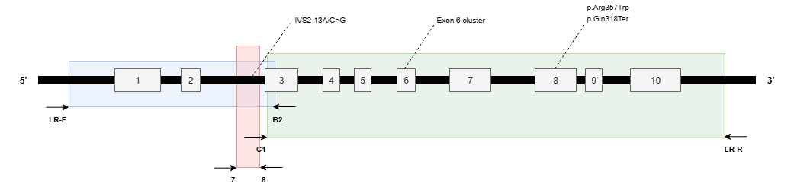
Right arrows: forward primers; left arrows: reverse primers; dash lines: annotated CYP21A2 point variants; blue box: PCR fragment from the first round amplifying exon 1 and 2; red box: PCR fragment from the second round amplifying intron 2; green box: PCR fragment amplifying exon 3 to 10.

Figure 1. Annealing sites of PCR primers for the CYP21A2

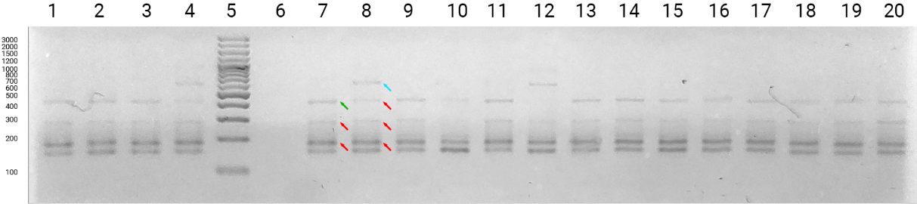
Marker: lane 5; non-template control: lane 6; positive control: lane 7; negative control: lane 8; positive results: lane 1–3 (CAH 087, 092, 093), 9–11 (CAH 114, 116, 118), 13–20 (CAH 121, 122, 123, 128, 129, 130, 131, 096); negative results: 4 and 12 (CAH 112 and 120). Red arrows show unknown fragments in both positive and negative controls, green arrow shows unknown in positive control, and blue arrow shows unknown fragment in negative control. Fragment sizes are pointed out on the side in bp.

Figure 2. RFLP result of IVS2-13A/C>G

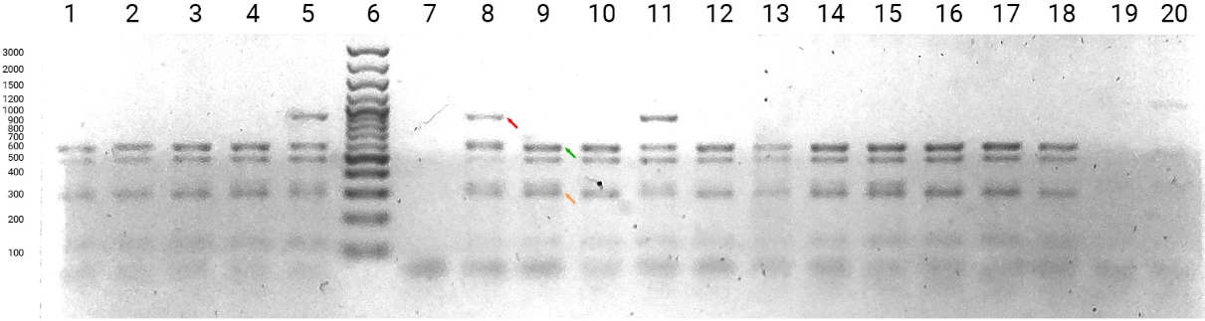
Marker: lane 6; non-template control: lane 7; positive control: lane 8 (CAH 025); negative control: lane 9 (CAH 022); positive results: lane 5 and 11 (CAH 079 and CAH 088); negative results: 1–4 (CAH 120, 121, 072, 077), 10 (CAH 086), 12–18 (CAH 094, 096, 100, 102, 103, 104, 105, 111); inconclusive: 19 and 20 (CAH 111 and 117). Red arrow shows fragment at 865 bp in the positive control, green and orange arrows show fragments at 567 and 298 bp, respectively. Fragment sizes are pointed out on the side in bp.

Figure 3. RFLP Results of p.Gln318Ter

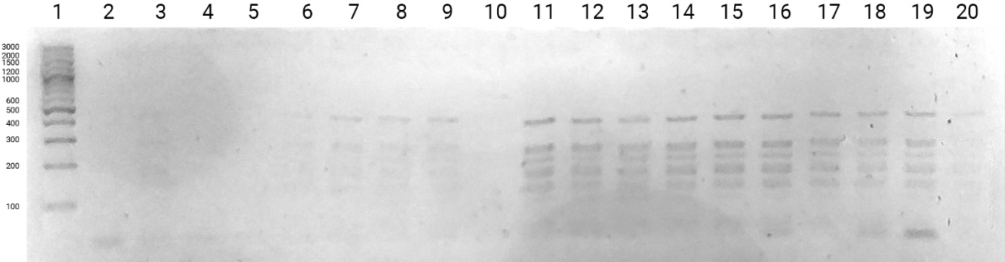
Marker: lane 1; non-template control: lane 2; positive control: lane 3 (CAH 029); negative control: lane 4 (CAH 031); inconclusive: lane 5–20 (CAH 061, 062, 063, 064, 066, 067, 069, 070, 072, 073, 074, 075, 078, 080, 083, 065). Fragment sizes are pointed out on the side in bp.

Figure 4. RFLP Results of p.Arg357Trp

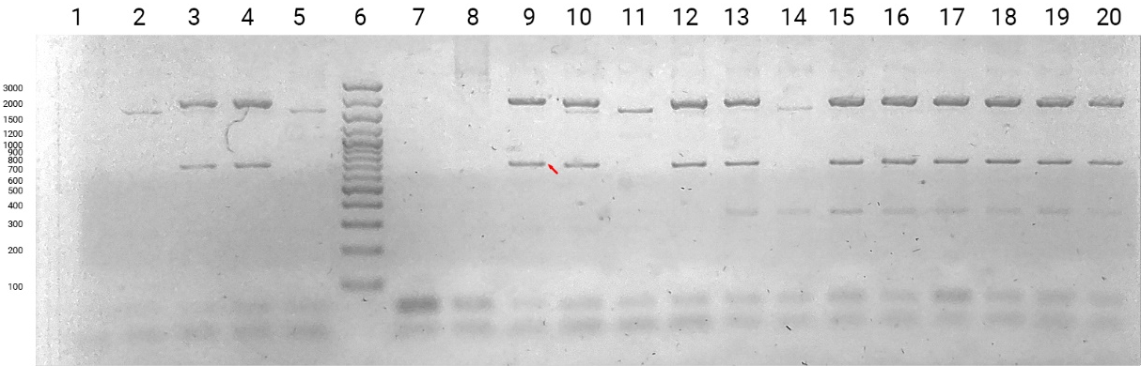
Marker: lane 6; non-template control: lane 7; positive control: lane 8 (CAH 002); negative control: lane 9 (CAH 022); inconclusive: 1–5 (CAH 061, 062, 063, 064, 065), 10–20 (CAH 066, 067, 069, 070, 072, 073, 074, 075, 078, 080, 083). Red arrow shows fragment at 719 bp in the negative control. Fragment sizes are pointed out on the side in bp.

Figure 5. RFLP Results of p.[Ile236Asn; Val237Glu; Met239Lys] variant

TABLE CAPTIONS

Table 1. Restriction enzymes for digesting the CYP21A2 fragments
Variant | Restriction enzyme | Sequence Specificity | Fragment size (bp)
Variant | Restriction enzyme | Sequence Specificity | Wild-type | Mutant
p.Arg357Trp | AciI | CCGC(-3/-1) | 189/30 | 219
IVS2-13A/C>G | Sau3AI | /GATC | 156 | 133/23
p.Gln318Ter | PstI | CTGCA/G | 567/298 | 865
p.[Ile236Asn; Val237Glu; Met239Lys] | DraIII | CACNNN/GTG | 687/28 | 715

Table 2. Genotype-phenotype frequency of Indonesian SW-CAH patients
 | Positive | Negative | No Band | Total
IVS2-13A/C>G | 26 (96.3%) | 1 (3.75) | 0 | 27 (100%)
p.Gln318Ter | 3 (6.1%) | 34 (69.4%) | 12 (24.5%) | 49 (100%)

Table 3. Genotype-phenotype correlation of Indonesian SW-CAH patients
Group | Variant | No. of Patients  n (%) | Expected Phenotype | Expected Residual Enzymatic Activity
Null | p.Gln318Ter | 3 (6.1) | SW | 0%
A | IVS2-13A/C>G | 26 (96.3) | SW or SV | 0-1%
B | N/A | 0 | N/A | N/A
C | N/A | 0 | N/A | N/A
SW: salt wasting; SV: simple virilizing; N/A: Not applicable

