Table 1. The genotype distribution of MTHFR A1298C and C677T
in the case and control groups
Genotype | Case Group n (%) | Control Group n (%)
MTHFR A1298C - AA | 39 (55.71%) | 41 (58.57%)
MTHFR A1298C - Polymorphism (AC, CC) | 31 (44.29%) | 29 (41.43%)
MTHFR C677T - CC | 43 (61.43%) | 50 (71.43%)
MTHFR C677T - Polymorphism (CT, TT) | 27 (38.57%) | 20 (28.57%)

Table 2. Statistical analysis of GPx, sEng, and MTHFR Gene Polymorphisms
in Case and Control Groups
No | Variable | Case  (n=70) | Control  (n=70) | p values
1 | Glutathione peroxidase (GPx)  - Mean + SD  - Median (min - max) | 87,5+47,55  76,45(46,7-309,6) | 82,2+30,7  78,45(8,5-190,6) | 0,782
2 | Soluble endoglin (sEng)  - Mean + SD  - Median (min - max) | 11,0 + 5,22  10,70 (2,5-23,9) | 8,1+ 5,31  7 (1,3-25) | 0,001
3 | MTHFR C677T Gene  - Polimorfisme (CT,TT)  - Wildtype (CC) | 27 (38,57%)  43 (61,43%) | 20 (28,57%)  50 (71,43%) | 0,283
4 | MTHFR A1298C Gene  - Polimorfisme (AC,CC)  - Wildtype (AA) | 31 (44,29%)  39 (55,71%) | 29 (41,43%)  41 (58,57%) | 0,864

Table 3. Association analysis between GPx and sEng levels with
MTHFR A1298C gene polymorphism in preeclampsia

No | Variable | MTHFR A1298C gene |  | p values
No | Variable | Polymorphism  (AC,CC)  n=31 | Normal  (AA)  n=39 | p values
1 | Glutathione peroxidase (GPx)  - Mean + SD  - Median (min - max) | 89,8+55,85  76,60(46,7-309,6) | 85,7+40,43  76,30(49,9-286,7) | 0,887
2 | Soluble endoglin (sEng)  - Mean + SD  - Median (min - max) | 9,3 + 5,11  8 (2,5-17,5) | 12,4+ 4,95  12 (2,8-23,9) | 0,013

Table 4. Association analysis between GPx and sEng levels with
MTHFR C677T genepolymorphism in preeclampsia

No | Variable | MTHFR C677T gene |  | p values
No | Variable | Polymorphism  (CT,TT)  n=27 | Normal  (CC)  n=43 | p values
1 | Glutathione peroxidase (GPx)  - Mean + SD  - Median (min - max) | 88,6+42,61  82,3(49,9-286,7) | 86,8+50,88  74,3(46,7-309,6) | 0,136
2 | Soluble endoglin (sEng)  - Mean + SD  - Median (min - max) | 11,7 + 5,47  11 (2,8-23,8) | 10,6+ 5,07  10,2 (2,5-23,9) | 0,399

Table 5. Chi-square test of sEng level with MTHFR A1298C
gene polymorphism in preeclampsia

No | Variable | MTHFR A1298C Gene |  | p value
No | Variable | Polymorphism  (n=31) | Normal  (n=39) | p value
1 | Soluble endoglin (sEng)  - High (≥7,75)  - Low (<7,75) | 17 (54,8%)  14 (45,2%) | 32 (82,1%)  7 (17,9%) | 0,027  (OR:0,266;  RR:0,520)

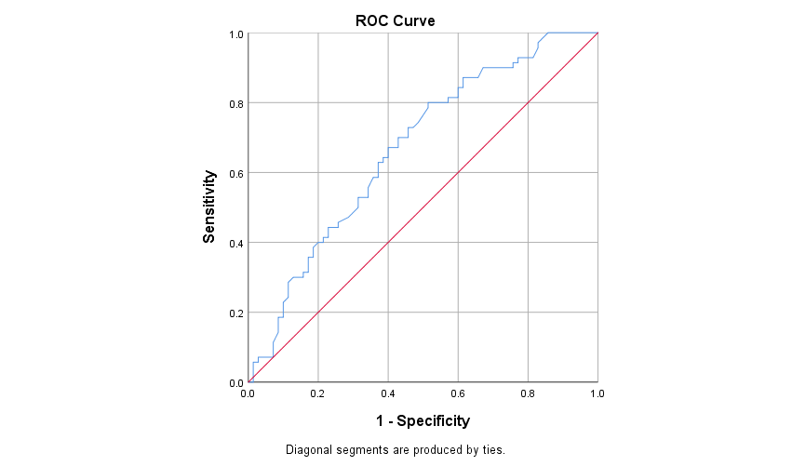
Figure 1. ROC curve for determining cut-off levels of sEng as predictor of preeclampsia

