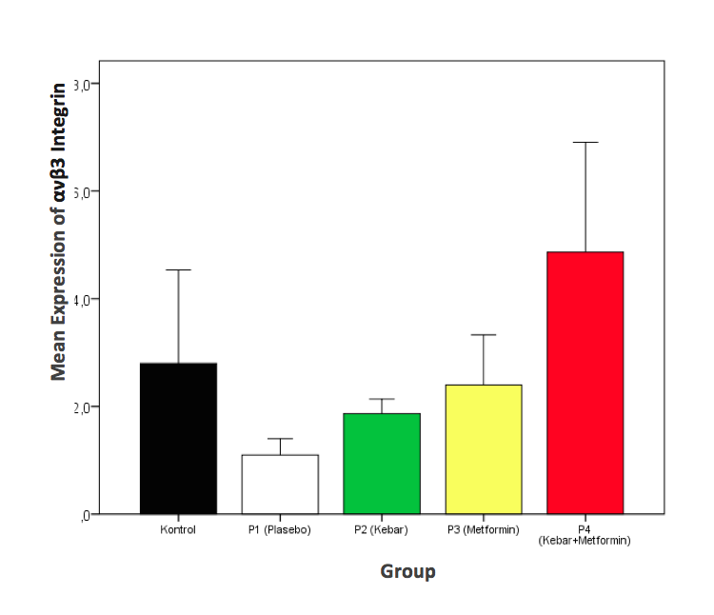
Figure 2. Comparison of ανβ3 Integrin expression of endometrial tissue of Balb/c endometriosis mice model (n = 30)

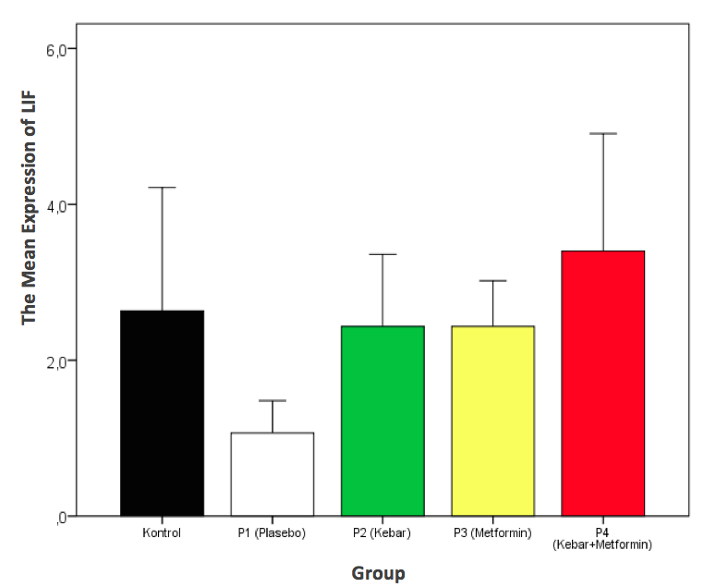
Figure 4. LIF expression comparison of endometrial tissue of Balb / c mice model of endometriosis (n = 30)

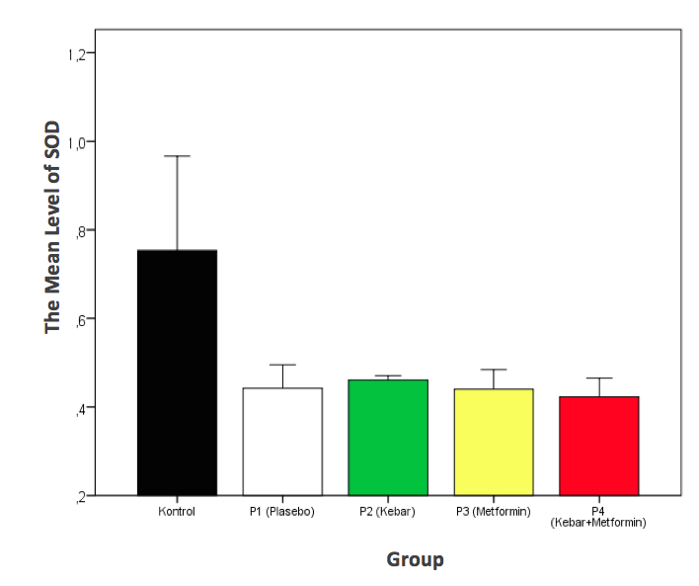
Figure 5. Serum SOD levels of Balb / c mice (n = 30)

Table 1. Integrin αvβ3 expression of Balb/c mice endometrial tissue (n=30)
Group |  | Mean±SD | Median |  |  |  | (Min-Max) |  |  |  | p*
Control |  | 2,8±1,73 | 2,0 |  |  |  | (1,6 - 6,0) |  |  |  | 0,001
P1 (Placebo) |  | 1,1±0,30 | 1,1 |  |  |  | (0,8 - 1,6)
P2 (Kebar) |  | 1,9±,27 | 1,9 |  |  |  | (1,4 - 2,2)
P3 (Metformin) |  | 2,4±,93 | 2,7 |  |  |  | ,(6,0 - 3,0)
P4 (Kebar+Metformin) |  | 4,9±2,04 | 4,2 |  |  |  | (2,8 - 8,6)
*Kruskall-Wallis Test
The result of comparison between group with Mann-Whitney test:
K vs P1: p=0,004  K vs P2: p=0,6  K vs P3: p=0,8  K vs P4: p=0,06 | P1 vs P2: p=0,004  P1 vs P3: p=0,06  P1 vs P4: p=0,002 |  |  | P2 vs P3: p=0,06  P2 vs P4: p=0,002 |  |  |  |  | P3 vs P4: p=0,01
Table 2. LIF expression of Balb/c mice endometrial tissue (n=30)
Group |  | Mean±SD | Median |  |  |  | (Min-Max) |  |  |  | p*
Control |  | 2,6±1,58 | 2,0 |  |  |  | (1,4 - 5,6) |  |  |  | 0,006
P1 (Placebo) |  | 1,1±0,41 | 1,1 |  |  |  | (0,6 - 1,6)
P2 (Kebar) |  | 2,4±0,92 | 2,0 |  |  |  | (1,6 - 3,6)
P3 (Metformin) |  | 2,4±0,59 | 2,3 |  |  |  | (1,8 - 3,2)
P4 (Kebar+Metformin) |  | 3,4±1,51 | 3,3 |  |  |  | (1,6 - 5,8)
*Kruskall-Wallis Test
The result of comparison between groups with Mann-Whitney test:
K vs P1: p=0,009  K vs P2: p=0,8  K vs P3: p=0,7  K vs P4: p=0,2 | P1 vs P2: p=0,002  P1 vs P3: p=0,002  P1 vs P4: p=0,002 |  |  | P2 vs P3: p=0,8  P2 vs P4: p=0,2 |  |  |  |  | P3 vs P4: p=0,3
Table 3. Serum SOD level of Balb/c mice (n=30)
Group |  | Mean±SD |  |  | Median |  |  | (Min-Max) |  |  |  | p*
Control |  | 0,75±0,213 |  |  | 0,88 |  |  | (0,46 - 0,92) |  |  |  | 0,007
P1 (Placebo) |  | 0,44±0,053 |  |  | 0,46 |  |  | (0,36 - 0,50)
P2 (Kebar) |  | 0,46±0,010 |  |  | 0,46 |  |  | (0,44 - 0,47)
P3 (Metformin) |  | 0,44± 0,044 |  |  | 0,45 |  |  | (0,36 - 0,49)
P4 (Kebar+Metformin) |  | 0,42± 0,042 |  |  | 0,43 |  |  | (0,34 - 0,46)
*Uji Kruskall-Wallis
The result of comparison between group with Mann-Whitney test:
K vs P1: p=0,03  K vs P2: p=0,01  K vs P3: p=0,004  K vs P4: p=0,002 | P1 vs P2: p=0,8  P1 vs P3: p=0,7  P1 vs P4: p=0,4 |  |  |  |  | P2 vs P3: p=0,2  P2 vs P4: p=0, 01 |  |  |  | P3 vs P4: p=0,3

