COVER LETTER

Fujiati Fujiati¹, Haryati Haryati² 12/03/2024
¹Department of Biochemistry and Biomolecular, Faculty of Medicine Lambung Mangkurat University, Banjarmasin, South Kalimantan, Indonesia
²Department Pulmonology and Respiratory Medicine, Faculty of Medicine Lambung Mangkurat University, Banjarmasin, South Kalimantan, Indonesia
Jl. Veteran No.128, Banjarmasin, South Kalimantan, Indonesia, 70122

Dear Editor Journal of Medicine and Translational Research

We would like to submit an original article entitled " Effects of Coal Dust Exposure in Eosinophil And IL-13 on Pulmonary Remodeling in Asthmatic Mice Models" for consideration by Journal of Medicine and Translational Research.

We confirm that this paper is original and has neither been published elsewhere nor is currently under consideration.

This paper showed Eosinophils' indirect effect on lung remodeling via IL-13 and IL-13 directly affects airway remodeling, especially epithelium and subepithelial fibrosis components in the mice combination of asthma and coal dust models. This study is significant because South Kalimantan is one of Indonesia's three largest provinces coal mining produces. Coal dust is one of the important air pollutions contributing to increased respiratory diseases, including asthma. The main cause of asthma is allergic reaction and dysregulation of the immune response. In asthmatic patients, bronchial inflammation causes airway narrowing, and goblet cell hyperplasia leads to mucus hypersecretion that blocks the airways. It is a new hope that the positive results from animal studies may help design new treatments for human patients to control asthma symptoms.

We have no conflicts of interest to disclose.

Please address all correspondence concerning this manuscript to us at haryati@ulm.ac.id.

Thank you so much for considering this manuscript.

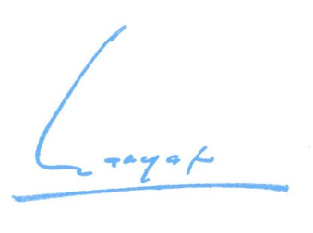
Sincerely,

Haryati Haryati
[Correponding Author]

