LAMPIRAN

- Output Statistik Menggunakan SPSS
A.1. Berat Badan
A.1.1. Data Deskriptif Berat Badan Hewan Coba
Data deskriptif berat badan hewan coba sebelum perlakuan (hewan coba telah dikondisikan menjadi obesitas) dan selama perlakuan dimana berat badan ditimbang setiap minggu sampai minggu ke-4.

Descriptives
 | Kelompok penelitian |  |  | Statistic | Std. Error
Berat badan (gr) sebelum perlakuan | X(-) | Mean |  | 226.0000 | 1.29099
 |  | 95% Confidence Interval for Mean | Lower Bound | 222.6814
 |  |  | Upper Bound | 229.3186
 |  | 5% Trimmed Mean |  | 226.0556
 |  | Median |  | 226.5000
 |  | Variance |  | 10.000
 |  | Std. Deviation |  | 3.16228
 |  | Minimum |  | 221.00
 |  | Maximum |  | 230.00
 |  | Range |  | 9.00
 |  | Interquartile Range |  | 5.25
 |  | Skewness |  | -.569 | .845
 |  | Kurtosis |  | .148 | 1.741
 | X(+) | Mean |  | 239.1667 | 1.01379
 |  | 95% Confidence Interval for Mean | Lower Bound | 236.5606
 |  |  | Upper Bound | 241.7727
 |  | 5% Trimmed Mean |  | 239.2407
 |  | Median |  | 239.5000
 |  | Variance |  | 6.167
 |  | Std. Deviation |  | 2.48328
 |  | Minimum |  | 235.00
 |  | Maximum |  | 242.00
 |  | Range |  | 7.00
 |  | Interquartile Range |  | 4.00
 |  | Skewness |  | -.871 | .845
 |  | Kurtosis |  | .735 | 1.741
 | X1 | Mean |  | 244.0000 | 1.29099
 |  | 95% Confidence Interval for Mean | Lower Bound | 240.6814
 |  |  | Upper Bound | 247.3186
 |  | 5% Trimmed Mean |  | 243.9444
 |  | Median |  | 243.5000
 |  | Variance |  | 10.000
 |  | Std. Deviation |  | 3.16228
 |  | Minimum |  | 240.00
 |  | Maximum |  | 249.00
 |  | Range |  | 9.00
 |  | Interquartile Range |  | 5.25
 |  | Skewness |  | .569 | .845
 |  | Kurtosis |  | .148 | 1.741
 | X2 | Mean |  | 244.6667 | 1.45297
 |  | 95% Confidence Interval for Mean | Lower Bound | 240.9317
 |  |  | Upper Bound | 248.4016
 |  | 5% Trimmed Mean |  | 244.5741
 |  | Median |  | 243.5000
 |  | Variance |  | 12.667
 |  | Std. Deviation |  | 3.55903
 |  | Minimum |  | 241.00
 |  | Maximum |  | 250.00
 |  | Range |  | 9.00
 |  | Interquartile Range |  | 6.75
 |  | Skewness |  | .769 | .845
 |  | Kurtosis |  | -1.138 | 1.741
 | X3 | Mean |  | 241.1667 | 1.13774
 |  | 95% Confidence Interval for Mean | Lower Bound | 238.2420
 |  |  | Upper Bound | 244.0913
 |  | 5% Trimmed Mean |  | 241.1296
 |  | Median |  | 240.5000
 |  | Variance |  | 7.767
 |  | Std. Deviation |  | 2.78687
 |  | Minimum |  | 238.00
 |  | Maximum |  | 245.00
 |  | Range |  | 7.00
 |  | Interquartile Range |  | 5.50
 |  | Skewness |  | .493 | .845
 |  | Kurtosis |  | -1.552 | 1.741
 | X4 | Mean |  | 238.8333 | 1.85143
 |  | 95% Confidence Interval for Mean | Lower Bound | 234.0741
 |  |  | Upper Bound | 243.5926
 |  | 5% Trimmed Mean |  | 238.9815
 |  | Median |  | 239.5000
 |  | Variance |  | 20.567
 |  | Std. Deviation |  | 4.53505
 |  | Minimum |  | 231.00
 |  | Maximum |  | 244.00
 |  | Range |  | 13.00
 |  | Interquartile Range |  | 7.00
 |  | Skewness |  | -1.015 | .845
 |  | Kurtosis |  | 1.348 | 1.741
Berat badan (gr) minggu ke-1 | X(-) | Mean |  | 232.0000 | 1.46059
 |  | 95% Confidence Interval for Mean | Lower Bound | 228.2454
 |  |  | Upper Bound | 235.7546
 |  | 5% Trimmed Mean |  | 231.8889
 |  | Median |  | 232.0000
 |  | Variance |  | 12.800
 |  | Std. Deviation |  | 3.57771
 |  | Minimum |  | 228.00
 |  | Maximum |  | 238.00
 |  | Range |  | 10.00
 |  | Interquartile Range |  | 5.50
 |  | Skewness |  | .825 | .845
 |  | Kurtosis |  | .740 | 1.741
 | X(+) | Mean |  | 251.6667 | 1.05409
 |  | 95% Confidence Interval for Mean | Lower Bound | 248.9570
 |  |  | Upper Bound | 254.3763
 |  | 5% Trimmed Mean |  | 251.6852
 |  | Median |  | 251.5000
 |  | Variance |  | 6.667
 |  | Std. Deviation |  | 2.58199
 |  | Minimum |  | 248.00
 |  | Maximum |  | 255.00
 |  | Range |  | 7.00
 |  | Interquartile Range |  | 4.75
 |  | Skewness |  | -.077 | .845
 |  | Kurtosis |  | -.867 | 1.741
 | X1 | Mean |  | 253.3333 | 1.25610
 |  | 95% Confidence Interval for Mean | Lower Bound | 250.1044
 |  |  | Upper Bound | 256.5622
 |  | 5% Trimmed Mean |  | 253.2593
 |  | Median |  | 252.5000
 |  | Variance |  | 9.467
 |  | Std. Deviation |  | 3.07679
 |  | Minimum |  | 250.00
 |  | Maximum |  | 258.00
 |  | Range |  | 8.00
 |  | Interquartile Range |  | 5.75
 |  | Skewness |  | .705 | .845
 |  | Kurtosis |  | -.930 | 1.741
 | X2 | Mean |  | 253.8333 | 1.74005
 |  | 95% Confidence Interval for Mean | Lower Bound | 249.3604
 |  |  | Upper Bound | 258.3063
 |  | 5% Trimmed Mean |  | 253.7593
 |  | Median |  | 252.5000
 |  | Variance |  | 18.167
 |  | Std. Deviation |  | 4.26224
 |  | Minimum |  | 249.00
 |  | Maximum |  | 260.00
 |  | Range |  | 11.00
 |  | Interquartile Range |  | 8.00
 |  | Skewness |  | .637 | .845
 |  | Kurtosis |  | -1.224 | 1.741
 | X3 | Mean |  | 250.5000 | 1.33542
 |  | 95% Confidence Interval for Mean | Lower Bound | 247.0672
 |  |  | Upper Bound | 253.9328
 |  | 5% Trimmed Mean |  | 250.4444
 |  | Median |  | 249.5000
 |  | Variance |  | 10.700
 |  | Std. Deviation |  | 3.27109
 |  | Minimum |  | 247.00
 |  | Maximum |  | 255.00
 |  | Range |  | 8.00
 |  | Interquartile Range |  | 6.50
 |  | Skewness |  | .617 | .845
 |  | Kurtosis |  | -1.638 | 1.741
 | X4 | Mean |  | 247.6667 | 1.87380
 |  | 95% Confidence Interval for Mean | Lower Bound | 242.8499
 |  |  | Upper Bound | 252.4834
 |  | 5% Trimmed Mean |  | 247.9074
 |  | Median |  | 249.0000
 |  | Variance |  | 21.067
 |  | Std. Deviation |  | 4.58984
 |  | Minimum |  | 239.00
 |  | Maximum |  | 252.00
 |  | Range |  | 13.00
 |  | Interquartile Range |  | 5.50
 |  | Skewness |  | -1.689 | .845
 |  | Kurtosis |  | 3.298 | 1.741
Berat badan (gr) minggu ke-2 | X(-) | Mean |  | 238.5000 | 1.56525
 |  | 95% Confidence Interval for Mean | Lower Bound | 234.4764
 |  |  | Upper Bound | 242.5236
 |  | 5% Trimmed Mean |  | 238.6111
 |  | Median |  | 239.0000
 |  | Variance |  | 14.700
 |  | Std. Deviation |  | 3.83406
 |  | Minimum |  | 232.00
 |  | Maximum |  | 243.00
 |  | Range |  | 11.00
 |  | Interquartile Range |  | 5.75
 |  | Skewness |  | -.894 | .845
 |  | Kurtosis |  | 1.020 | 1.741
 | X(+) | Mean |  | 264.8333 | 1.19490
 |  | 95% Confidence Interval for Mean | Lower Bound | 261.7618
 |  |  | Upper Bound | 267.9049
 |  | 5% Trimmed Mean |  | 264.9259
 |  | Median |  | 265.5000
 |  | Variance |  | 8.567
 |  | Std. Deviation |  | 2.92689
 |  | Minimum |  | 260.00
 |  | Maximum |  | 268.00
 |  | Range |  | 8.00
 |  | Interquartile Range |  | 5.00
 |  | Skewness |  | -.904 | .845
 |  | Kurtosis |  | .250 | 1.741
 | X1 | Mean |  | 260.6667 | 1.11555
 |  | 95% Confidence Interval for Mean | Lower Bound | 257.7991
 |  |  | Upper Bound | 263.5343
 |  | 5% Trimmed Mean |  | 260.6296
 |  | Median |  | 260.5000
 |  | Variance |  | 7.467
 |  | Std. Deviation |  | 2.73252
 |  | Minimum |  | 257.00
 |  | Maximum |  | 265.00
 |  | Range |  | 8.00
 |  | Interquartile Range |  | 4.25
 |  | Skewness |  | .435 | .845
 |  | Kurtosis |  | .586 | 1.741
 | X2 | Mean |  | 261.6667 | 1.42984
 |  | 95% Confidence Interval for Mean | Lower Bound | 257.9911
 |  |  | Upper Bound | 265.3422
 |  | 5% Trimmed Mean |  | 261.6296
 |  | Median |  | 260.5000
 |  | Variance |  | 12.267
 |  | Std. Deviation |  | 3.50238
 |  | Minimum |  | 258.00
 |  | Maximum |  | 266.00
 |  | Range |  | 8.00
 |  | Interquartile Range |  | 7.25
 |  | Skewness |  | .625 | .845
 |  | Kurtosis |  | -1.856 | 1.741
 | X3 | Mean |  | 257.5000 | 1.11803
 |  | 95% Confidence Interval for Mean | Lower Bound | 254.6260
 |  |  | Upper Bound | 260.3740
 |  | 5% Trimmed Mean |  | 257.5000
 |  | Median |  | 257.5000
 |  | Variance |  | 7.500
 |  | Std. Deviation |  | 2.73861
 |  | Minimum |  | 254.00
 |  | Maximum |  | 261.00
 |  | Range |  | 7.00
 |  | Interquartile Range |  | 5.50
 |  | Skewness |  | .000 | .845
 |  | Kurtosis |  | -1.541 | 1.741
 | X4 | Mean |  | 254.8333 | 1.66166
 |  | 95% Confidence Interval for Mean | Lower Bound | 250.5619
 |  |  | Upper Bound | 259.1048
 |  | 5% Trimmed Mean |  | 254.9259
 |  | Median |  | 255.5000
 |  | Variance |  | 16.567
 |  | Std. Deviation |  | 4.07022
 |  | Minimum |  | 248.00
 |  | Maximum |  | 260.00
 |  | Range |  | 12.00
 |  | Interquartile Range |  | 6.00
 |  | Skewness |  | -.781 | .845
 |  | Kurtosis |  | 1.218 | 1.741
Berat badan (gr) minggu ke-3 | X(-) | Mean |  | 244.1667 | 1.42400
 |  | 95% Confidence Interval for Mean | Lower Bound | 240.5062
 |  |  | Upper Bound | 247.8272
 |  | 5% Trimmed Mean |  | 244.1296
 |  | Median |  | 244.0000
 |  | Variance |  | 12.167
 |  | Std. Deviation |  | 3.48807
 |  | Minimum |  | 240.00
 |  | Maximum |  | 249.00
 |  | Range |  | 9.00
 |  | Interquartile Range |  | 6.75
 |  | Skewness |  | .216 | .845
 |  | Kurtosis |  | -1.453 | 1.741
 | X(+) | Mean |  | 279.5000 | .76376
 |  | 95% Confidence Interval for Mean | Lower Bound | 277.5367
 |  |  | Upper Bound | 281.4633
 |  | 5% Trimmed Mean |  | 279.5000
 |  | Median |  | 279.5000
 |  | Variance |  | 3.500
 |  | Std. Deviation |  | 1.87083
 |  | Minimum |  | 277.00
 |  | Maximum |  | 282.00
 |  | Range |  | 5.00
 |  | Interquartile Range |  | 3.50
 |  | Skewness |  | .000 | .845
 |  | Kurtosis |  | -1.200 | 1.741
 | X1 | Mean |  | 269.1667 | 1.53659
 |  | 95% Confidence Interval for Mean | Lower Bound | 265.2167
 |  |  | Upper Bound | 273.1166
 |  | 5% Trimmed Mean |  | 269.1296
 |  | Median |  | 269.0000
 |  | Variance |  | 14.167
 |  | Std. Deviation |  | 3.76386
 |  | Minimum |  | 264.00
 |  | Maximum |  | 275.00
 |  | Range |  | 11.00
 |  | Interquartile Range |  | 5.75
 |  | Skewness |  | .313 | .845
 |  | Kurtosis |  | .398 | 1.741
 | X2 | Mean |  | 269.6667 | 1.58465
 |  | 95% Confidence Interval for Mean | Lower Bound | 265.5932
 |  |  | Upper Bound | 273.7401
 |  | 5% Trimmed Mean |  | 269.5185
 |  | Median |  | 269.0000
 |  | Variance |  | 15.067
 |  | Std. Deviation |  | 3.88158
 |  | Minimum |  | 266.00
 |  | Maximum |  | 276.00
 |  | Range |  | 10.00
 |  | Interquartile Range |  | 7.00
 |  | Skewness |  | .839 | .845
 |  | Kurtosis |  | -.059 | 1.741
 | X3 | Mean |  | 264.8333 | 1.30171
 |  | 95% Confidence Interval for Mean | Lower Bound | 261.4872
 |  |  | Upper Bound | 268.1795
 |  | 5% Trimmed Mean |  | 264.8148
 |  | Median |  | 264.5000
 |  | Variance |  | 10.167
 |  | Std. Deviation |  | 3.18852
 |  | Minimum |  | 261.00
 |  | Maximum |  | 269.00
 |  | Range |  | 8.00
 |  | Interquartile Range |  | 6.50
 |  | Skewness |  | .226 | .845
 |  | Kurtosis |  | -1.626 | 1.741
 | X4 | Mean |  | 262.1667 | 1.88709
 |  | 95% Confidence Interval for Mean | Lower Bound | 257.3157
 |  |  | Upper Bound | 267.0176
 |  | 5% Trimmed Mean |  | 262.2407
 |  | Median |  | 262.0000
 |  | Variance |  | 21.367
 |  | Std. Deviation |  | 4.62241
 |  | Minimum |  | 255.00
 |  | Maximum |  | 268.00
 |  | Range |  | 13.00
 |  | Interquartile Range |  | 7.75
 |  | Skewness |  | -.378 | .845
 |  | Kurtosis |  | -.061 | 1.741
Berat badan (gr) mimnggu ke-4 | X(-) | Mean |  | 250.3333 | 1.40633
 |  | 95% Confidence Interval for Mean | Lower Bound | 246.7182
 |  |  | Upper Bound | 253.9484
 |  | 5% Trimmed Mean |  | 250.3148
 |  | Median |  | 250.5000
 |  | Variance |  | 11.867
 |  | Std. Deviation |  | 3.44480
 |  | Minimum |  | 246.00
 |  | Maximum |  | 255.00
 |  | Range |  | 9.00
 |  | Interquartile Range |  | 6.75
 |  | Skewness |  | .018 | .845
 |  | Kurtosis |  | -1.274 | 1.741
 | X(+) | Mean |  | 292.6667 | .88192
 |  | 95% Confidence Interval for Mean | Lower Bound | 290.3996
 |  |  | Upper Bound | 294.9337
 |  | 5% Trimmed Mean |  | 292.6296
 |  | Median |  | 292.5000
 |  | Variance |  | 4.667
 |  | Std. Deviation |  | 2.16025
 |  | Minimum |  | 290.00
 |  | Maximum |  | 296.00
 |  | Range |  | 6.00
 |  | Interquartile Range |  | 3.75
 |  | Skewness |  | .463 | .845
 |  | Kurtosis |  | -.300 | 1.741
 | X1 | Mean |  | 277.1667 | 1.51474
 |  | 95% Confidence Interval for Mean | Lower Bound | 273.2729
 |  |  | Upper Bound | 281.0604
 |  | 5% Trimmed Mean |  | 277.1852
 |  | Median |  | 277.5000
 |  | Variance |  | 13.767
 |  | Std. Deviation |  | 3.71035
 |  | Minimum |  | 272.00
 |  | Maximum |  | 282.00
 |  | Range |  | 10.00
 |  | Interquartile Range |  | 7.00
 |  | Skewness |  | -.196 | .845
 |  | Kurtosis |  | -.991 | 1.741
 | X2 | Mean |  | 277.6667 | 1.45297
 |  | 95% Confidence Interval for Mean | Lower Bound | 273.9317
 |  |  | Upper Bound | 281.4016
 |  | 5% Trimmed Mean |  | 277.5741
 |  | Median |  | 276.5000
 |  | Variance |  | 12.667
 |  | Std. Deviation |  | 3.55903
 |  | Minimum |  | 274.00
 |  | Maximum |  | 283.00
 |  | Range |  | 9.00
 |  | Interquartile Range |  | 6.75
 |  | Skewness |  | .769 | .845
 |  | Kurtosis |  | -1.138 | 1.741
 | X3 | Mean |  | 273.8333 | 1.30171
 |  | 95% Confidence Interval for Mean | Lower Bound | 270.4872
 |  |  | Upper Bound | 277.1795
 |  | 5% Trimmed Mean |  | 273.8148
 |  | Median |  | 273.5000
 |  | Variance |  | 10.167
 |  | Std. Deviation |  | 3.18852
 |  | Minimum |  | 270.00
 |  | Maximum |  | 278.00
 |  | Range |  | 8.00
 |  | Interquartile Range |  | 6.50
 |  | Skewness |  | .226 | .845
 |  | Kurtosis |  | -1.626 | 1.741
 | X4 | Mean |  | 270.1667 | 2.08833
 |  | 95% Confidence Interval for Mean | Lower Bound | 264.7985
 |  |  | Upper Bound | 275.5349
 |  | 5% Trimmed Mean |  | 270.1852
 |  | Median |  | 269.0000
 |  | Variance |  | 26.167
 |  | Std. Deviation |  | 5.11534
 |  | Minimum |  | 263.00
 |  | Maximum |  | 277.00
 |  | Range |  | 14.00
 |  | Interquartile Range |  | 8.75
 |  | Skewness |  | .098 | .845
 |  | Kurtosis |  | -.721 | 1.741

A.1.2. Uji Normalitas Berat Badan Hewan Coba
Karena jumlah hewan coba kecil <50 dan data berskala interval, maka uji normalitas yang digunakan adalah Shapiro-Wilk. Data berdistribusi normal jika signifikansi p>0,05.

Tests of Normality
 | Kelompok penelitian | Kolmogorov-Smirnovª |  |  | Shapiro-Wilk
 |  | Statistic | df | Sig. | Statistic | df | Sig.
Berat badan (gr) sebelum perlakuan | X(-) | .167 | 6 | .200* | .979 | 6 | .949
 | X(+) | .153 | 6 | .200* | .957 | 6 | .794
 | X1 | .167 | 6 | .200* | .979 | 6 | .949
 | X2 | .241 | 6 | .200* | .902 | 6 | .387
 | X3 | .191 | 6 | .200* | .925 | 6 | .540
 | X4 | .181 | 6 | .200* | .944 | 6 | .688
Berat badan (gr) minggu ke-1 | X(-) | .223 | 6 | .200* | .933 | 6 | .607
 | X(+) | .150 | 6 | .200* | .979 | 6 | .945
 | X1 | .210 | 6 | .200* | .930 | 6 | .582
 | X2 | .244 | 6 | .200* | .917 | 6 | .483
 | X3 | .227 | 6 | .200* | .894 | 6 | .340
 | X4 | .276 | 6 | .173 | .835 | 6 | .118
Berat badan (gr) minggu ke-2 | X(-) | .181 | 6 | .200* | .954 | 6 | .769
 | X(+) | .189 | 6 | .200* | .943 | 6 | .682
 | X1 | .146 | 6 | .200* | .988 | 6 | .985
 | X2 | .242 | 6 | .200* | .845 | 6 | .142
 | X3 | .153 | 6 | .200* | .958 | 6 | .801
 | X4 | .183 | 6 | .200* | .962 | 6 | .835
Berat badan (gr) minggu ke-3 | X(-) | .151 | 6 | .200* | .961 | 6 | .830
 | X(+) | .122 | 6 | .200* | .982 | 6 | .961
 | X1 | .146 | 6 | .200* | .990 | 6 | .988
 | X2 | .172 | 6 | .200* | .912 | 6 | .452
 | X3 | .173 | 6 | .200* | .941 | 6 | .667
 | X4 | .153 | 6 | .200* | .978 | 6 | .939
Berat badan (gr) mimnggu ke-4 | X(-) | .167 | 6 | .200* | .963 | 6 | .843
 | X(+) | .121 | 6 | .200* | .983 | 6 | .964
 | X1 | .149 | 6 | .200* | .977 | 6 | .938
 | X2 | .241 | 6 | .200* | .902 | 6 | .387
 | X3 | .173 | 6 | .200* | .941 | 6 | .667
 | X4 | .180 | 6 | .200* | .949 | 6 | .733
*. This is a lower bound of the true significance.
a. Lilliefors Significance Correction

Hasil uji normalitas menunjukkan semua data berat badan hewan coba terdistribusi normal, p>0,05. Karena variabel data lebih dari 2 kelompok dan data berpasangan, maka digunakan uji lanjut repeated measures ANOVA untuk melihat perbandingan antar kelompok.

A.1.3. Uji lanjut Repeated Measures ANOVA Berat Badan Hewan Coba
Variabel berat badan di kelompokkan menjadi 5 variabel sebagai berikut:

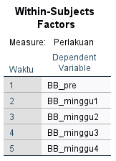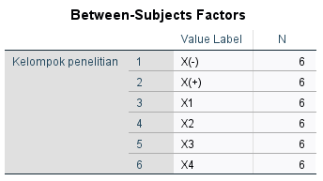

Kemudian kesamaan varian data penelitian dilihat melalui uji Sphericity. Jika p>0,05, maka data dinilai homogen (memenuhi asumsi kesamaan varian).
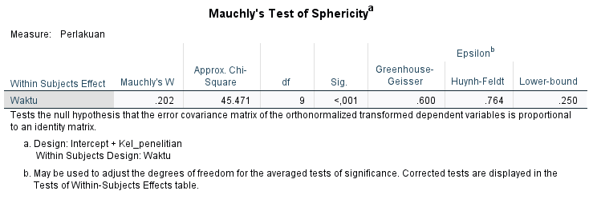

Hasil output uji Sphericity menunjukkan p <0,05, data dinilai tidak homogen (tidak memenuhi asumsi kesamaan varian). Maka nilai signifikansi selanjutnya mengacu pada nilai Greenhouse-Geisser. Jika p <0,05, maka data dinilai signifikan.

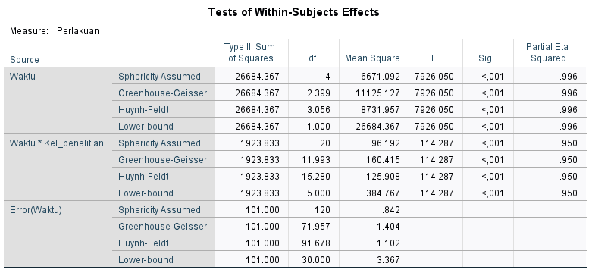

Nilai signifikansi pada kolom Greenhouse-Geisser menunjukkan p<0,05, sehingga data dinilai signifikan. Terdapat perbedaan penurunan berat badan hewan coba yang signifikan dari waktu ke waktu. Adapun nilai signifikansi Greenhouse-Geisser penelitian secara detail ditampilkan sebagai berikut;

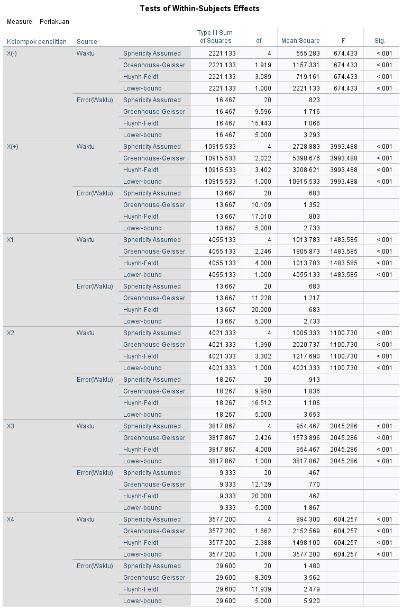

Hasil repeated measure ANOVA pada kolom Greenhouse-Geisser menunjukkan semua data signifikan p<0,05. Informasi mengenai rata-rata perubahan berat badan untuk setiap pengukuran dari waktu ke waktu menggunakan uji Post Hoc Bonferroni. Hasil uji ditunjukkan pada tabel Pairwise Comparisons.
Pairwise Comparisons
Measure: Perlakuan
Bonferroni
Kelompok penelitian | (I) Waktu | (J) Waktu | Mean Difference (I-J) | Std. Error | Sig.^{b} | 95% Confidence Interval for Difference^{b}
 |  |  |  |  |  | Lower Bound | Upper Bound
X(-) | 1 | 2 | -6.000* | .516 | .001 | -8.465 | -3.535
 |  | 3 | -12.500* | .342 | .000 | -14.130 | -10.870
 |  | 4 | -18.167* | .401 | .000 | -20.083 | -16.251
 |  | 5 | -24.333* | .558 | .000 | -26.996 | -21.671
 | 2 | 1 | 6.000* | .516 | .001 | 3.535 | 8.465
 |  | 3 | -6.500* | .671 | .002 | -9.702 | -3.298
 |  | 4 | -12.167* | .401 | .000 | -14.083 | -10.251
 |  | 5 | -18.333* | .494 | .000 | -20.693 | -15.973
 | 3 | 1 | 12.500* | .342 | .000 | 10.870 | 14.130
 |  | 2 | 6.500* | .671 | .002 | 3.298 | 9.702
 |  | 4 | -5.667* | .558 | .002 | -8.329 | -3.004
 |  | 5 | -11.833* | .792 | .000 | -15.615 | -8.051
 | 4 | 1 | 18.167* | .401 | .000 | 16.251 | 20.083
 |  | 2 | 12.167* | .401 | .000 | 10.251 | 14.083
 |  | 3 | 5.667* | .558 | .002 | 3.004 | 8.329
 |  | 5 | -6.167* | .307 | .000 | -7.634 | -4.700
 | 5 | 1 | 24.333* | .558 | .000 | 21.671 | 26.996
 |  | 2 | 18.333* | .494 | .000 | 15.973 | 20.693
 |  | 3 | 11.833* | .792 | .000 | 8.051 | 15.615
 |  | 4 | 6.167* | .307 | .000 | 4.700 | 7.634
X(+) | 1 | 2 | -12.500* | .342 | .000 | -14.130 | -10.870
 |  | 3 | -25.667* | .333 | .000 | -27.258 | -24.076
 |  | 4 | -40.333* | .558 | .000 | -42.996 | -37.671
 |  | 5 | -53.500* | .342 | .000 | -55.130 | -51.870
 | 2 | 1 | 12.500* | .342 | .000 | 10.870 | 14.130
 |  | 3 | -13.167* | .477 | .000 | -15.445 | -10.889
 |  | 4 | -27.833* | .543 | .000 | -30.423 | -25.243
 |  | 5 | -41.000* | .447 | .000 | -43.135 | -38.865
 | 3 | 1 | 25.667* | .333 | .000 | 24.076 | 27.258
 |  | 2 | 13.167* | .477 | .000 | 10.889 | 15.445
 |  | 4 | -14.667* | .715 | .000 | -18.079 | -11.254
 |  | 5 | -27.833* | .543 | .000 | -30.423 | -25.243
 | 4 | 1 | 40.333* | .558 | .000 | 37.671 | 42.996
 |  | 2 | 27.833* | .543 | .000 | 25.243 | 30.423
 |  | 3 | 14.667* | .715 | .000 | 11.254 | 18.079
 |  | 5 | -13.167* | .307 | .000 | -14.634 | -11.700
 | 5 | 1 | 53.500* | .342 | .000 | 51.870 | 55.130
 |  | 2 | 41.000* | .447 | .000 | 38.865 | 43.135
 |  | 3 | 27.833* | .543 | .000 | 25.243 | 30.423
 |  | 4 | 13.167* | .307 | .000 | 11.700 | 14.634
X1 | 1 | 2 | -9.333* | .333 | .000 | -10.924 | -7.742
 |  | 3 | -16.667* | .333 | .000 | -18.258 | -15.076
 |  | 4 | -25.167* | .307 | .000 | -26.634 | -23.700
 |  | 5 | -33.167* | .401 | .000 | -35.083 | -31.251
 | 2 | 1 | 9.333* | .333 | .000 | 7.742 | 10.924
 |  | 3 | -7.333* | .558 | .000 | -9.996 | -4.671
 |  | 4 | -15.833* | .601 | .000 | -18.702 | -12.965
 |  | 5 | -23.833* | .543 | .000 | -26.423 | -21.243
 | 3 | 1 | 16.667* | .333 | .000 | 15.076 | 18.258
 |  | 2 | 7.333* | .558 | .000 | 4.671 | 9.996
 |  | 4 | -8.500* | .500 | .000 | -10.887 | -6.113
 |  | 5 | -16.500* | .671 | .000 | -19.702 | -13.298
 | 4 | 1 | 25.167* | .307 | .000 | 23.700 | 26.634
 |  | 2 | 15.833* | .601 | .000 | 12.965 | 18.702
 |  | 3 | 8.500* | .500 | .000 | 6.113 | 10.887
 |  | 5 | -8.000* | .365 | .000 | -9.743 | -6.257
 | 5 | 1 | 33.167* | .401 | .000 | 31.251 | 35.083
 |  | 2 | 23.833* | .543 | .000 | 21.243 | 26.423
 |  | 3 | 16.500* | .671 | .000 | 13.298 | 19.702
 |  | 4 | 8.000* | .365 | .000 | 6.257 | 9.743
X2 | 1 | 2 | -9.167* | .401 | .000 | -11.083 | -7.251
 |  | 3 | -17.000* | .516 | .000 | -19.465 | -14.535
 |  | 4 | -25.000* | .365 | .000 | -26.743 | -23.257
 |  | 5 | -33.000* | .258 | .000 | -34.232 | -31.768
 | 2 | 1 | 9.167* | .401 | .000 | 7.251 | 11.083
 |  | 3 | -7.833* | .654 | .001 | -10.955 | -4.711
 |  | 4 | -15.833* | .601 | .000 | -18.702 | -12.965
 |  | 5 | -23.833* | .543 | .000 | -26.423 | -21.243
 | 3 | 1 | 17.000* | .516 | .000 | 14.535 | 19.465
 |  | 2 | 7.833* | .654 | .001 | 4.711 | 10.955
 |  | 4 | -8.000* | .856 | .002 | -12.088 | -3.912
 |  | 5 | -16.000* | .683 | .000 | -19.261 | -12.739
 | 4 | 1 | 25.000* | .365 | .000 | 23.257 | 26.743
 |  | 2 | 15.833* | .601 | .000 | 12.965 | 18.702
 |  | 3 | 8.000* | .856 | .002 | 3.912 | 12.088
 |  | 5 | -8.000* | .365 | .000 | -9.743 | -6.257
 | 5 | 1 | 33.000* | .258 | .000 | 31.768 | 34.232
 |  | 2 | 23.833* | .543 | .000 | 21.243 | 26.423
 |  | 3 | 16.000* | .683 | .000 | 12.739 | 19.261
 |  | 4 | 8.000* | .365 | .000 | 6.257 | 9.743
X3 | 1 | 2 | -9.333* | .422 | .000 | -11.346 | -7.321
 |  | 3 | -16.333* | .422 | .000 | -18.346 | -14.321
 |  | 4 | -23.667* | .333 | .000 | -25.258 | -22.076
 |  | 5 | -32.667* | .333 | .000 | -34.258 | -31.076
 | 2 | 1 | 9.333* | .422 | .000 | 7.321 | 11.346
 |  | 3 | -7.000* | .516 | .000 | -9.465 | -4.535
 |  | 4 | -14.333* | .494 | .000 | -16.693 | -11.973
 |  | 5 | -23.333* | .494 | .000 | -25.693 | -20.973
 | 3 | 1 | 16.333* | .422 | .000 | 14.321 | 18.346
 |  | 2 | 7.000* | .516 | .000 | 4.535 | 9.465
 |  | 4 | -7.333* | .333 | .000 | -8.924 | -5.742
 |  | 5 | -16.333* | .333 | .000 | -17.924 | -14.742
 | 4 | 1 | 23.667* | .333 | .000 | 22.076 | 25.258
 |  | 2 | 14.333* | .494 | .000 | 11.973 | 16.693
 |  | 3 | 7.333* | .333 | .000 | 5.742 | 8.924
 |  | 5 | -9.000 | .000 | . | -9.000 | -9.000
 | 5 | 1 | 32.667* | .333 | .000 | 31.076 | 34.258
 |  | 2 | 23.333* | .494 | .000 | 20.973 | 25.693
 |  | 3 | 16.333* | .333 | .000 | 14.742 | 17.924
 |  | 4 | 9.000 | .000 | . | 9.000 | 9.000
X4 | 1 | 2 | -8.833* | .401 | .000 | -10.749 | -6.917
 |  | 3 | -16.000* | .577 | .000 | -18.756 | -13.244
 |  | 4 | -23.333* | .333 | .000 | -24.924 | -21.742
 |  | 5 | -31.333* | .667 | .000 | -34.516 | -28.151
 | 2 | 1 | 8.833* | .401 | .000 | 6.917 | 10.749
 |  | 3 | -7.167* | .703 | .002 | -10.523 | -3.810
 |  | 4 | -14.500* | .671 | .000 | -17.702 | -11.298
 |  | 5 | -22.500* | .992 | .000 | -27.233 | -17.767
 | 3 | 1 | 16.000* | .577 | .000 | 13.244 | 18.756
 |  | 2 | 7.167* | .703 | .002 | 3.810 | 10.523
 |  | 4 | -7.333* | .803 | .003 | -11.165 | -3.501
 |  | 5 | -15.333* | 1.085 | .000 | -20.514 | -10.153
 | 4 | 1 | 23.333* | .333 | .000 | 21.742 | 24.924
 |  | 2 | 14.500* | .671 | .000 | 11.298 | 17.702
 |  | 3 | 7.333* | .803 | .003 | 3.501 | 11.165
 |  | 5 | -8.000* | .365 | .000 | -9.743 | -6.257
 | 5 | 1 | 31.333* | .667 | .000 | 28.151 | 34.516
 |  | 2 | 22.500* | .992 | .000 | 17.767 | 27.233
 |  | 3 | 15.333* | 1.085 | .000 | 10.153 | 20.514
 |  | 4 | 8.000* | .365 | .000 | 6.257 | 9.743
Based on estimated marginal means
*. The mean difference is significant at the ,05 level.
b. Adjustment for multiple comparisons: Bonferroni.

Berdasarkan tabel Pairwise Comparisons Bonferroni, data semua kelompok perlakuan ternilai signifikan.

A.1.4. Uji Lanjut Paired t Test Berat Badan Hewan Coba Sebelum dan Sesudah Pemberian Tepung Tempe

Descriptives
 | Kelompok penelitian |  |  | Statistic | Std. Error
Delta_BB | X(-) | Mean |  | 24.3333 | .55777
 |  | 95% Confidence Interval for Mean | Lower Bound | 22.8995
 |  |  | Upper Bound | 25.7671
 |  | 5% Trimmed Mean |  | 24.3704
 |  | Median |  | 24.5000
 |  | Variance |  | 1.867
 |  | Std. Deviation |  | 1.36626
 |  | Minimum |  | 22.00
 |  | Maximum |  | 26.00
 |  | Range |  | 4.00
 |  | Interquartile Range |  | 1.75
 |  | Skewness |  | -.889 | .845
 |  | Kurtosis |  | 1.339 | 1.741
 | X(+) | Mean |  | 53.5000 | .34157
 |  | 95% Confidence Interval for Mean | Lower Bound | 52.6220
 |  |  | Upper Bound | 54.3780
 |  | 5% Trimmed Mean |  | 53.4444
 |  | Median |  | 53.0000
 |  | Variance |  | .700
 |  | Std. Deviation |  | .83666
 |  | Minimum |  | 53.00
 |  | Maximum |  | 55.00
 |  | Range |  | 2.00
 |  | Interquartile Range |  | 1.25
 |  | Skewness |  | 1.537 | .845
 |  | Kurtosis |  | 1.429 | 1.741
 | X1 | Mean |  | 33.1667 | .40139
 |  | 95% Confidence Interval for Mean | Lower Bound | 32.1349
 |  |  | Upper Bound | 34.1985
 |  | 5% Trimmed Mean |  | 33.1852
 |  | Median |  | 33.5000
 |  | Variance |  | .967
 |  | Std. Deviation |  | .98319
 |  | Minimum |  | 32.00
 |  | Maximum |  | 34.00
 |  | Range |  | 2.00
 |  | Interquartile Range |  | 2.00
 |  | Skewness |  | -.456 | .845
 |  | Kurtosis |  | -2.390 | 1.741
 | X2 | Mean |  | 33.0000 | .25820
 |  | 95% Confidence Interval for Mean | Lower Bound | 32.3363
 |  |  | Upper Bound | 33.6637
 |  | 5% Trimmed Mean |  | 33.0000
 |  | Median |  | 33.0000
 |  | Variance |  | .400
 |  | Std. Deviation |  | .63246
 |  | Minimum |  | 32.00
 |  | Maximum |  | 34.00
 |  | Range |  | 2.00
 |  | Interquartile Range |  | .50
 |  | Skewness |  | .000 | .845
 |  | Kurtosis |  | 2.500 | 1.741
 | X3 | Mean |  | 32.6667 | .33333
 |  | 95% Confidence Interval for Mean | Lower Bound | 31.8098
 |  |  | Upper Bound | 33.5235
 |  | 5% Trimmed Mean |  | 32.6296
 |  | Median |  | 32.5000
 |  | Variance |  | .667
 |  | Std. Deviation |  | .81650
 |  | Minimum |  | 32.00
 |  | Maximum |  | 34.00
 |  | Range |  | 2.00
 |  | Interquartile Range |  | 1.25
 |  | Skewness |  | .857 | .845
 |  | Kurtosis |  | -.300 | 1.741
 | X4 | Mean |  | 31.3333 | .66667
 |  | 95% Confidence Interval for Mean | Lower Bound | 29.6196
 |  |  | Upper Bound | 33.0471
 |  | 5% Trimmed Mean |  | 31.3704
 |  | Median |  | 31.5000
 |  | Variance |  | 2.667
 |  | Std. Deviation |  | 1.63299
 |  | Minimum |  | 29.00
 |  | Maximum |  | 33.00
 |  | Range |  | 4.00
 |  | Interquartile Range |  | 3.25
 |  | Skewness |  | -.383 | .845
 |  | Kurtosis |  | -1.481 | 1.741

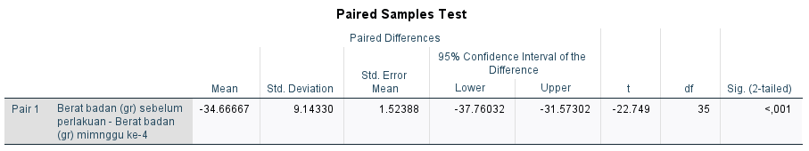

Hasil uji paired t test menunjukkan signifikansi p<0,05, maka data dinilai signifikan.
A.1.5. Uji Normalitas Delta BB minggu ke-0 dan BB minggu ke-4
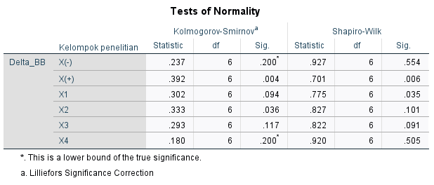
Pada kelompok X+, data tidak terdistribusi normal karena signifikansi p<0,05. Maka uji menggunakan Kruskall Wallis dan dilanjutkan dengan uji Mann Whitney.

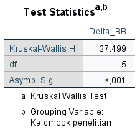
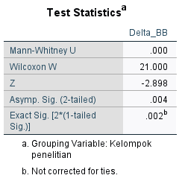

A.2. Lee Index
A.2.1. Data Deskriptif Lee Index Hewan Coba
Data deskriptif Lee-Index hewan coba setelah perlakuan minggu ke-4.

Descriptives
 | Kelompok penelitian |  |  | Statistic | Std. Error
Lee index >300 setelah perlakuan minggu ke-4 | X(-) | Mean |  | 289.2000 | 1.13957
 |  | 95% Confidence Interval for Mean | Lower Bound | 286.2706
 |  |  | Upper Bound | 292.1294
 |  | 5% Trimmed Mean |  | 289.1661
 |  | Median |  | 288.8850
 |  | Variance |  | 7.792
 |  | Std. Deviation |  | 2.79137
 |  | Minimum |  | 286.24
 |  | Maximum |  | 292.77
 |  | Range |  | 6.53
 |  | Interquartile Range |  | 5.29
 |  | Skewness |  | .204 | .845
 |  | Kurtosis |  | -2.473 | 1.741
 | X(+) | Mean |  | 347.3750 | .90680
 |  | 95% Confidence Interval for Mean | Lower Bound | 345.0440
 |  |  | Upper Bound | 349.7060
 |  | 5% Trimmed Mean |  | 347.3467
 |  | Median |  | 347.3300
 |  | Variance |  | 4.934
 |  | Std. Deviation |  | 2.22119
 |  | Minimum |  | 344.24
 |  | Maximum |  | 351.02
 |  | Range |  | 6.78
 |  | Interquartile Range |  | 2.96
 |  | Skewness |  | .457 | .845
 |  | Kurtosis |  | 1.644 | 1.741
 | X1 | Mean |  | 307.9450 | 1.06345
 |  | 95% Confidence Interval for Mean | Lower Bound | 305.2113
 |  |  | Upper Bound | 310.6787
 |  | 5% Trimmed Mean |  | 308.0039
 |  | Median |  | 308.3950
 |  | Variance |  | 6.786
 |  | Std. Deviation |  | 2.60491
 |  | Minimum |  | 303.90
 |  | Maximum |  | 310.93
 |  | Range |  | 7.03
 |  | Interquartile Range |  | 4.79
 |  | Skewness |  | -.635 | .845
 |  | Kurtosis |  | -.455 | 1.741
 | X2 | Mean |  | 303.1367 | 1.53576
 |  | 95% Confidence Interval for Mean | Lower Bound | 299.1889
 |  |  | Upper Bound | 307.0845
 |  | 5% Trimmed Mean |  | 303.2230
 |  | Median |  | 303.6050
 |  | Variance |  | 14.151
 |  | Std. Deviation |  | 3.76183
 |  | Minimum |  | 297.21
 |  | Maximum |  | 307.51
 |  | Range |  | 10.30
 |  | Interquartile Range |  | 6.69
 |  | Skewness |  | -.615 | .845
 |  | Kurtosis |  | -.226 | 1.741
 | X3 | Mean |  | 295.8883 | .74045
 |  | 95% Confidence Interval for Mean | Lower Bound | 293.9850
 |  |  | Upper Bound | 297.7917
 |  | 5% Trimmed Mean |  | 295.8870
 |  | Median |  | 295.5850
 |  | Variance |  | 3.290
 |  | Std. Deviation |  | 1.81372
 |  | Minimum |  | 293.79
 |  | Maximum |  | 298.01
 |  | Range |  | 4.22
 |  | Interquartile Range |  | 3.49
 |  | Skewness |  | .158 | .845
 |  | Kurtosis |  | -2.428 | 1.741
 | X4 | Mean |  | 306.5133 | 1.83329
 |  | 95% Confidence Interval for Mean | Lower Bound | 301.8007
 |  |  | Upper Bound | 311.2259
 |  | 5% Trimmed Mean |  | 306.5731
 |  | Median |  | 306.8150
 |  | Variance |  | 20.166
 |  | Std. Deviation |  | 4.49062
 |  | Minimum |  | 300.20
 |  | Maximum |  | 311.75
 |  | Range |  | 11.55
 |  | Interquartile Range |  | 7.48
 |  | Skewness |  | -.270 | .845
 |  | Kurtosis |  | -1.713 | 1.741

A.2.2. Uji Normalitas Lee Index Hewan Coba
Karena jumlah hewan coba kecil <50 dan data berskala interval, maka uji normalitas yang digunakan adalah Shapiro-Wilk. Data berdistribusi normal jika signifikansi p>0,05.
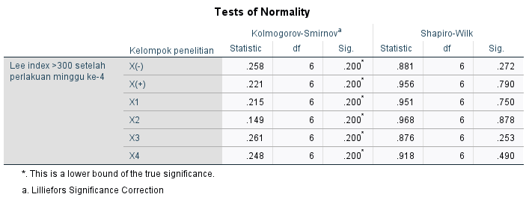

Hasil uji normalitas menunjukkan semua data Lee Index hewan coba terdistribusi normal, p>0,05. Karena variabel data lebih dari 2 kelompok dan data tidak berpasangan, maka digunakan uji lanjut one way ANOVA untuk melihat perbandingan antar kelompok.

A.2.3. Uji lanjut one way ANOVA Lee Index Hewan Coba
Sebelum uji one way ANOVA dilakukan, kesamaan varian data penelitian dilihat melalui uji Sphericity. Jika p>0,05, maka data dinilai homogen (memenuhi asumsi kesamaan varian).

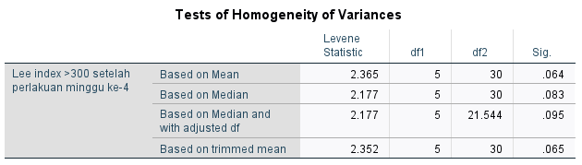

Hasil output uji Sphericity menunjukkan p>0,05, data dinilai homogen (memenuhi asumsi kesamaan varian). Maka dilakukan uji one way ANOVA dengan uji lanjut Post Hoc Bonferroni. Jika p <0,05, maka data dinilai signifikan.

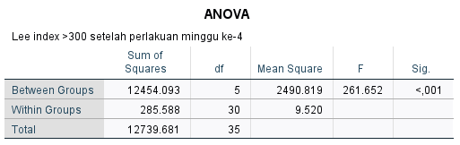

Hasil tabel one way ANOVA diatas menunjukkan data Lee-Index signifikan p<0,05. Informasi mengenai rata-rata perbandingan Lee Index kelompok menggunakan uji Post Hoc Bonferroni. Hasil uji ditunjukkan pada tabel Multiple Comparisons.

Multiple Comparisons
Dependent Variable: Lee index >300 setelah perlakuan minggu ke-4
Bonferroni
(I) Kelompok penelitian | (J) Kelompok penelitian | Mean Difference (I-J) | Std. Error | Sig. | 95% Confidence Interval
 |  |  |  |  | Lower Bound | Upper Bound
X(-) | X(+) | -58.17500* | 1.78135 | .000 | -63.8554 | -52.4946
 | X1 | -18.74500* | 1.78135 | .000 | -24.4254 | -13.0646
 | X2 | -13.93667* | 1.78135 | .000 | -19.6170 | -8.2563
 | X3 | -6.68833* | 1.78135 | .011 | -12.3687 | -1.0080
 | X4 | -17.31333* | 1.78135 | .000 | -22.9937 | -11.6330
X(+) | X(-) | 58.17500* | 1.78135 | .000 | 52.4946 | 63.8554
 | X1 | 39.43000* | 1.78135 | .000 | 33.7496 | 45.1104
 | X2 | 44.23833* | 1.78135 | .000 | 38.5580 | 49.9187
 | X3 | 51.48667* | 1.78135 | .000 | 45.8063 | 57.1670
 | X4 | 40.86167* | 1.78135 | .000 | 35.1813 | 46.5420
X1 | X(-) | 18.74500* | 1.78135 | .000 | 13.0646 | 24.4254
 | X(+) | -39.43000* | 1.78135 | .000 | -45.1104 | -33.7496
 | X2 | 4.80833 | 1.78135 | .170 | -.8720 | 10.4887
 | X3 | 12.05667* | 1.78135 | .000 | 6.3763 | 17.7370
 | X4 | 1.43167 | 1.78135 | 1.000 | -4.2487 | 7.1120
X2 | X(-) | 13.93667* | 1.78135 | .000 | 8.2563 | 19.6170
 | X(+) | -44.23833* | 1.78135 | .000 | -49.9187 | -38.5580
 | X1 | -4.80833 | 1.78135 | .170 | -10.4887 | .8720
 | X3 | 7.24833* | 1.78135 | .005 | 1.5680 | 12.9287
 | X4 | -3.37667 | 1.78135 | 1.000 | -9.0570 | 2.3037
X3 | X(-) | 6.68833* | 1.78135 | .011 | 1.0080 | 12.3687
 | X(+) | -51.48667* | 1.78135 | .000 | -57.1670 | -45.8063
 | X1 | -12.05667* | 1.78135 | .000 | -17.7370 | -6.3763
 | X2 | -7.24833* | 1.78135 | .005 | -12.9287 | -1.5680
 | X4 | -10.62500* | 1.78135 | .000 | -16.3054 | -4.9446
X4 | X(-) | 17.31333* | 1.78135 | .000 | 11.6330 | 22.9937
 | X(+) | -40.86167* | 1.78135 | .000 | -46.5420 | -35.1813
 | X1 | -1.43167 | 1.78135 | 1.000 | -7.1120 | 4.2487
 | X2 | 3.37667 | 1.78135 | 1.000 | -2.3037 | 9.0570
 | X3 | 10.62500* | 1.78135 | .000 | 4.9446 | 16.3054
*. The mean difference is significant at the 0.05 level.

Berdasarkan tabel Multiple Comparisons Bonferroni, data semua kelompok perlakuan ternilai signifikan kecuali antar kelompok X1 dengan X2; X1 dengan X4; X2 dengan X4.

A.3. hs-CRP (C- Reactive Protein)
A.3.1. Data Deskriptif hs-CRP Hewan Coba
Data deskriptif hs-CRP hewan coba setelah perlakuan minggu ke-4.

Descriptives
 | Kelompok penelitian |  |  | Statistic | Std. Error
hs-CRP (pg/ml) | X(-) | Mean |  | 2.9950 | .05110
 |  | 95% Confidence Interval for Mean | Lower Bound | 2.8636
 |  |  | Upper Bound | 3.1264
 |  | 5% Trimmed Mean |  | 2.9928
 |  | Median |  | 3.0000
 |  | Variance |  | .016
 |  | Std. Deviation |  | .12518
 |  | Minimum |  | 2.85
 |  | Maximum |  | 3.18
 |  | Range |  | .33
 |  | Interquartile Range |  | .23
 |  | Skewness |  | .272 | .845
 |  | Kurtosis |  | -.859 | 1.741
 | X(+) | Mean |  | 17.4517 | .34216
 |  | 95% Confidence Interval for Mean | Lower Bound | 16.5721
 |  |  | Upper Bound | 18.3312
 |  | 5% Trimmed Mean |  | 17.4457
 |  | Median |  | 17.4000
 |  | Variance |  | .702
 |  | Std. Deviation |  | .83813
 |  | Minimum |  | 16.49
 |  | Maximum |  | 18.52
 |  | Range |  | 2.03
 |  | Interquartile Range |  | 1.56
 |  | Skewness |  | .129 | .845
 |  | Kurtosis |  | -2.346 | 1.741
 | X1 | Mean |  | 7.7833 | .17966
 |  | 95% Confidence Interval for Mean | Lower Bound | 7.3215
 |  |  | Upper Bound | 8.2452
 |  | 5% Trimmed Mean |  | 7.7859
 |  | Median |  | 7.8200
 |  | Variance |  | .194
 |  | Std. Deviation |  | .44008
 |  | Minimum |  | 7.30
 |  | Maximum |  | 8.22
 |  | Range |  | .92
 |  | Interquartile Range |  | .84
 |  | Skewness |  | -.072 | .845
 |  | Kurtosis |  | -3.069 | 1.741
 | X2 | Mean |  | 5.0650 | .09858
 |  | 95% Confidence Interval for Mean | Lower Bound | 4.8116
 |  |  | Upper Bound | 5.3184
 |  | 5% Trimmed Mean |  | 5.0583
 |  | Median |  | 5.0800
 |  | Variance |  | .058
 |  | Std. Deviation |  | .24147
 |  | Minimum |  | 4.78
 |  | Maximum |  | 5.47
 |  | Range |  | .69
 |  | Interquartile Range |  | .37
 |  | Skewness |  | .743 | .845
 |  | Kurtosis |  | 1.013 | 1.741
 | X3 | Mean |  | 3.9850 | .12826
 |  | 95% Confidence Interval for Mean | Lower Bound | 3.6553
 |  |  | Upper Bound | 4.3147
 |  | 5% Trimmed Mean |  | 3.9911
 |  | Median |  | 4.0900
 |  | Variance |  | .099
 |  | Std. Deviation |  | .31418
 |  | Minimum |  | 3.56
 |  | Maximum |  | 4.30
 |  | Range |  | .74
 |  | Interquartile Range |  | .61
 |  | Skewness |  | -.582 | .845
 |  | Kurtosis |  | -1.921 | 1.741
 | X4 | Mean |  | 4.2433 | .16964
 |  | 95% Confidence Interval for Mean | Lower Bound | 3.8073
 |  |  | Upper Bound | 4.6794
 |  | 5% Trimmed Mean |  | 4.2420
 |  | Median |  | 4.1800
 |  | Variance |  | .173
 |  | Std. Deviation |  | .41553
 |  | Minimum |  | 3.69
 |  | Maximum |  | 4.82
 |  | Range |  | 1.13
 |  | Interquartile Range |  | .76
 |  | Skewness |  | .211 | .845
 |  | Kurtosis |  | -.905 | 1.741

A.3.2. Uji Normalitas hs-CRP Hewan Coba
Karena jumlah hewan coba kecil <50 dan data berskala interval, maka uji normalitas yang digunakan adalah Shapiro-Wilk. Data berdistribusi normal jika signifikansi p>0,05.
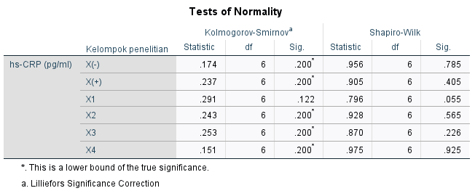

Hasil uji normalitas menunjukkan semua data hs-CRP hewan coba terdistribusi normal, p>0,05. Karena variabel data lebih dari 2 kelompok dan data tidak berpasangan, maka digunakan uji lanjut one way ANOVA untuk melihat perbandingan antar kelompok.

A.3.3. Uji lanjut one way ANOVA hs-CRP Hewan Coba
Sebelum uji one way ANOVA dilakukan, kesamaan varian data penelitian dilihat melalui uji Sphericity. Jika p>0,05, maka data dinilai homogen (memenuhi asumsi kesamaan varian).

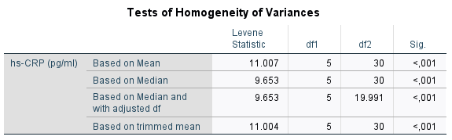

Hasil output uji Sphericity menunjukkan p <0,05, data dinilai tidak homogen (tidak memenuhi asumsi kesamaan varian). Maka uji one way ANOVA masih bisa digunakan dengan uji lanjut Games Howell karena data terdistribusi normal. Jika p <0,05, maka data dinilai signifikan.

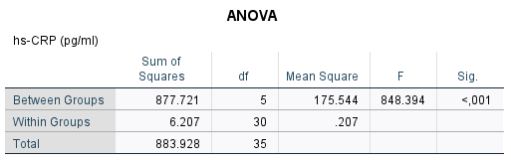

Hasil tabel one way ANOVA diatas menunjukkan data hs-CRP signifikan p<0,05 pada semua kelompok. Informasi mengenai rata-rata perbandingan kelompok menggunakan uji Post Hoc Games Howell. Hasil uji ditunjukkan pada tabel Multiple Comparisons.

Multiple Comparisons
Dependent Variable: hs-CRP (pg/ml)
Games-Howell
(I) Kelompok penelitian | (J) Kelompok penelitian | Mean Difference (I-J) | Std. Error | Sig. | 95% Confidence Interval
 |  |  |  |  | Lower Bound | Upper Bound
X(-) | X(+) | -14.45667* | .34596 | .000 | -15.9064 | -13.0070
 | X1 | -4.78833* | .18679 | .000 | -5.5404 | -4.0362
 | X2 | -2.07000* | .11104 | .000 | -2.4826 | -1.6574
 | X3 | -.99000* | .13807 | .002 | -1.5239 | -.4561
 | X4 | -1.24833* | .17717 | .003 | -1.9576 | -.5391
X(+) | X(-) | 14.45667* | .34596 | .000 | 13.0070 | 15.9064
 | X1 | 9.66833* | .38646 | .000 | 8.2353 | 11.1013
 | X2 | 12.38667* | .35608 | .000 | 10.9547 | 13.8186
 | X3 | 13.46667* | .36541 | .000 | 12.0417 | 14.8916
 | X4 | 13.20833* | .38191 | .000 | 11.7794 | 14.6373
X1 | X(-) | 4.78833* | .18679 | .000 | 4.0362 | 5.5404
 | X(+) | -9.66833* | .38646 | .000 | -11.1013 | -8.2353
 | X2 | 2.71833* | .20493 | .000 | 1.9637 | 3.4730
 | X3 | 3.79833* | .22075 | .000 | 3.0151 | 4.5816
 | X4 | 3.54000* | .24709 | .000 | 2.6812 | 4.3988
X2 | X(-) | 2.07000* | .11104 | .000 | 1.6574 | 2.4826
 | X(+) | -12.38667* | .35608 | .000 | -13.8186 | -10.9547
 | X1 | -2.71833* | .20493 | .000 | -3.4730 | -1.9637
 | X3 | 1.08000* | .16177 | .001 | .5106 | 1.6494
 | X4 | .82167* | .19620 | .025 | .1055 | 1.5378
X3 | X(-) | .99000* | .13807 | .002 | .4561 | 1.5239
 | X(+) | -13.46667* | .36541 | .000 | -14.8916 | -12.0417
 | X1 | -3.79833* | .22075 | .000 | -4.5816 | -3.0151
 | X2 | -1.08000* | .16177 | .001 | -1.6494 | -.5106
 | X4 | -.25833 | .21267 | .820 | -1.0082 | .4915
X4 | X(-) | 1.24833* | .17717 | .003 | .5391 | 1.9576
 | X(+) | -13.20833* | .38191 | .000 | -14.6373 | -11.7794
 | X1 | -3.54000* | .24709 | .000 | -4.3988 | -2.6812
 | X2 | -.82167* | .19620 | .025 | -1.5378 | -.1055
 | X3 | .25833 | .21267 | .820 | -.4915 | 1.0082
*. The mean difference is significant at the 0.05 level.

Berdasarkan tabel Multiple Comparisons Games Howell, data semua kelompok perlakuan ternilai signifikan kecuali antar kelompok X3 dengan X4.

A.4. Total Kolesterol
A.4.1. Data Deskriptif Total Kolesterol Hewan Coba
Data deskriptif total kolesterol hewan coba setelah perlakuan minggu ke-4.

Descriptives
 | Kelompok penelitian |  |  | Statistic | Std. Error
Total kolesterol (mg/dl) | X(-) | Mean |  | 86.8883 | 1.28007
 |  | 95% Confidence Interval for Mean | Lower Bound | 83.5978
 |  |  | Upper Bound | 90.1789
 |  | 5% Trimmed Mean |  | 86.8609
 |  | Median |  | 87.1350
 |  | Variance |  | 9.831
 |  | Std. Deviation |  | 3.13552
 |  | Minimum |  | 83.09
 |  | Maximum |  | 91.18
 |  | Range |  | 8.09
 |  | Interquartile Range |  | 5.89
 |  | Skewness |  | .060 | .845
 |  | Kurtosis |  | -1.480 | 1.741
 | X(+) | Mean |  | 196.8133 | 1.33848
 |  | 95% Confidence Interval for Mean | Lower Bound | 193.3727
 |  |  | Upper Bound | 200.2540
 |  | 5% Trimmed Mean |  | 196.8676
 |  | Median |  | 197.0600
 |  | Variance |  | 10.749
 |  | Std. Deviation |  | 3.27859
 |  | Minimum |  | 191.91
 |  | Maximum |  | 200.74
 |  | Range |  | 8.83
 |  | Interquartile Range |  | 5.51
 |  | Skewness |  | -.400 | .845
 |  | Kurtosis |  | -.934 | 1.741
 | X1 | Mean |  | 118.7517 | 1.28367
 |  | 95% Confidence Interval for Mean | Lower Bound | 115.4519
 |  |  | Upper Bound | 122.0514
 |  | 5% Trimmed Mean |  | 118.7107
 |  | Median |  | 118.7500
 |  | Variance |  | 9.887
 |  | Std. Deviation |  | 3.14434
 |  | Minimum |  | 114.71
 |  | Maximum |  | 123.53
 |  | Range |  | 8.82
 |  | Interquartile Range |  | 5.51
 |  | Skewness |  | .312 | .845
 |  | Kurtosis |  | -.211 | 1.741
 | X2 | Mean |  | 100.4883 | 1.45504
 |  | 95% Confidence Interval for Mean | Lower Bound | 96.7480
 |  |  | Upper Bound | 104.2286
 |  | 5% Trimmed Mean |  | 100.4609
 |  | Median |  | 99.6300
 |  | Variance |  | 12.703
 |  | Std. Deviation |  | 3.56410
 |  | Minimum |  | 96.32
 |  | Maximum |  | 105.15
 |  | Range |  | 8.83
 |  | Interquartile Range |  | 7.17
 |  | Skewness |  | .448 | .845
 |  | Kurtosis |  | -1.626 | 1.741
 | X3 | Mean |  | 95.2200 | .82168
 |  | 95% Confidence Interval for Mean | Lower Bound | 93.1078
 |  |  | Upper Bound | 97.3322
 |  | 5% Trimmed Mean |  | 95.2200
 |  | Median |  | 95.2200
 |  | Variance |  | 4.051
 |  | Std. Deviation |  | 2.01270
 |  | Minimum |  | 92.65
 |  | Maximum |  | 97.79
 |  | Range |  | 5.14
 |  | Interquartile Range |  | 4.05
 |  | Skewness |  | .000 | .845
 |  | Kurtosis |  | -1.549 | 1.741
 | X4 | Mean |  | 104.6567 | 1.58426
 |  | 95% Confidence Interval for Mean | Lower Bound | 100.5842
 |  |  | Upper Bound | 108.7291
 |  | 5% Trimmed Mean |  | 104.6435
 |  | Median |  | 104.4150
 |  | Variance |  | 15.059
 |  | Std. Deviation |  | 3.88062
 |  | Minimum |  | 99.26
 |  | Maximum |  | 110.29
 |  | Range |  | 11.03
 |  | Interquartile Range |  | 6.61
 |  | Skewness |  | .132 | .845
 |  | Kurtosis |  | -.247 | 1.741

A.4.2. Uji Normalitas Total Kolesterol Hewan Coba
Karena jumlah hewan coba kecil <50 dan data berskala interval, maka uji normalitas yang digunakan adalah Shapiro-Wilk. Data berdistribusi normal jika signifikansi p>0,05.
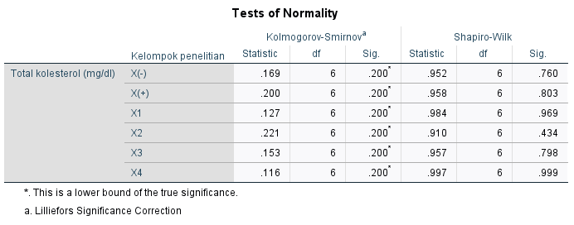

Hasil uji normalitas menunjukkan semua data total kolesterol hewan coba terdistribusi normal, p>0,05. Karena variabel data lebih dari 2 kelompok dan data tidak berpasangan, maka digunakan uji lanjut one way ANOVA untuk melihat perbandingan antar kelompok.

A.4.3. Uji lanjut one way ANOVA Total Kolesterol Hewan Coba
Sebelum uji one way ANOVA dilakukan, kesamaan varian data penelitian dilihat melalui uji Sphericity. Jika p>0,05, maka data dinilai homogen (memenuhi asumsi kesamaan varian).

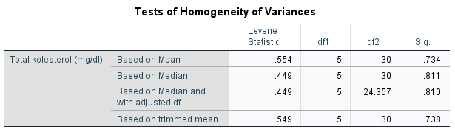

Hasil output uji Sphericity menunjukkan p>0,05, data dinilai homogen (memenuhi asumsi kesamaan varian). Maka uji one way ANOVA digunakan dengan uji lanjut Post Hoc Bonferroni. Jika p <0,05, maka data dinilai signifikan.

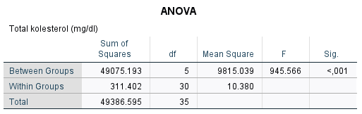

Hasil tabel one way ANOVA diatas menunjukkan data total kolesterol signifikan p<0,05 pada semua kelompok. Informasi mengenai rata-rata perbandingan kelompok menggunakan uji Post Hoc Bonferroni. Hasil uji ditunjukkan pada tabel Multiple Comparisons.

Multiple Comparisons
Dependent Variable: Total kolesterol (mg/dl)
Bonferroni
(I) Kelompok penelitian | (J) Kelompok penelitian | Mean Difference (I-J) | Std. Error | Sig. | 95% Confidence Interval
 |  |  |  |  | Lower Bound | Upper Bound
X(-) | X(+) | -109.92500* | 1.86011 | .000 | -115.8565 | -103.9935
 | X1 | -31.86333* | 1.86011 | .000 | -37.7949 | -25.9318
 | X2 | -13.60000* | 1.86011 | .000 | -19.5315 | -7.6685
 | X3 | -8.33167* | 1.86011 | .002 | -14.2632 | -2.4001
 | X4 | -17.76833* | 1.86011 | .000 | -23.6999 | -11.8368
X(+) | X(-) | 109.92500* | 1.86011 | .000 | 103.9935 | 115.8565
 | X1 | 78.06167* | 1.86011 | .000 | 72.1301 | 83.9932
 | X2 | 96.32500* | 1.86011 | .000 | 90.3935 | 102.2565
 | X3 | 101.59333* | 1.86011 | .000 | 95.6618 | 107.5249
 | X4 | 92.15667* | 1.86011 | .000 | 86.2251 | 98.0882
X1 | X(-) | 31.86333* | 1.86011 | .000 | 25.9318 | 37.7949
 | X(+) | -78.06167* | 1.86011 | .000 | -83.9932 | -72.1301
 | X2 | 18.26333* | 1.86011 | .000 | 12.3318 | 24.1949
 | X3 | 23.53167* | 1.86011 | .000 | 17.6001 | 29.4632
 | X4 | 14.09500* | 1.86011 | .000 | 8.1635 | 20.0265
X2 | X(-) | 13.60000* | 1.86011 | .000 | 7.6685 | 19.5315
 | X(+) | -96.32500* | 1.86011 | .000 | -102.2565 | -90.3935
 | X1 | -18.26333* | 1.86011 | .000 | -24.1949 | -12.3318
 | X3 | 5.26833 | 1.86011 | .123 | -.6632 | 11.1999
 | X4 | -4.16833 | 1.86011 | .489 | -10.0999 | 1.7632
X3 | X(-) | 8.33167* | 1.86011 | .002 | 2.4001 | 14.2632
 | X(+) | -101.59333* | 1.86011 | .000 | -107.5249 | -95.6618
 | X1 | -23.53167* | 1.86011 | .000 | -29.4632 | -17.6001
 | X2 | -5.26833 | 1.86011 | .123 | -11.1999 | .6632
 | X4 | -9.43667* | 1.86011 | .000 | -15.3682 | -3.5051
X4 | X(-) | 17.76833* | 1.86011 | .000 | 11.8368 | 23.6999
 | X(+) | -92.15667* | 1.86011 | .000 | -98.0882 | -86.2251
 | X1 | -14.09500* | 1.86011 | .000 | -20.0265 | -8.1635
 | X2 | 4.16833 | 1.86011 | .489 | -1.7632 | 10.0999
 | X3 | 9.43667* | 1.86011 | .000 | 3.5051 | 15.3682
*. The mean difference is significant at the 0.05 level.

Berdasarkan tabel Multiple Comparisons Bonferroni, data semua kelompok perlakuan ternilai signifikan kecuali antar kelompok X2 dengan X3; X2 dengan X4.
A.5. Trigliserida
A.5.1. Data Deskriptif Trigliserida Hewan Coba
Data deskriptif trigliserida hewan coba setelah perlakuan minggu ke-4.

Descriptives
 | Kelompok penelitian |  |  | Statistic | Std. Error
Trigliserida (mg/dl) | X(-) | Mean |  | 66.9283 | 1.20215
 |  | 95% Confidence Interval for Mean | Lower Bound | 63.8381
 |  |  | Upper Bound | 70.0186
 |  | 5% Trimmed Mean |  | 66.9426
 |  | Median |  | 66.7950
 |  | Variance |  | 8.671
 |  | Std. Deviation |  | 2.94467
 |  | Minimum |  | 62.45
 |  | Maximum |  | 71.15
 |  | Range |  | 8.70
 |  | Interquartile Range |  | 4.55
 |  | Skewness |  | -.126 | .845
 |  | Kurtosis |  | .588 | 1.741
 | X(+) | Mean |  | 129.1167 | 2.87681
 |  | 95% Confidence Interval for Mean | Lower Bound | 121.7216
 |  |  | Upper Bound | 136.5117
 |  | 5% Trimmed Mean |  | 128.8385
 |  | Median |  | 127.6650
 |  | Variance |  | 49.656
 |  | Std. Deviation |  | 7.04672
 |  | Minimum |  | 121.74
 |  | Maximum |  | 141.50
 |  | Range |  | 19.76
 |  | Interquartile Range |  | 10.87
 |  | Skewness |  | 1.182 | .845
 |  | Kurtosis |  | 1.479 | 1.741
 | X1 | Mean |  | 98.4183 | 1.53850
 |  | 95% Confidence Interval for Mean | Lower Bound | 94.4635
 |  |  | Upper Bound | 102.3732
 |  | 5% Trimmed Mean |  | 98.4181
 |  | Median |  | 97.6250
 |  | Variance |  | 14.202
 |  | Std. Deviation |  | 3.76854
 |  | Minimum |  | 93.28
 |  | Maximum |  | 103.56
 |  | Range |  | 10.28
 |  | Interquartile Range |  | 6.72
 |  | Skewness |  | .202 | .845
 |  | Kurtosis |  | -.786 | 1.741
 | X2 | Mean |  | 81.2917 | 1.99450
 |  | 95% Confidence Interval for Mean | Lower Bound | 76.1646
 |  |  | Upper Bound | 86.4187
 |  | 5% Trimmed Mean |  | 81.1452
 |  | Median |  | 79.4450
 |  | Variance |  | 23.868
 |  | Std. Deviation |  | 4.88552
 |  | Minimum |  | 76.68
 |  | Maximum |  | 88.54
 |  | Range |  | 11.86
 |  | Interquartile Range |  | 9.49
 |  | Skewness |  | .846 | .845
 |  | Kurtosis |  | -1.308 | 1.741
 | X3 | Mean |  | 74.5733 | .97113
 |  | 95% Confidence Interval for Mean | Lower Bound | 72.0770
 |  |  | Upper Bound | 77.0697
 |  | 5% Trimmed Mean |  | 74.6026
 |  | Median |  | 74.7050
 |  | Variance |  | 5.659
 |  | Std. Deviation |  | 2.37876
 |  | Minimum |  | 71.15
 |  | Maximum |  | 77.47
 |  | Range |  | 6.32
 |  | Interquartile Range |  | 4.54
 |  | Skewness |  | -.281 | .845
 |  | Kurtosis |  | -1.023 | 1.741
 | X4 | Mean |  | 77.8650 | 1.23655
 |  | 95% Confidence Interval for Mean | Lower Bound | 74.6864
 |  |  | Upper Bound | 81.0436
 |  | 5% Trimmed Mean |  | 77.7333
 |  | Median |  | 76.6800
 |  | Variance |  | 9.174
 |  | Std. Deviation |  | 3.02891
 |  | Minimum |  | 75.10
 |  | Maximum |  | 83.00
 |  | Range |  | 7.90
 |  | Interquartile Range |  | 4.94
 |  | Skewness |  | 1.150 | .845
 |  | Kurtosis |  | .398 | 1.741

A.5.2. Uji Normalitas Trigliserida Hewan Coba
Karena jumlah hewan coba kecil <50 dan data berskala interval, maka uji normalitas yang digunakan adalah Shapiro-Wilk. Data berdistribusi normal jika signifikansi p>0,05.

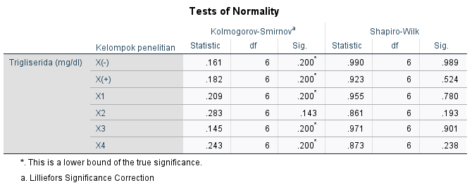

Hasil uji normalitas menunjukkan semua data trigliserida hewan coba terdistribusi normal, p>0,05. Karena variabel data lebih dari 2 kelompok dan data tidak berpasangan, maka digunakan uji lanjut one way ANOVA untuk melihat perbandingan antar kelompok.

A.5.3. Uji lanjut one way ANOVA Trigliserida Hewan Coba
Sebelum uji one way ANOVA dilakukan, kesamaan varian data penelitian dilihat melalui uji Sphericity. Jika p>0,05, maka data dinilai homogen (memenuhi asumsi kesamaan varian).

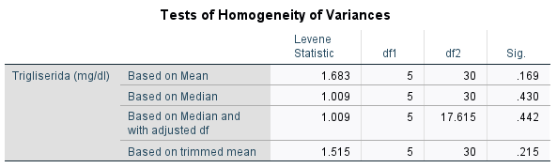
Hasil output uji Sphericity menunjukkan p>0,05, data dinilai homogen (memenuhi asumsi kesamaan varian). Maka uji one way ANOVA digunakan dengan uji lanjut Post Hoc Bonferroni. Jika p <0,05, maka data dinilai signifikan.
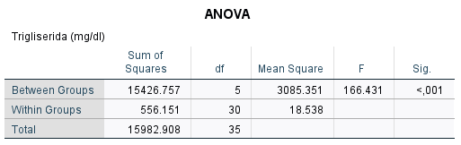

Hasil tabel one way ANOVA diatas menunjukkan data trigliserida signifikan p<0,05 pada semua kelompok. Informasi mengenai rata-rata perbandingan kelompok menggunakan uji Post Hoc Bonferroni. Hasil uji ditunjukkan pada tabel Multiple Comparisons.

Multiple Comparisons
Dependent Variable: Trigliserida (mg/dl)
Bonferroni
(I) Kelompok penelitian | (J) Kelompok penelitian | Mean Difference (I-J) | Std. Error | Sig. | 95% Confidence Interval
 |  |  |  |  | Lower Bound | Upper Bound
X(-) | X(+) | -62.18833* | 2.48585 | .000 | -70.1152 | -54.2614
 | X1 | -31.49000* | 2.48585 | .000 | -39.4169 | -23.5631
 | X2 | -14.36333* | 2.48585 | .000 | -22.2902 | -6.4364
 | X3 | -7.64500 | 2.48585 | .067 | -15.5719 | .2819
 | X4 | -10.93667* | 2.48585 | .002 | -18.8636 | -3.0098
X(+) | X(-) | 62.18833* | 2.48585 | .000 | 54.2614 | 70.1152
 | X1 | 30.69833* | 2.48585 | .000 | 22.7714 | 38.6252
 | X2 | 47.82500* | 2.48585 | .000 | 39.8981 | 55.7519
 | X3 | 54.54333* | 2.48585 | .000 | 46.6164 | 62.4702
 | X4 | 51.25167* | 2.48585 | .000 | 43.3248 | 59.1786
X1 | X(-) | 31.49000* | 2.48585 | .000 | 23.5631 | 39.4169
 | X(+) | -30.69833* | 2.48585 | .000 | -38.6252 | -22.7714
 | X2 | 17.12667* | 2.48585 | .000 | 9.1998 | 25.0536
 | X3 | 23.84500* | 2.48585 | .000 | 15.9181 | 31.7719
 | X4 | 20.55333* | 2.48585 | .000 | 12.6264 | 28.4802
X2 | X(-) | 14.36333* | 2.48585 | .000 | 6.4364 | 22.2902
 | X(+) | -47.82500* | 2.48585 | .000 | -55.7519 | -39.8981
 | X1 | -17.12667* | 2.48585 | .000 | -25.0536 | -9.1998
 | X3 | 6.71833 | 2.48585 | .168 | -1.2086 | 14.6452
 | X4 | 3.42667 | 2.48585 | 1.000 | -4.5002 | 11.3536
X3 | X(-) | 7.64500 | 2.48585 | .067 | -.2819 | 15.5719
 | X(+) | -54.54333* | 2.48585 | .000 | -62.4702 | -46.6164
 | X1 | -23.84500* | 2.48585 | .000 | -31.7719 | -15.9181
 | X2 | -6.71833 | 2.48585 | .168 | -14.6452 | 1.2086
 | X4 | -3.29167 | 2.48585 | 1.000 | -11.2186 | 4.6352
X4 | X(-) | 10.93667* | 2.48585 | .002 | 3.0098 | 18.8636
 | X(+) | -51.25167* | 2.48585 | .000 | -59.1786 | -43.3248
 | X1 | -20.55333* | 2.48585 | .000 | -28.4802 | -12.6264
 | X2 | -3.42667 | 2.48585 | 1.000 | -11.3536 | 4.5002
 | X3 | 3.29167 | 2.48585 | 1.000 | -4.6352 | 11.2186
*. The mean difference is significant at the 0.05 level.

Berdasarkan tabel Multiple Comparisons Games Bonferroni, data semua kelompok perlakuan ternilai signifikan kecuali antar kelompok X- dengan X3; X2 dengan X3; X2 dengan X4; X3 dengan X4.

A.6. LDL (Low Density Lipoprotein)
A.6.1. Data Deskriptif LDL Hewan Coba
Data deskriptif LDL hewan coba setelah perlakuan minggu ke-4.

Descriptives
 | Kelompok penelitian |  |  | Statistic | Std. Error
LDL (mg/dl) | X(-) | Mean |  | 27.2400 | .69214
 |  | 95% Confidence Interval for Mean | Lower Bound | 25.4608
 |  |  | Upper Bound | 29.0192
 |  | 5% Trimmed Mean |  | 27.2400
 |  | Median |  | 27.2400
 |  | Variance |  | 2.874
 |  | Std. Deviation |  | 1.69538
 |  | Minimum |  | 25.09
 |  | Maximum |  | 29.39
 |  | Range |  | 4.30
 |  | Interquartile Range |  | 3.22
 |  | Skewness |  | .000 | .845
 |  | Kurtosis |  | -1.875 | 1.741
 | X(+) | Mean |  | 87.9333 | .54538
 |  | 95% Confidence Interval for Mean | Lower Bound | 86.5314
 |  |  | Upper Bound | 89.3353
 |  | 5% Trimmed Mean |  | 87.9465
 |  | Median |  | 88.1700
 |  | Variance |  | 1.785
 |  | Std. Deviation |  | 1.33591
 |  | Minimum |  | 86.02
 |  | Maximum |  | 89.61
 |  | Range |  | 3.59
 |  | Interquartile Range |  | 2.51
 |  | Skewness |  | -.389 | .845
 |  | Kurtosis |  | -.937 | 1.741
 | X1 | Mean |  | 51.7317 | 2.23310
 |  | 95% Confidence Interval for Mean | Lower Bound | 45.9913
 |  |  | Upper Bound | 57.4720
 |  | 5% Trimmed Mean |  | 51.8246
 |  | Median |  | 52.6900
 |  | Variance |  | 29.920
 |  | Std. Deviation |  | 5.46994
 |  | Minimum |  | 44.44
 |  | Maximum |  | 57.35
 |  | Range |  | 12.91
 |  | Interquartile Range |  | 10.76
 |  | Skewness |  | -.350 | .845
 |  | Kurtosis |  | -2.146 | 1.741
 | X2 | Mean |  | 37.7550 | 1.77234
 |  | 95% Confidence Interval for Mean | Lower Bound | 33.1991
 |  |  | Upper Bound | 42.3109
 |  | 5% Trimmed Mean |  | 37.7683
 |  | Median |  | 38.3550
 |  | Variance |  | 18.847
 |  | Std. Deviation |  | 4.34132
 |  | Minimum |  | 31.54
 |  | Maximum |  | 43.73
 |  | Range |  | 12.19
 |  | Interquartile Range |  | 7.35
 |  | Skewness |  | -.169 | .845
 |  | Kurtosis |  | -.472 | 1.741
 | X3 | Mean |  | 30.5850 | .88101
 |  | 95% Confidence Interval for Mean | Lower Bound | 28.3203
 |  |  | Upper Bound | 32.8497
 |  | 5% Trimmed Mean |  | 30.5583
 |  | Median |  | 30.4650
 |  | Variance |  | 4.657
 |  | Std. Deviation |  | 2.15802
 |  | Minimum |  | 27.96
 |  | Maximum |  | 33.69
 |  | Range |  | 5.73
 |  | Interquartile Range |  | 4.13
 |  | Skewness |  | .281 | .845
 |  | Kurtosis |  | -1.028 | 1.741
 | X4 | Mean |  | 36.4400 | 1.19078
 |  | 95% Confidence Interval for Mean | Lower Bound | 33.3790
 |  |  | Upper Bound | 39.5010
 |  | 5% Trimmed Mean |  | 36.5067
 |  | Median |  | 36.9200
 |  | Variance |  | 8.508
 |  | Std. Deviation |  | 2.91680
 |  | Minimum |  | 31.54
 |  | Maximum |  | 40.14
 |  | Range |  | 8.60
 |  | Interquartile Range |  | 4.30
 |  | Skewness |  | -.785 | .845
 |  | Kurtosis |  | 1.227 | 1.741

A.6.2. Uji Normalitas LDL Hewan Coba
Karena jumlah hewan coba kecil <50 dan data berskala interval, maka uji normalitas yang digunakan adalah Shapiro-Wilk. Data berdistribusi normal jika signifikansi p>0,05.

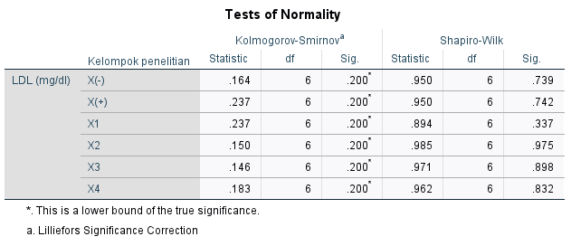

Hasil uji normalitas menunjukkan semua data LDL hewan coba terdistribusi normal, p>0,05. Karena variabel data lebih dari 2 kelompok dan data tidak berpasangan, maka digunakan uji lanjut one way ANOVA untuk melihat perbandingan antar kelompok.

A.6.3. Uji lanjut one way ANOVA LDL Hewan Coba
Sebelum uji one way ANOVA dilakukan, kesamaan varian data penelitian dilihat melalui uji Sphericity. Jika p>0,05, maka data dinilai homogen (memenuhi asumsi kesamaan varian).

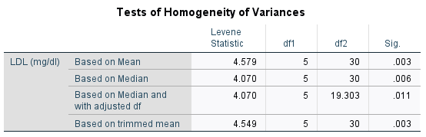

Hasil output uji Sphericity menunjukkan p<0,05, data dinilai tidak homogen (tidak memenuhi asumsi kesamaan varian). Maka uji one way ANOVA masih bisa digunakan dengan uji lanjut Games Howell karena data terdistribusi normal. Jika p <0,05, maka data dinilai signifikan.

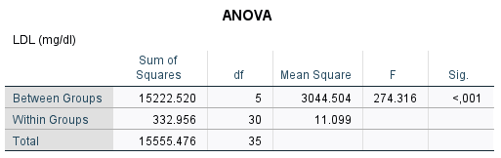

Hasil tabel one way ANOVA diatas menunjukkan data LDL signifikan p<0,05 pada semua kelompok. Informasi mengenai rata-rata perbandingan kelompok menggunakan uji Post Hoc Games Howell. Hasil uji ditunjukkan pada tabel Multiple Comparisons.

Multiple Comparisons
Dependent Variable: LDL (mg/dl)
Games-Howell
(I) Kelompok penelitian | (J) Kelompok penelitian | Mean Difference (I-J) | Std. Error | Sig. | 95% Confidence Interval
 |  |  |  |  | Lower Bound | Upper Bound
X(-) | X(+) | -60.69333* | .88119 | .000 | -63.7880 | -57.5987
 | X1 | -24.49167* | 2.33790 | .000 | -33.8221 | -15.1612
 | X2 | -10.51500* | 1.90269 | .009 | -17.8932 | -3.1368
 | X3 | -3.34500 | 1.12037 | .108 | -7.2807 | .5907
 | X4 | -9.20000* | 1.37732 | .001 | -14.2272 | -4.1728
X(+) | X(-) | 60.69333* | .88119 | .000 | 57.5987 | 63.7880
 | X1 | 36.20167* | 2.29873 | .000 | 26.8209 | 45.5824
 | X2 | 50.17833* | 1.85435 | .000 | 42.7719 | 57.5848
 | X3 | 57.34833* | 1.03616 | .000 | 53.6017 | 61.0950
 | X4 | 51.49333* | 1.30973 | .000 | 46.5321 | 56.4546
X1 | X(-) | 24.49167* | 2.33790 | .000 | 15.1612 | 33.8221
 | X(+) | -36.20167* | 2.29873 | .000 | -45.5824 | -26.8209
 | X2 | 13.97667* | 2.85095 | .007 | 3.9709 | 23.9825
 | X3 | 21.14667* | 2.40060 | .001 | 11.8510 | 30.4424
 | X4 | 15.29167* | 2.53074 | .003 | 5.9303 | 24.6530
X2 | X(-) | 10.51500* | 1.90269 | .009 | 3.1368 | 17.8932
 | X(+) | -50.17833* | 1.85435 | .000 | -57.5848 | -42.7719
 | X1 | -13.97667* | 2.85095 | .007 | -23.9825 | -3.9709
 | X3 | 7.17000 | 1.97923 | .058 | -.2324 | 14.5724
 | X4 | 1.31500 | 2.13521 | .987 | -6.3186 | 8.9486
X3 | X(-) | 3.34500 | 1.12037 | .108 | -.5907 | 7.2807
 | X(+) | -57.34833* | 1.03616 | .000 | -61.0950 | -53.6017
 | X1 | -21.14667* | 2.40060 | .001 | -30.4424 | -11.8510
 | X2 | -7.17000 | 1.97923 | .058 | -14.5724 | .2324
 | X4 | -5.85500* | 1.48126 | .027 | -11.0895 | -.6205
X4 | X(-) | 9.20000* | 1.37732 | .001 | 4.1728 | 14.2272
 | X(+) | -51.49333* | 1.30973 | .000 | -56.4546 | -46.5321
 | X1 | -15.29167* | 2.53074 | .003 | -24.6530 | -5.9303
 | X2 | -1.31500 | 2.13521 | .987 | -8.9486 | 6.3186
 | X3 | 5.85500* | 1.48126 | .027 | .6205 | 11.0895
*. The mean difference is significant at the 0.05 level.

Berdasarkan tabel Multiple Comparisons Games Howell, data semua kelompok perlakuan ternilai signifikan kecuali antar kelompok X- dengan X3; X2 dengan X3; X2 dengan X4.

A.7. HDL (High Density Lipoprotein)
A.7.1. Data Deskriptif HDL Hewan Coba
Data deskriptif HDL hewan coba setelah perlakuan minggu ke-4.

Descriptives
 | Kelompok penelitian |  |  | Statistic | Std. Error
HDL (mg/dl) | X(-) | Mean |  | 83.6050 | 1.05797
 |  | 95% Confidence Interval for Mean | Lower Bound | 80.8854
 |  |  | Upper Bound | 86.3246
 |  | 5% Trimmed Mean |  | 83.5900
 |  | Median |  | 83.3350
 |  | Variance |  | 6.716
 |  | Std. Deviation |  | 2.59148
 |  | Minimum |  | 80.49
 |  | Maximum |  | 86.99
 |  | Range |  | 6.50
 |  | Interquartile Range |  | 5.29
 |  | Skewness |  | .226 | .845
 |  | Kurtosis |  | -1.627 | 1.741
 | X(+) | Mean |  | 21.0033 | .82408
 |  | 95% Confidence Interval for Mean | Lower Bound | 18.8850
 |  |  | Upper Bound | 23.1217
 |  | 5% Trimmed Mean |  | 20.9431
 |  | Median |  | 20.7350
 |  | Variance |  | 4.075
 |  | Std. Deviation |  | 2.01857
 |  | Minimum |  | 18.70
 |  | Maximum |  | 24.39
 |  | Range |  | 5.69
 |  | Interquartile Range |  | 3.25
 |  | Skewness |  | .870 | .845
 |  | Kurtosis |  | .735 | 1.741
 | X1 | Mean |  | 63.5517 | 1.05754
 |  | 95% Confidence Interval for Mean | Lower Bound | 60.8332
 |  |  | Upper Bound | 66.2702
 |  | 5% Trimmed Mean |  | 63.5213
 |  | Median |  | 63.4150
 |  | Variance |  | 6.710
 |  | Std. Deviation |  | 2.59044
 |  | Minimum |  | 60.98
 |  | Maximum |  | 66.67
 |  | Range |  | 5.69
 |  | Interquartile Range |  | 5.07
 |  | Skewness |  | .108 | .845
 |  | Kurtosis |  | -2.760 | 1.741
 | X2 | Mean |  | 66.9383 | .71713
 |  | 95% Confidence Interval for Mean | Lower Bound | 65.0949
 |  |  | Upper Bound | 68.7818
 |  | 5% Trimmed Mean |  | 66.9681
 |  | Median |  | 67.0750
 |  | Variance |  | 3.086
 |  | Std. Deviation |  | 1.75659
 |  | Minimum |  | 64.23
 |  | Maximum |  | 69.11
 |  | Range |  | 4.88
 |  | Interquartile Range |  | 3.05
 |  | Skewness |  | -.460 | .845
 |  | Kurtosis |  | -.304 | 1.741
 | X3 | Mean |  | 74.7967 | .86544
 |  | 95% Confidence Interval for Mean | Lower Bound | 72.5720
 |  |  | Upper Bound | 77.0214
 |  | 5% Trimmed Mean |  | 74.7513
 |  | Median |  | 74.3900
 |  | Variance |  | 4.494
 |  | Std. Deviation |  | 2.11989
 |  | Minimum |  | 72.36
 |  | Maximum |  | 78.05
 |  | Range |  | 5.69
 |  | Interquartile Range |  | 3.86
 |  | Skewness |  | .611 | .845
 |  | Kurtosis |  | -.646 | 1.741
 | X4 | Mean |  | 69.2417 | .94910
 |  | 95% Confidence Interval for Mean | Lower Bound | 66.8019
 |  |  | Upper Bound | 71.6814
 |  | 5% Trimmed Mean |  | 69.2569
 |  | Median |  | 69.5150
 |  | Variance |  | 5.405
 |  | Std. Deviation |  | 2.32480
 |  | Minimum |  | 65.85
 |  | Maximum |  | 72.36
 |  | Range |  | 6.51
 |  | Interquartile Range |  | 4.06
 |  | Skewness |  | -.252 | .845
 |  | Kurtosis |  | -.460 | 1.741

A.7.2. Uji Normalitas HDL Hewan Coba
Karena jumlah hewan coba kecil <50 dan data berskala interval, maka uji normalitas yang digunakan adalah Shapiro-Wilk. Data berdistribusi normal jika signifikansi p>0,05.

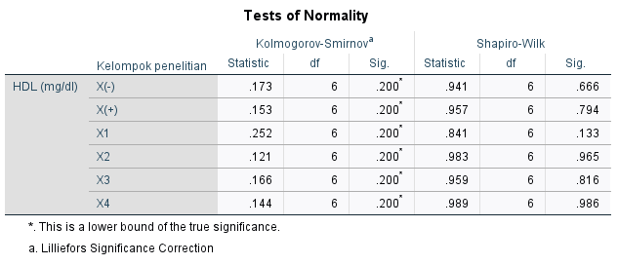

Hasil uji normalitas menunjukkan semua data HDL hewan coba terdistribusi normal, p>0,05. Karena variabel data lebih dari 2 kelompok dan data tidak berpasangan, maka digunakan uji lanjut one way ANOVA untuk melihat perbandingan antar kelompok.

A.7.3. Uji lanjut one way ANOVA HDL Hewan Coba
Sebelum uji one way ANOVA dilakukan, kesamaan varian data penelitian dilihat melalui uji Sphericity. Jika p>0,05, maka data dinilai homogen (memenuhi asumsi kesamaan varian).

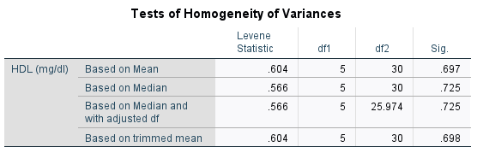

Hasil output uji Sphericity menunjukkan p>0,05, data dinilai homogen (memenuhi asumsi kesamaan varian). Maka uji one way ANOVA digunakan dengan uji lanjut Bonferroni. Jika p <0,05, maka data dinilai signifikan.

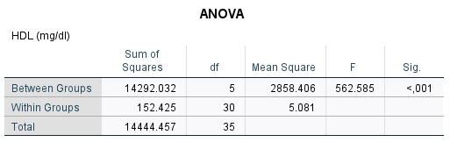

Hasil tabel one way ANOVA diatas menunjukkan data HDL signifikan p<0,05 pada semua kelompok. Informasi mengenai rata-rata perbandingan kelompok menggunakan uji Post Hoc Bonferroni. Hasil uji ditunjukkan pada tabel Multiple Comparisons.

Multiple Comparisons
Dependent Variable: HDL (mg/dl)
Bonferroni
(I) Kelompok penelitian | (J) Kelompok penelitian | Mean Difference (I-J) | Std. Error | Sig. | 95% Confidence Interval
 |  |  |  |  | Lower Bound | Upper Bound
X(-) | X(+) | 62.60167* | 1.30139 | .000 | 58.4518 | 66.7515
 | X1 | 20.05333* | 1.30139 | .000 | 15.9035 | 24.2032
 | X2 | 16.66667* | 1.30139 | .000 | 12.5168 | 20.8165
 | X3 | 8.80833* | 1.30139 | .000 | 4.6585 | 12.9582
 | X4 | 14.36333* | 1.30139 | .000 | 10.2135 | 18.5132
X(+) | X(-) | -62.60167* | 1.30139 | .000 | -66.7515 | -58.4518
 | X1 | -42.54833* | 1.30139 | .000 | -46.6982 | -38.3985
 | X2 | -45.93500* | 1.30139 | .000 | -50.0849 | -41.7851
 | X3 | -53.79333* | 1.30139 | .000 | -57.9432 | -49.6435
 | X4 | -48.23833* | 1.30139 | .000 | -52.3882 | -44.0885
X1 | X(-) | -20.05333* | 1.30139 | .000 | -24.2032 | -15.9035
 | X(+) | 42.54833* | 1.30139 | .000 | 38.3985 | 46.6982
 | X2 | -3.38667 | 1.30139 | .214 | -7.5365 | .7632
 | X3 | -11.24500* | 1.30139 | .000 | -15.3949 | -7.0951
 | X4 | -5.69000* | 1.30139 | .002 | -9.8399 | -1.5401
X2 | X(-) | -16.66667* | 1.30139 | .000 | -20.8165 | -12.5168
 | X(+) | 45.93500* | 1.30139 | .000 | 41.7851 | 50.0849
 | X1 | 3.38667 | 1.30139 | .214 | -.7632 | 7.5365
 | X3 | -7.85833* | 1.30139 | .000 | -12.0082 | -3.7085
 | X4 | -2.30333 | 1.30139 | 1.000 | -6.4532 | 1.8465
X3 | X(-) | -8.80833* | 1.30139 | .000 | -12.9582 | -4.6585
 | X(+) | 53.79333* | 1.30139 | .000 | 49.6435 | 57.9432
 | X1 | 11.24500* | 1.30139 | .000 | 7.0951 | 15.3949
 | X2 | 7.85833* | 1.30139 | .000 | 3.7085 | 12.0082
 | X4 | 5.55500* | 1.30139 | .003 | 1.4051 | 9.7049
X4 | X(-) | -14.36333* | 1.30139 | .000 | -18.5132 | -10.2135
 | X(+) | 48.23833* | 1.30139 | .000 | 44.0885 | 52.3882
 | X1 | 5.69000* | 1.30139 | .002 | 1.5401 | 9.8399
 | X2 | 2.30333 | 1.30139 | 1.000 | -1.8465 | 6.4532
 | X3 | -5.55500* | 1.30139 | .003 | -9.7049 | -1.4051
*. The mean difference is significant at the 0.05 level.

Berdasarkan tabel Multiple Comparisons Bonferroni, data semua kelompok perlakuan ternilai signifikan kecuali antar kelompok X1 dengan X2; X2 dengan X4.

- Data Hasil Pengukuran Antropometri, hs-CRP, dan Profil Lipid
B.1. Data Antropometri

KEL | Berat badan (gram) |  |  |  |  |  |  | Panjang badan (cm)_minggu ke4 | Lee Index
 | BB_awal (non-obes) | BB_pre (obes) | BB_1 | BB_2 | BB_3 | BB_4 | ∆ BB pre-BB_4
X (-).1 | 209 | 227 | 233 | 240 | 245 | 251 | 24.00 | 21,96 | 287,25
X (-).2 | 204 | 221 | 228 | 232 | 240 | 247 | 26.00 | 21,92 | 286,24
X (-).3 | 208 | 226 | 231 | 238 | 243 | 250 | 24.00 | 21,60 | 291,65
X (-).4 | 211 | 230 | 238 | 243 | 249 | 255 | 25.00 | 21,66 | 292,77
X (-).5 | 206 | 224 | 229 | 237 | 241 | 246 | 22.00 | 21,85 | 286,77
X (-).6 | 208 | 228 | 233 | 241 | 247 | 253 | 25.00 | 21,77 | 290,52
X (+).1 | 202 | 235 | 248 | 260 | 278 | 290 | 55.00 | 19,05 | 347,46
X (+).2 | 210 | 242 | 254 | 268 | 282 | 296 | 54.00 | 19,15 | 348,01
X (+).3 | 208 | 240 | 252 | 265 | 280 | 293 | 53.00 | 19,13 | 347,20
X (+).4 | 205 | 238 | 250 | 263 | 277 | 291 | 53.00 | 19,25 | 344,24
X (+).5 | 209 | 241 | 255 | 267 | 281 | 294 | 53.00 | 19,20 | 346,32
X (+).6 | 206 | 239 | 251 | 266 | 279 | 292 | 53.00 | 18,90 | 351,02
X1.1 | 211 | 243 | 253 | 259 | 268 | 277 | 34.00 | 21,45 | 303,90
X1.2 | 208 | 240 | 250 | 257 | 264 | 272 | 32.00 | 21,00 | 308,53
X1.3 | 215 | 249 | 258 | 265 | 275 | 282 | 33.00 | 21,43 | 306,00
X1.4 | 212 | 244 | 252 | 261 | 270 | 278 | 34.00 | 20,99 | 310,93
X1.5 | 210 | 242 | 251 | 260 | 267 | 274 | 32.00 | 21,07 | 308,26
X1.6 | 213 | 246 | 256 | 262 | 271 | 280 | 34.00 | 21,10 | 310,05
X2.1 | 208 | 241 | 249 | 258 | 266 | 275 | 34.00 | 21,88 | 297,21
X2.2 | 213 | 244 | 252 | 260 | 270 | 277 | 33.00 | 21,29 | 306,19
X2.3 | 217 | 250 | 260 | 266 | 276 | 283 | 33.00 | 21,58 | 304,24
X2.4 | 211 | 243 | 253 | 259 | 268 | 276 | 33.00 | 21,49 | 302,97
X2.5 | 210 | 242 | 251 | 261 | 266 | 274 | 32.00 | 21,60 | 300,70
X2.6 | 215 | 248 | 258 | 266 | 272 | 281 | 33.00 | 21,30 | 307,51
X3.1 | 205 | 238 | 248 | 255 | 261 | 270 | 32.00 | 22,00 | 293,79
X3.2 | 212 | 245 | 255 | 260 | 268 | 277 | 32.00 | 21,98 | 296,57
X3.3 | 210 | 241 | 249 | 258 | 265 | 274 | 33.00 | 22,05 | 294,56
X3.4 | 206 | 239 | 247 | 254 | 262 | 271 | 32.00 | 21,73 | 297,80
X3.5 | 213 | 244 | 254 | 261 | 269 | 278 | 34.00 | 21,90 | 298,01
X3.6 | 209 | 240 | 250 | 257 | 264 | 273 | 33.00 | 22,02 | 294,60
X4.1 | 204 | 237 | 247 | 253 | 260 | 268 | 31.00 | 21,23 | 303,69
X4.2 | 208 | 240 | 250 | 255 | 263 | 270 | 30.00 | 21,53 | 300,20
X4.3 | 206 | 239 | 248 | 257 | 261 | 268 | 29.00 | 21,20 | 304,12
X4.4 | 200 | 231 | 239 | 248 | 255 | 263 | 32.00 | 20,70 | 309,51
X4.5 | 211 | 244 | 252 | 260 | 268 | 277 | 33.00 | 20,91 | 311,75
X4.6 | 207 | 242 | 250 | 256 | 266 | 275 | 33.00 | 20,99 | 309,81

B.2. Data Biokimia

KEL | Profil lipid (mg/dl) |  |  |  | hs-CRP (pg/ml)
 | Tot_Kolesterol | Trigliserida | LDL | HDL
X (-).1 | 86,03 | 71,15 | 25,09 | 86,18 | 2,97
X (-).2 | 83,82 | 68,77 | 26,52 | 82,93 | 2,85
X (-).3 | 83,09 | 66,40 | 27,96 | 80,49 | 3,07
X (-).4 | 88,97 | 65,61 | 25,81 | 83,74 | 2,87
X (-).5 | 91,18 | 62,45 | 28,67 | 81,30 | 3,18
X (-).6 | 88,24 | 67,19 | 29,39 | 86,99 | 3,03
X (+).1 | 198,53 | 124,11 | 89,61 | 19,51 | 16,49
X (+).2 | 195,59 | 132,02 | 88,17 | 21,14 | 18,15
X (+).3 | 199,26 | 126,48 | 86,02 | 24,39 | 16,92
X (+).4 | 194,85 | 128,85 | 88,17 | 18,70 | 18,52
X (+).5 | 200,74 | 141,50 | 86,74 | 21,95 | 17,88
X (+).6 | 191,91 | 121,74 | 88,89 | 20,33 | 16,75
X1.1 | 116,18 | 98,02 | 44,44 | 60,98 | 8,14
X1.2 | 118,38 | 93,28 | 46,59 | 66,67 | 7,50
X1.3 | 123,53 | 96,44 | 57,35 | 61,79 | 7,36
X1.4 | 120,59 | 101,98 | 55,20 | 65,04 | 8,22
X1.5 | 119,12 | 103,56 | 56,63 | 65,85 | 8,18
X1.6 | 114,71 | 97,23 | 50,18 | 60,98 | 7,30
X2.1 | 100,00 | 79,84 | 40,14 | 69,11 | 5,06
X2.2 | 104,41 | 76,68 | 43,73 | 66,67 | 4,86
X2.3 | 96,32 | 79,05 | 34,41 | 67,48 | 5,47
X2.4 | 99,26 | 86,17 | 31,54 | 64,23 | 5,10
X2.5 | 105,15 | 88,54 | 39,43 | 68,29 | 4,78
X2.6 | 97,79 | 77,47 | 37,28 | 65,85 | 5,12
X3.1 | 97,06 | 76,68 | 30,82 | 74,80 | 3,56
X3.2 | 95,59 | 74,31 | 27,96 | 72,36 | 4,22
X3.3 | 93,38 | 72,73 | 33,69 | 76,42 | 3,98
X3.4 | 94,85 | 71,15 | 30,11 | 78,05 | 3,65
X3.5 | 97,79 | 75,10 | 28,67 | 73,98 | 4,30
X3.6 | 92,65 | 77,47 | 32,26 | 73,17 | 4,20
X4.1 | 102,21 | 83,00 | 35,13 | 72,36 | 4,61
X4.2 | 99,26 | 77,47 | 37,28 | 69,92 | 4,26
X4.3 | 103,68 | 75,89 | 36,56 | 65,85 | 3,69
X4.4 | 110,29 | 79,84 | 40,14 | 69,11 | 4,82
X4.5 | 107,35 | 75,89 | 37,99 | 67,48 | 4,10
X4.6 | 105,15 | 75,10 | 31,54 | 70,73 | 3,98

- SPSS Boxplot Hasil Penelitian
C.1. Berat Badan
C.1.1. Berat badan pre-perlakuan (sudah terkondisi obesitas)
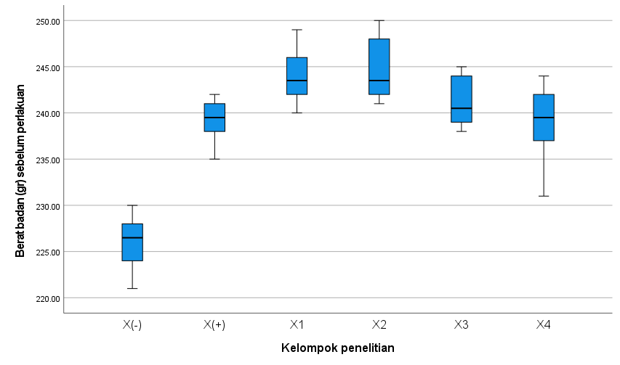

C.1.2. Berat badan minggu ke-1
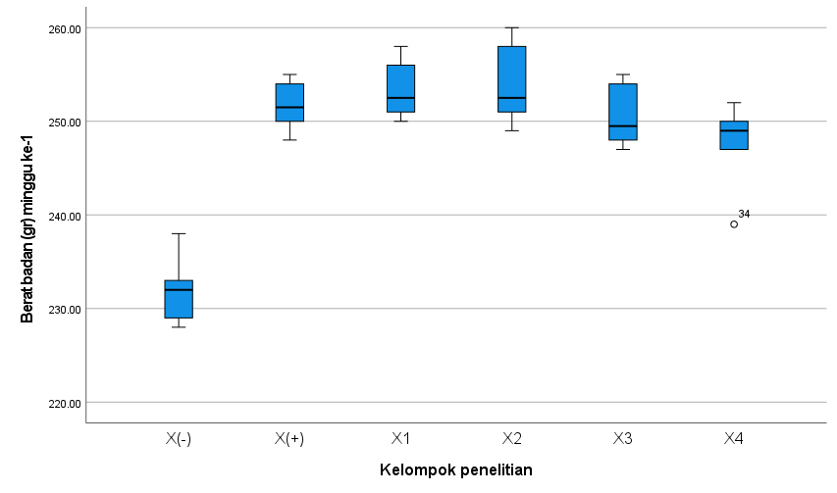

C.1.3. Berat badan minggu ke-2
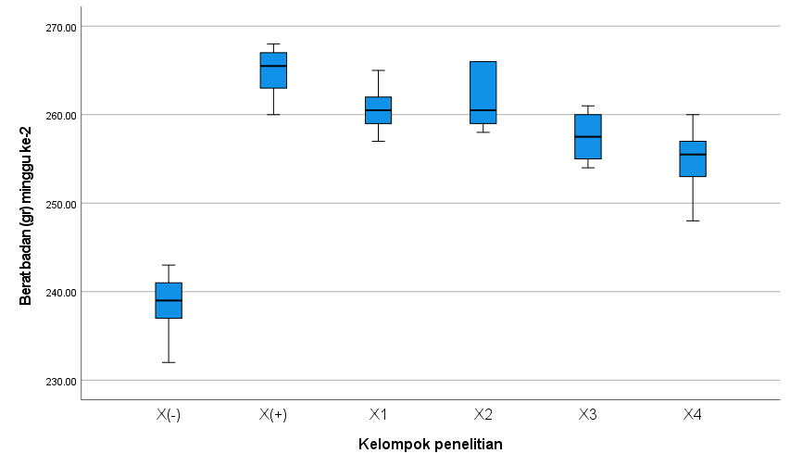
C.1.4. Berat badan minggu ke-3
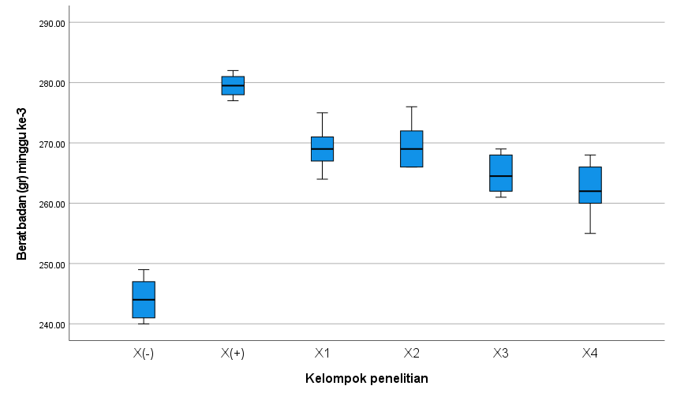
C.1.5. Berat badan minggu ke-4
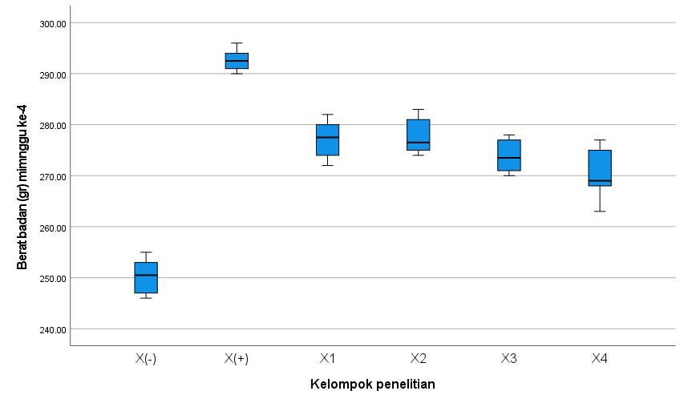

C.2. Lee-Index
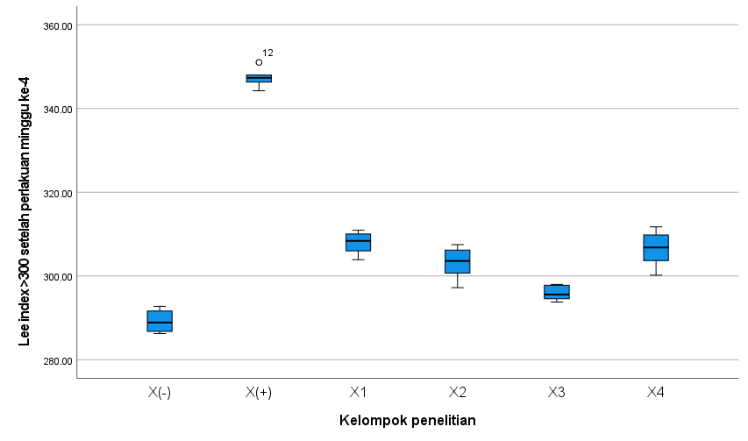
C.3. hs-CRP
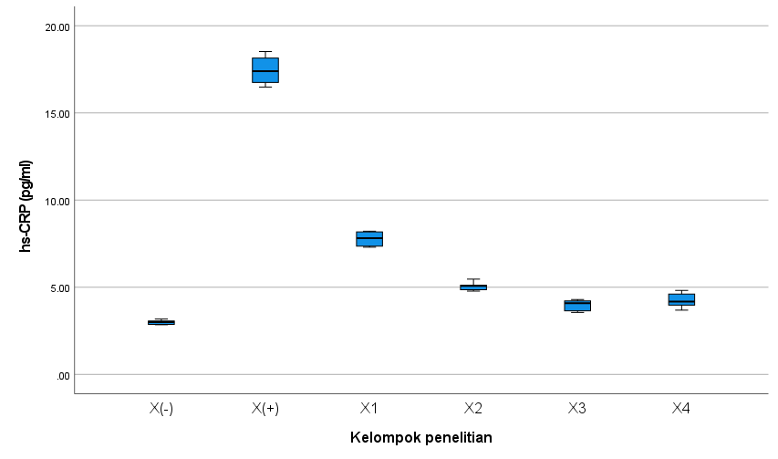
C.4. Total Kolesterol
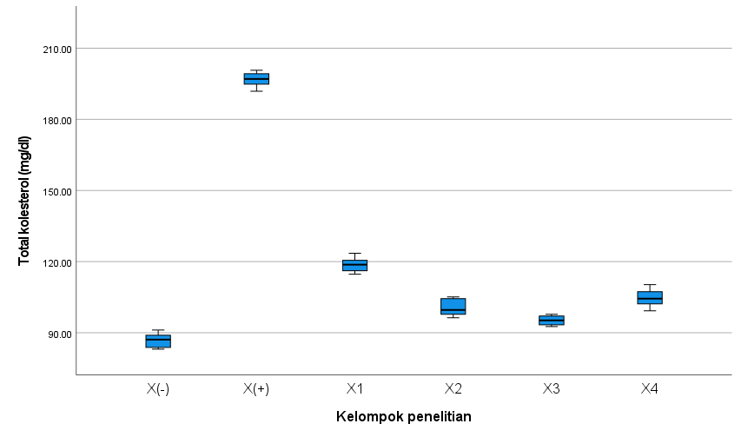

C.5. Trigliserida
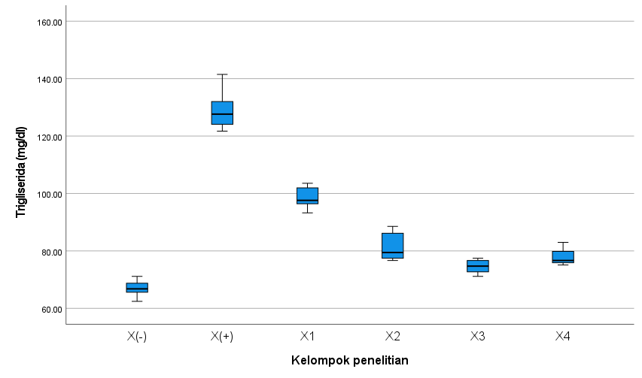
C.6. LDL
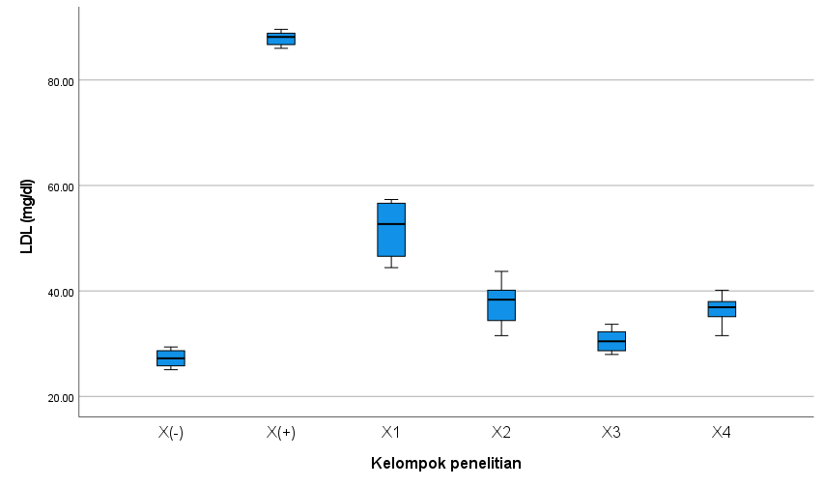
C.7. HDL
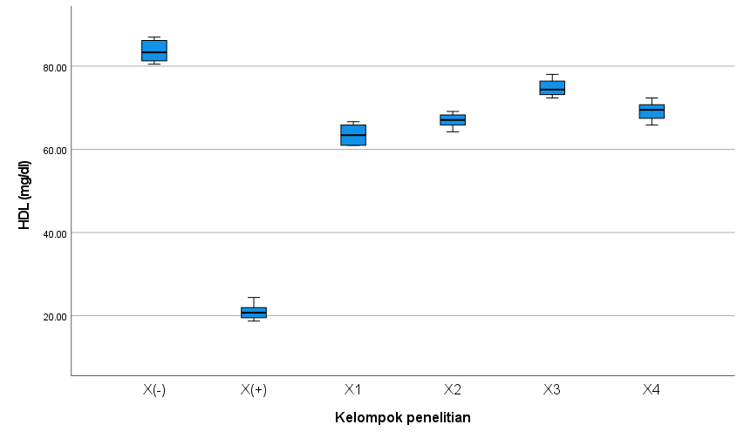
- Hasil Pengukuran HPLC (Total Isoflavon dan Genistein)
