INTRODUCTION
Spleen is the largest secondary lymphoid organ that plays role in the human immune system as well as in recycling and filtering blood. It is the second-largest hematopoietic center after the liver since the week twelfth of embryonic development. Histologically, the spleen has stromal and parenchymal (splenic pulp) parts with an absence of cortex and medulla. The splenic pulp can be divided into the red and white pulp. The red pulp contains macrophages that mostly serve to filter blood and recycle iron from senescent red blood cells. Diverse splenic populations not only trap and remove blood-borne antigens but also initiate innate and adaptive immune responses against pathogens. The white pulp is structurally similar to a lymph node, it contains T-cell and B-cell zones and allows the generation of antigen-specific immune responses that protect the body against diseases caused by blood-borne bacterial, viral, and fungal infections.¹ Thus, the spleen is important for the immune system in both humans and animals.
In general, aging can be defined as a natural declining process of physiological functions in organisms. The aging spleen showed a reduced number of lymphocytes, total T helper, T cytotoxic cells, and B cells, which of them are marks of immune response relation.² Aging is also related to the increased number of pro-inflammatory cytokines and macrophages as the defense immune response.³ Those are some of the reasons why the elderly are more prone to getting diseases. In the aging spleen, changes in both stroma and parenchyma have been reported, including a lower number of lymphocytes, fewer germinal centers, and an increased number of macrophages and fibroblasts in the reticular connective tissue, leading to fibrosis.^{4,5} Other than aging, infection, radiation, and toxic substances might also lead to fibrosis.⁶
The presence of fibrosis in the spleen can be an indicator of the aging process which is triggered by inflammatory reactions.⁵ Fibrosis is a pathological condition defined by the accumulation of extracellular matrix (ECM) components. Fibrosis often emerges in the red pulp of the parenchymal spleen and extends to the white pulp in more severe cases. Physical activity is known to be able to gradually decrease the production of inflammatory cytokines and ROS, leading to reduced synthesis of extracellular matrix by fibroblasts. It can also inhibit the differentiation of fibroblast to myofibroblast activation, eventually preventing fibrosis.⁷
The intensity of physical activity can be categorized into light, moderate, and vigorous activities. Moderate and vigorous physical activities are recommended for adults between 18-65 years old to obtain personal fitness, prevent unhealthy weight gain and chronic diseases, as well as stabilize body metabolism to slow down the aging process.⁸ Moderate physical activity also reduces the risk of infection compared with a sedentary lifestyle, but prolonged physical activity can also increase the infection risk.⁹ Collectively, regular physical activity is very essential to maintain and enhance body fitness, endurance, and immune system.¹⁰ Knowing the benefits of physical activity on the immune system, we aimed to study the effects of mild and moderate-intensity treadmill exercise on the aging spleen by examining the fibrosis fraction area and the number of macrophages in d-Galactose-induced aging rat models.

MATERIALS AND METHODS
Research Design
This study was a posttest-only control group design. The study used 3-month-old male Wistar rats administered with D-galactose to promote aging. Some of the rats were then given a 4-week low and moderate treadmill exercise conducted at the Physiology Department, Faculty of Medicine, Public Health, and Nursing (FK-KMK), Universitas Gadjah Mada (UGM). The spleen samples were processed at Anatomy Department, FK-KMK UGM.
Ethical Clearance
The experimental procedures were approved by the Ethics Committee of the Integrated Research and Testing Laboratory (LPPT), Universitas Gadjah Mada (reference number: 00055/04/LPPT/VI/2017).
Study Subjects
Twenty-four male Wistar rats weighing between 200–300 g were obtained from the Department of Pharmacology and Therapy, Faculty of Medicine, Public Health and Nursing (FK-KMK), Universitas Gadjah Mada (UGM), Faculty of Pharmacy UGM, and Universitas Islam Indonesia. Before the experiment, the rats underwent acclimatization for seven days. They were kept at room temperature with a light‐dark cycle (12/12 h). Food and water were available ad libitum. The rats were randomly divided into four groups.
Sample Size Determination
The sample size was determined with the E = N – T formula, with E being a constant/fixed value of 10-20, N is the number of rats in each group times the number of treatment groups, and T is the number of treatment groups. In this experiment, there were four treatment groups. Assuming there were six rats per group, we obtained the E of 20, which was still within the constant range. Therefore, we used twenty-four rats for this experiment. They were randomly divided into four groups: G1 (control group), G2 (administered with d‐Galactose, no exercise regimen), G3 (administered with d‐Galactose, low-intensity treadmill exercise), and G4 (administered with d‐Galactose, moderate-intensity treadmill exercise).¹¹
Intervention
A dose of 300 mg/kgBW d‐Galactose in 0.9% NaCl (Tokyo Chemical Industries, Japan) was administered daily to G2, G3, and G4 for 4 weeks. The d-Galactose injected rats were adapted to the treadmill apparatus (Gama Tread version 2010, FK-KMK UGM) at the slowest speed (11 m/min) with 0° slope for 3-7 days following the modified Brown et al. (2007) protocol.¹² The six rats showing unwillingness to run were included in the G2 group while the rest were divided into G3 and G4. The rats in G3 and G4 were then given another exercise to measure the maximum running speed of each rat which was needed to estimate the VO2max index with the following formula:
VO2maxIndex=[maximum speed (m/min)]×[slope(%)×100]×[BW (kg)].
A slope of 0° equals 1 in the formula. The rats in G3 and G4 were given treadmill exercise four times a week for four weeks. Each treadmill exercise was conducted at 0° slope and started with five minutes of warming-up (20% of individual VO2max Index), 20 minutes of the main exercise with low-intensity treadmill exercise (45% of individual VO2max Index) for G3 and moderate-intensity treadmill exercise (55% of individual VO2max Index) for G4, continued with 5 minutes of cooling down (20% of individual VO2max Index).
Spleen Measurements
The weight, length, and width measurements of the spleens from each rat were conducted after the four-week intervention. The weights were measured using a digital weight scale while the length and width of the spleens were measured using a caliper.
Laboratory Analysis
The spleens were collected after the four-week intervention. Ketamine HCl 40 mg/kgBW (PT Guardian Pharmatama, Jakarta, Indonesia) was used to anesthetize the rats. The rats were then euthanized, and their spleens were collected. The spleens were stored in 10% neutral buffered formalin and then processed using paraffin methods for further histological examination. The histological slides were stained with a combination of Weigert’s hematoxylin and picrosirius red for fibrosis observation and CD68 antibody (Abcam Ab955) for macrophage immuno-histological observation. From each histological slide, 10 random fields of view were examined using a light microscope with the magnifications of 40x for the picrosirius red-stained slides and 400x for the immune-histological slides with CD68 marker. The random fields of view were then photographed using Optilab, and the images were analyzed using ImageJ software to determine the percentage of fibrosis fraction area and macrophage cell count.
Statistical Analysis
The data were analyzed statistically using SPSS software. The Shapiro-Wilk test showed that the data were normally distributed, therefore One-way ANOVA was used to analyze the difference between groups, followed by Tamhane and Bonferroni post-hoc tests.

RESULTS
Spleen Measurements
Table 1 shows the results of spleen measurements, covering the weight, length, and width of the organ. The data showed that there were no differences in spleen size among all groups (P > 0.05), indicating that treadmill exercise and the administration of d-Galactose did not affect the size of the spleen.
Percentage of Fibrosis
Figure 1 shows the percentages of fibrosis of all groups. The groups with d-Galactose administration showed significantly higher percentages of fibrosis than the control group (G1) with the P values of 0.027 (G1:G2), 0.022 (G1:G3), and 0.002 (G1:G4). G3 and G4 were not significantly different from G2, however, G3 and G4 showed lower percentages of fibrosis than G2 as seen in Figure 1. It indicates that low and moderate-intensity treadmill exercises for four weeks were not sufficient to significantly lower the percentage of spleen fibrosis. The data shown in Figure 1 were also supported by the histological imaging presented in Figure 2. In G2, G3, and G4, more collagen fibers were seen mostly in the peripheral part of the spleen, close to the spleen capsule as indicated by the bracket. The picrosirius red staining dyed the collagen fibers red.
Macrophage Cell Count
The macrophage cell count results show that G2 (P = 0009) and G3 (P = 0.017) had higher macrophage cell counts compared to the control group as presented in Figure 3. The number of macrophages in G4 was higher than G1 but it did not show any significant difference, showing that moderate-intensity treadmill exercise could lower the spleen macrophage cell count in d-Galactose-induced aging rats. The immune-histological imaging also showed a similar pattern, where CD68 macrophages (brown-stained cells) were more densely observed in G2 and G3 than in G1 and G4 as shown in Figure 4.

DISCUSSION
Aging induction using d-Galactose administration caused the spleen to show aging markers such as increased fibrosis and number of macrophages, without any changes in weight, length, or width of the organ. The low and moderate-intensity treadmill exercise given to aging rats for four weeks could not significantly lower the fibrosis fraction area. However, the moderate-intensity treadmill exercise was able to reduce the number of macrophages in the aging spleen.
In this study, the aging spleen did not show any different measurements among groups. This might have been due to the preservation of spleen samples in neutral buffered formalin before the measurements were taken. The preservation could change the shape and consistency of the spleens, therefore affecting the gross measurements of the organs.
Aging is related to the pathophysiological processes in organisms that lead to health complications, diseases, and the decline of memory, mobility, and cardiac function.¹³ d-Galactose is a reducing sugar that can be found in daily food intakes such as honey, cherries, yogurt, butter, and many more with a concentration of less than 10 mg/dL. It has also been reported that exogenous d-Galactose can induce aging in several organs including the spleen by increasing oxidative stress, apoptosis, and inflammation.¹⁴ This was in accordance with our results where all d-Galactose induced rats showed higher percentages of fibrosis fraction area and macrophage cell count.
In this study, the physical activities given to the animal models were unable to significantly decrease the percentage of fibrosis fraction area. However, the data showed reduced percentages of fibrosis in both light and moderate-intensity treadmill exercise groups. Physical activity is known to be able to gradually decrease the production of inflammatory cytokines and ROS, leading to reduced synthesis of extracellular matrix by fibroblasts. It can also inhibit the differentiation of fibroblast to myofibroblast activation, eventually preventing fibrosis.⁷ Even though physical activity reduces fibrosis, the spleen cannot completely return to its normal condition because of its limited ability to regenerate immunologically. Spleen fragment appears to be able to regenerate functionally and histologically, but it remains unclear whether it can fully regenerate immune competence.¹⁵
Fibrosis in the spleen is characterized by changes in stiffness and coloration, as well as an increased amount of collagen and fibroblast that can be seen in both capsular and parenchymal areas.¹⁶ Spleen capsular fibrosis was reported to develop before the fibrosis in the red pulp which might be caused by the more abundant connective tissue containing fibroblasts in the capsule area as seen in Figure 2.^{6,16}
The aging spleen is also characterized by an increased number of macrophages as the pro-inflammatory agents of the organ. Macrophages that can be found in red, white, and marginal zones of the spleen will protect the body against exogenous pathogens.^{4,17,18} Macrophages in each spleen zone show different characteristics, the white pulp mostly consists of CD68+ macrophages while F4/80 and CD206 macrophages can be found in the red pulp. There are many cytokines involved in the activation of macrophages through various pathways. In some cases, Interferon Gamma (IFN-γ), low molecular weight hyaluronic acids (LMWHA), and lipopolysaccharides (LPS) activate macrophages through classical activation of macrophages (CAMs), characterized by increased reactive oxygen. Interleukin 4 (IL-4) and IL-13 activate macrophages through alternative activation of macrophages (AAMs) which is characterized by the production of polyamines, leading to the activation of myofibroblast and resulting in fibrosis.⁷
The moderate-intensity treadmill exercise given in this experiment was more effective in reducing macrophage infiltration. In line with that, Jun et al. (2014) also reported that moderate-intensity exercise reduced the marker of macrophage infiltration in ovariectomized rats more than low-intensity exercise. Moderate-intensity exercise can reduce proinflammatory cytokine production.¹⁹
Physical activity has many ways to decrease the inflammatory response of the body and inhibits the aging process. Physical activity directly affects inflammation by reducing IFN-γ which is produced by Th1, natural killer (NK) cells, CD4+, and T lymphocytes.²⁰ IFN-γ is an important cytokine for both innate and adaptive immune systems against pathogens like bacteria and viruses. Lower IFN-γ is associated with a temporary decrease in T1-mediated immunity, low peripheral CD8+ and T lymphocytes, as well as an increase in anti-inflammatory response.^{21,22}
The neuroendocrine system also plays role in regulating body homeostasis during exercise. Acute exercise affects the neuroendocrine system via hormonal responses such as catecholamine, cortisol-estradiol, and testosterone (in men) to improve the immune system. There are various neuroendocrine pathways related to the body’s immune system, for example, Hypothalamic-Pituitary-Adrenal (HPA) Axis, Sympathetic Nervous System (SNS), Estradiol, and Testosterone hormones.²³ The HPA axis triggers the anterior pituitary to produce adrenocorticotropic hormone (ACTH) leading to the synthesis of glucocorticoid by the adrenal gland.²⁴ Exercise also causes motor center and afferent impulses to release some hypothalamic-releasing factors that will increase the secretion of ACTH.²⁵ Glucocorticoid, especially cortisol, is known to affect immunological processes by suppressing inflammation.^{26,27} Other than that, increased SNS activity also initiates the release of catecholamine (adrenaline and noradrenaline), which is known as a down-regulator of lipopolysaccharides (LPS).²⁵
This study has some limitations. The fibrosis and macrophage data presented in the Results section showed down-trend patterns when given low and moderate-intensity treadmill exercise. However, the decreases were not significant, except for macrophage cell count in aging rats given moderate-intensity training. This might be due to the limited duration of the exercise given which was only four weeks. For future studies, a longer duration of the exercise should be considered to see the longer-term effects of low and moderate-intensity treadmill exercise, as well studying the effects of the given exercise in other organs. The results of this and future studies can later be used to formulate a training regimen for the elderly to lessen their risks of having fibrosis and inflammation in their visceral organs.

CONCLUSION
The administration of d-Galactose in rats caused fibrosis and an increased number of macrophages in the spleen. Low and moderate-intensity treadmill exercise for four weeks could not lower the percentages of fibrosis fraction area. However, the moderate-intensity treadmill exercise was effective in lowering the number of macrophages.

ACKNOWLEDGMENTS
The authors were grateful to Denny Agustiningsih, Wiwit Ananda, and Suparno for the support, guidance, and assistance in conceptualizing and conducting the experiment. This study was a part of Pramita Dwinda Mulyana's thesis, and it was funded by the Research Grant of Public Funding of Universitas Gadjah Mada (No. UPPM/221/M/05/04/05.17).

REFERENCES
- Bronte V, Pittet MJ. The spleen in local and systemic regulation of immunity. Immunity. 2013;39(5):806-818. doi:10.1016/j.immuni.2013.10.010
- Flaherty DK, Wagner CA, Gross CJ, Panyik MA. Aging and lymphocyte subsets in the spleen and peripheral blood of the Sprague-Dawley rat. Immunopharmacol Immunotoxicol. 1997;19(2):185-195. doi:10.3109/08923979709007658
- Linehan E, Fitzgerald DC. Ageing and the immune system: focus on macrophages. Eur J Microbiol Immunol (Bp). 2015;5(1):14-24. doi:10.1556/EUJMI-D-14-00035
- Masters AR, Jellison ER, Puddington L, Khanna KM, Haynes L. Attrition of T Cell Zone Fibroblastic Reticular Cell Number and Function in Aged Spleens. Immunohorizons. 2018;2(5):155-163. doi:10.4049/immunohorizons.1700062
- Aw D, Hilliard L, Nishikawa Y, Cadman ET, Lawrence RA, Palmer DB. Disorganization of the splenic microanatomy in ageing mice. Immunology. 2016;148(1):92-101. doi:10.1111/imm.12590
- Li X, Zhu L, Wang B, Yuan M, Zhu R. Drugs and Targets in Fibrosis. Front Pharmacol. 2017;8:855. doi:10.3389/fphar.2017.00855
- Wynn TA, Ramalingam TR. Mechanisms of fibrosis: therapeutic translation for fibrotic disease. Nat Med. 2012;18(7):1028-1040. doi:10.1038/nm.2807
- Takagi D, Nishida Y, Fujita D. Age-associated changes in the level of physical activity in elderly adults. J Phys Ther Sci. 2015;27(12):3685-3687. doi:10.1589/jpts.27.3685
- Gleeson, M. Effect of Exercise on Immune Function. Sports Science Exchange. 2015;28(151):1-6. https://www.gssiweb.org/sports-science-exchange/article/sse-151-effects-of-exercise-on-immune-function
- Nieman DC, Wentz LM. The compelling link between physical activity and the body's defense system. J Sport Health Sci. 2019;8(3):201-217. doi:10.1016/j.jshs.2018.09.009
- Mulyana PD, Wasityastuti W, Anggorowati N. The effect of physical activity on spleen fibrosis and macrophage number in d-Galactose induced aging Wistar rat model. Yogyakarta: ETD UGM Theses and Dissertations Repository; 2018. http://etd.repository.ugm.ac.id/home/detail_pencarian/169142
- Brown DA, Johnson MS, Armstrong CJ, et al. Short-term treadmill running in the rat: what kind of stressor is it? J Appl Physiol. 2007;103(6):1979-1985. doi:10.1152/japplphysiol.00706.2007
- Ji M, Su X, Liu J, et al. Comparison of naturally aging and D-galactose induced aging model in beagle dogs. Exp Ther Med. 2017;14(6):5881-5888. doi:10.3892/etm.2017.5327
- Shwe T, Pratchayasakul W, Chattipakorn N, Chattipakorn SC. Role of D-galactose-induced brain aging and its potential used for therapeutic interventions. Exp Gerontol. 2018;101:13-36. doi:10.1016/j.exger.2017.10.029
- Tan JKH, Watanabe T. Determinants of postnatal spleen tissue regeneration and organogenesis. NPJ Regen Med. 2018;3:1. doi:10.1038/s41536-018-0039-2
- Jones TC, Ward JM, Mohr U, Hunt RD. Hemopoietic System: Monographs on Pathology of Laboratory Animals. Springer: Berlin; 1990.
- Gordon S, Plüddemann A. Tissue macrophages: heterogeneity and functions. BMC Biol. 2017;15(1):53. doi:10.1186/s12915-017-0392-4
- Tarantino G, Scalera A, Finelli C. Liver-spleen axis: intersection between immunity, infections and metabolism. World J Gastroenterol. 2013;19(23):3534-3542. doi:10.3748/wjg.v19.i23.3534
- Jun JK, Lee WL, Park HG, Lee SK, Jeong SH, Lee YR. Moderate intensity exercise inhibits macrophage infiltration and attenuates adipocyte inflammation in ovariectomized rats. J Exerc Nutrition Biochem. 2014;18(1):119-127. doi:10.5717/jenb.2014.18.1.119
- Ivashkiv LB. IFNγ: signalling, epigenetics and roles in immunity, metabolism, disease and cancer immunotherapy. Nat Rev Immunol. 2018;18(9):545-558. doi:10.1038/s41577-018-0029-z
- de Souza DC, Matos VAF, Dos Santos VOA, et al. Effects of High-Intensity Interval and Moderate-Intensity Continuous Exercise on Inflammatory, Leptin, IgA, and Lipid Peroxidation Responses in Obese Males. Front Physiol. 2018;9:567. doi:10.3389/fphys.2018.00567
- Ertek S, Cicero A. Impact of physical activity on inflammation: effects on cardiovascular disease risk and other inflammatory conditions. Arch Med Sci. 2012;8(5):794-804. doi:10.5114/aoms.2012.31614
- Fragala MS, Kraemer WJ, Denegar CR, Maresh CM, Mastro AM, Volek JS. Neuroendocrine-immune interactions and responses to exercise. Sports Med. 2011;41(8):621-639. doi:10.2165/11590430-000000000-00000
- Allen MJ, Sharma S. Physiology, Adrenocorticotropic Hormone (ACTH) [Updated 2021 Aug 17]. In: StatPearls [Internet]. Treasure Island (FL): StatPearls Publishing; 2022 Jan. Available from: https://www.ncbi.nlm.nih.gov/books/NBK500031/
- Kizaki T, Sato S, Sakurai T, et al. The effect of exercise on macrophage function. J Phys Fitness Sports Med. 2012;1(1):113-123. doi:10.7600/jpfsm.1.113
- Ponticelli C, Locatelli F. Glucocorticoids in the Treatment of Glomerular Diseases: Pitfalls and Pearls. Clin J Am Soc Nephrol. 2018;13(5):815-822. doi:10.2215/CJN.12991117
- Hodgens A, Sharman T. Corticosteroids. [Updated 2021 Oct 16]. In: StatPearls [Internet]. Treasure Island (FL): StatPearls Publishing; 2022 Jan. Available from: https://www.ncbi.nlm.nih.gov/books/NBK554612/

FIGURE CAPTIONS
Figure 1. The Percentage of Fibrosis in All Groups. *P value < 0.05
Figure 2. Histological Imaging of the Spleen. A: G1, B: G2, C: G3, and D: G4; ↑: spleen capsule; [: area with visible fibrosis; 40x magnification.
Figure 3. Spleen Macrophage Cell Count in All Groups. *P value < 0.05
Figure 4. The immuno-histological imaging of the spleens from all groups. A: G1, B: G2, C: G3, and D: G4; ↓: lymphocytes; →: macrophages; 400x magnification.

TABLE CAPTIONS
Table 1. Spleen Measurements (Weight, Length, and Width) among Groups

Table 1. Spleen Measurements (Weight, Length, and Width) among Groups
Group | n | Weight (gr) | Length (cm) | Width (cm)
G1 | 6 | 911,08±112,64 | 4,03±0,18 | 1,05±0,05
G2 | 6 | 860,25±240,55 | 3,9±0,32 | 0,98±0,11
G3 | 6 | 1133,16±329,57 | 4,01±0,36 | 1,1±0,1
G4 | 6 | 901,92±210,33 | 3,6±0,28 | 1,1±0,12
P value |  | 0,215 | 0,164 | 0,197

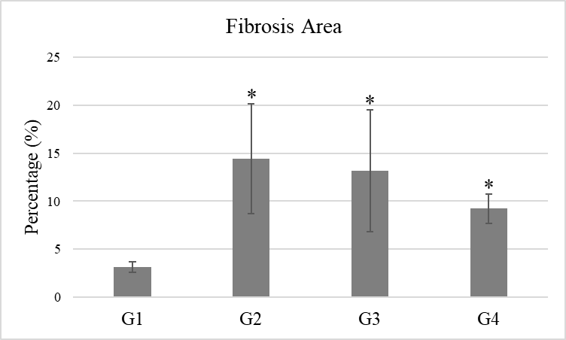
Figure 1. The Percentage of Fibrosis in All Groups. *P value < 0.05

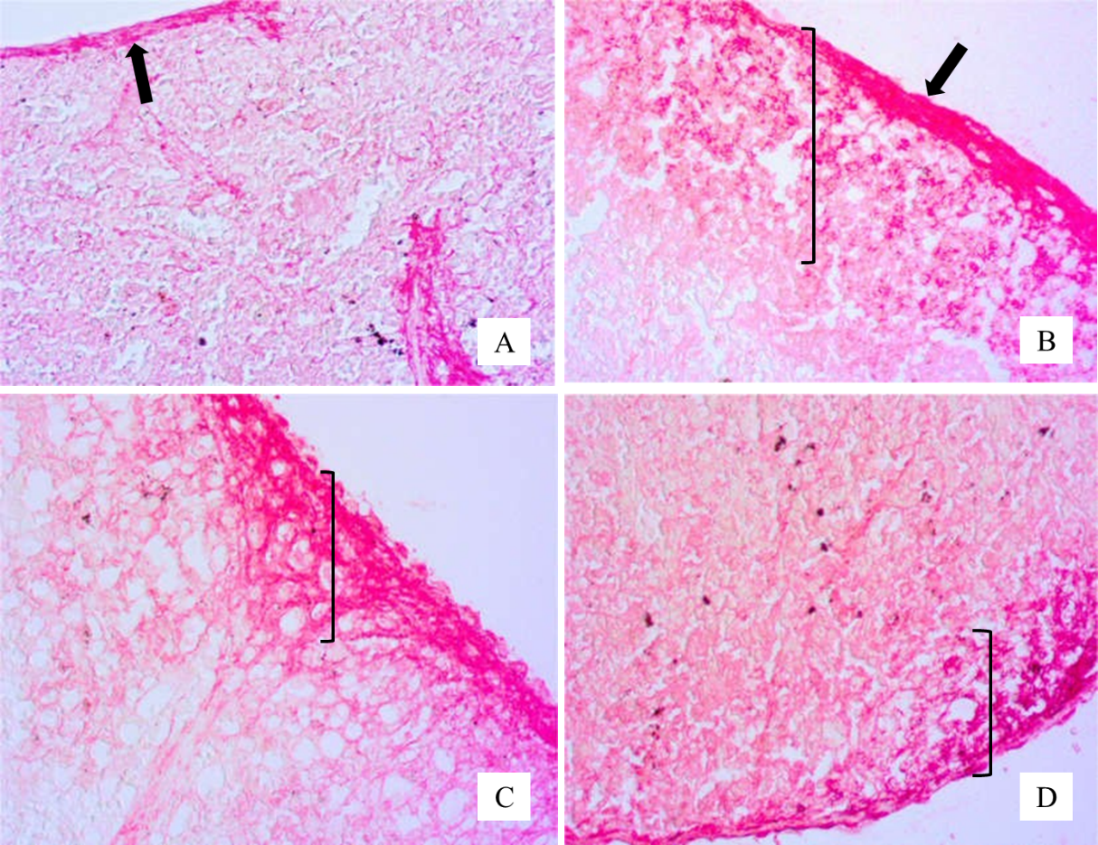
Figure 2. Histological Imaging of the Spleen. A: G1, B: G2, C: G3, and D: G4; ↑: spleen capsule; [: area with visible fibrosis; 40x magnification.

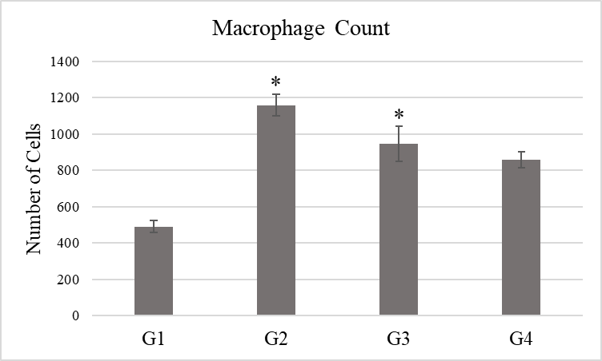
Figure 3. Spleen Macrophage Cell Count in All Groups. *P value < 0.05

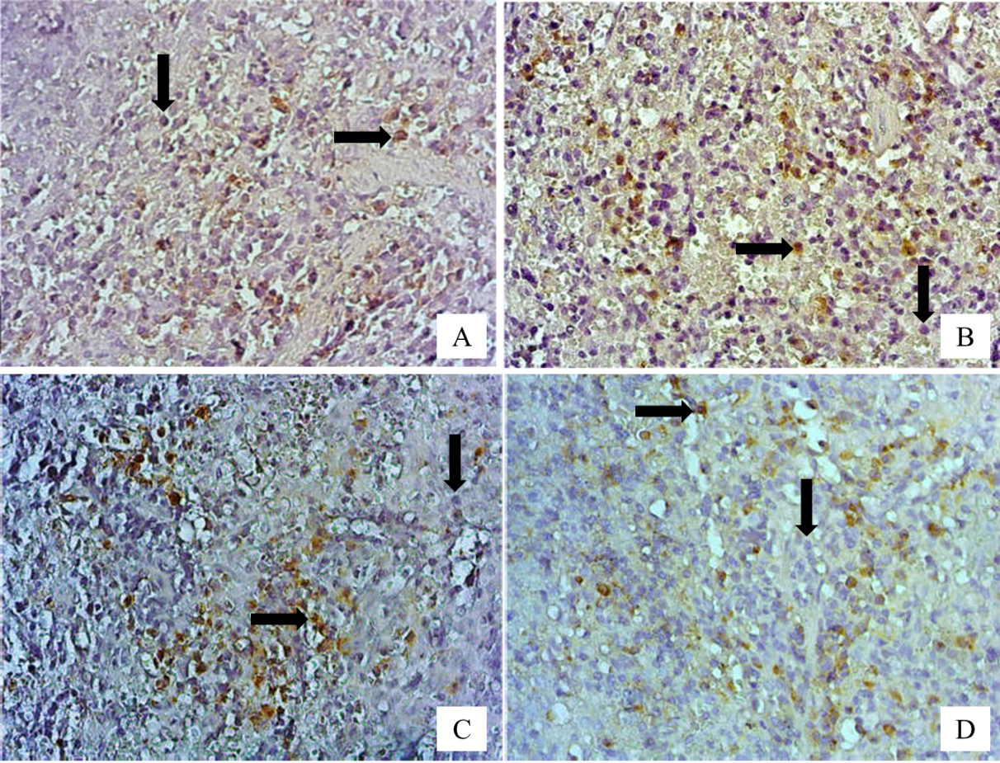
Figure 4. The immuno-histological imaging of the spleens from all groups. A: G1, B: G2, C: G3, and D: G4; ↓: lymphocytes; →: macrophages; 400x magnification.

