Potential reviewers
- Imelda R Sianipar (h index Scopus 5)
Email: imelda.rosalyn@ui.ac.id
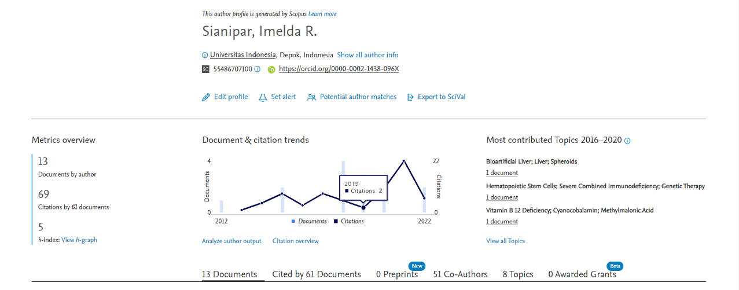

- Jajar Setiawan (h index Scopus 5)
Email: jajarsetiawan@ugm.ac.id
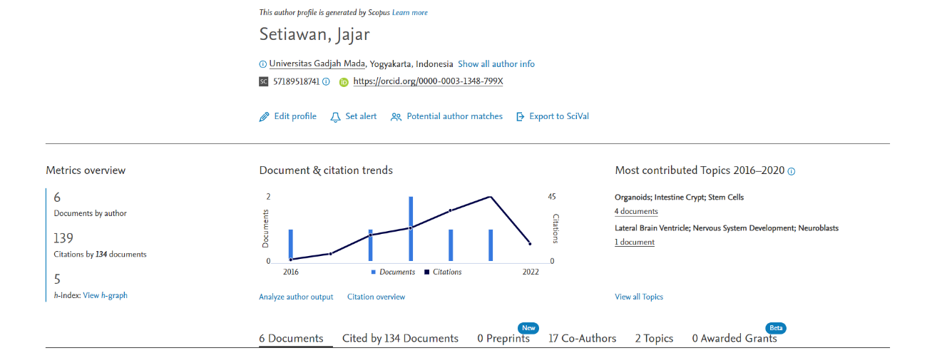
- Emy Huriyati (h index Scopus 6)
Email: emyhuriyati@ugm.ac.id
