Journal of Biomedicine and Translational Research (JBTR)
ISSN: 2503-2178

CONFLICT OF INTEREST DECLARATION AND COPYRIGHT TRANSFER AGREEMENT FORM

Journal of Biomedicine and Translational Research (JBTR) requires a formal written conflict of interest declaration and transfer of copyright from the author(s) for each article published. We therefore ask you to complete and return this form along with the final paper layout that should be corrected by Author(s) within 2x24 hours. Your cooperation is essential and appreciated. Any delay will result in a delay in publication.

Title of the Manuscript
The Effect of Duration of Administration and Discontinuation of Fluorometholone

Eye Drops on The Thickness of The Trabecular Meshwork Extracellular Matrix

Name of All Author(s):
dr. Sandi Muslim, dr. Arnila Novitasari Saubig SpM (K)

dr. Riski Prihatningtias Sp. M (K), Dr. A. Kentar A. S. MSi. Med Sp. M (K)
Dr. dr. Fifin L. Rahmi, M.S.,Sp.M(K)

Corresponding Author:
dr. Sandi Muslim

Please tick one of the following boxes:

✓
◻ We have no conflict of interest to declare.

◻ We have a competing interest to declare (please fill in box below):

1. I/We submit to the Journal of Biomedicine and Translational Research for the above manuscript. I/We certify that the work reported here has not been published before and contains no materials the publication of which would violate any copyright or other personal or proprietary right of any person or entity.

2. I/We hereby agree to transfer to Faculty of Medicine, Diponegoro University the copyright of the above - named manuscript. I/We reserve the following: (1) All proprietary rights other than copyright such as patent rights. (2) The right to use all or part of this article in future works of our own such as in books and lectures.

Author(s) (filled in and signed by each author)
(Write name and Title of Author)

1. |   Signature:
1. | Name: dr. Sandi Muslim  Date: 07-03-2022
2. | Signature: 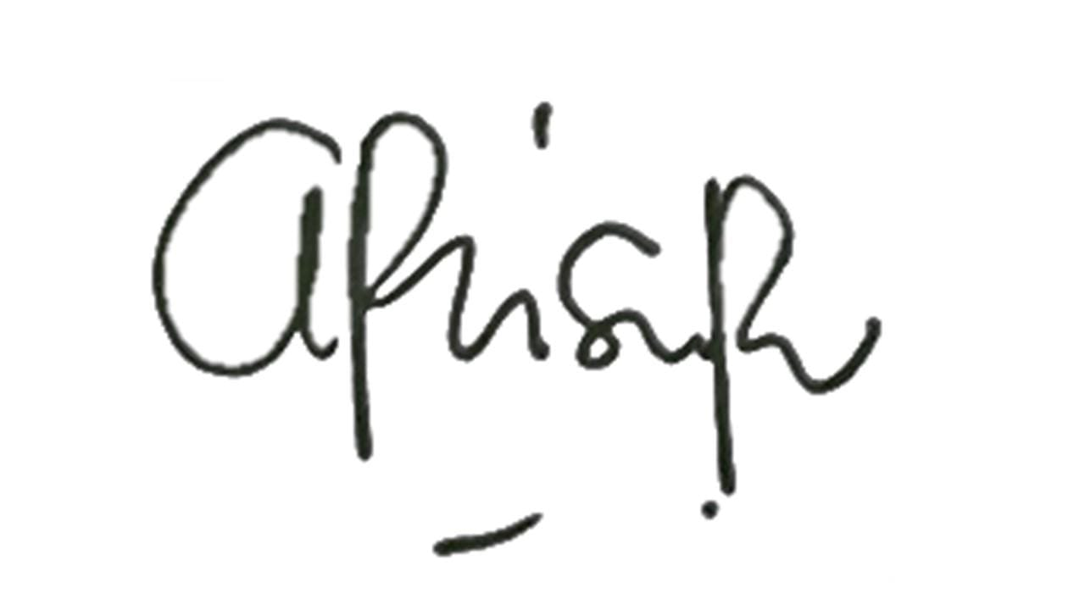
2. | Name: dr. Arnila Novitasari Saubig SpM (K)  Date: 07-03-2022
3. | Signature: 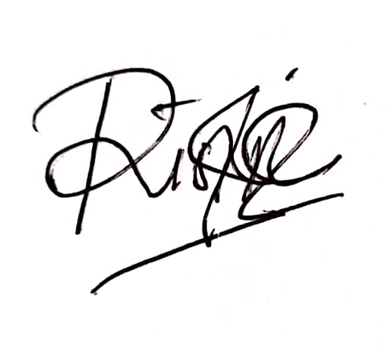
3. | Name: dr. Riski Prihatningtias Sp. M (K)  Date: 07-03-2022
4. | Signature: 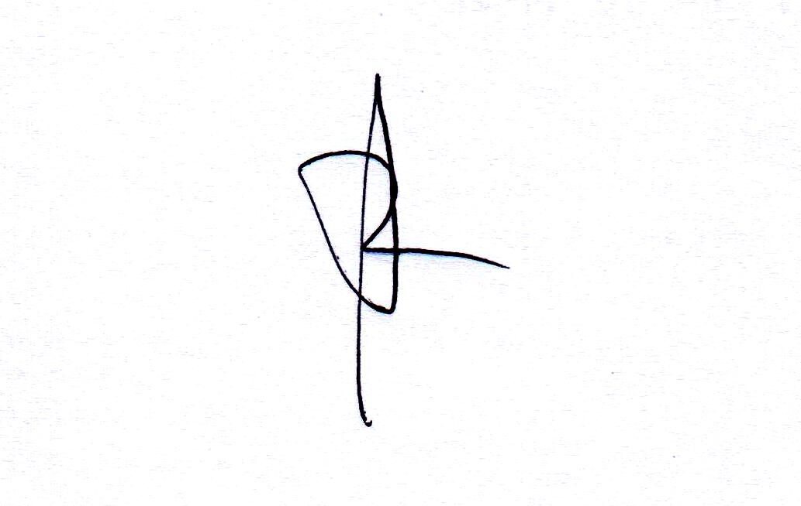
4. | Name: Dr. A. Kentar A. S. MSi.Med Sp.M(K)  Date: 07-03-2022
5. | Signature: 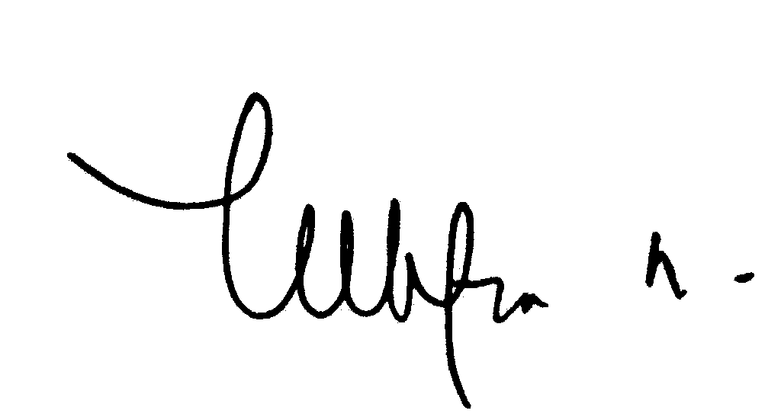
5. | Name: Dr. dr. Fifin L. Rahmi, M.S.,Sp.M(K)  Date: 07-03-2022
6. | Signature:
6. | Name:  Date:

◻ Please check this box if you are submitting this on behalf of all authors.

