Subacute spinal subdural hematoma in one year old boy due to severe hemophilia A: A case report

Tun Paksi Sareharto^{1*}, Suciati Jandraningrum¹, Vetty Kurniawati¹, Agus Priambodo², Sukma Imawati³, Alifiani Hikmah Putranti¹
¹Department of Pediatrics, Diponegoro University Medical School/Dr. Kariadi Hospital, Semarang, Indonesia
²Department of Surgery, Diponegoro University Medical School/Dr. Kariadi Hospital, Semarang, Indonesia
³Department of Radiology, Diponegoro University Medical School/Dr. Kariadi Hospital, Semarang, Indonesia

*Corresponding Author: Tun Paksi Sareharto, paksi@fk.undip.ac.id

Subacute spinal subdural hematoma in hemophilia A

ABSTRACT

Background: Paraparesis may result from a variety of or primary central nervous system conditions or systemic disorders, and although rare, it may also caused by spinal cord hemorrhage. Spontaneous spinal subdural hematomas (SSDH) are most frequently associated with coagulopathies. People with congenital clotting disorders such as hemophilia are at increased risk for experiencing spontaneous spinal subdural hemorrhage at unusual sites, which is a rare case and a neurological emergency required urgent recognition. We report a boy with paraparesis caused by subacute SSDH due to hemophilia A.
Case Presentation: A 15 month-old boy, with chief complain of difficulty in moving his leg and pain when walking, physical examination revealed a lower motor neuron lesion, laboratory showed a low factor VIII at 0.4% level, Magnetic Resonance Imaging (MRI) showed anterior and posterior displacement of the spinal cord due to the presence of the subacute subdural hematoma extending from 1st cervical to 1st lumbar spine. He assessed with inferior paraparesis caused by subacute spinal subdural hematoma due to hemophilia A. The patient’s condition was improved after received replacement therapy of factor VIII and proper laminectomy neurosurgery.
Conclusion: This case showed an approach for a comprehensive diagnostic and management for a rare case of paraparesis due to hemophilia. Pay attention to the physical examination which shows a lower motor neuron lesion in an acute paralysis cases, there is still a possibility that it is an upper motor neuron lesion.

Key word:
paraparesis inferior, hemophilia A, spinal subdural hematoma, factor VIII

INTRODUCTION

Hemophilia is an inherited hemorrhagic disorder due to clotting factor deficiency. Hemophilia A is the most common hemophilic case (up to 85%), is an X-linked recessive disease due to factor VIII deficiency. One of the most common cause of morbidity and mortality of hemophilia is central nervous system bleeding. Intraspinal bleeding especially subdural hematoma is extremely rare.^{[1]} Despite its rarity, spinal subdural hematoma (SSDH) is a neurological emergency, required urgent recognition. It can cause a paralysis, a weakness or partial loss of muscle function for one or more muscle groups that may impaired mobility of the affected part.^{[2, 3]}

The burden of the disease was not only caused by neurological deficits and physical impairment due to spinal cord injury, but also from serious psychosocial problems. Often neglected, symptoms, signs, and possible causes of spinal cord injury in children needed to be assessed carefully to avoid diagnostic and treatment delay of this medical emergency.^{[4]} Early diagnosis and treatment improves outcome.^{[5]} A rare case of a 15 month-old boy with paraparesis caused by subacute SSDH due to hemophilia A is reported and discussed.

CASE REPORTS

A 15 month-old boy, with body weight 9.5 kgs and body length 79 cm, presented with inability to walk and in pain while he tried to stand from 4 days prior to admission. One month before, there was limitation of upward and sideward movement of the neck, although seemed clumsy but walking was still possible. There was no recent trauma, but patient had history of frequent spontaneous bruising on his feet and hands. Patient was once admitted to hospital due to low hemoglobin level (6.5 g/dL) and was transfused with 100 ml of packed red cell (PRC). Family history showed that patient’s father once bled after circumcision but medical diagnosis were neither elucidated nor confirmed.

On admission, patient was fully alert, in pain (visual analog scale (VAS) 3), flaccid paraparesis with hyporeflexia of both lower limbs (upper limb 5/5, lower limb 3/3), but urinary control and sensory function were preserved. Imaging study with X-ray showed no spinal deformity and normal pelvic girdle. Laboratory blood examination found a hypochromic microcytic anemia, normal creatine phosphokinase (CPK) level (60 U/L), and factor VIII deficiency (0.4%), indicated a hemophilia A.

Whole spine MRI (figure 1) found hyperintense images on both T1-weighted image (T1WI) and T2-weighted image (T2WI), a cystic lesion with septation at level of 1st cervical to 1st lumbar spine. 1st cervical spine to 9th thoracic spine were on the anterior aspect compressed the spinal cord to the posterior, then 10th thoracic spine to 1st lumbar spine were on the posterior aspect compressed the spinal cord to the anterior. This indicates a suspicious sign of a hematoma, which is late sub acute. On axial imaging of the spinal cord (figure 2), the lesion is located within the dural sac, it bounded by the paired lateral denticulate ligament and the dorsal septum, compressed the spinal cord but did not extend into the neural foramina or made direct contact with the bone. This means that the lesion is intradural extramedullary (subdural). The initial treatments were Fe supplementation 1,5 mg/kgBW/day and factor VIII transfusion (30 IU/kgBW/12 hours).

The patient was consulted to surgery department for hematoma evacuation. Laminectomy was performed on day 8th of admission, made by incision only on 10th of thoracic spine because the SSDH in the two locations were connected. At duramater there was a hematome capsule with yellowish fluid inside of it, as hematoma fluid, then analyzed (protein 199.6 mg/dL, glucose 94 mg/dL, polymorphonuclear (PMN) leukocytes 37 cells/μL, mononuclear (MN) leukocytes 47 cells/μL, erythrocyte 723,000 cells/μL). Erythrocyte cells are very high because the fluid comes from the blood, accompanied by the presence of leukocytes both PMN and MN, with high protein levels from the degradation of erythrocytes. There was no complication during procedure and bleeding was minimal.

After surgery, patient was sent to high care unit and was given an intravenous injection of tranexamid acid 10 mg/kgBW/8 hours, factor VIII 50 IU/kgBW/8 hours, and programmed to laboratorium examination and evaluate factor VIII level every 8 hours. Laboratory result was Hb 9.4 g/dL, hematocrite 31.1%, leucocyte 12,500/μL, platelet 575,000/μL, sodium 135 mmol/L, pottasium 3.9 mmol/L, chloride 105 mmol/L, calcium 2.3 mmol/L, and factor VIII level was 39.3%.

DISCUSSION

Paraparesis in children is rare. The incidence of paraparesis in children under 16 year was estimated at 0.49 per 100,000 children.^{[6]} Specifically of traumatic spinal cord injury (SCI) in children aged under 18 years, the incidence was 5.99 per 100,000 person-years.^{[6],[7]} Spinal cord lesions are typically divided into extradural (or epidural), intradural extramedullary and intramedullary.^{[8],[9]} The earliest sign of intradural extramedullary spinal lesion is pain, either with or without radicular pain. Accompanying symptoms that may be found are motor dysfunction, sensory dysfunction, reflex abnormalities, and autonomic dysfunction. Subacute subdural hematoma are included in the upper motor neuron (UMN) lesions although the neurological examination in this case showed otherwise. Hypoactive physiological reflexes and absent of pathological reflexes might also possibly seen early in UMN lesion.^{[9],[10]}

Spinal subdural hematoma in hemophilia is rarely found, there were only two cases out of 1,410 patients from 1960-1991, and six cases out of 2,500 patients in 1965-1976. The incidence of intracerebral bleeding was 65 out of these 2,500. Among these, they could find only one case of spinal subdural hematoma.^{[1]} In a meta-analysis of over 600 spinal hematomas, only 4% were subdural. Although SSDH are much less common than epidural hematomas, it progressed faster due to direct cord compression.^{[11]}

There was some proposed pathogenic mechanism of the bleeding although remained unclear. The source of the bleeding might come from (1) the rupture of vasculature within subarachnoid vessels with concomitant rupture into subdural space due to increased pressure whether in intra-abdomen or intrathoracic, or (2) the bleeding begins in the subdural space itself, which was only a “capillary slit” in normal conditions and is extended into a genuine space under pathological conditions (thus, subdural hematoma).^{[1],[11],[12]}

The clinical manifestations of SSDH present as acute back pain with signs of radicular pain. It is often accompanied by motor, sensory, and autonomic dysfunction including urinary retention, spinal pain, radicular pain, paresthesia, and headache. The severity varies from the presence of pain without motor or sensory deficits to quadriplegia. Hemiparesis may also occur depending on the location of the hematoma.^{[9],[12]}

The patient in this case was a boy aged 15 month-old, with chief complaint of inability to walk and seemed in pain when he tried to stand, occurred four days prior to admission. The patient also had difficulty in neck movement one month prior to admission, although he was still able to walk that time. At first we thought as lower motor neuron (LMN) lesion rather than UMN lesion. Laboratory examination include CPK and X-ray of the pelvic girdle were performed, but the result was within normal limit. Spine MRI were performed and extramedulary intradural cystic lesion with septation at level of 1st cervical spine until 1st lumbar spine were visualized. The spinal cord was compressed posteriorly at 1st cervical spine until 9th thoracic spine, and compressed anteriorly from 10th thoracic until 1st lumbar spine level (suspiciously caused by late subacute subdural hematoma). The onset was in line with patient’s chronological history with complete development of this hemorrhage until it presents sign and symptoms between week to month. This case also progressed gradually. Starting from difficulty of neck motion, followed by difficulty to stand up and pain on both legs, and finally weakness of both legs presented at the emergency room.

Without any comprehensive assessment of the patient and family history, onset and chronology of the disease, and other useful information, the diagnosis of spinal subdural hematoma in children is easily neglected. Several diagnostic evaluation should be performed. Relevant methods are mentioned in these cases such as CSF analysis, radiologic imaging (i.e. pelvic x-ray / myelography / CT / MRI), laboratory examination (including coagulation factors, CPK) and histopathologic or microscopic examination.^{[12]}

In radiographic features, subdural hematomas occur within the dural sac; distinguishing it from epidural hematomas. At the cervical level (axial slice), hematoma is bounded by the paired lateral denticulate ligaments and the dorsal septum. And thus it compresses the nerve roots but does not extend into the neural foramina or make direct contact with bone.^{[12]}

There are several treatment options for management of spinal subdural hematoma, and the decision of selecting one or combined treatment was made individually according to the patient’s condition. The options are (1) surgical evacuation, (2) conservative treatment, and (3) percutaneous drainage. Other considerations in patients with hemophilia are good medical management (bleeding control, substitution therapy, analgesic, anti-inflammatory medication, antifibrinolytic drugs) and interdisciplinary non-medical management.^{[1]}

Conservative treatment with careful monitoring (i.e. Follow up with serial MRIs) may be selected in a case of minimum clotting. On the other hand, in cases with significant neurological deficit, laminectomy with clot evacuation should be performed as early as possible. An early surgical decompression especially with mild preoperative neurologic symptoms might results in the best outcome including a possibility of complete recovery.^{[7]}

In this case, factor VIII was administered according to Dr. Kariadi hospital’s hemophilia A protocol. Before laminectomy, patients received a transfusion of factor VIII according to the major surgery protocol, which is 50 units/kgBW/hour until target level 100-150% was achieved. Laminectomy procedure was performed to evacuate the hematoma that compresses the spinal cord. Administration of factor VIII is still underway and continued postoperatively by evaluating factor VIII levels every 8 hour. While the protocol for prophylactic therapy has not yet been implemented in Indonesia, the main obstacle is the cost required for the administration of factor VIII concentrate. The physiotherapy was also given to this patient, with general range of movement exercise and walking practice. Patient was discharged on the fifth day after surgery.

Prognosis of this case was dubia ad bonam for quo ad functionam, since neurological deficit was mild and adequate factor VIII replacement therapy and surgery were performed early. But the prognosis for quo ad vitam and quo ad sanam were dubia ad malam because this patient had severe hemophilia.

CONCLUSION

This report raised awareness for a comprehensive diagnostic and management options for a rare case of intraspinal hematoma in hemophilic children. In cases of acute paralysis, attention should be made that clinical manifestations indicated lower motor neuron lesion, it might be early manifestation of an upper motor neuron lesion. From MRI, we have to determine what the lesion is, how long it has been there, and where it is located in the spinal cord cavity, so that we can determine the appropriate surgical procedure to be performed. We examined the fluid the lesion found which was a hematoma. Although surgical intervention for hematoma evacuation was done in this case, factor VIII replacement therapy was also given prior to and after surgery because of patient’s severe hemophilic condition. The physical therapy was also performed in this patient, with general range of movement exercise and walking practice. Patient’s condition was better after surgery and physical therapy, he could walk again with less pain. Thus, a combined conservative treatment and proper neurosurgical intervention might be selected considering patient’s condition.

ACKNOWLEDGMENTS
None.

REFERENCES

1. Eftekhar B, Ghodsi M, Ketabchi E, Bakhtiari A, Mostajabi P. Spinal subdural hematoma revealing hemophilia A in a child: A case report. BMC Blood Disord. 2003;3:1-4. doi: https://dx.doi.org/10.1186/F1471-2326-3-2.
2. McGee S. Examination of the motor system: Approach to weakness. In: McGee S, editor. Evidence-Based Physical Diagnosis. 4 ed. Philadelphia: Elsevier. 2018. p. 551-68.
3. Dobkin BH, Havton LA. Paraplegia and spinal cord syndromes. In: Daroff R, Jankovic J, Mazziotta J, Pomeroy S, editors. Bradley's Neurology in Clinical Practice: Elsevier. 2016. p. 273-8.
4. Schwenkreis P, Pennekamp W, Tegenthoff M. Differential diagnosis of acute and subacute non-traumatic paraplegia. Dtsch Arztebl. 2006;103(44):1-9.
5. Beer MHd, Smeets MME, Koppen H. Spontaneous spinal subdural hematoma. Neurologist. 2017;22(1):34-9. doi: https://doi.org/10.1097/nrl.0000000000000100.
6. Sharpe AN, Forsyth R. Acute paediatric paraplegia: a case series review. Eur J Paediatr Neurol. 2013;17(6):620-4. doi: https://doi.org/10.1016/j.ejpn.2013.05.014.
7. Chien L-C, Wu J-C, Chen Y-C, Liu L, Huang W-C, Chen T-J, et al. Age, Sex, and Socio-Economic Status Affect the Incidence of Pediatric Spinal Cord Injury: An Eleven-Year National Cohort Study. PLoS ONE. 2012;7(6):e39264. doi: https://doi.org/10.1371/journal.pone.0039264.
8. Romano N, Castaldi A. What's around the spinal cord? Imaging features of extramedullary diseases. Clin Imaging. 2019;60(1):109-22. doi: https://doi.org/10.1016/j.clinimag.2019.12.004.
9. Harini C, Rosman NP. Spinal Cord Injury. In: Swaiman KF, Ashwal S, Ferriero DM, Schor NF, Finkel RS, Gropman AL, et al., editors. Swaiman’s pediatric neurology principles and practice. 6 ed. Philadelphia: Elsevier. 2017. p. 824-30.
10. Shaban A, Moritani T, Kasab SA, Sheharyar A, Limaye KS, Jr HPA. Spinal Cord Hemorrhage. J Stroke Cerebrovasc Dis. 2018;27(6):1435-6. doi: https://doi.org/10.1016/j.jstrokecerebrovasdis.2018.02.014.
11. Kreppel D, Antoniadis G, Seeling W. Spinal hematoma: a literature survey with meta-analysis of 613 patients. Neurosurg Rev. 2003;26:1-49. doi: http://dx.doi.org/10.1007/s10143-002-0224-y.
12. Rettenmaier LA, Holland MT, Abel TJ. Acute, nontraumatic spontaneous spinal subdural hematoma: A case report and systematic review of the literature. Case Rep Neurol Med. 2017;2017:1-12. doi: https://dx.doi.org/10.1155%2F2017%2F2431041.

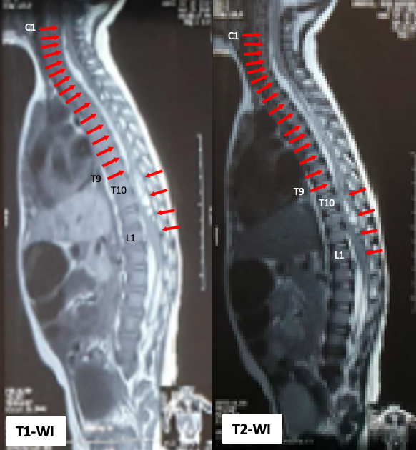
Figure 1. MRI of whole spine sagittal T1-weighted image and T2-weighted image revealed a subacute subdural hematoma extending from C1 to T9 on anterior aspect, then T10 to L1 on posterior aspect.

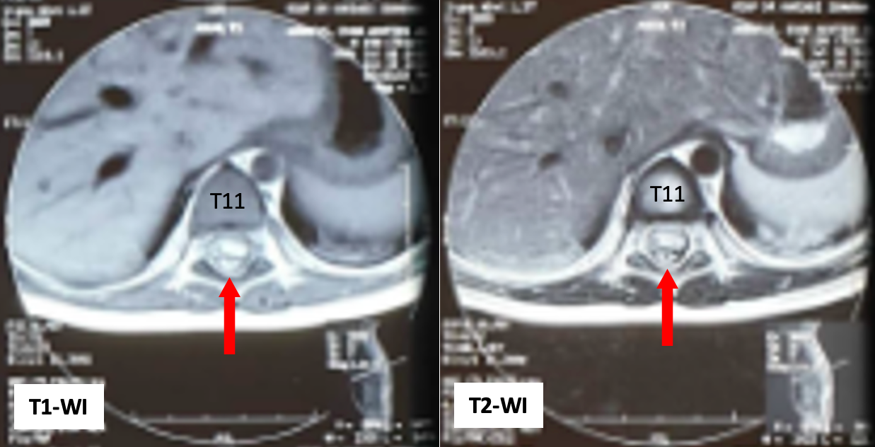
Figure 2. MRI images of an axial section T1-weighted image and T2-weighted image at the T11 level also showed a displacement of the spinal cord to anterior due to the hematoma.

