Figure 1. Pedigree of CHARGE syndrome case.
The counselee is the only affected individual in three generation pedigree. He has two healthy siblings from healthy parents, thus, the pattern of inheritance is de novo.

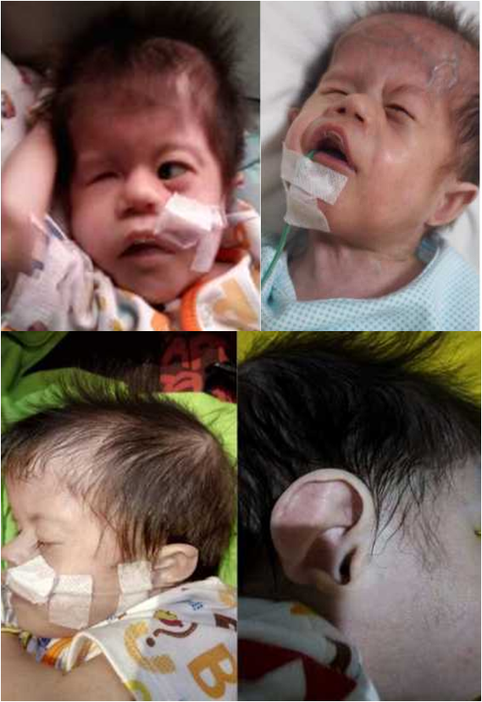
C
B
A
D
Figure 2. Clinical features of CHARGE syndrome in the case (patient).
Micropthalmia on the right eye (A); Small nosthril especially on the left side (B); prominent anti-helix discontinuous with antitragus, rudimentary lobe (C); and thin and unfold helix, prominent anti-helix discontinuous with antitragus, and rudimentary lobe (D).

