Multidisciplinary Management of Disorders of Sex Development in Indonesia, A Prototype in Developing Country
Nurin Aisyiyah Listyasari¹, Achmad Zulfa Juniarto¹, Sultana MH Faradz¹
¹ Center for Biomedical Research (CEBIOR) Faculty of Medicine, Diponegoro University

Corresponding author:
Prof. Sultana MH Faradz, MD, PhD (UNSW, Sydney)
Head of Center for Biomedical Research and
Master Program on Genetic Counseling
Faculty of Medicine Diponegoro University, Semarang, Indonesia
Ph/Fax: 62-24-8454714 www.cebior.fk.undip.ac.id/

Email : sultanafaradz@gmail.com
Other email address: smhfaradz@yahoo.com

ABSTRACT
Background : Disorder of sex development (DSD) patients require comprehensive management to improve quality of life. A standardized management protocol for patients in Indonesia is not yet available resulting in patients infrequently received a proper diagnosis. This study reported a multidisciplinary management DSD in Indonesia based on minimal diagnostic facilities and expertise in developing country.
Objectives : The purpose of the study is to review the management of DSD patients in Indonesia relates to providing appropriate gender assignment and to improving patients quality of life.
Methodology : We analyzed the records of DSD patient admitted to the division of Human Genetics Center for Biomedical Research (CEBIOR) Faculty of Medicine Diponegoro University, Semarang, Indonesia from May 2004 - December 2015. Data were collected and analyzed for physical examination, family pedigree karyotyping, hormonal assays and psychosocial. Other examination such as ultrasonography, Xray and Cytoscopy were also recorded for selected cases. Bimonthly, Sexual Adjustment Team (SAT) meeting was recorded.
Results : From the total 617 DSD cases we found 426 cases (69,04 %) with 46, XY DSD, 117 cases (18,96%) with 46,XX DSD and 74 cases (12%) with sex chromosome DSD. Most of the patients in the group of 46, XY DSD are Unknown Male Undervirilization (UMU) with 256 cases (60.09%). As the majority cases of 46, XX DSD was Congenital Adrenal Hyperplasia with 81 cases (69.23%). The remaining cases were Androgen Action Disorder (AAD) with 140 cases (32.86%), 46, XY DSD Gonadal Dysgenesis with 30 cases (7.04%), Androgen Excess Disorders with 3 cases (2.56%), Defect of Mullerian Development with 19 cases (16,24%), 3 cases (2.56%) of Androgen Excess and 3 cases (2.56%) of 46, XX Gonadal Dysgenesis.
Conclusion : Comprehensive management for DSD Patients help patient in diagnosis, gender assignment and support patient to improve quality of life. This multidisciplinary of DSD team is the only team in Indonesia that can be used as a model for other center in Indonesia as well as other developing countries with minimal diagnostic facilities.
Keywords: Disorder of Sex Development; Sexual Adjustment Team; Chromosome.
Introduction
Disorder of Sex Development (DSD) is defined by congenital conditions in which development of chromosomal, gonadal, or anatomical sex is atypical.¹ This broad category is divided into three primary roots based on karyotype namely 46,XY DSD; 46,XY DSD and Sex Chromosome DSD. Secondary root is depicted based on hormone assessment and imaging and the tertiary root is obtained based on molecular and/or histopathology examination.
In Indonesia, it is very rare to have a complete diagnosis procedure where molecular evaluation is needed for DSD confirmation. Molecular analysis as part of health care service is limited on research center of the universities in the big cities. Early diagnosis and integrated treatment are important for DSD patients, in order to anticipate the proper treatment within medical, psychological and social aspect through the gender team.
Sexual Adjustment Team (SAT) is the only team available in Indonesia with the members from Dr. Kariadi Hospital and Faculty of Medicine Diponegoro University (FMDU), which is consist of specialists from various departments : urology, plastic surgery, gynecology, anesthesiology, adult and child endocrinology, genetic experts, andrology, psychiatry, psychology, pathology, legal, religion and social-medical staffs.
Studies from a number of different countries and cultural differences showed that while many patients managed sequentially, gender counseling, as well as sexual counseling, should be part of the multi-disciplinary service available to patients with DSD to avoid gender dysphoria.^{2,3} Aims this study is to review the management of DSD patients in Indonesia as a developing country relates to providing appropriate gender assignment and to improving patients quality of life.
Methodology
We reviewed the records of DSD patient admitted to the division of Human Genetics Center for Biomedical Research (CEBIOR) Faculty of Medicine Diponegoro University, Semarang, Indonesia from May 2004 - December 2015. The patients were referred by clinicians of the departments of urology, pediatrics, internal medicine, obstetrics and member of sexual adjustment team. The reason for referral was the presence of ambiguous genitalia or any anatomical abnormality of external or internal genitalia. However, a few may present with delayed puberty or primary amenorrhea.
Each patients with genital disorder is referred to the SAT member, with the goal of establishing the chromosomal sex, the gonadal sex, and the phenotypic sex (appearance of the external and internal genitalia) to determine the underlying diagnosis.
Components of the evaluation include; maternal history, medical history, detailed family history of any individuals with infertility, genital abnormalities, delayed puberty or multiple miscarriage, physical examination, external genital examination, including prader stage, quigley stage and external masculinization score, endocrinologic evaluation including FSH, LH and testosterone level, evaluation of the internal genitalia was done for special cases.
Blood sample for karyotyping, hormonal and gene analysis was obtained from all patients. Karyotyping was established using a G-banding technique in the Molecular and Cytogenetics Laboratory of the Center for Biomedical Research of FMDU (Semarang). Hormonal assays were done for serum testosterone levels, FSH and LH. Ultrasonography and cystoscopy were also performed in selected cases. Sexual Adjustment Team (SAT) meeting was performed to review gender assignment for DSD patients.
Psychological evaluation to identify the concerns of the parents of a newborn with ambiguous genitalia and provide support for the accompanying uncertainty. This evaluation includes an assessment of parents’ expectations regarding the gender of their baby, their understanding of what they have been told since the baby’s birth, and their preferences, particularly within the context of their cultural and religious background, as well as a general assessment of coping strategies.
Approval from the medical ethics committee of FMDU and informed consent from all participants, or parents / guardians prior to their participation in this study were obtained.
Result
From the total 617 DSD patients has shown the highest number of patient in 2004 because of the start of the study and the free of charge of genetic and hormonal testing. From 2010-2013, there was increase number of patients due to the availability of national health insurance. Since 2014, because of goverment policy, the national health insurance no longer covered for most of the diagnostic testing as well as treatment of DSD on the following years the number of patients was decreased.
Diagnosis Procedure :
Stepwise diagnostic approach were used to established the diagnosis. Physical examination, chromosome determination and hormonal analysis were used with the aim to classify the patients following the DSD classification.
Patients were categorized according to their karyotype; 426 cases (69,04 %) with 46, XY DSD, 117 cases (18,96%) with 46,XX DSD and 74 cases (12 %) with sex chromosome DSD (Figure 1). Most of the patients in the group of 46, XY DSD were 256 cases (60.09%) with Unknown Male Undervirilization (UMU) (Figure 2) and in the group 46, XX DSD were 81 cases (69.23%) with Congenital Adrenal Hyperplasia. (Figure 3).
The remaining cases of 46, XY DSD group were 140 cases (32.86%) with Androgen Action Disorder (AAD) and 30 cases (7.04%) with Gonadal Dysgenesis, while 46, XX DSD groups were Androgen Excess Disorders 3 cases (2.56%), Defect of Mullerian Development with 19 cases (16,24%), 3 cases (2.56%) of Androgen Excess and 3 cases (2.56%) of 46, XX DSD Gonadal Dysgenesis. In the grup Sex Chromosome DSD, there were 74 cases (100%) with Gonadal Dysgenesis. (Figure 4)
Discussion
The medical management approach to DSD is based on the belief that DSD is pathological and devalues the experience of affected individuals. The management of DSD must always be undertaken on a case-by-case basis with the goal of maximizing long-term physical and psychological outcomes for individuals with DSD.⁴
In Indonesia, as well as in South Asian countries, genetic counselor as health care provider is not very common, therefore clinical physicians quite often dealing with patients and families by their own way.⁵ As the majority cases of 46, XX DSD was Congenital Adrenal Hyperplasia (69 cases) who required immediate comprehensive treatment because its nature of the crisis often leads to a life-threatening situation. Unfortunately, most of the medication for CAH is not available in Indonesia, donation based on research were obtained from our collaborator such Erasmus University the Netherlands.
DSD is a broad term covering many different aspects that affect abnormal sexual anatomy, which is the result of various events occurring during sex differentiation. Many stages and genes are involved in known pathways that lead to gonadal formation and differentiation, it is not always possible to identify the causes of the disorders. There are potentially novel and alternative pathways may play a role.^{6–8} Consequently, the scope of molecular genetic analysis has markedly expanded. In Indonesia laboratory with molecular diagnosis facilities is very rare and advanced molecular testing only available in big cities. Although clinical and psychological management have already been done, many undiagnosed DSD should be later analyzed using advanced molecular techniques.
The wide spectrum of the clinical presentation of DSD is another aspect, and the interval of detection from the antenatal period into childhood or adolescence is also a factor to consider.^{9,10} Financial resources, health insurance issues, social, and cultural variables can also influence the attitudes of the parents for gender preference of a newborn or child with DSD. Because of National Health Insurance (JKN) cannot cover for diagnostic testing and treatment of DSD, the funds were sometimes coming out from fund rising. This is become big issues for patients and family. They should consider whether they have sufficient funds to undergo therapy. The distances to a referral hospital is the second issue that must be faced by patients and their families. The long distance means they have to leave their families at home and they can not go to work while going for medical consultation and treatment. They must consider not only the decision from him/ herself, but also must consider the decision of the whole family.
Many patients come in late condition with physical and psychological complex dilemma. In many of underprivileged Asian countries, a child born with ambiguous genitalia grow up while bearing the congenital anatomic sex features, which remain untreated in the form of surgical treatment until adolescences or adulthood.^{2,3,11}
Adult untreated patients either they already changed their gender or still undecided gender were suffered from stigmatization and gender dysphoria and need thorough psychological assessment.¹² Culture is an important part of the context in which decisions are made on sex assignment. Attitudes concerning gender and sexuality, including the acceptance of intersexuality, may differ between various cultures.^{2,5} In our study, cultural differences in dealing with DSD individuals not only influence the patient's own psychosexual development but also medical decisions regarding sex assignment and consecutive management.
The complexity of DSD and the emotions attached to the diagnosis have the potential to limit the ethics-based decision-making process. Anxiety, shock, and confusion may limit parents abilities to obtain and correctly process the information they need to make fully informed decisions on behalf of their child.^{9,} ¹³ Many parents have no knowledge of sex determination and differentiation that resulting confusion, or even disbelief, about their child’s medical condition. In our experience, a contributing factor to stress, depressive and anxious symptoms for parents of children with DSD is confusion surrounding their child’s diagnosis and treatment options.
The majority of well established diagnosis were AR gene and CYP 21 mutation in 46,XY and 46, XX DSD respectively. The well-known genes were identified such as AR gene mutation in Androgen Insensitivity Syndrome (AIS) and CYP 21 mutation in Congenital Adrenal Hyperplasia (CAH). In our previous study showed that there are CYP11B1 and CYP21A2 gene mutation in CAH patients.¹⁴
In Indonesia, diagnosis and management of DSD patients have not received attention that they should deserve since infectious disease is still a priority as the major cause of death. A multidiscipline approach on DSD management firstly conducted in Indonesia is in our center. Once we provided a multidisciplinary service and publicized to the community, a lot of patients come for consultation. Lacks of expertise, laboratory equipment and financial burden, as well as awareness of medical personnel and community were slow down its developments. The genital abnormality seems taboo culturally for some ethnic group to disclosure to the family and medical personnel. The accountable general guideline of DSD management should be set and standardized nationally; hence it will provide adjustable implementation for the various conditions of patients and their families. Therefore, DSD management should be employed differently along with the diversity of cultural and demographic background in the societies.
Understanding on this issue, including an extensive research of patients and identify the structure of each ethnic and cultural background is necessary for general medical community in Indonesia in the management of patients with DSD complex. This report is expected to contribute to DSD patients, suggestions, advice or recommendations on what is needed in the diagnosis and management of DSD which will ultimately improve the quality of medical care and quality of life of DSD patients in Indonesia. Recognition, support, caring and providing the medication from the government should be soon become reality.
Conclusion
Comprehensive management for DSD Patients help patient in diagnosis, gender assignment and support patient to improve quality of life. This multidisciplinary of DSD team is the only team in Indonesia that can be used as a model for other center in Indonesia as well as other developing countries with minimal diagnostic facilities.
Acknowledgement
We thank Prof Stenvert L.S Drop who provided insight and expertise that greatly assisted the research and Sexual Adjustment Team Diponegoro University.
Statement of Authorship
All author have given approval to the final version submitted.
Author Disclosure
All the authors declared no conflicts of interest.
Funding Source
None.

REFERENCES
1. Lee PA, Houk CP, Ahmed SF HIICC on I organized by the LWPES and the ES for PE. Consensus Statement on Management of Intersex. Ped. 2006;118(2):488–500.
2. Warne GL, Raza J. Disorders of sex development (DSDs), their presentation and management in different cultures. Rev Endocr Metab Disord. 2008;9(3):227–36.
3. Warne GL. Long-term outcome of disorders of sex development. Sex Dev. 2008;2(4–5):268–77.
4. Lathrop B, Cheney TB. Ethical perspectives on the management of disorders of sex development in children. Medicolegal Bioeth. 2015;5:27–34.
5. Zayts O, Sarangi S, Thong MK, Chung BHY, Lo IFM, Kan ASY, et al. Genetic counseling/consultation in South-East Asia: A report from the workshop at the 10th Asia pacific conference on human genetics. J Genet Couns. 2013;22(6):917–24.
6. Piprek RP. Molecular and cellular machinery of gonadal differentiation in mammals. Int J Dev Biol. 2010;54(5):779–86.
7. Kousta E, Papathanasiou A, Skordis N. Sex determination and disorders of sex development according to the revised nomenclature and classification in 46,XX individuals. Hormones. 2010;9(3):218–31.
8. Eggers S, Sinclair A. Mammalian sex determination-insights from humans and mice. Chromosom Res. 2012;20(1):215–38.
9. Özbey H, Etker S. Disorders of sexual development in a cultural context. Arab J Urol. 2013;11(1):33–9.
10. Ediati A, Maharani N, Utari A. Sociocultural aspects of disorders of sex development Sociocultural Aspects of Disorders of Sex Development. Embryo Today Rev. 2016;108(12):380–3.
11. Lee PA, Nordenström A, Houk CP, Ahmed SF, Auchus R, Baratz A, et al. Global disorders of sex development update since 2006: Perceptions, approach and care. Horm Res Paediatr. 2016;85(3):158–80.
12. Ediati A, Faradz SMH, Juniarto AZ, van der Ende J, Drop SLS, Dessens AB. Emotional and behavioral problems in late-identified Indonesian patients with disorders of sex development. J Psychosom Res. 2015;79(1):76–84.
13. Wisniewski AB, Sandberg DE. Parenting children with disorders of sex development (DSD): A developmental perspective beyond gender. Horm Metab Res. 2015;47(5):375–9.
14. Juniarto Z, van der Zwan YG, Santosa A, Ariani MD, Eggers S, Hersmus R, et al. Hormonal evaluation in relation to phenotype and genotype in 286 patients with a Disorder of Sex Development from Indonesia. Clin Endocrinol (Oxf). 2016;0:1–11.

Figure 1
Six hundred and seventeen patients with various form of DSD were evaluated in our center. All the patients were categorized based on chromosome analysis result. There are 426 cases (69,04 %) with 46, XY DSD, 117 cases (18,96%) with 46,XX DSD and 74 cases (12 %) with sex chromosome DSD.
Figure 2
Among 46, XY DSD cases, most patients were 256 cases (60.09%) with Unknown Male Undervirilization (UMU) following by 140 cases (32.86%) with Androgen Action Disorders (AAD) and 30 cases (7.04%) with Gonadal Dysgenesis (GD).
Figure 3
In 46, XX DSD group, most patients were 81 cases (69.23%) with Congenital Adrenal Hyperplasia (CAH) following by 19 cases (16,24%) with Defect of Mullerian Development; 3 cases (2.56%) of Androgen Excess and 3 cases (2.56%) of Gonadal Dysgenesis.
Figure 4
Among Sex Chromosomal DSD group, there were 74 cases (100%) with gonadal dysgenesis sex chromosomal DSD.

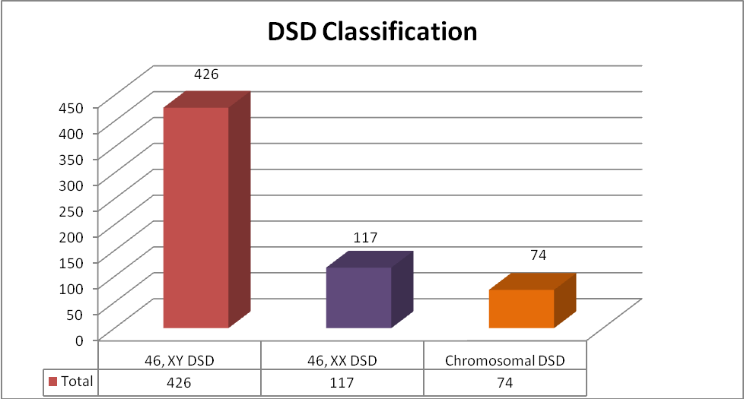
Figure 1 . Six hundred and seventeen patients with various form of DSD were evaluated in our center. All the patients were categorized based on chromosome analysis result. There are 426 cases (69,04 %) with 46, XY DSD, 117 cases (18,96%) with 46,XX DSD and 74 cases (12 %) with sex chromosome DSD.

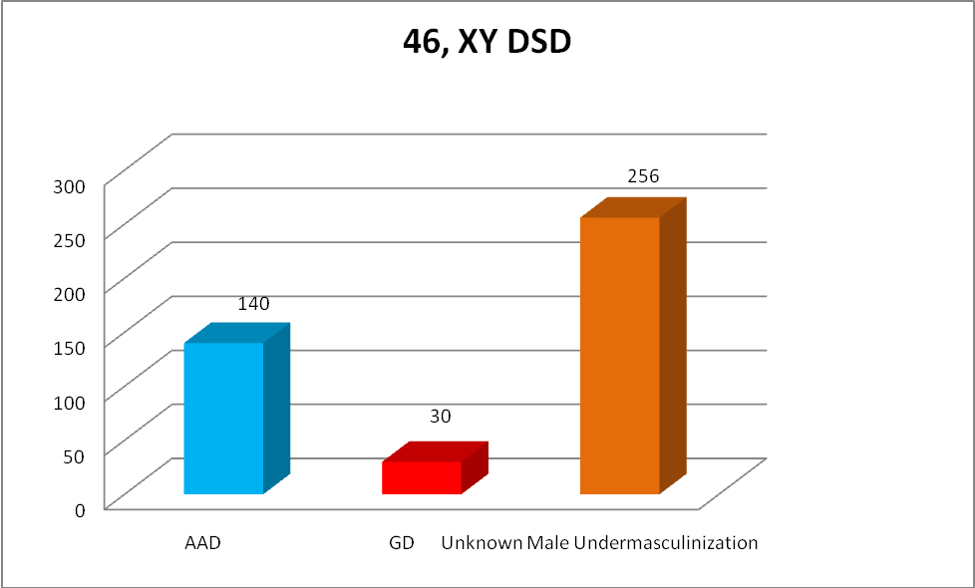
Figure 2. Among 46, XY DSD cases, most patients were 256 cases (60.09%) with Unknown Male Undervirilization (UMU) following by 140 cases (32.86%) with Androgen Action Disorders (AAD) and 30 cases (7.04%) with Gonadal Dysgenesis (GD).

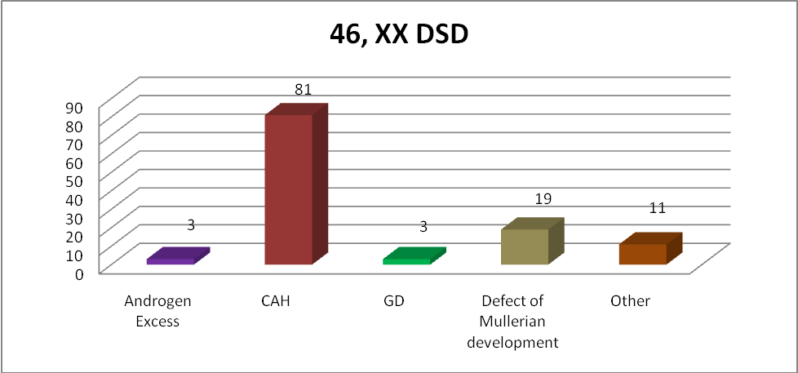

Figure 3. In 46, XX DSD group, most patients were 81 cases (69.23%) with Congenital Adrenal Hyperplasia (CAH) following by 19 cases (16,24%) with Defect of Mullerian Development; 3 cases (2.56%) of Androgen Excess and 3 cases (2.56%) of Gonadal Dysgenesis.

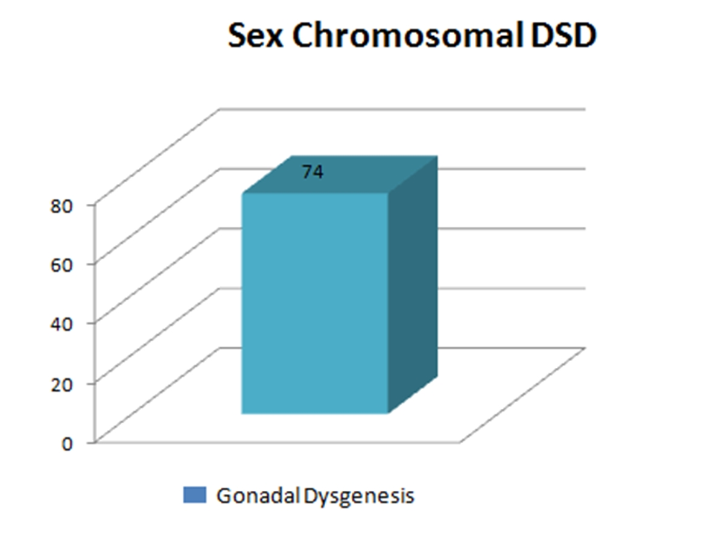
Figure 4. Among Sex Chromosomal DSD group, there were 74 cases (100%) with gonadal dysgenesis sex chromosomal DSD

