Identification Of The Need For The Design Of A Speak Therapy Aid With Augmented Reality Technology

Manik Mahachandra^{1,2}, Abel Kristanto Widodo¹, Wiwik Budiawan³

¹ Department of Industrial Engineering, Faculty of Engineering, Diponegoro University
²Center of Excellence in Science (CES) for Biomechanics, Biomaterial, Biomechatronics, and Biosignal Processing, Universitas Diponegoro
Prof. Soedarto, SH Street, Undip Tembalang Campus, Semarang, Indonesia 50275
3Mas Wiwik Institution

ABSTRACT. Speech Delay (purely) is one of the highest contributors to the case of children's speech delay. Those things occurs due to the lack of child interaction in this modern era. The treatment can be provided for children who experience speech delays are flashcards, hand puppet stories, multimedia, mobile applications, and computer games. The handling has not yet fulfilled the multisensory (visual, auditory, and tactile) components needed by children. Augmented reality technology will be the answer as a tool for speech therapy because children will interact significantly with virtual objects that have been combined with conditions in the real world. Before the use of augmented reality, it is necessary to identify the appropriate needs. The process of identification by the Delphi method for the design factors for speech therapy aids with Ulrich & Eppinger until the concept development stage. Delphi results indicate there are 3 main factors, visual, sound, and interactive technology. These factors become the basis of planning. The design will generate a low-fidelity prototype. Usability test results obtained: Effectiveness (82%), Efficiency (0.01285 goals/sec), and Satisfaction (87%) with task performance easy to do. Speech therapy aids are recommended at Rp 100,000. The companion is willing to use this speech therapy aid if it is recommended or the product is sold.
Keywords: speech delay, multisensory, augmented reality, delphi, ulrich & eppingger, usability test
Article History: Received xxx; Received in revised form xxxx; Accepted xxx; Available online: xxx (7.5 pt)
DOI: 10.14710/jbiomes.x.x.xxx-xxx

- Introduction
Speech delay can interfere with children's growth and development that occurs at preschool age [1], when children have difficulty reading, writing, paying attention, and socializing. Speech delays in children have two types of delays, primary delays, and secondary delays. Pure delays are closely related to impaired expressive and/or receptive abilities, while delays accompanied by inclusion are known as delays in the presence of certain conditions, such as autism, cerebral palsy, loss of hearing ability, and so on [2]. Pure speech delay is one of the high contributors to child cases, due to the lack of child interaction in this modern era. Moreover, research [3] conducted by Dr. Cipto Mangunkusumo showed that 50% of the 126 children had speech delays. So, it is important to have treatment for children who have speech delays.
The form of handling for children who have speech delays can be in the form of flashcards [4], stories with hand puppets [5], multimedia [6], mobile applications [7], and computer games [8]. The form of handling flashcards and stories with dolls only focuses on visuals for children and requires a speech therapist to use them. Meanwhile, multimedia, mobile applications, and computer games have not been able to fully fulfill the multisensory (visual (sight), auditory (hearing), and tactile (touch) components, known as TVA [9]. Other technologies can accommodate children's needs by providing interactive technology with a combination of visual and auditory aspects, namely augmented reality.
Augmented Reality will be the answer as a speech therapy medium with simulations that can be done at home. Children can interact in real with virtual objects that have been combined with conditions or circumstances in the real world so that children will feel directly the object to be studied. Before using augmented reality, it is necessary to identify the appropriate needs.
Needs identification can be done using the Delphi method. The advantage of this method is that the expert does not interact with other respondents, this will minimize the shortcomings of the " confrontation" model. The confrontation model can lead to only a few experts voicing their opinions or the dominance of several experts over their opinions accompanied by psychological pressure, examples of this model are focus groups or round-table discussions. This method can also be used to identify and select the right variables compared to other methods. For example, the QFD method focuses on product characteristics on the requirements that have been given along with a description of their impact on realizing consumer needs [10]. The application of the Delphi method itself in the need identification process has been widely considered an appropriate tool, starting with the design of a strategy based on the lean startup methodology [11], the design of a geographic-based information system to support the decision to choose a place to eat [12] and various other applications.
The process of identifying needs with augmented reality considers an expert, namely a speech therapist in several hospitals. The output of this need identification is a product design requirement factor. According to [13], product design is known as the steps or activities that seek to compile, design, and commercialize a product. This design goes through several phases until the product can be commercialized, namely the planning phase, the concept development phase, the system-level design phase, the detail design phase, the testing and repair phase, and the initial production phase. The design is carried out in the identification process up to the concept development phase.
For the results of the design, it is necessary to test the product by using a usability test. A usability test is an evaluation method to see the level of ease and comfort of users in using or interacting with a product [14]. In assisting testing in terms of product marketing, user willingness can be identified by using the willingness to pay (WTP) and willingness to use (WTU). [15] interprets that willingness to pay as the willingness of users to pay rewards (in the form of money) for the products they get. The role of willingness to use to get user responses to product designs made [16].
This study tries to identify the need for speech therapy aids using Augmented Reality technology. Identification of product design needs using the Delphi method. The results of the identification will be a factor in product design needs. Product design is carried out to the stage of concept development. The research uses usability tests to determine product acceptance for users. This includes using the willingness to pay for the willingness to buy the product if it has been made (assessed by the criteria of the user's desire to buy the product) and willingness to use for willingness to use the product.
2. RESEARCH METHODS
Delphi is a modification of brainstorming and survey techniques with communication through several questionnaires [17]. The iterations carried out in this study have 4 phases, namely:
- Phase 0: Identification
The identification process uses open-ended questions given to experts (speech therapists) about the design factors of speech therapy aids.
Example questions:
According to you, what factors are needed if we want to make speech therapy aids?
- Phase 1: Determination and equalization of perceptions
The therapist provides an evaluation of each answer given in phase 0 to get a determination and commonality of perception between speech therapists.
- Phase 2: Determination and sequencing
The therapist performs the sequencing of the design factors to get the main design factors which will be further developed later.
Example questions:
Based on animation, sound, and color factors, which one do you think is important?
- Phase 3: Product design factors
Obtained product design factors that match the aspects of the expert group, speech therapists. Expanded questions if needed.2.2 Authors
Author names should be in 13 pt Times New Roman with 6 pts above and 6 pts below. Author addresses are superscripted by numerals and centered over both columns of manuscripts. Professional positions/ titles such as Professor, Dr., Production Manager, etc., are to be avoided.

Design evaluation with Usability test based on ISO 9241-4:
- Effectiveness
This can be calculated by the completion rate. The extent to which users can use the product for the first time. It is calculated as follows:

$Effectiveness=\frac{Number of tasks that can be completed}{Total number of assigned tasks}x100\%$ (1)

- Efficiency
It is measured in terms of the time a task takes the user to complete. Where the task time is the reduction of the end time with the start time. Efficiency can be calculated with time-based efficiency as follows:
$Time-based efficiency= \frac{\sum_{j=1}^{R}{\sum_{i=1}^{N}{\frac{n_{ij}}{t_{ij}}}}}{NR}$ (2)

- Satisfaction
Determination of user satisfaction in using the product can be SEQ (Single Ease Questions) to determine task performance and System Usability Scale (SUS) to determine usability performance.

The evaluation process also shows the results of consideration based on Willingness to Pay or a user's willingness to pay rewards (in the form of money) for the products they get. With this, it will help to determine the level of user willingness and product marketing that must be done [15]. Willingness to Use is a form of willingness to use by individuals for a product with certain criteria [16]. With this, it will provide an overview of the sustainability of the products that have been made.

3. Results and Discussion
- Identification Process
The identification process is carried out from phase 0 to phase 3. Phase 0 describes the outline of the handling and conditions of speech delay and the factors needed in the design of speech therapy aids. The process of handling children who have speech delays begins with screening, this is to find out how the child's language development is. The results of the screening can also help the therapist in determining the material to be given, and the approach and method of speech therapy that adjusts to the type of speech delay experienced by the child. Flashcard is a method with image or photo media that is commonly used by speech therapists. [18] stated that if the therapist targets multiple target words, the flashcard method can be applied to prevent failure. But the flashcard method has little effect on the development of imitative and expressive abilities in children with autism [19]. The type of speech delay that commonly occurs in children is the type of pure delay (primary) caused by a lack of child communication where children interact more with gadgets that receive information without any interaction. This is in line with what was done by Nurmasari [20], that there is a significant relationship between the intensity of using gadgets and delays in the development of speech and language aspects in children.
Phase 1 shows the common perception of the factors that have been mentioned in table 1.

Table 1
Results of Design Factors
Code | Statement
A1 | Visual
A2 | Interactive technology.
A3 | Voice
A4 | Interactive role with parents
A5 | Focus
A6 | Durable

Phase 2 is the sequencing of design aspects carried out on an ordinal scale. There are 3 (three) main factors obtained in table 2. This supports the presence of augmented reality which can provide the experience of interacting with virtual objects so that there is no longer a boundary between the real world and the virtual world.

Table 2
Results of Sequencing Aspects of Design
Priority | Aspect
1 | Visual
2 | Voice
3 | Interactive technology
4 | Focus
5 | Active Role of Family
6 | Durable

Phase 3 expands the product design picture, especially the visual aspect, pay attention to Table 3.

Table 3.
Design Factors
No. | Visual Aspect
1. | Items that are easily accessible to children.
2. | The real stuff, not animation.
3. | Attractive display.

It was found that speech therapy aids must produce visuals in the form of objects that are easily accessible to children, original objects, and attractive appearances. First, children will find it easier to remember objects around them compared to objects they are rarely familiar with. Second, the real object will provide an image of the real stimulus to the brain to get the appropriate experience. This is in line with [21], that the characteristics of children in terms of association and memory show that children easily understand and memorize vocabulary that they see directly, meaning real-life situations. Pictures will be an integral medium in children's language development. Third, an attractive appearance will increase the child's stimulus in conducting training with speech therapy aids. This is in line with [6], that an attractive appearance is a non-functional requirement in speech therapy aids. Speech therapy aids must be able to provide user-friendly).

- Design Process
The process of designing speech therapy aids up to the concept development stage, involving 8 speech therapists in 4 different hospitals in Semarang. Phase 0 or planning explains the basics before developing the concept, starting with the content, material, and mechanism aspects provided. The initial content contains the sign-up and login pages. The list consists of aspects of the name, date of birth, gender, therapist ID (optional), and hospital (optional). While the login only contains the entry of the child's name, and the therapist ID (optional). The therapist ID is used to store a child development database that can be known by speech therapists, while the hospital is only a separate database to identify children who are doing rehabilitation at the hospital. The next content is preliminary questions (screening process) and training. The two contents occur continuously between screening and training. The material is given starts from the age of 6 months to 7 years.
Phase 1 is the next stage of the planning that has been done. The concept development stage includes an information system for speech therapy aids and low-fidelity prototypes. Context Diagram shows the data that flows in the speech therapy aid system, pay attention to Figure 1.

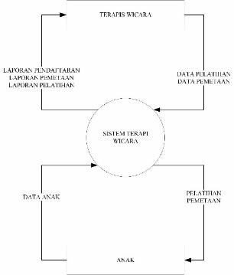
Fig 1. Context Diagram

Low fidelity prototype that provides a quick overview by describing the concept of a design without showing in detail how the system operates. This prototype resulted from the factors given by the previous therapist. The results of the prototype are then evaluated by a speech therapist.
Design 1: Homepage
The following is the start page consisting of the initial screen, register, and log in.

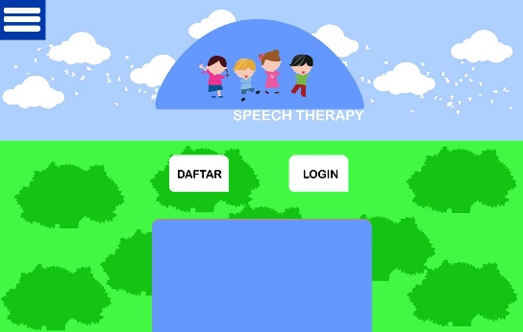
Fig 2. Initial View of the Design

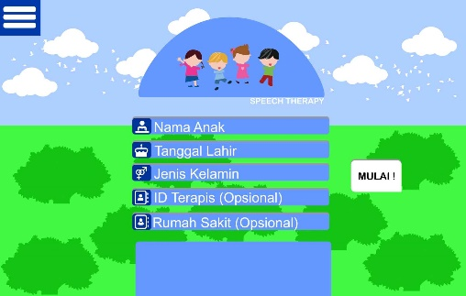
Fig 3. Part List Design

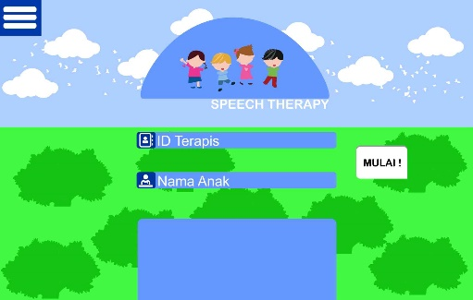
Fig 4. Login Section Design

Design 2: Preliminary Questions
The following is a preview of the introductory question. This design focuses on children aged 3.5 – 4 years (Oral Ability – Pronunciation of Consonants II; Oral Comprehension – Recognizing Colors).

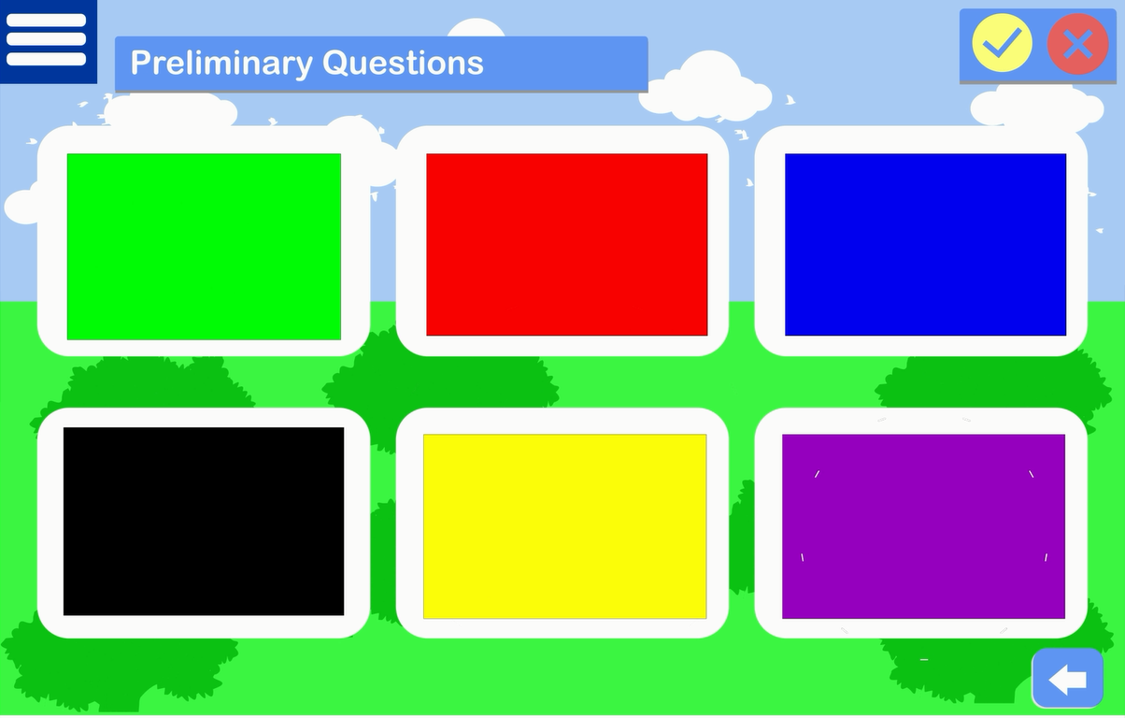
Fig 5. Design of Preliminary Questions (Knowing Colors)

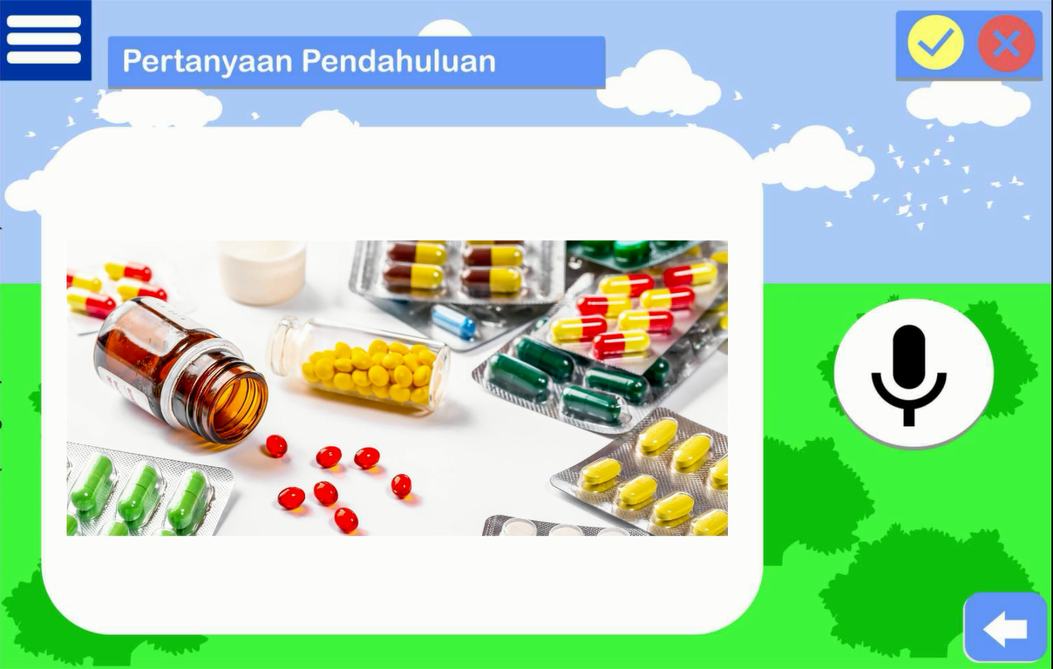
Fig 6. Design of Preliminary Questions (Pronunciation of Consonants II)

Design 3: Mapping Results
The following is a display of the mapping results. The results of the mapping were obtained from the assessment of the preliminary questions in design 2.\

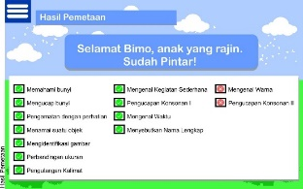
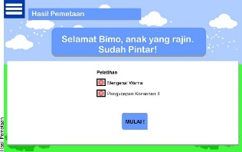

Fig 7. Mapping Result Design

Design 4: Training
Here is a training view. This design focuses on children aged 3.5 – 4 years (Oral Ability – Pronunciation of Consonants II; Oral Comprehension – Recognizing Colors).

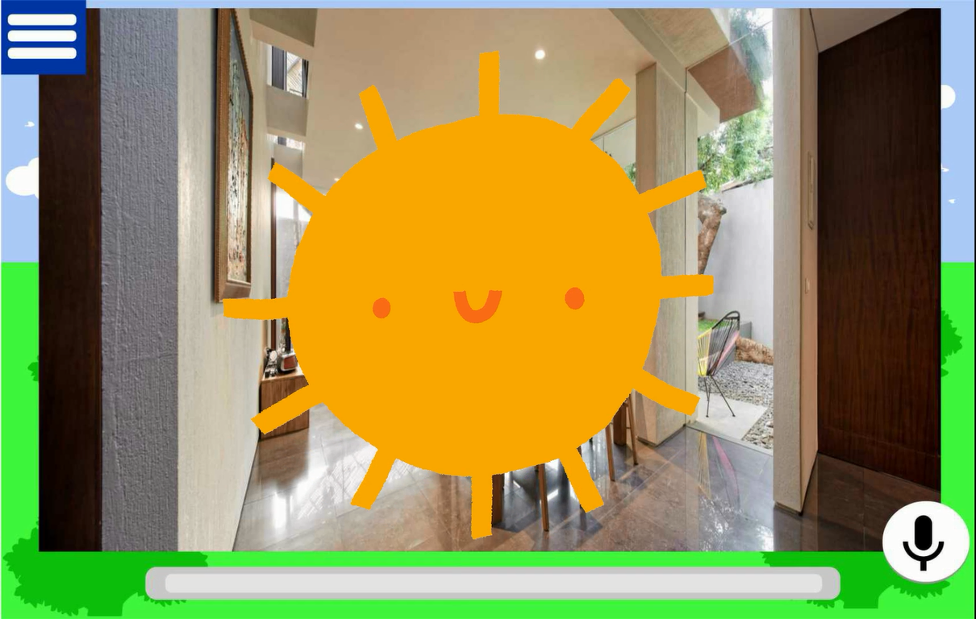
Fig 8. Training Plan
(Recognizing Color)

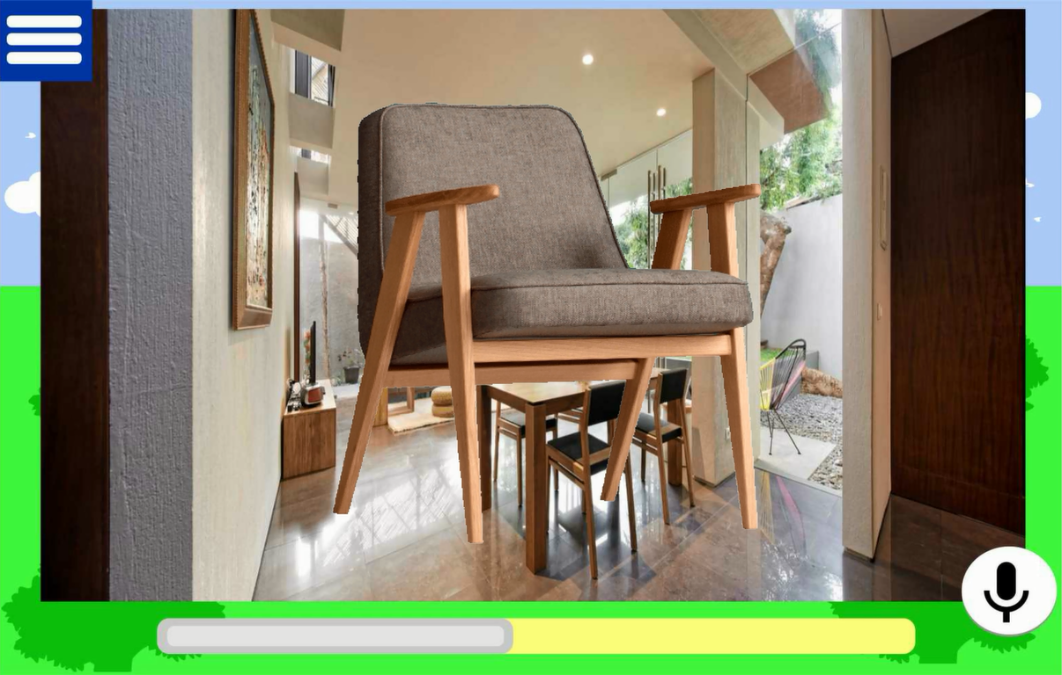
Fig 9. Training Plan
(Consonant II pronunciation)

Design 5: Training Results
The following is a display of the training results. The results of the training are obtained from the assessment of the training in design 4.

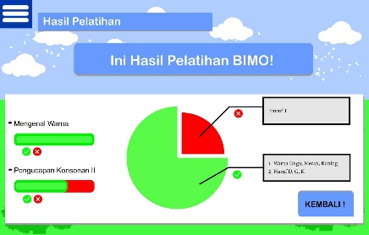
Fig 10. Design of Training Results

Design 5: Additional
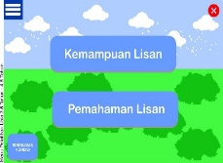
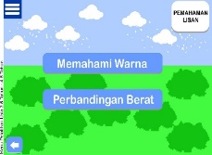
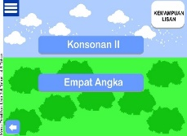
The following are additional designs provided, including menus and exits.

Fig 11. Menu Design

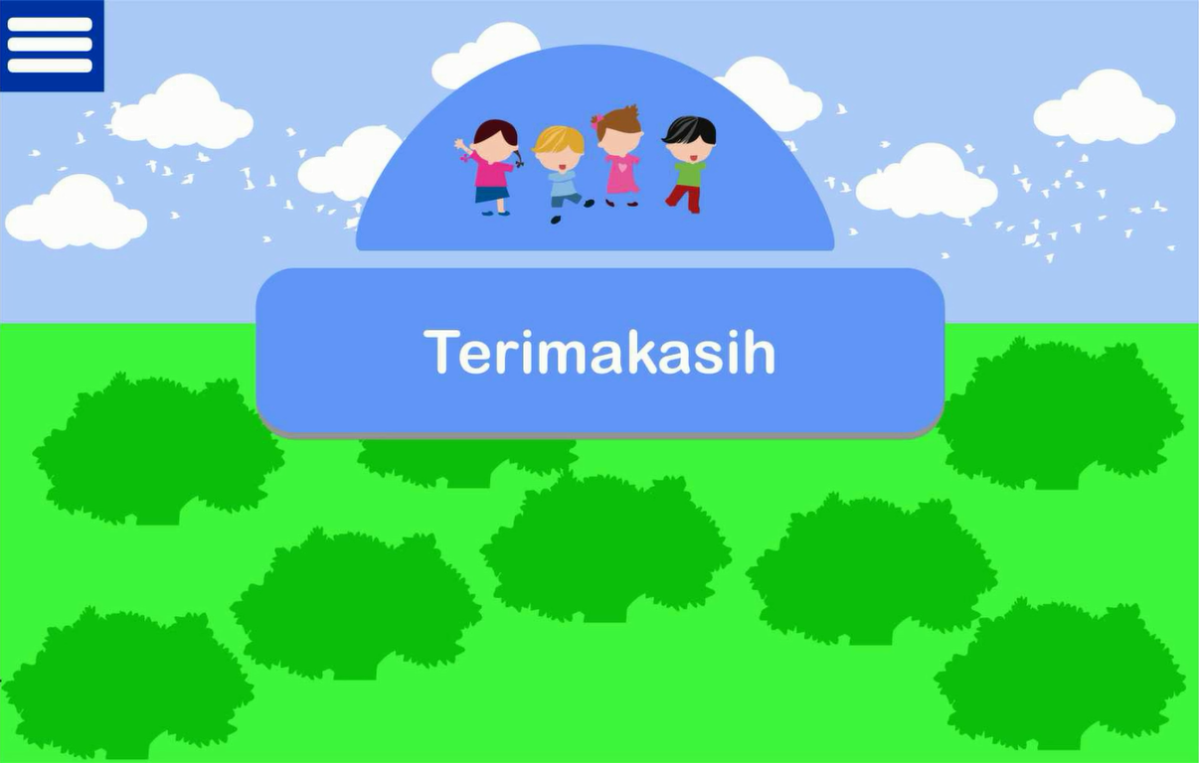
Fig 12. Exit Design

The results of the design were evaluated by the speech therapist again on the content, delivery and the first experience of speech therapists in using the design of speech therapist aids with Augmented Reality technology. In terms of delivery, the evaluation results show that the design of speech therapy aids is following its objectives. This is viewed from the pronunciation, the training process, and the preliminary questions are given. In terms of content, the results of the evaluation are as follows:
First, the background is made plain and soft in the training section and introductory questions. This is in line with research [7], that a plain or soft background will give the impression of being simple and able to function according to its purpose.
Second, if the background music is too loud, it's better to just turn it off. This is different from research [22], that background music will improve material mastery and critical thinking skills for the given learning.
Third, Mapping can be done from the child's age and backward from the age as a whole. For example, when a child is four years old, when he registers, the mapping is carried out starting from the age of four years to six months. This is in line with research [23], that the child's development process can be stopped and backward if there is no language learning or illness. Therefore, knowing the development of children can be done starting from the age of the child and backward from his age.
Fourth, the training content must have a high variation which does not have to be the same between the objects/words studied between the preliminary questions and the training. This is in line with research [24], that image variation media can improve learning mastery and activity for children.
Fifth, the word speech therapy is changed to a speech therapist. The second language is one of the causes of speech delay [25].
Sixth, the report changed to a star shape will encourage children to understand the learning process. Assessment with symbols such as stars and ticks is something that is commonly used by children [26].
Finally, the content provided has been adapted to the times when children are generally in contact with gadgets, then the content can be developed by giving a cheerful impression. This is in line with research [27], that the child's persona has a cheerful impression.
The results of the evaluation given by the therapist, and the results of the updated design are as follows:
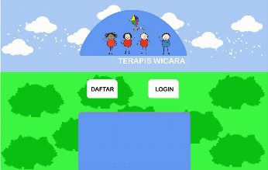
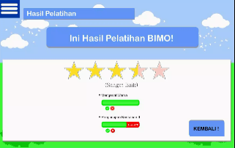
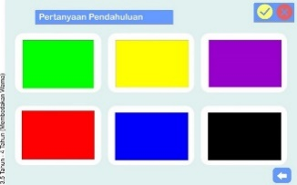

Fig 13. Design Update (Top to bottom – Soft colors, star evaluation results, and name change)

- Evaluation Process
The design evaluation was carried out in several stages, usability tests and willing to pay, and willingness to use. The usability test considered the aspects of effectiveness, efficiency, and satisfaction by involving 3 children who experience primary speech delay in the age range of 1.5-4.5 years. Usability test assessment based on ISO 9241-2 which is shown in Table 4:

Table 4
Usability Test
No. | Usability Aspect | Results
1. | Effective | This result has an average effectiveness score of 82% which shows that the level of effectiveness is good. This is in line with research [14], that the evaluation results are acceptable with a minimum of 70%.
2. | Efficiency | The efficiency score is calculated based on the time-based efficiency equation which is obtained at 0.01285 goal/sec. This shows that the child's working time in one task is 77 seconds.
3. | Satisfaction | Satisfaction is calculated based on the System Usability Scale and Single Easy Question. The score of SUS shows 87%. This means the design is in the acceptable category. This is in line with research [28], that the average total score of SUS, including acceptable, is >70%. Meanwhile, SEQ shows that the task is said to be easy to do.

Based on the results of willingness to pay and willingness to use, it was found that augmented reality technology was the first thing to be heard of. Companions feel they will use it if there is this technology for free. The assistant is willing to spend an average of IDR 100,000 to use this speech therapy tool. The companion is willing to use this speech therapy aid if it is recommended or this product is sold. Based on Table 9, it is found that there are differences in costs and time spent when using a speech therapist with this speech therapy tool. This shows that this product can help children in speech therapy by being recommended at an affordable price with flexible time.
Table 5
Comparison Results
Type | Price | Time
Speech Therapist | Rp 150.000/ meeting | 45 menit/ meeting
Product Design | Rp 100.000/ purchase * | 39 minutes/day*
* Average Calculation
4. CONCLUSION
The purpose of this study was to identify product design factors in speech therapy with augmented reality technology. There are six product design factors, namely visual, interactive technology, sound, children's focus, interactive role with parents, and durability. Visuals are one of the main factors in product design that are easily accessible to children, original objects, and attractive interfaces. Augmented reality can provide the experience of interacting with virtual objects so that there is no longer a boundary between the real world and the virtual world.
This research focuses on concept development. The results of this plan will be the basis of a development concept that discusses information systems and low Fidelity prototypes. A development plan is needed to add an appropriate and practical stimulation program that is tailored to the characteristics of the age and condition of the speech delay disorder.
This prototype is to evaluate with a usability test, willingness to pay, and willingness to use. From usability tests, the results were: effectiveness (82%); efficiency (0.01285 goals/sec); and satisfaction (good scores and task performance are easy to do). Augmented reality therapy is recommended at IDR 100,000. Users are willing to use this speech therapy tool if the product is sold. The next research is the development of speech therapy aids with Augmented Reality Technology based on the basis and product designs that have been made in this research.
References
[1] | Sunanik, "Pelaksanaan Terapi Wicara dan Terapi Sensori Integrasi pada Anak Terlambat Bicara," Jurnal Pendidikan Islam, vol. 7, no. 1, pp. 19-44, 2013.
[2] | M. R. McLaughlin, "Speech and Language Delay in Children," American Family Physician, vol. 83, no. 10, pp. 1183-1188, 2011.
[3] | S. Tan, I. Mangunatmadja and T. Wiguna, "Risk factors for delayed speech in children aged 1-2 years," Paediatrica Indonesiana, vol. 59, no. 2, pp. 55-59, 2019.
[4] | A. Widayanto, Suleman and I. Anita S, "Rancang Bangun Aplikasi Kategori Bahasa Untuk Tuna Wicara Berbasis Android," Jurnal Evolusi, vol. 5, no. 2, pp. 18-26, 2017.
[5] | A. Fadhilah, Pengaruh Terapi Bermain Bercerita Metode Boneka Tangan terhadap Kemampuan Berkomunikasi Verbal pada Anak Prasekolah, Jombang: Insan Cendekia, 2018.
[6] | M. H. Poernomo, W. W. Winarno and Sukoco, "Perancangan Multimedia Pembelajaran untuk Terapi Anak Berkebutuhan Khusus," SMATIKA Jurnal, vol. 6, no. 1, pp. 1-9, 2016.
[7] | T. Yogasara and C. Stefiany, "Aplikasi Terapi Wicara bagi Remaja Penyandang Disabilitas Intelektual Ringan," Jurnal Optimasi Sistem Industri, vol. 18, no. 1, pp. 86-96, 2019.
[8] | C. Rico-Olarte, D. M. López, S. Narváez, C. D. Farinango, and P. S. Pharow, "HapHop-Physio: a computer game to support cognitive therapies in children," Psychology Research and Behavior Management, vol. 10, pp. 209-217, 2017.
[9] | D. H. Afiati, Pelaksaaan Bina Wicara pada Anaka Tunarungu di SLBN 2 Bantul, Yogyakarta: Universitas Negeri Yogyakarta, 2017.
[10] | I. N. Azizah, R. N. Lestari and H. H. & Purba, "Penerapan Metode Quality Function Deployment dalam Memenuhi Kepuasan Konsumen pada Industri Komponen Otomotif," Jurnal Teknik Industri, vol. 19, no. 2, pp. 127-136, 2018.
[11] | Z. Afdi and B. Purwanggono, "Perancangan Strategi berbasis metodologi lean startup untuk mendorong pertumbuhan Perusahaan rintisan berbasis Teknologi di Indonesia," Jurnal Teknik Industri, vol. 6, no. 4, pp. 1-13, 2018.
[12] | B. S. Tambun, I. G. Jananuraga, P. A. Mahatmavidya and R. P. Soesanto, "Perancangan Sistem Informasi Berbasis Geografis untuk Mendukung Keputusan Pemilihan Tempat Makan di Kawasan Pendidikan Telkom University dengan Menggunakan Metode Factor Rating dan Metode Delphi," 2014.
[13] | K. T. Ulrich and S. D. Eppinger, Perancangan & Pengembangan Produk, Jakarta: Salemba Teknika, 2001.
[14] | J. Rubin and D. Chisnell, Handbook of Usability Testing, Indianapolis: Wiley Publishing, Inc, 2008.
[15] | R. C. R. Febrita, Analisis Kesediaan Membayar (Willingness to Pay) Beras Organik (Studi Kasus: Gelael Signature di Kota Makassar), Makassar: Universitas Hasanuddin, 2017.
[16] | I. Aumann, M. Treskova, N. Hagemann and J.-M. von der Schulenburg, "Analysis of Driving Factors of Willingness to Use and Willingness to Pay for Existing Pharmacological Smoking Cessation Aids Among Young and Middle-Aged Adults in Germany," Applied Health Economics and Health Policy, vol. 14, no. 4, pp. 441-452, 2016.
[17] | C. Powell, "The Delphi Technique: Myth and Realities," Journal of Advanced Nursing, vol. 41, no. 4, pp. 376-382, 2003.
[18] | A. Basso, Aphasia and Its Therapy, Oxford: Oxford, 2003.
[19] | D. Rapmauli and A. Matulessy, "Pengaruh Terapi Bermain FlashcardUntuk Meningkatkan Interaksi Sosial Pada Anak Autis di Miracle Centre Surabaya," Jurnal Psikologi Indonesia, vol. 4, no. 1, pp. 51-60, 2015.
[20] | A. Nurmasari, Hubungan Intensitas Penggunaan Gadget dengan keterlambatan Perkembangan Pada Aspek Bicara dan Bahasa Pada Balita Di Kelurahan Tambakrejo Surabaya, Surabaya: Diss. Universitas Airlangga, 2016.
[21] | D. Kurniawati, "Keefektifan Pengajaran Kosakata Bahasa Inggris Pada Anak Sekolah Dasar Dengan Menggunakan Flash Card," TERAMPIL: Jurnal Pendidikan dan Pembelajaran Dasar, vol. 1, no. 1, pp. 57-64, 2014.
[22] | D. Permatasari and E. Widodo, "Pengaruh Backsound Musik Dalam Pembelajaran Dinamika Newton Dengan Strategi Quantum Learning Terhadap Penguasaan Materi Dan Keterampilan Berpikir Kritis Peserta Didik Sma N 1 Prambanan The Effect Of Music Backsound In Newton Dinamic Learning With Quantum," E-Journal Pendidikan Fisika, vol. 5, no. 6, pp. 390-398, 2016.
[23] | I. H. Zusfindhana, "Implementasi Pendekatan Floor Time Untuk Mengatasi Anak Lambat Bicara Usia 3-4 Tahun," Journal of Elemantary School, vol. 1, no. 1, pp. 1-8, 2018.
[24] | S. Sugiarti, "Upaya Meningkatkan Kosa Kata Anak Tunarungu melalui Media Variasi Gambar pada Siswa Kelas V/B di SLB Negeri Surakarta," Solo, 2015.
[25] | Khoiriyah, A. Ahmad and D. Fitriani, "Model Pengembangan Kecakapan Berbahasa Anak Yang Terlambat Berbicara (Speech Delay)," Jurnal Ilmiah Mahasiswa Pendidikan Anak Usia Dini, vol. 1, no. 1, pp. 36-45, 2016.
[26] | E. D. Marta, Implementasi Pemberian Reward Kepada Siswa Sd Muhammadiyah Bantul Kota, Yogyakarta: Skripsi:UNY, 2016.
[27] | D. R. Andini and R. E. Rizkiantono, "Perancangan Kotak Aktivitas ABC Petualang Sebagai Media Bermain dan Perkembangan Dasar Anak Pra-Sekolah," Journal Desain, vol. 18, no. 1, pp. 31-36, 2019.
[28] | A. Bangor, P. Kortum, and J. Miller, "Determining What Individual SUS Scores Mean: Adding an Adjective Rating Scale," Usability Professionals’ Association, vol. 4, no. 3, p. 114–123, 2009.

© 2020. This article is an open-access article distributed under the terms and conditions of the Creative Commons Attribution (CC BY) license (http://creativecommons.org/licenses/by/4.0/)

