The Antioxidant Activity of Yogurt Drink by Mangosteen Rind Extract (Garcinia mangostana L.)
Jeki Mediantari Wahyu Wibawanti*, Zulfanita and Dedi Runanto
Animal Science Department, Faculty of Agriculture
Muhammadiyah University of Purworejo, Central Java, Indonesia
*Corresponding author jekiwibawanti@gmail.com

Abstract
Yogurt drink can be produces from goat milk. Yogurt drink was added mangosteen rind extract for increasing characteristics product. This study aimed to determine antioxidant activity (total phenol chompound, antioxidant activity by IC₅₀ and TBA value) of yogurt drink from goat milk by mangosteen rind extract. Complete Randomized Design was used in this research with 4 treatments and 5 replications. The antioxidant activities of yogurt supplemented with 0, 1, 2, and 3% (v/v) mangosteen rind extract. The result show that the total phenol contents increased with increasing levels of mangosteen rind extract. Yogurt drink by mangosteen rind extract have radical scavening activity higher than control (IC₅₀ 20.25). TBA results for yogurt drink by mangosteen rind extract shows that there were significant differences (p<0.05). The conclusion of this research ware showed that mangosteen rind extract have the potential for improving antioxidant of yogurt drink.

Keywords: antioxidant, goat milk, mangosteen rind, yogurt drink

Introduction
Goat milk is known to have unique characteristics while comparison to cow milk. Goat milk also contains higher proportion of fat, which is responsible to the unique flavor. Goat milk processed into yogurt drink as a functional foods (Fatma et al., 2014). Yogurt is a dairy product with a rich nutritional being considered human health. It is a high source of bioactive peptides with antioxidant activity that are produced during fermentation (Nguyen and Hwang, 2016). Yoghurt drink added with antioxidants would be improves the functionality and acceptability of consumers (Wibawanti and Rinawidiastuti, 2018).
Recently, yogurt products are developed with natural sources of antioxidants. Addition of mangosteen peel extract to yogurt drinks is possible to increase antioxidant activity. Mangosteen (Garcinia mangostana L.) is one of the most famous fruits in Indonesia. The extracts from Mangosteen are known as antimicrobial and antioxidation potential. Mangosteen plants contain natural antioxidant constituents such as phenolic compounds (Zarena and Sankar, 2011). They have been widely used as a traditional medicine (Vishnu et al., 2010).
Several study have shown that phenol contains obtained from mangosteen have remarkable biological activity. The aim of the current study was to assess antioxidant activity (total phenol chompound, antioxidant activity by IC₅₀ and TBA value) of fermented milk product (yogurt) with different level of mangosteen rind extract.
Materials and Methods
The yogurt samples were obtained in laboratory conditions, using the following raw materials: goat milk, lactic bacteria cultures and mangosteen rinds. Fresh goat milk was obtained from Peranakan Etawah (PE) Lurisae Farm, Loano, Central Java Province. Yogurt starter composed Lactobacillus acidophilus, Lactobacillus bulgaricus and Strepcoccus thermophiles. Mangosteen rinds were provided from local markets Kaligesing, Purworejo, Indonesia.
Manufacture of Yogurt
The raw milk was divided into four lots. The production of yogurt drink were made by fresh goat milk. The goat milk was pasteurized by temperature at 71⁰C for 15 seconds. After it was cooled down to 45-43⁰C and inoculated with 2% yogurt culture. The samples were cultivated at 38⁰C until coagulation and fortification with mangosteen rind extract with differences level concentration. The finished yogurt samples were stored at 4°C and then the analyses were performed in order to determine the antioxidant properties of samples.
Mangosteen rind extract
The mangosteen was selected from fresh fruits. They were cleaned by water. The making of mangosteen rind extract is done by selecting the dried mangosteen rind inside. Then weighing 200 g of mangosteen peel. The next step is adding 1L of distilled water and homogenized. Then filtering is done with filter paper. The results of the filter were put in a centrifuge with a speed of 6000 rpm for 10 minutes and obtained mangosteen rind extract (Wibawanti et al., 2018)
Total Phenol Determination
The extract solution (50 mg/mL; 1 mL) was mixed with Folin-Ciocalteu reagent (5 mL, previously diluted with water 1:10, v/v) and sodium carbonate (75 g/L, 4 mL). The tubes were vortex mixed for 15 s and allowed to stand for 30 min at 40°C for color development. Absorbance was then measured at 730 nm in a spectrophotometer. The total phenolic content was expressed as gallic acid equivalent in mg per gram of dry extract.

Antioxidant Activity by DPPH Method
The DPPH radical scavenging capacity of yogurt drink was determined according to the method of Mangla et al. (2010) with some modifications. Various dilutions of yogurt drink by mangosteen rind extrct were made with differences concentration. Each of liquid smoke concentration was taken as 1 ml. In 5 ml Volumetric Flasks added 2 ml of DPPH solution (0.1 mM DPPH in methanol), 7 ml of Methanol, 1 ml of liquid smoke, and incubated at 37⁰C for 30 min. A standard radical scavenging activity curve was prepared by Butyrate Hydroxyl Toluene (BHT) of diluted DPPH. The absorbance was measured at 517 nm. All treatments were done in triplicate
% Inhibition = [(A_{C} – A_{S})]/ A_{C} x 100 …………………………….………. (1)
A_{C} is absorbance of control (DPPH sample without test sample) and A_{S} is the absorbance in the presence of the test sample. IC₅₀ value (a concentration at 50% inhibition) was determined from the curve between percentage inhibition and concentration. The IC₅₀ value was calculated by using the equation of line.

Determination of Thiobarbituric Acid (TBA)
TBA value by following the method describes by Nkhata et al., (2015) with modification. Five gram of yogurt drink sample was prepared to TBA analysis. Yogurt was put in Erlenmeyer flash 100 ml. It was added 25 ml of 10% TCA solution to sample. The flask were shake frequently for four minutes. The entire content was separated using filter paper or centrifuge until clear filtrate. Then 1 ml was pipetted into the flask. The sample was added 5 ml of 0.02 m TBA. The sample was heated in boiling water for 45 minute in water bath. The sample was cooled under running water and diluted with 10 ml distilled water. The antioxidant activity was evaluated by measuring the absorbance at 530 nm using spectrophotometer
Data Analysis
Statistical analysis were performed by SPSS programe. All result was colected in a completely randomized design using analysis of variance (ANOVA) for each experiment. It means comparison in each experiment was performed using Least Significant Differences (LSD) and Duncan in degrees of freedom (df) 0.05.
Results and Discussion
Total Phenol Content
The research have reported the presence of phenolic compound in yogurt drink by mangosteen rind extract, as detected by spectrophotometer method. Total phenol content of yogurts drink with mangosteen rind extract were shown in Figure 1. The presence of mangosteen rind extract showed no significant differences in total phenol content (p>0.05). The value of phenol of yogurt drink increased by mangosten rind extract. The highest total phenolic content in yogurt drink was found in 3% treatment of addition mangosteen rind extract compared to another level. The total phenol content in the control yogurt was 5.14, while yogurt drink 1-3% mangosteen rind extract had higher phenol content than the control, with values ranging from 5.1-5.3. However, they have similarly value each other treatment of mangosteen rind extract.
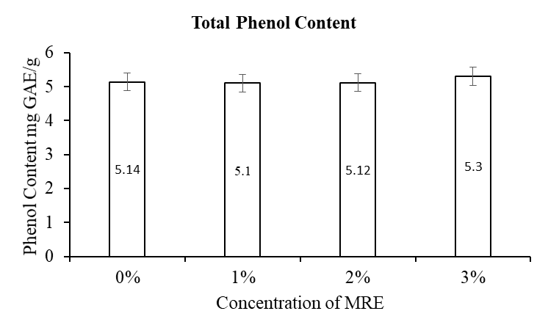
Figure 1. Total Phenol Content of Yogurt Drink by Mangosteen Rind Extract (MRE)

The research of total phenol content varied in yogurt depending on the level extract of mangosteen rind extract that was used. The differences in the total phenol content may be attributed to the presence of different extractable components. Starter bacteria cultures also contributed to the increasing antioxidant activity of fermented yogurt drink. The total phenol was correlated with antioxidant activity. Antioxidant activity was preserved during storage of yogurt drink. Liu et al. (2008) reported that the antioxidant activity was correlated with phenolic content. Phenolic content was responsible to the flavor, color and oxidative stability of fresh and processed products (Luzia et al., 1997).
Antioxidant activity by DPPH
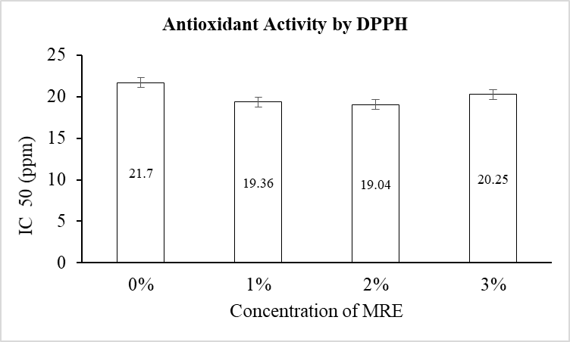
The scavenging of DPPH free radicals was used for measuring the antioxidant activity. Antioxidant activity is a molecule that inhibits the oxidation of other molecules caused by free radicals. Figure 2. shows the antioxidant content of yogurt drink added with different level of mangosteen rind extract. The antioxidant activity (IC₅₀) was exhibited 5.14; 5.1; 5.12 and 5.3 for, 1, 2 and 3% treatments, respectively. In this research of yogurt drink control showed IC₅₀ value higher than the with mangosteen rind extract. It mean yogurt drink by mangosteen rind extract have radical scavening activity higher than control. The research showed that mangosteen rind extract used in yogurt drink had increasing antioxidant activity compared to the control.

Figure 2. The Antioksidant Activity of Yogurt Drink by Mongosteen Rind Extract (MRE)

The antioxidant activity in yogurt drink might result from the bioactive compound of the mangosteen rind extract. Phenol compound in mangosteen rind extract have ability antioxidant activity may be due to hydrogen atoms of the phenolic hydroxyl groups can be donated to stabilize the free radicals. The DPPH assay was presented the ability of the extrack bas free radical scavengers or hydrogen donor. (Wibawanti et al., 2018) reported that among these extracts from mangosteen parts, each part (peel, leaves, and bark) showed antioxidant activity with different IC₅₀ value. Arazo et al., (2011) reported the antioxidant activity of phenolic acids present in mangosteen have concentrated on the major secondary metabolite xanthones. The DPPH assay provides basic information on the antiradical activity of the extracts. The DPPH radical has been widely used to test the ability of the extracts as free-radical scavengers or hydrogen donors (Chaverri et al., 2008)
Thiobarbituric Acid (TBA) Value
The antioxidant activity was determined by TBA (thiobarbituric acid) method. TBA results for yogurt drink by mangosteen rind extract shows that there were significant differences (p<0.05) as shown in Figure 3. Yogurt drink 3% of mangosteen rind extract were founded the lowest TBA values throughout the testing period. The control was showed the hightest TBA value (7.85 mg.mal/kg). TBA value of yogurt drink of mangosteen rind extract was 7.48; 7.44; 7.06, mg.mal/kg for, 1, 2 and 3% treatments, respectively. They have similarly value each other treatment of mangosteen rind extract. This study indicates that yogurt drink by mangosteen rind extract decreasing of lipid oxidation. This may be due to phenol activity that changes of fats structure. It related changes hydrolysis and oxidation.
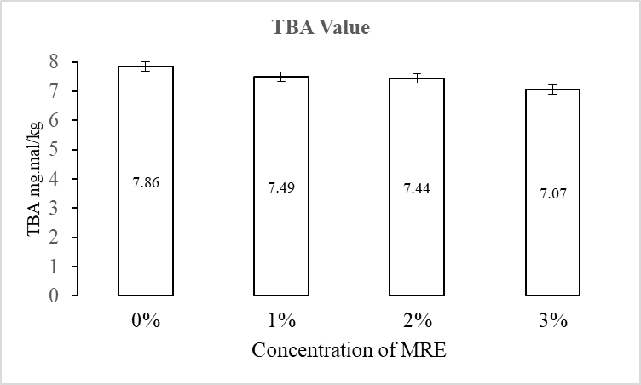
Figure 3. The TBA Value of Yogurt Drink by Mongosteen Rind Extract (MRE)

Low TBA value was related hydroperoxide formation in the early stages of lipid oxidation (Nkhata et al., 2015). Dobarganes and Velasco, (2002) reported the changes that occur in the structure of lipid are known as rancidity. That changes mainly involve oxidation and hydrolysis, which decrease the quality of lipid, leading to the formation of an unpleasant flavor and the loss of nutritional value.

Conclusion
The addition of mangosteen rind extract on the yogurt drink has contributed to the antioxidant activity. The phenol content of yogurt drink increased by mangosten rind extract. Based on the IC₅₀ and TBA value that mangosten rind extract has potential to increase antioxidant activity.

Acknowledgments
This research was supported by The Ministry of Research, Technology, and Higher Education of Republic Indonesia (Penelitian Dosen Pemula). It also supported by LPPM (Lembaga Penelitian dan Pengabdian Masyarakat) Muhammadiyah University of Purworejo.

References

Arazo, M., Bello, A., Rastrell, L., Monteller, M., Delgado, L.,Panfet, C. 2011. Antioxidant properties of pulp and peel of yellow mangosteen fruits. Emir. J. Food Agric. 23 (6): 517-524.

Chaverri, J. P., Rodriguez, N. C., Ibarra, M. O.,Rojas, J. M.P. 2008. Medical properties of mangosteen (Garcinia mangostana). Food and Chemical Toxiology. 46: 3227-3239.

Dobarganes, M.C., Velasco, J. 2002. Analysis of Hydroperoxide. Eur. J.Lipid. Sci. Technol. 104: 420-428.

Hassan, F. A. M., Abbas, H.M., Abd El-Gawad, M. A. M., Enab, A.K. 2014. Goats dairy products as a potentially functional food. Life Science Journal: 11 (648-657).

Liu, X., Zhao, M., Wang, J., Yang, B., Jiang, Y. 2008. Antioxidant activity of methanolic extract of emblica fruit (Phyllanthus emblica L.) from six regions in China. Journal of Food Composition and Analysis 21: 219-228.

Luzia, M. R., Paixao, D. A., Marcilio, K. C.C., Trugo, L.C., Quinreiro, L.M.C., De Mariq, C.A.B., Effect of 5-caffeoylquinic acid on soybean oil oxidative stability. Int. J. Food Sci. Technol. 32: 15-19.

Mangla, M., Shuaib, M., Jain, J., Kashyap, M. 2010. In-Vitro Evaluation of Antioxidant Activity of Curcuma caesia. International Journal of Pharmaceutical Sciences and Research. 1 (9): 98-102.

Nkhata, S.G., Ustunol, Z., Menevseoglu, A. 2015. Iron Fortification of Yogurt and Pasteurized Milk. Journal of Nutritional Health & Food Science. 3(3): 1-12. DOI: http://dx.doi.org/10.15226/jnhfs.2015.00142

Nguyen, L., Hwang, E. S., 2016. Quality characteristics and antioxidant activity of yogurt supplemented with aronia (Aronia melanocarpa) juice. Prev. Nutr. Food Sci. 21(4):330-337.

Priya, V.V., Jainu, M., Mohan, S. K., Saraswathi, P., Gopan, C. S. V. 2010. Antimicrobial activity of pericarp extract of Garcinia Mangostana Linn. International Journal of Pharma Sciences and Research (IJPSR) Vol.1(8): 278-281.

Sahreen S, Khan, M.R., Khan, R.A. 2010. Evaluation of antioxidant activities of various solvent extracts of carissa opacus fruits. Food Chemistry. 122: 1205-1211.

Wibawanti, J. M. W and Rinawidiastuti. 2018. Physical and organoleptical properties goat milk yogurt drink fortified by mangosteen rind (Garcinia mangostana lin.). Teknologi Hasil Ternak (JITEK). 13 1: 27-37. (In Bahasa Indonesia).

Wibawanti, J. M. W., Rinawidiastuti, Arifin H. D., Zulfanita. 2018. Improving characteristics of goat milk yogurt drink fortified by mangosteen rind (Garcinia mangostana lin.) extract. IOP Conference Series: Earth and Environmental Science. 102 (1), 012008. Doi 10.1088/1755-1315/102/1/012008.

Zarena, A. S., Sankar, K. U. 2011. Phenolic acids, flavonoid profile and antioxidant activity in Mangosteen (Garcinia Mangostana L.) pericarp. Journal of Food Biochemistry. 627-633.

