Sustainable Tourism concept to revitalize Ocarina area in Batam City

Hendro Murtiono¹, Helen Cia², I Gusti Ngurah Anom Gunawan³

¹University Diponegoro, Semarang, Indonesia

Corresponding e-mail: hendromurtiono@gmail.com, helencia0179@gmail.com, anom.iap@gmail.com

Article info:
Received: , Revised: , Accepted:
Abstract. The purpose of this research is to explore the concept of revitalizing the coastal tourism area with a sustainable tourism approach. Ocarina area is one of the tourist destinations in Batam city. Its strategic location is right in the heart of Batam and is surrounded by several areas with different functions, among others there are housing (housing Regata, housing Monde Residence, housing Avante, Monde Signature housing, etc.), there is a school (school Mondial), a commercial area (shop Pasir Putih, shop Mahkota Raya) and also the location of Ocarina area close to the international ferry The phenomenon that occurs in this tourist area has long been built and managed but megannatural decline so visitors need to be revitalized by using the concept of sustainable tourism. This strategic location is not accompanied by the success of the development of the Ocarina area as a public space that offers a variety of game facilities and culinary venues. The phenomenon that makes the need for revitalizing measures both physically and economically to make the Ocarina area can be maximal to be able to attract visitors to come and enjoy the facilities that are in it. The research method used is a qualitative method of direct observation in the field. Analysis done is to identify the problems that exist in the field today especially in the area of Ocarina Phase 1 so that the area of Ocarina Phase 2 can make Ocarina Phase 1 to be revitalized area and can be one of the sustainable tourism Batam city that can improve the economy of Batam city.

Keywords: revitalization, sustainable tourism, visitor
- Introduction
Ocarina area is a family fun area that also becomes one of the tourist destinations in Batam city. The area of Ocarina is located in an area with a total of ± 60 hectares which besides as a playground area there is also a residential area (housing Monde Bay, Monde Residence, Monde Signature, Regata, Avante), the education area of the national Plus Mondial School, Commercial District (department store Trikarsa Ekualita, Oriental shops, shops Monde Bay, shops Pasir Putih) and also there is a market that besides being a market is also a foodcourt of the white sand market.
Revitalizing as one of the actions so that a region becomes a positive area again, the part of the city that used to be crowded with community activities then increasingly experienced setbacks and degradation.
The physical aspects and economic aspects of either the building or the city part is an important aspect when we will take the revitalizing action of an area. Physical revitalization means a short-term strategy in order to encourage increased long-term economic activity. Economic activity also needs to consider the socio-cultural aspects and environmental aspects (environmental objectives). Aspects of social culture and environmental aspects are needed so that with the proper utilization, it will likely establish a consistent maintenance and control mechanism in relation to the availability of city facilities and infrastructure.
This discussion uses the theory of revitalization and Sustainable Tourism theory. This theory learns about the physical or social significance of the particular region, its function, its history, or even from its name. This theory will review the question of the form that is seen and taken that in the form of actual design should be used to strengthen the meaning and always continue (sustainable).

Teori Sustainable Tourism
Sustainable Tourism (sustainable tourism) and sustainable development are terms that lead to various responses from managers, tourism planners, and environmental defenders, both skeptical and attentive.
Concepts and strategies for regional development tourism destination
A destination can be said to do tourism development if there are already tourist activities. To be able to increase the potential of its tourism, what needs to be done is to plan the development of tourism to be better than before. Three key principles in sustainability development (McIntyre, 1993:10):
Ecological Sustainability, that is to ensure that the development is done in accordance with the ecological processes, biology, and diversity of existing ecological resources.
Social and Cultural Sustainability, that is to ensure that the development has made a positive impact on the lives of people around and according to the culture and values that apply to the society.
Economic Sustainability, that is to ensure that the development is economically efficient and that the resources used can survive for future needs.
Design planning that can be done to prevent the reduction of native environmental land from excessive development, namely:
  - Maximize land and building use and reduce development that can reduce green land
  - Provide eco-friendly housing
  - Encouraging the arrangement of urban areas good by way of building quality, road planning, and open space with good facilities
  - Facilitate the activities of local people from going to work and other facilities.
  - Make public transportation comfortable and feasible and make walking and cycling activities attractive

- Methods
Survey Primer data collection with visual observation of "time budget method" Observation and photo media, secondary data collection techniques by means of finding the needs of the user's activities both visitors and tenants.
The "Place centred healthcare mapping" method is one of the ways to conduct the Behavioral Mapping (Sommer, 1986) in (Haryadi, 1995) where this method of observation is used to analyze the behavior of people or groups of people utilizing or pouring their behavior into certain conditions and places. If it is interpreted, this method is more concentrated in a more specific place both small and wide in this area of Ocarina located in the city of Batam. Some problems in the area of Ocarina Batam City are:
a. Recreational facilities in the area are less interested in visitors due to the condition that many are damaged and poorly maintained
b. The location selling the tenants are less comfortable because of the weather and the sea breeze is hot and strong.
c. Lack of street furniture in sidewalk along the area so that the visitors less interested to walk along the area
Data collection method is done with visual observation that is observation at a certain time ("time budget Method") and photo media documentation. Time budget method is based on the assumption that weekend visitors mostly set aside time to relax both for themselves and with family and relationships especially for tourists and local visitors.
- Result and Discussion
3.1. Activities in and around Ocarina area
Activities in the area of Ocarina and surrounding areas are generally residential (housing Avante, the Monde Signature housing, housing Monde Residence, Monde Bay, Costarina Housing), shops, Minimart, offices (shops, white sand, shops Trikarsa Ekualita, etc.), education (school Mondial) and the market to become Foodcourt (white sand market).
Activities of the Ocarina area and surrounding areas are divided into several parts, among others: (Source: Author, 2019)
No. | Location of activity perpetrators | Activity time | Perpetrators
1. | Housing activities | 24 hours | guest & residents
2. | Commercial Activities | 07.00 WIB – 18.00 WIB | seller & buyers
3. | Office activities | 09.00 WIB – 17.00 WIB | employee & client
4. | Indomaret Minimarket | 24 hours | seller & buyers
5. | Education | 07.00 WIB – 17.00 WIB | teacher, student & old man
6. | Market & foodcourt | 07.00 WIB – 17.00 WIB | seller & buyers
7. | Areas of Ocarina | 09.00 WIB – 21.00 WIB  (weekdays)  07.00 WIB – 22.00 WIB  (weekend) | tenant & visitors
.

3.2.Activities in the Ocarina area
Activities within the area of Ocarina on weekends and national holidays are relatively much more crowded than weekdays (Mondays to Fridays). Visitors activities and tenants are also relatively more on weekends and national holidays, among others in the morning around 06.00 WIB there are already visitors who come to exercise morning and at 07.00 WIB every Saturday and day week from the organizer held sports gymnastics activities along with inviting local instructors and tenants on weekdays usually open starting from 09.00 WIB until 18.00 WIB at the weekend open early around 07.00 WIB and Closes longer 22.00 WIB and also appears tenant-tenant which is open only on Saturdays and Sundays using the means of portable tents.

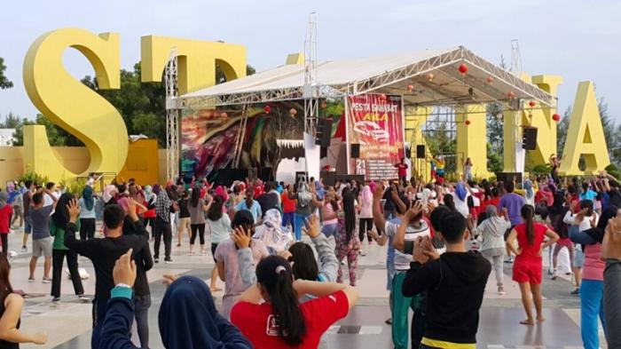  Pic. 3.1. Joint sports activities weekend Source: Google, 2016 | 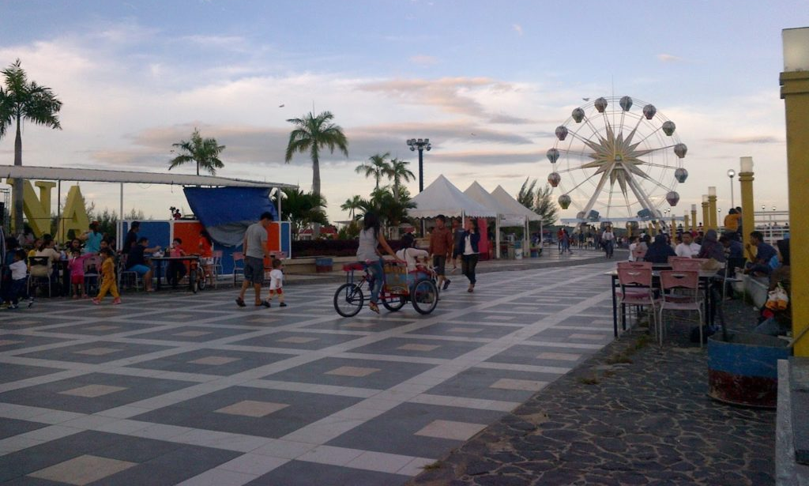  Pic. 3.2. Tenants selling with tent means Source:Google, 2019
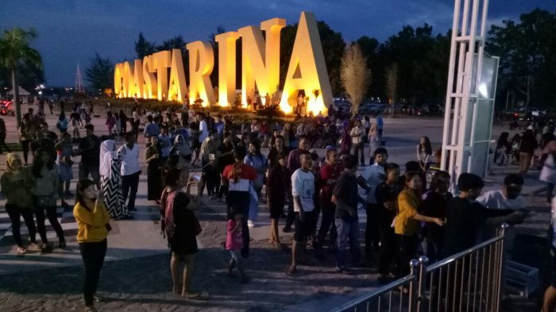  Picture. 3.3. Ocarina area on Saturday night  Source: Google, 2018 | 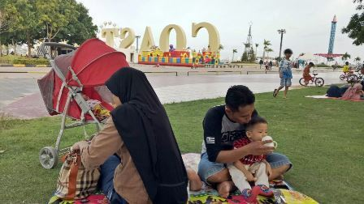  Picture. 3.4. Visitors activities in the Ocarina area Source: Google, 2018

Road traffic in the Ocarina area is divided into 2 (two), namely:
Vehicle lines where the vehicle lines within the Ocarina area are relatively safe and facilitated because the parking bags are available and can accommodate tourist buses and also the main road area is felt quite large ± 20 meters, both two-wheeled vehicles and four-wheeled roads that cross the main road of the region.
Walking trails (sidewalk), pedestrians are mostly used for leisure, cycling, rickshaw and roller-skis both adults and children visitors.

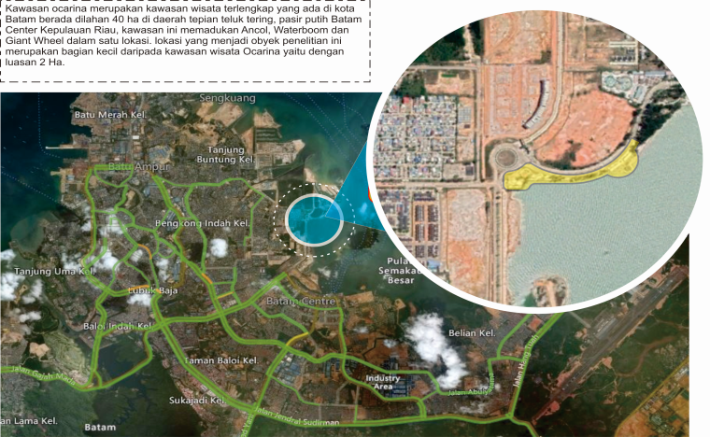
Fig. 3.5. Map of the and around Ocarina region
Source: Author, 2019

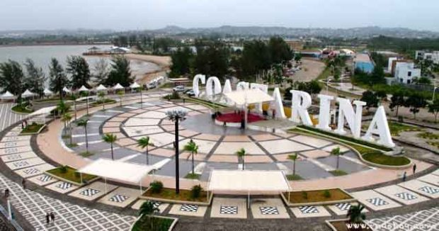
Picture. 3.6. Public open space in the Ocarina area of Batam
Source: Google, 2016

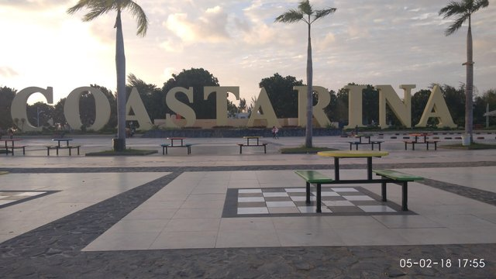
Picture. 3.7. In and around Coastaina in the Ocarina area
Source:Google, 2018

Coastarina in the tourist area of Ocarina is a landmark of the Ocarina area is located public open space as a center of visitor activities such as exercise together as in the picture. 3.1, as well as the place of activity on Saturday night as in the picture. 3.3. The writing of Coastarina is a record with the largest size in tourist area can be seen in the picture 3.7

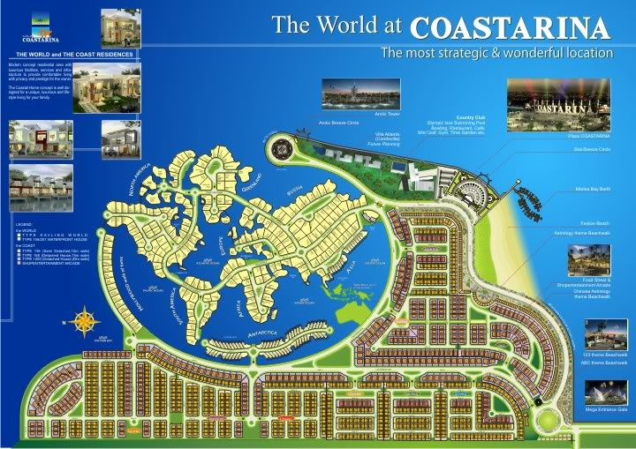
Picture. 3.8. Masteplan area of Coastarina
Source: Google,2018

Ocarina area Besides a tourist area is also a middle-up residential area with the concept of continents in the world by doing sea reclamation. The houses in Coastarina have the characteristics and concept of the building in accordance with the name of the form. Each continent connected by a bridge can be seen in the picture. 3.8.

3.3. Area of Ocarina 2
3.3.1. Location Ocarina 2

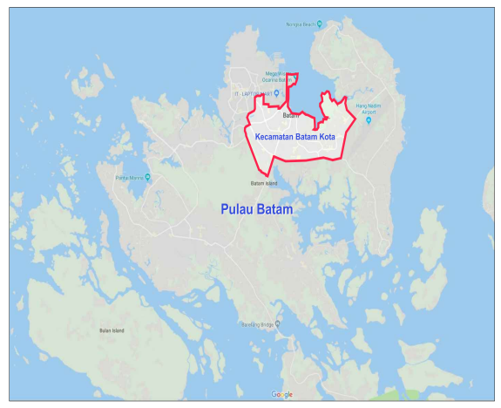
Figure. 3.9. Map of the Ocarina region in Batam Island
Source: Google, 2019

The area of Ocarina 2 is located in Batam City district, Batam City can be seen in the picture. 3.9, figure. 3.10, figure. 3.11. Is a tourism area that is designed as a tourist destination in the city of Batam.

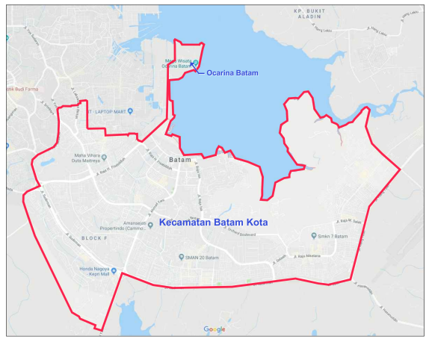
Picture. 3.10. Map of Batam City District
Source: Google, 2019

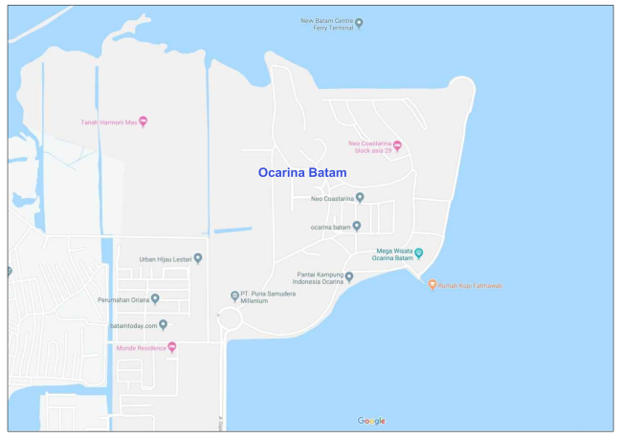
Picture. 3.11. Ocarina Area Source: Google, 2019

3.3.2. Ocarina Area Planning 2

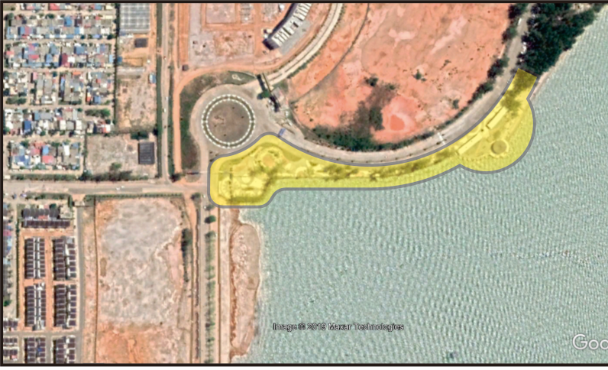
Picture.3.12.Site Plan Ocarina 2 Sourcer: Author, 2019

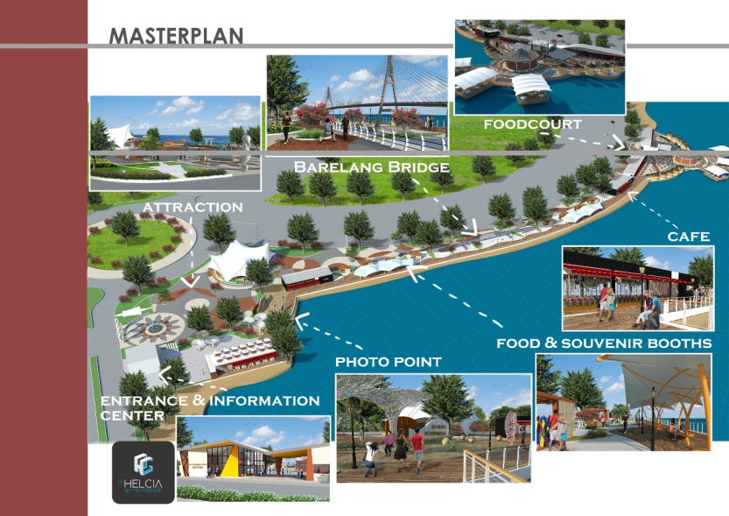
Picture.3.13. Master Plan Ocarina 2 Source: Author,2019

The area of Ocarina 2 blends with the Ocarina area can be seen in the picture. 3.12, development by reclaiming the coastal area. As for some planning the development can be seen in the picture. 3.13, picture. 3.14, picture. 3.15, picture. 3.16, picture. 3.17, picture. 3.18, picture. 3.18, picture. 3.19, picture. 3.20, among others:

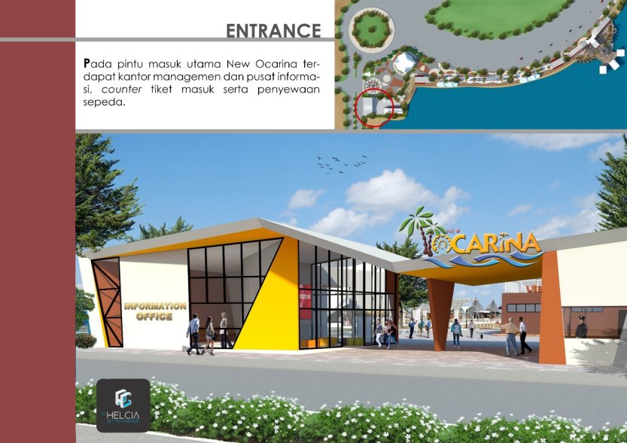
Picture.3.14. Entrance Plan Source: Author, 2019

Entrance Building with modern building concept adjacent to information room, with glass material and bright paint color.

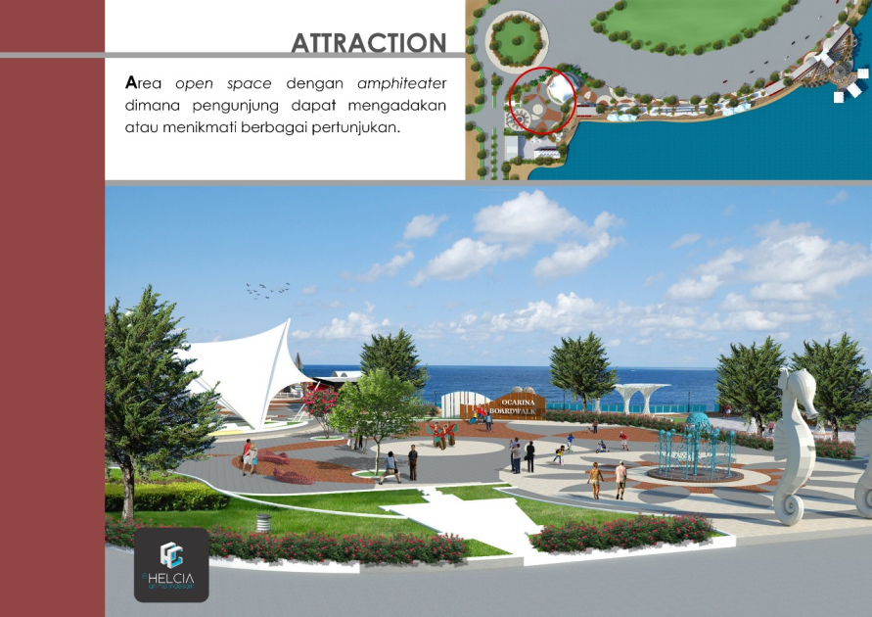
Picture.3.15.Atraction Area Source: Author, 2019

Atraction area is an inclusive concept where as a place that can accommodate the show/attractions of all ages, all genders special performances of Malay arts that want to be featured as a show for tourists who visit.
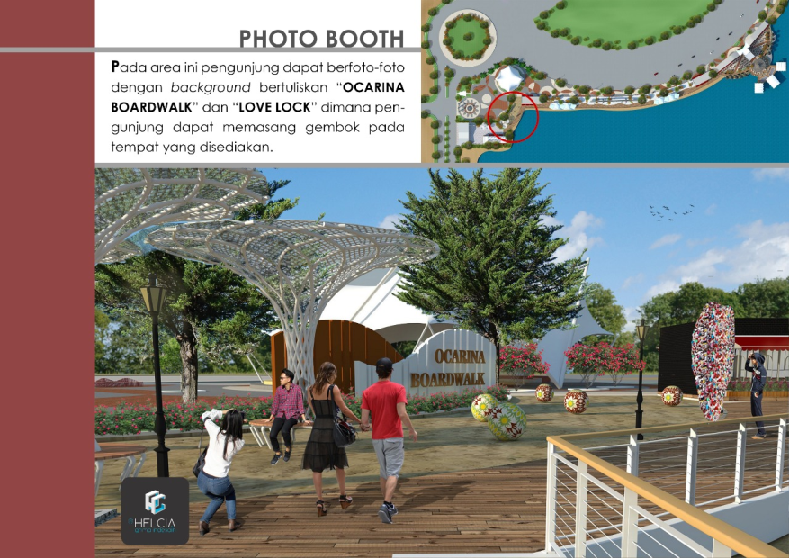
Picture. 3.16.Photo Booth Area Source: Author, 2019

The modern photo Booth Area is provided as a photo tourist spot, there is a bridge in the form of Barelang, there is also a building similar in Singapore.

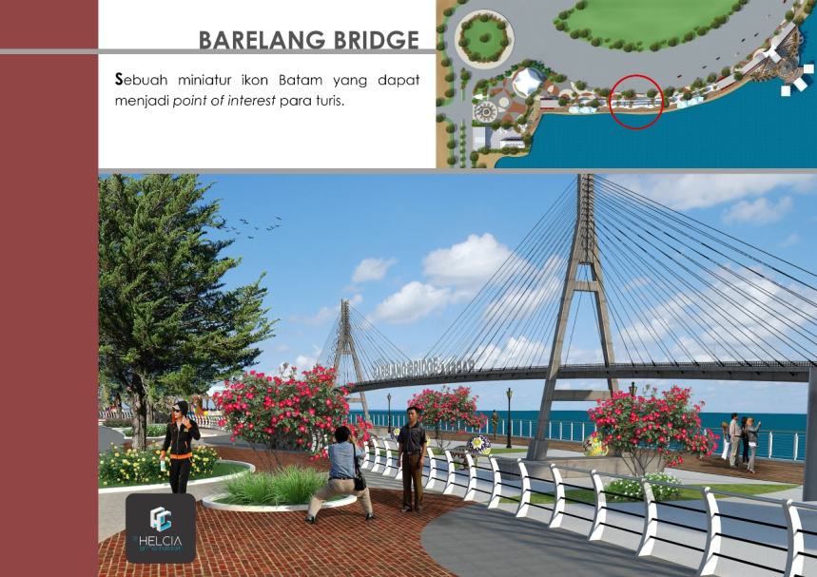
Picture.3.17.Barelang Bridge Source: Author, 2019

As an auxiliary tourism area Ocarina 2 is also equipped with a café.
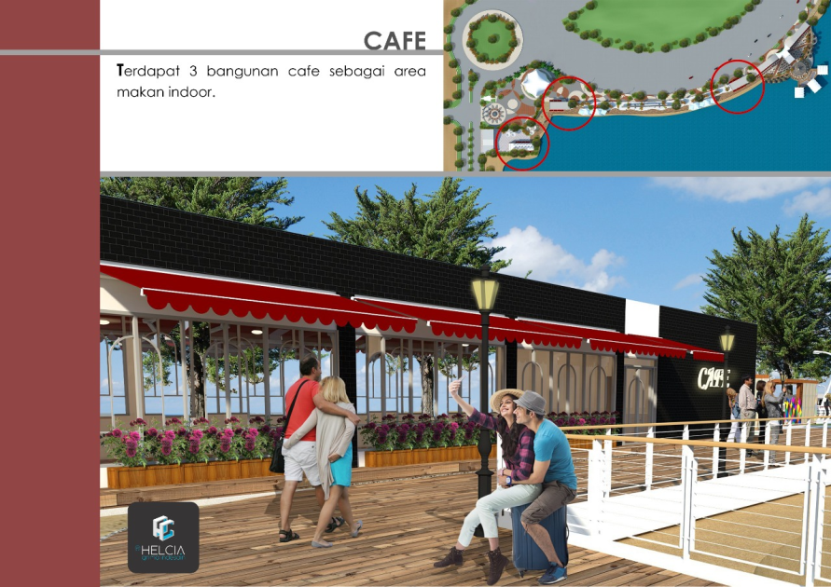
Picture.3.18.Design Café Source: Author,2019

Also equipped with foodcourt and eating area like the picture below

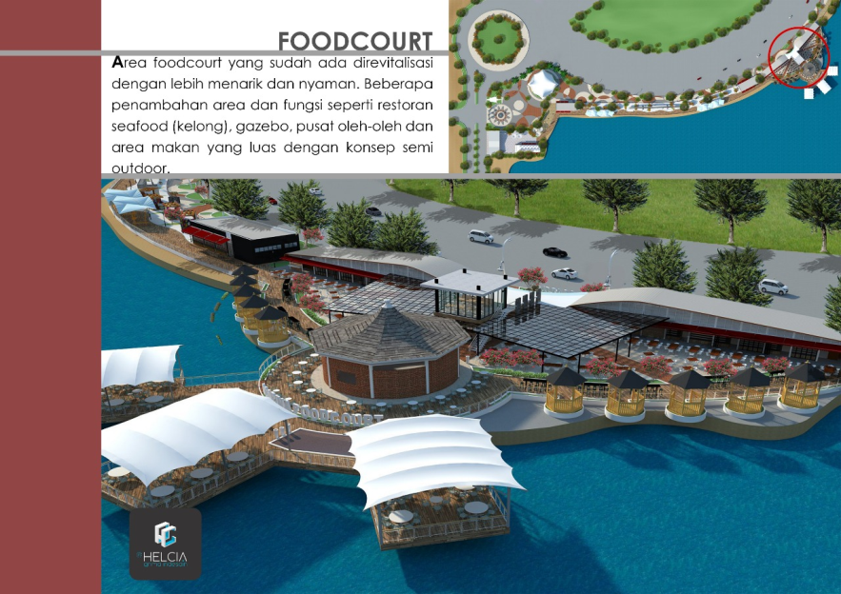
Picture.3.19.Foodcourt Area Source: Author, 2019

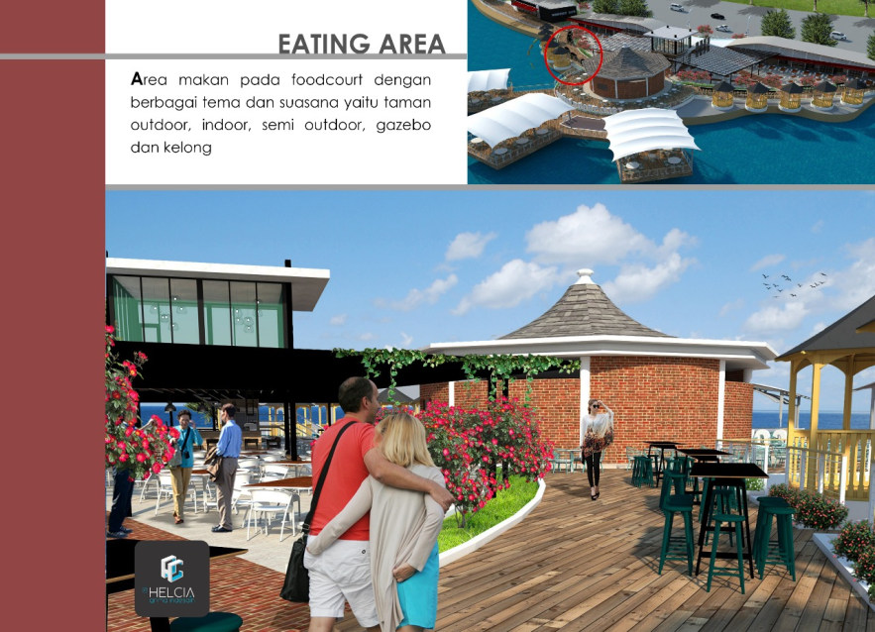
Picture.3.20.Eating Area Source: Author, 2019

3.3.3 Ocarina 2 area with Sustainable Tourism concept
The area of Ocarina 2 features the concept of a sustainable tourism destination including: (1) The Ecological Sustainability Design has applied openings with Windows utilizing sunlight as a lighting and utilizing angina as an air conditioner, using environmentally friendly building materials, as well as planting of trees as greenery, retaining and replanting mangrove forests, and utilizing the rainwater that is processed and accommodated as a plant sprinkler; (2) The Social and Cultural Sustainability area of Ocarina 2 is planned as Mobilizer and revive the Ocarina region, as well as the area surrounding Ocarina which has decreased the quality of its activity is diminishing and deserted, Malay culture is highlighted in the form of art and culture and Malay food is prepared in the Foodcourt Area;(3) Economic Sustainability, Ocarina 2 area in development considering material efficiency, prioritizing local materials and environmentally friendly , electricity energy using Solarcell system, water use by processing rainwater as a plant sprinklers. Faucet-water faucet using automatic sensor will be dead itself when not in use.

- Conclusion
The concept of tourism area Ocarina 2 has been weighing and has implemented Suistanable City in the Ocarina 2 area planning such as; 1 Preservation is maintaining and maintaining existing plants;(2) education by providing learning for visitors to save the natural resources, especially water by giving an appeal in the toilets, by providing a trash can determine to give learning clean, healthy and disciplined, invite visitors to maintain the environment by treating the plants with a good;(3) The economy is able to accommodate the work area for the residents of Batam, increasing tourist visits to Batam , Upgrading PAD Batam City, revive the area of Ocarina particularly residential surrounding that was previously not developed and many abandoned its owners.

Acknowledgments
Together this author thanks to the lecturers of the architecture Megister Diponegoro University who always guide and give direction, the Senior architects who have given advice and input to the Design planning Ocarina 2, as well as college friends Force 2018 always give encouragement so that the author can complaint this journal.

- References

Goeldner R, Ritchie B.R.J; McIntosh W.R. (2000), Tourism : Principles, Practices, Philosophies. Jon Willey & Sons, Canada.
Gunn C. (1994), Tourism Planning; Basic, Concepts and Cases, Taylor and Francis, USA.
Lynch, Kevin. (1977). The Image of The City. Cambridge, Massachusetts, and London, England: The M.I.T. Press.

