**Visualization and Mapping of Research Topics Transportation Model Sustainable Movement for Livestock Folding Container Ship as Sea Toll Supports**

Sutini1, M.Handajani2, Ismiyati3

*1Civil Engineering Postgraduate Program, Faculty of Engineering, Diponegoro University, Indonesia.*

*Email:* [*paleon_sutini@yahoo.com*](mailto:paleon_sutini@yahoo.com)

*2Civil Engineering Department, Faculty of Engineering, Semarang University, Indonesia.*

*3Civil Engineering Department, Faculty of Engineering, Diponegoro University, Indonesia.*

**Abstract**

A study was conducted on the visualization and mapping analysis of research topics related to transportation model for livestock folding container as sea toll support using the Crossref-based data retrieval method. Data search was carried out using the assistance of Publish or Perish 8 software, utilizing keywords "livestock folding container" and "sea toll," within the time range from 2014 to 2023. The search yielded a total of 1000 publications, consisting of 18 document types. The retrieved data was categorized based on predefined criteria and analyzed using Microsoft Excel. For visualizing and mapping the results retrieved from Crossref, the Visualization Of Similarity (VOS) Viewer was employed. The study's results revealed that since 2018, research topics related to livestock folding containers and sea toll have shown a consistent increase up to the present. The most prolific author in publishing research on livestock folding containers and sea toll is David C. Barret, with 45 documented publications, while the author with the highest number of citations is Stephen C. Bishop, with 124 citations. The most productive country in publishing research on livestock folding containers and sea toll is the United Kingdom. Institutions such as Professor of Bovine Medicine, Editorial Board Member, Consultant Editor, Central University of Tamil Nadu, European Specialist in Equine Internal, Los Alamos National Lab, Howells Veterinary Services, Scottish Center for Production Animal, and Veterinary Surgeon and Consultant are among the leading contributors in publishing research on livestock folding containers and sea toll. Research topics such as container, cargo, livestock, toll, Northern Sea Route, ship, vessel, transportation, sea transport, and container transportation have been consistently studied since 2018 up to the present.

Keywords: sea toll, livestock folding container, VOSviewer

**1.Introduction**

The implementation of the sea toll concept provides opportunities to enhance welfare within Indonesian society, especially for those residing in less developed areas, isolated regions, remote territories, and border areas. President Joko Widodo introduced the idea of the maritime toll logistics system. This plan aims to connect major ports across the Indonesian archipelago. By strengthening the connections between various maritime ports, the transportation of cargo can be facilitated even to distant locations. Furthermore, this initiative aims to achieve price uniformity for logistics services throughout Indonesia's regions. The sea toll has been designed to enhance the movement of passengers and goods, thereby reducing transportation and logistics costs, and ultimately lowering the prices of goods (Soedarno, Ranti & Nugroho, 2020).

Generally, the term 'livestock container' refers to a facility or enclosure used to transport or store livestock animals such as cattle, sheep, goats, and pigs. The design of these containers aims to provide a safe and comfortable environment for the animals during travel or temporary storage. Another variation is the 'folding container,' a type of container that can be folded or flattened when not in use, making it more space-efficient for storage or return. This container model is often used in various sectors to transport goods and can be made from various materials such as metal, plastic, or fabric. With this concept, the 'livestock folding container' is a portable shipping container specifically designed to transport livestock animals, which can be transformed by folding when not needed. Such container models are highly useful in the field of livestock farming, as they allow farmers or animal owners to carry the container to different locations.

Mapping the research topics of livestock folding container and sea toll is highly significant because, up to this point, bibliometric visualization and mapping of livestock folding container and sea toll based on Crossref data have never been undertaken. The visualization and mapping study of transportation model for livestock folding container ship as sea toll support aims to (1) identify the annual trends in research topics related to livestock folding container and sea toll, (2) identify the most prolific authors in the livestock folding container and sea toll research topics, (3) identify the most productive countries in livestock folding container and sea toll research, (4) determine co-authorship networks of organizations or affiliations in livestock folding container and sea toll publications, (5) generate co-citation network maps of journals within the livestock folding container and sea toll research topics, (6) create co-occurrence network maps of research topics in livestock folding container and sea toll based on keywords.

**2.literature review**

**2.1 Sea toll**

Sea toll is a concept aimed at improving the logistics transportation process in Indonesia, which is currently being vigorously implemented. As a result, the distribution of goods (especially foodstuffs in Indonesia) is expected to become more streamlined, leading to more equitable prices of essential commodities throughout the entire region of Indonesia. What the Indonesian populace needs to understand is that the sea toll concept does not entail building toll roads on the sea. Rather, it involves unobstructed shipping routes that connect nearly all ports across Indonesia (Sutini, 2022). The ships used in the sea toll program typically have an average Gross Registered Tonnage (GRT) of 2000 tons, aiming to enable their access to remote ports across the entirety of Indonesia (Luthfi Hakim, 2016).

A sailing route is a voyage plan or passage planning, outlining the course of the journey from the departure port to the destination port, taking into consideration navigation systems, with the shortest and quickest route that ensures safety, security, effectiveness, and efficiency (Wiwin Nurzanah, 2020). The goal of an optimal sailing route is to navigate from the destination port to the arrival port in support of sea toll, utilizing the shortest and safest route.

**2.2 Livestock folding container**

Fundamentally, to create a foldable livestock container for inter-island animal transportation, reference is made to the AMSA (Australian Maritime Safety Authority) standard container design, which has been applied for shipping animals like cattle, camels, horses, and other livestock. This specialized foldable container resembles a portable enclosure that can be loaded onto ships, lifted onto container trucks, and can also be folded when not in use, reducing the required storage space for the container (Subiyantoro, 2016).

**2.3 Science mapping**

Scientific mapping is very useful to know the development of literature in relation to the development of science that is reviewed, because scientific mapping aims to build a bibliometric map describing how certain disciplines, scientific domains, or research areas are conceptually arranged, intellectually, and socially (Cobo, Herera & Viedma, 2011). Using the science mapping method, the development of science can be mapped properly and this map can change and develop along with the development of science itself. The science mapping approach displays the structural and dynamic aspects of scientific research; it is a spatial representation of how disciplines, fields, and writers relate to one another (Bolivar, Munos & Cobo, 2018).

Nowadays, many computer applications can be used for science mapping, such as CiteSpace (2003), Science of Science Tool (2009), VOSviewers (2010), and SciMAT(2012) (Chen, 2013). In this study, the mapping process used VOSviewers software. VOSviewers is one of the computer applications that is considered capable and is widely used in processing metadata sourced from Scopus. VOSviewer is used to establish a network of scientific publications, scientific journals, researchers, research organizations, countries, keywords, or terms. VOSviewers can create maps based on network data and visualize the maps in the form of network visualization, overlay visualization, and density visualization (van Eck & Waltman, 2017).

**3.Research methodology**

The study was conducted through literature search based on Crossref data using the assistance of Publish or Perish 8 software, utilizing the keywords "livestock folding container" and "sea toll," within the time range from 2014 to 2023. The search yielded a total of 1000 publications, comprising 18 document types as shown in Table 1.

**Table 1**. Distribution of documents on the research topics of livestock folding containers and sea toll.

|  |  |  |
| --- | --- | --- |
|  | | |
| Document type | Documents | Percentage (%) |
| journal-article | 587 | 58.7 |
| book-chapter | 187 | 18.7 |
| proceedings-article | 70 | 7 |
| reference-entry | 56 | 5.6 |
| report | 35 | 3.5 |
| book | 11 | 1.1 |
| peer-review | 11 | 1.1 |
| component | 11 | 1.1 |
| posted-content | 10 | 1 |
| proceedings | 5 | 0.5 |
| monograph | 5 | 0.5 |
| other | 5 | 0.5 |
| edited-book | 2 | 0.2 |
| journal-issue | 1 | 0.1 |
| book-part | 1 | 0.1 |
| reference-book | 1 | 0.1 |
| dataset | 1 | 0.1 |
| database | 1 | 0.1 |
| Jumlah | 1000 | 100 |
| Source : Crossref |  |  |

The search results data of 1000 documents were categorized based on predefined criteria in alignment with the research objectives and were analyzed using Microsoft Excel. Meanwhile, for visualizing and mapping the results retrieved from Crossref, the Visualization Of Similarity (VOS) Viewer was used to examine co-authorship based on affiliations or institutions, co-citation network maps of livestock folding container and sea toll publications, and co-occurrence network maps of research topics related to livestock folding containers and sea toll based on keywords.

**4.Finding and discussion**

**4.1 Annual publication trends of the research topics on livestock folding container and sea toll.**

The publication trends of the research topics on foldable livestock containers and sea toll based on years can be observed as depicted in Figure 1. Publications related to livestock folding containers and sea toll first appeared in 2017 with the title "Container Shipping Network Efficiency Comparison in Indonesia: Nusantara Pendulum and Sea Tollway." Between the years 2015 and 2017, the number of publications on the topics of livestock folding containers and sea toll experienced a decrease (below 100 documents). It wasn't until 2018 that research topics related to livestock folding containers and sea toll began to steadily increase up to the present. There was a significant increase in the number of publications on livestock folding containers and sea toll research topics in 2019, with a total of 51 publications.

**Figure 1**. Annual publication trends of research topics on livestock folding containers and sea toll.

(Source : Results of data analysis using Microsoft Excel)

**4.2 Ten most prolific authors on the research topics of livestock folding containers and sea toll.**

The results of VOSviewer analysis of authors' contributions to the discussed topics, the ten most prolific authors can be observed in Table 2, the ten authors with the highest number of citations in Table 3, and the top 20 documents with the highest number of citations in Table 4.

**Table 2**. Ten most prolific authors on the research topics of livestock folding containers and sea toll

|  |  |
| --- | --- |
| Authors | Publications |
| David C. Barret | 45 |
| April Taylor | 20 |
| David Rendle | 12 |
| Ricard Laven | 11 |
| David Barret | 10 |
| James Breen | 10 |
| Peter de Tender | 8 |
| John Carr | 7 |
| Russel Parker | 7 |
| Liu Yuan | 6 |

(Source : Results of data analysis using Microsoft Excel)

**Table 3**. Ten authors with the highest number of citations on the research topics of

livestock folding containers and sea toll

|  |  |
| --- | --- |
| Authors | Citations |
| Stephen C. Bishop | 124 |
| Saber Qanbari | 109 |
| Amir Hossein Gharehgozli | 108 |
| Dusan Ku | 60 |
| S.C. McClelland | 55 |
| Craig Martin | 47 |
| Hui Zhao | 45 |
| Carolina Figueroa | 35 |
| K.A. Saravanan | 33 |
| Morten Svindland | 32 |

(Source : Results of data analysis using Microsoft Excel)

**Table 4**. The top 20 documents with the highest number of citations on the research topics of

livestock folding containers and sea toll

|  |  |
| --- | --- |
| Documents | Publication year |
| Genomics and disease resistance studies in livestock | 2014 |
| Mapping signatures of positive selection in the genome of livestock | 2014 |
| Sea container terminals: New technologies and OR models | 2015 |
| Container relocation problem with time windows for container departure | 2016 |
| Type and number of environmental impact categories used in livestock life cycle assessment: A systematic review | 2018 |
| shipping container | 2016 |
| Study on China-EU container shipping network in the context of Northern Sea Route | 2016 |
| Coinfection takes its toll: Sea lice override the protective effects of vaccination against a bacterial pathogen in Atlantic salmon | 2017 |
| Selection signatures in livestock genome: A review of concepts, approaches and applications | 2020 |
| The environmental effects of emission control area regulations on short sea shipping in Northern Europe: The case of container feeder vessels | 2018 |
| Economic feasibility of an NSR/SCR-combined container service on the Asia-Europe lane: a new approach dynamically considering sea ice extent | 2018 |
| LNG-fuelled container ship sailing on the Arctic Sea: Economic and emission assessment | 2020 |
| Perceptions of antibiotic use in livestock farming in Germany, Italy and the United States | 2020 |
| Scheduling of container-handling equipment during the loading process at an automated container terminal | 2020 |
| Berth allocation in container terminals that service feeder ships and deep-sea vessels | 2016 |
| Haematological changes and plasma fluid dynamics in livestock during thermal stress, and response to mitigative measures | 2018 |
| The feeder network design problem: Application to container services in the Black Sea region | 2014 |
| Energy-Saving Potential and an Economic Feasibility Analysis for an Arctic Route between Shanghai and Rotterdam: Case Study from China’s Largest Container Sea Freight Operator | 2018 |
| Combinable containers: A container innovation to save container fleet and empty container repositioning costs | 2019 |
| A simulation optimization method for deep-sea vessel berth planning and feeder arrival scheduling at a container port | 2020 |

(Source : Results of data analysis using Microsoft Excel)

**4.3 The ten most productive countries publishing research on livestock folding containers and sea tolls**

The search results indicate that a total of 56 countries have published research findings on livestock folding containers and sea tolls. The most productive country in terms of publishing research on livestock folding containers and sea tolls is the United Kingdom. Detailed information on the top ten productive countries publishing research on livestock folding containers and sea tolls can be found in Table 5.

**Table 5**. Ten most productive countries publishing research on livestock folding containers and sea tolls

|  |  |
| --- | --- |
| Countries | Publications |
| UK | 299 |
| USA | 148 |
| Denmark | 84 |
| China | 76 |
| Spain | 46 |
| India | 41 |
| Indonesia | 40 |
| Germany | 27 |
| Rusia | 25 |
| France | 22 |

(Source : Results of data analysis using Microsoft Excel)

**4.4 Co-authorship network of organizations or affiliations in publications on livestock folding containers and sea tolls.**

The visualization of the co-authorship network of organizations or affiliations, as shown in Figure 2, reveals that these institutions do not collaborate with each other in publishing research on livestock folding containers and sea tolls. Meanwhile, Table 6 presents the top 10 institutions with the highest citations and document counts.

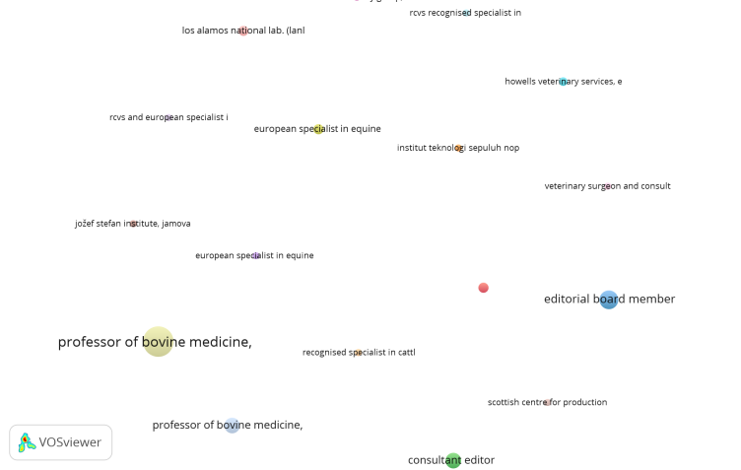

**Figure 2**. Co-authorship network of organizations or affiliations in publications on livestock folding containers and sea tolls (Source : Results of data analysis using VOSviewer)

**Table 6**. The top 10 institutions with the highest citations and document counts

on livestock folding containers and sea tolls

|  |  |  |
| --- | --- | --- |
| Organization | documents | citation |
| Professor of bovine medicine, University | 33 | 5 |
| Editorial board member | 13 | 1 |
| Professor of bovine medicine, Product | 9 | 1 |
| Consultant editor | 9 | 0 |
| Central university of tamil nadu | 4 | 0 |
| European specialist in equine internal | 4 | 2 |
| Los alamos national lab | 4 | 0 |
| Howells veterinary services | 3 | 0 |
| Scottish center for production animal | 2 | 5 |
| Veterinary surgeon and consultant | 2 | 2 |

(Source : Results of data analysis using VOSviewer)

**4.5 Co-citation network map of journals in the research topics of livestock folding containers and sea tolls.**

The visualization results of co-citation in publications related to livestock folding containers and sea tolls, based on publication sources using VOSviewer software, reveal the presence of 18 items grouped into 5 clusters, as shown in Figure 3. Among the 18 items, it is evident from Table 7 that the European Journal of Operational Research, OR Spectrum, Transportation Research Part E: Logistics, and Transportation Science have the highest total link strength.

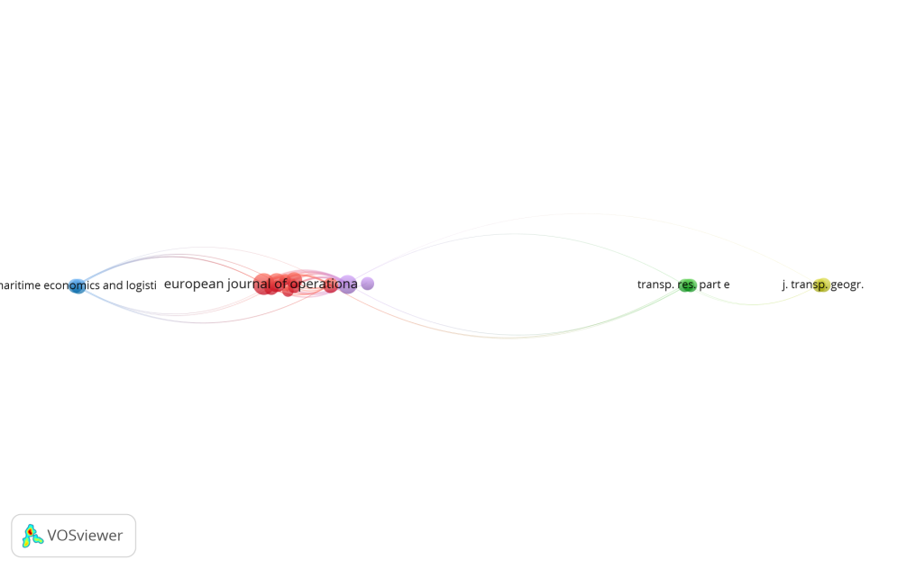

**Figure 3**. Co-citation network analysis map based on sources.

(Source : Results of data analysis using VOSviewer)

**Table 7**. The top ten journals with the highest total link strength in the research topic of livestock folding containers and sea tolls.

|  |  |  |
| --- | --- | --- |
| Sources | Citation | Total Link Strength |
| European journal of operational research | 72 | 2815 |
| Or spectrum | 57 | 2815 |
| Transportation Research Part e: logistic | 58 | 2794 |
| Transportation science | 40 | 1936 |
| Computers and operation research | 23 | 1340 |
| J. Climate | 38 | 1216 |
| Maritime policy and management | 34 | 1116 |
| Geophys | 24 | 1012 |
| Nature | 55 | 1001 |
| Transportation Research Part b : methodological | 20 | 994 |

(Source : Results of data analysis using VOSviewer)

**4.6 Co-occurrence network map of research topics on livestock folding containers and sea tolls based on keywords.**

The analysis of keyword co-occurrence using VOSviewer software reveals the utilization of 70 keywords in publications related to livestock folding containers and sea tolls, distributed across 4 clusters as depicted in Figure 4. Table 8 presents the top 10 most frequently used keywords in the research topic of livestock folding containers and sea tolls. Overlay analysis indicates that keywords present in the research topic of livestock folding containers and sea tolls, such as 'container,' 'cargo,' 'livestock,' 'toll,' 'northern sea route,' 'ship,' 'vessel,' 'transportation,' 'sea transport,' and 'container transportation,' have been explored from 2018 to the present.

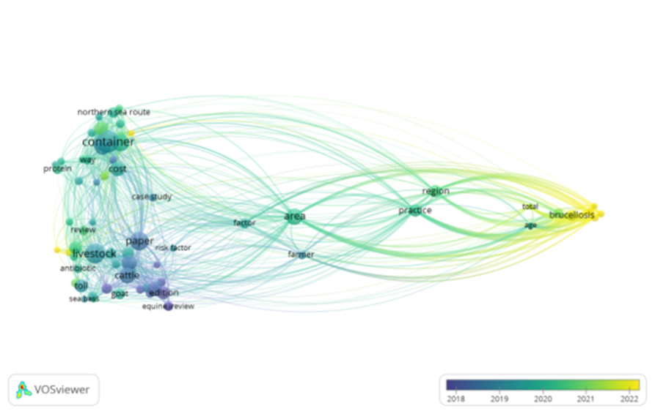

**Figure 4**. Co-occurrence network map of the research topic of livestock folding containers and sea tolls based on keywords. (Source : Results of data analysis using VOSviewer)

**Table 8**. The top ten keywords frequently used in the research topic of livestock folding containers and sea tolls

|  |  |  |
| --- | --- | --- |
| Keyword | Occurrances | Total Link Strength |
| container | 117 | 384 |
| livestock | 94 | 420 |
| paper | 86 | 430 |
| port | 73 | 331 |
| area | 67 | 910 |
| ship | 62 | 346 |
| cattle | 61 | 278 |
| management | 55 | 218 |
| vessel | 52 | 294 |
| transportation | 51 | 524 |

(Source : Results of data analysis using VOSviewer)

**5.Conclusion and further research**

Starting from 2018, research topics related to livestock folding containers and sea toll have shown a consistent increase up to the present. The most prolific author in publishing research on livestock folding containers and sea toll is David C. Barret, with 45 documented publications, while the author with the highest number of citations is Stephen C. Bishop, with 124 citations. The most productive country in publishing research on livestock folding containers and sea toll is the United Kingdom. Institutions such as Professor of Bovine Medicine, Editorial Board Member, Consultant Editor, Central University of Tamil Nadu, European Specialist in Equine Internal, Los Alamos National Lab, Howells Veterinary Services, Scottish Center for Production Animal, and Veterinary Surgeon and Consultant are among the leading contributors in publishing research on livestock folding containers and sea toll. Research topics such as container, livestock, toll, Northern Sea Route, ship, vessel, transportation, and container transportation have been consistently studied since 2018 up to the present. As of the writing of this paper, no identified work has modeled transportation for livestock folding container ships as a support for sea toll. The obtained results are expected to expand knowledge, and future researchers will be able to identify and fill gaps in research areas that require further investigation to complement the existing research literature.

**Bibliography**

Soedarno, B. Ranti and W. S. Nugroho, "*Use of Physical Internet System to Increase Effectiveness of Sea Toll Logistics Operations in Indonesia*," 2020 6th International Conference on Interactive Digital Media (ICIDM), Bandung, Indonesia, 2020, pp. 1-6, doi: 10.1109/ICIDM51048.2020.9339641.

Sutini, S. (2022). Pengembangan Sistem Logistik yang Efektif dengan Penataan Muatan Kontainer di Kapal Kontainer. *PROSIDING*.

Hakim, L. (2016). Penentuan Rute Pelayaran Terbaik Untuk Mendukung Program Tol Laut NKRI (Studi Kasus: Rute Pelayaran Pelabuhan Belawan Menuju Pelabuhan Tanjung Priok). *Jurnal Geografi Gea*, *16*(2), 160-168.

Nurzanah, W. (2020). Analisa Waktu Tunggu Bongkar Muat Kapal Dengan Fasilitas Crane Di Pelabuhan Gabion Belawan. *Buletin Utama Teknik*, *15*(2), 180-190.

Subiyantoro, C., & Achmadi, I. T. (2016). Pengembangan Desain Peti Kemas Konvensional Menjadi Peti Kemas Lipat Khusus untuk Alat Angkut Sapi. Institut Teknologi Sepuluh Nopember Surabaya.

M. J. Cobo, A. G. Lopez-Herrera, E. Herrera-Viedma, and F. Herrera, “Science Mapping Software Tools: Review, Analysis, and Cooperative Study Among Tools,” *J. Am. Soc. Inf. Sci. Technol.*, vol. 62, no. 7, pp. 1382–1402, 2011.

M. P. R. Bolivar, L. A. Munoz, and M. J. Cobo, “Analyzing the Scientific Evolution and Impact of e-Participation Research in JCR Journals Using Science Mapping,” *Int. J. Infformation Manag.*, vol. 40, pp. 111–119, 2018.

C. Chen, “Mapping Scientific Frontiers : The Quest for Knowledge Visualization,” *Second*, vol. 9781447151, no. Springer-Verlag London Ltd, 2013.

N. J. van Eck and L. Waltman, *VOSviwer Manual*. Netherland: Universiteit Leiden, 2017.

Fahmiasari, H., & Parikesit, D. (2017). *Container shipping network efficiency comparison in Indonesia: Nusantara Pendulum and Sea Tollway*. The Asian Journal of Shipping and Logistics, 33(2), 79-84.

Bishop, S. C., & Woolliams, J. A. (2014). Genomics and disease resistance studies in livestock. Livestock science, 166, 190-198.

Qanbari, S., & Simianer, H. (2014). Mapping signatures of positive selection in the genome of livestock. Livestock science, 166, 133-143.

Gharehgozli, A. H., Roy, D., & De Koster, R. (2016). Sea container terminals: New technologies and OR models. Maritime Economics & Logistics, 18, 103-140.

Ku, D., & Arthanari, T. S. (2016). Container relocation problem with time windows for container departure. European Journal of Operational Research, 252(3), 1031-1039.

McClelland, S. C., Arndt, C., Gordon, D. R., & Thoma, G. (2018). Type and number of environmental impact categories used in livestock life cycle assessment: A systematic review. Livestock Science, 209, 39-45.

Martin, C. (2016). Shipping container. Bloomsbury Publishing USA.

Zhao, H., Hu, H., & Lin, Y. (2016). Study on China-EU container shipping network in the context of Northern Sea Route. Journal of Transport Geography, 53, 50-60.

Figueroa, C., Bustos, P., Torrealba, D., Dixon, B., Soto, C., Conejeros, P., & Gallardo, J. A. (2017). Coinfection takes its toll: Sea lice override the protective effects of vaccination against a bacterial pathogen in Atlantic salmon. Scientific reports, 7(1), 17817.

Saravanan, K. A., Panigrahi, M., Kumar, H., Bhushan, B., Dutt, T., & Mishra, B. P. (2020). Selection signatures in livestock genome: A review of concepts, approaches and applications. Livestock Science, 241, 104257.

Svindland, M. (2018). The environmental effects of emission control area regulations on short sea shipping in Northern Europe: The case of container feeder vessels. Transportation Research Part D: Transport and Environment, 61, 423-430.

Xu, H., Yang, D., & Weng, J. (2018). Economic feasibility of an NSR/SCR-combined container service on the Asia-Europe lane: a new approach dynamically considering sea ice extent. Maritime Policy & Management, 45(4), 514-529.

Xu, H., & Yang, D. (2020). LNG-fuelled container ship sailing on the Arctic Sea: Economic and emission assessment. Transportation Research Part D: Transport and Environment, 87, 102556.

Busch, G., Kassas, B., Palma, M. A., & Risius, A. (2020). Perceptions of antibiotic use in livestock farming in Germany, Italy and the United States. Livestock Science, 241, 104251.

Luo, J., & Wu, Y. (2020). Scheduling of container-handling equipment during the loading process at an automated container terminal. Computers & Industrial Engineering, 149, 106848.

Emde, S., & Boysen, N. (2016). Berth allocation in container terminals that service feeder ships and deep-sea vessels. Journal of the Operational Research Society, 67(4), 551-563.

Habibu, B., Dzenda, T., Ayo, J. O., Yaqub, L. S., & Kawu, M. U. (2018). Haematological changes and plasma fluid dynamics in livestock during thermal stress, and response to mitigative measures. Livestock Science, 214, 189-201.

Polat, O., Günther, H. O., & Kulak, O. (2014). The feeder network design problem: Application to container services in the Black Sea region. Maritime Economics & Logistics, 16, 343-369.

Wan, Z., Ge, J., & Chen, J. (2018). Energy-saving potential and an economic feasibility analysis for an Arctic route between Shanghai and Rotterdam: Case study from China’s largest container sea freight operator. Sustainability, 10(4), 921.

Shintani, K., Konings, R., & Imai, A. (2019). Combinable containers: A container innovation to save container fleet and empty container repositioning costs. Transportation Research Part E: Logistics and Transportation Review, 130, 248-272.

Jia, S., Li, C. L., & Xu, Z. (2020). A simulation optimization method for deep-sea vessel berth planning and feeder arrival scheduling at a container port. Transportation Research Part B: Methodological, 142, 174-196.