Morphology of Ranai City Natuna as the small island border city and sustainable development input

A, B, Kapiarsa1*. B, D, Putra2. W, Pradoto3. A, Sarjito4. D, Nabila5. A, Pratama6. H, Priyatna7. D, F, Dewi8

***1-2****Urban and Regional Planning Study Program, Bandung Institute of Technology, Indonesia*

*\*email:* [*kapiarsa_laurentius@yahoo.com*](mailto:kapiarsa_laurentius@yahoo.com)

*3Urban and Regional Planning Study Program, Diponegoro University, Indonesia*

***4****Defense Management Study Program, Defense University, Indonesia*

***5-8****Urban and Regional Planning Study Program, Karimun University, Indonesia*

**Abstract**

The Ranai Urban Area is the center and capital of the Natuna Regency, which is spread throughout the East Bunguran District. As the main service center in Natuna Regency, Ranai will directly affect the shape, structure, and environment of the city, as well as the surrounding rural areas. So that the types of forms and structures of the city can be identified during the process. The purpose of this research is to identify the shape and structure of the city of Ranai as an example of a small town in the area of ​​small islands and the borders of Indonesia that has the potential to become a new growth center and has strategic value for the economy, security, and national defense, meanwhile still considering its sustainability for the future, especially in environmental dimension. The factors used to identify the form and structure of cities in this study are ecological and morphological approaches, which used spatial and descriptive qualitative analysis methods. The results of the study show that the shape of the Ranai Urban Area is a city that is not patterned. Spatial structures are sector models from north to east, and some of them have multicore structures from south to west. Furthermore, Ranai is more suitable for adopting the concept of green urbanism for further development, which aligns with the concept of sustainability.

**Keywords:** urban morphology, small island border city, sustainability, green urbanism

1. Introduction

The phenomenon of the growth of new small-scale cities in the Riau Islands region has been increasing and mushrooming since the last decade. This is caused by several trigger factors, including the high level of urbanization from villages to cities, which is stimulated by economic considerations such as the difference in income between villages and cities as well as higher job opportunities in urban areas (Nasution, 2015). Apart from the economic background, the growth of new cities is also caused by the formation of new cities as a result of administrative and political processes (Fitrani et al., 2005), as well as the formation of new cities and districts, which is referred to as regional expansion or blossoming (Mardiansjah & Rahayu, 2019) which has also happened very frequently in recent years in the Riau Islands from village, sub-district, and sub-district levels. The birth of new regions and cities aims to increase equitable development in Indonesia's outermost small islands and borders. Besides that, these growing small island border cities are rarely studied from an urban perspective, which is the basis for researchers to examine the form and structure of small urban spaces on the islands spread across the Riau Archipelago Province.

The city of Ranai was chosen as the main location to be studied from several other small island cities in the Riau Islands because of Ranai's strategic position, which is in the border area with other countries in Southeast Asia such as Malaysia, Vietnam, Thailand, the Philippines and even borders the maritime conflict area. South China; Besides that, Ranai is a unique growth area because it is quite far from the provincial capital in Tanjung Pinang and closer to Kuching City as the capital of the State of Sarawak in Malaysia(Susilowati & Masruroh, 2018) and is flanked by the Malaysian peninsula and Kalimantan-Malaysia (Setiawan, 2020). So basically, the city of Ranai is unique in terms of its geography, which is quite isolated and far from other big cities. These conditions make the city of Ranai, on the one hand, quite safe from the perspective of city defense and resilience, but on the other hand, city growth may be difficult to develop without a regional policy that can stimulate the city's economy. Apart from that, studies on the shape and structure of small island cities located in border areas and outermost small islands are still rarely found, so researchers want to study the shape and structure of small island border cities and as initial research in observing the development and growth of cities. Small border islands in the future.

A city is an area with various elements and complex relationships that form an urban system that continues to grow and develop. To understand the process of growth of a city, spatial approaches are needed, especially in the scientific field of urban geography (Kustiwan, 2014). The spatial approach referred to in this research is 2 of the 5 approaches to the internal structure factors of the city being studied, namely the ecological approach and the city morphology approach (Yunus, 2005).

## **Ecological Approach**

In the ecological approach, cities are seen as objects of study in which a relationship between humans and the environment occurs, resulting in a regular pattern of urban land use, with a classification of 3 types of urban land use, namely the concentric zone model which tends to develop into areas the city's edges and circles follow the original center in stages (Burgess, 2015); a sectoral model where cities are built per sector and land uses are grouped in a tart shape, resulting in urban areas with varying population groups and buildings (Adams, 2005); and the multiple centers or multiple nuclei model, which has a concept quite different from other models, namely the growth of several growth centers clustered and functionally connected in a city (Mandaka et al., 2022).

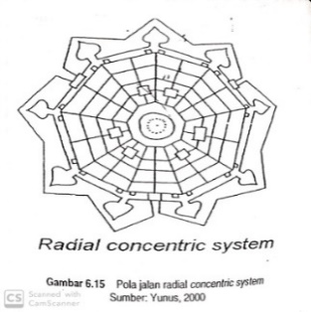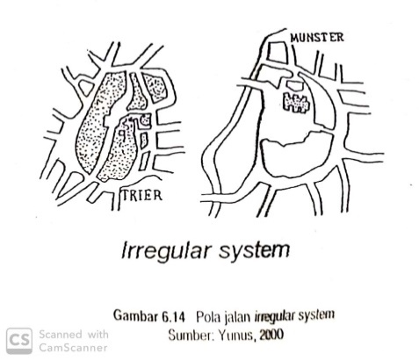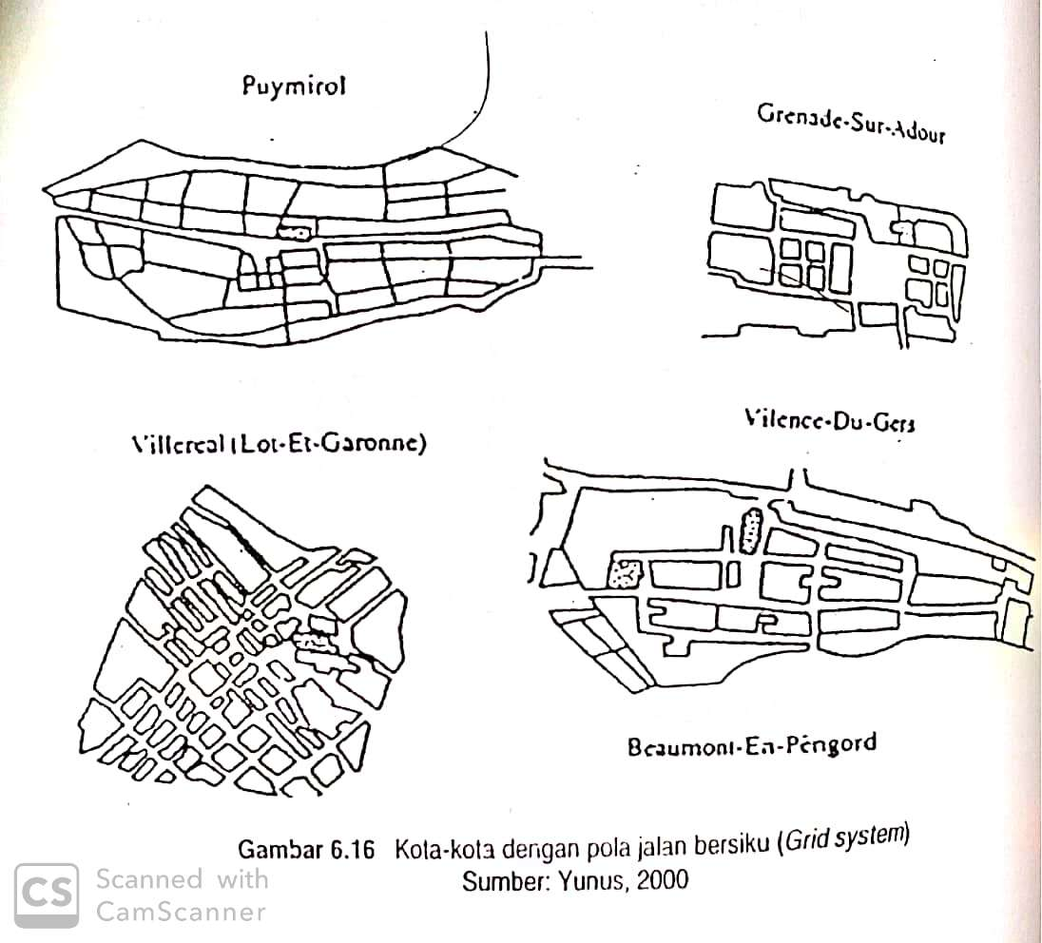

Grid System

***Figure 1.*** *Road Pattern System*

## **City Morphology Approach**

Morphology is defined as the science that studies the shape and structure of an object. So, city morphology is closely related to the shape and structure of the city. The shape of a city is a description or pattern of a built-up area that shows activities through land use, road networks, and the urban sprawl phenomenon (Chaidir, 2020). The network pattern itself is the most obvious component in determining the formation of a city by dividing it into three systems, namely the irregular street pattern system, which can be seen from the irregularity of the width and direction of the streets and is usually circular and has many dead ends; a concentric radial road pattern system which tends to make the road network look like a spider's web, has geometric regularity, and the main road network runs from the city center to the outskirts of the city regularly; and a grid pattern system that looks like cities are divided into rectangular blocks with longitudinal and transverse parallel roads forming right angles, the main roads running from the main entrance to the main city center square.

According to Schnore, the spatial structure will experience changes along with the growth of the region, such as in socio-economic aspects and forming a certain spatial organization, which is a representation of human use of space (Wan’s, 2019). According to Pryor, land use can also be an important indicator in determining city structure by dividing three urban land use subzones: urban areas, urban-rural fringe areas, and rural areas. This zoning division is based on the dominance of land use types between city and village, where the majority of land use is urban where many non-agricultural activities are included in the city area and vice versa. Meanwhile, if the area has equal dominance, it is classified as an urban-rural transition area.

Apart from road patterns and land use, the urban sprawl process is also an important study of the structure and shape of cities. Urban sprawl is the process of expanding/spreading city-built areas outward due to increasing population and urban activities. From the process, this phenomenon can be studied in terms of 3 types of urban sprawl processes, including concentric sprawl, namely sprawl that runs slowly and is limited; longitudinal spreading with the characteristic of following the transportation route so that it is finger-shaped and uneven; and jumping plants that occur scatter sporadically and grow in the middle of agricultural land so they tend to be considered environmentally unfriendly, uneconomical and unaesthetic. In the urban morphology approach, in general, spatial expression is not only studied from the focus of physical patterns such as road patterns and land use as above but also from the shape of the city which is divided into 2, namely compact cities (square, rectangular, fan, round, ribbon, octopus/star, and not patterned) and non-compact city (fragmented, chain, split, stellar, concentric, multi-noded, elongated, scattered, multi-noded concentric, elongated concentric, scattered concentric, elongated multi-noded, scattered multi-noded, and linear scattered).

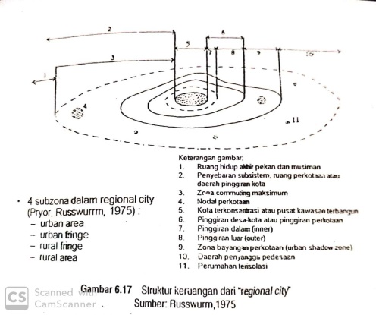 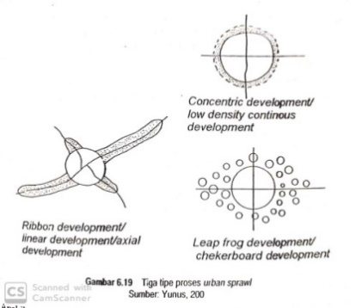 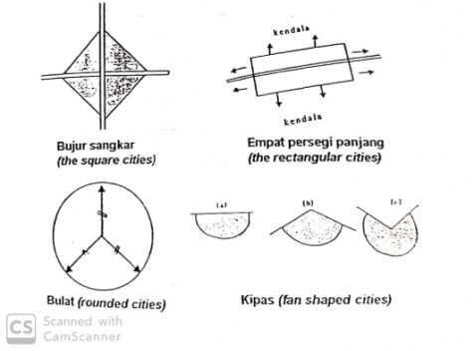

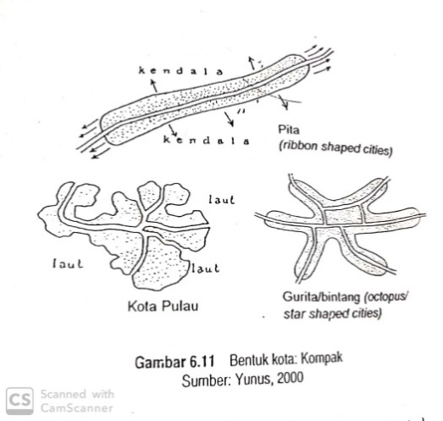 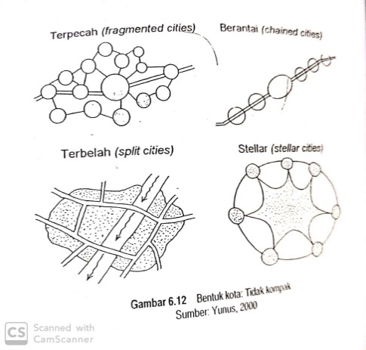 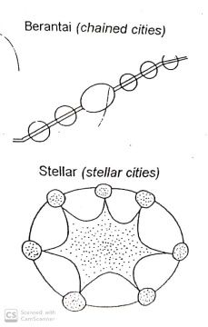 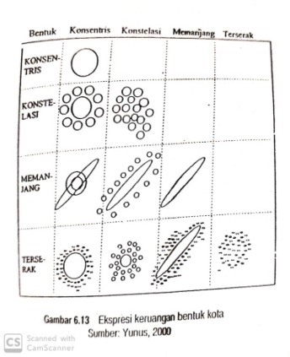

***Figure 2.*** *Land Use Subzone, Urban Sprawl, and Urban Form Types*

2. Research Method

From the explanation of research theory in the previous sub-chapter, variables, data requirements, and analysis techniques for this research can be determined, as seen in Table 1.

**Table 1.** Research Data

|  |  |  |  |  |  |
| --- | --- | --- | --- | --- | --- |
| Objective: To understand the shape and structure of the city of Ranai as a small border island city | | | | | |
|  | Target 1 | Target 2 | Target 3 | | Target 4 |
| Target | Identification of Ranai City Road Network Pattern | Identification of Ranai City Form and Urban Sprawl | Identification of Ranai City Structure | | Finding the environmental sustainability input for Ranai City Development |
| Variables | Road Network | Land Use and Road Network | Land Use | | Disaster Phenomenon |
| Analysis Technique | Spatial Analysis and Descriptive Qualitative | | | Literature Study | |
| Data Type | Primary Data | | | | Secondary Data |
| Data Source | Satellite Image, Google Map, East Bunguran District Archives | | | | |
| Year | 2023 | | | | |

The research method used in this research is a descriptive spatial and qualitative analysis by observing the distribution of land use and the local road infrastructure network that has been built and developed at the research location to identify the shape and spatial structure of small island cities located in border areas. This land use distribution map and local road infrastructure network were created from the digitization of the latest satellite imagery in 2023 using a GIS application.

The research location is in the Ranai City area in East Bunguran District, Natuna Regency. The area of this sub-district is 148.7 km2. It is administratively divided into four subdistricts and three villages, namely Ranai Kota Subdistrict, Ranai Basic Subdistrict, Bandarsyah Subdistrict, Batu Hitam Subdistrict, Batu Gajah Village, Sepempang Village, and Sungai Ulu Village. East Bunguran District is directly adjacent to North East Bunguran, Central Bunguran, West Bunguran, and South Bunguran Districts. Geographically, the East Bunguran District is on the east side of Natuna Besar Island, which has another name, Bunguran Island/Bunguran Besar Island, and faces the North Natuna Sea. If it continues eastward, Ranai City will face directly the State of Sarawak in Malaysia and the State of Brunei Darussalam.

|  |  |
| --- | --- |
|  |  |
| (a) | (b) |

***Figure 3.*** *East Bungaran District as Ranai City. (a) Administrative. (b) Satellite Image*

3. Result and Discussion

* 1. **Ranai City Road Network Pattern.**

Based on observations, the Ranai city area and the East Bunguran District have a fairly simple road network system and stretches along the eastern coastal area. Meanwhile, according to the road function, the road network in this city area consists of collector roads, local roads, environmental roads, and special roads. The collector road network itself is divided into two according to its class, namely primary collector I and primary collector III. The primary collector road network I is spread along the east coast of Natuna Besar Island from Sepempang Village in the north to Batu Gajah Village and continues around the island to Bungaran Selatan District. Meanwhile, the primary collector network III branches from the main collector to inland areas in all sub-districts and villages, apart from that it also connects the new government center in Bandarsyah Sub-district with the economic center in Ranai Barat and Ranai Kota sub-districts. However, it can be seen here that primary collectors are still dominantly located in Ranai Kota, Ranai Darat, and Bandarsyah sub-districts.

Apart from collector roads, there are also several local, environmental, and special roads in the road network system in the Ranai city area or East Bunguran District, which connect regional service centers with residential areas within them, for Special Roads as not intended for general traffic, but for own/specific traffic purposes organized by other than the Road operator. A special road in the Ranai city road network is intended for aviation activities at Raden Sadjad Airport.

From the condition of the road network, it can be seen that irregular road patterns dominate the road pattern system in the Ranai city area because this city has grown for a long time without any planning, so the city grows sporadically. However, based on observations, several concentric and angled radial road network patterns were found in several corners of the city due to urban planning that the government has implemented in the last decade. However, this is still far from significant because unplanned road patterns still dominate, even on the road network leading to the new government area in Bandarsyah Village.

|  |  |  |
| --- | --- | --- |
|  |  | (a) |
|  | (b) |
|  | (c) |

***Figure 4.*** *Road Pattern System Map of East Bunguran District, Ranai City. (a) Grid system. (b) Radial concentric system. (c)Irregular system.*

## **Ranai City Form and Urban Sprawl.**

Based on observations of land use in the Ranai city area from satellite imagery, it was found that the dominant land use is forest with varying densities and spread across the island's interior. Meanwhile, residential areas, trade services, and built-up land are concentrated along the coast of Ranai Kota, Ranai Darat, Bandarsyah, Batu Hitam, and Sepempang Villages. Meanwhile, Sungai Ulu and Batu Gajah villages are still dominated by forests and bushes and few rural residential areas. In several urban residential areas, you can still find lots of bushland and plantations owned by residents.

|  |  |  |
| --- | --- | --- |
|  |  |  |
| (a) | (b) | (c) |

***Figure 5.*** *Ranai City Form from Ecological Approach*

If studied from an ecological approach, the city of Ranai is unique as a small border island city that tends to take the form of a sectoral model and multiple centers. The sectoral model can be identified in the service trade center located on the coast of Ranai Kota Subdistrict and its residential areas, which extend to the city's outer edges following the primary collector road network. The residential area spreads from the center of Ranai City towards the north, entering Sepampang Village towards the west, entering Ranai Darat Village, and towards the south, entering Bandarsyah and Batu Hitam Villages. Apart from the sectoral model, it can also be identified that there is a multiple-center model with the government center being far from the central area of Ranai city in Bandarsyah Village and becoming a new service center with the surrounding area still dominated by forests, plantations, and bushes. Apart from that, many new residential areas have mushroomed around Sungai Ulu and Batu Gajah villages. This can also be explained based on an ecological approach, that the city of Ranai also has an urban sprawl process that does not only have 1 model but 2, namely longitudinal sprawl and jumping. The longitudinal spread can be seen from the distribution of settlements along the coast and the network of collector roads leaving the city center. Meanwhile, jumping can be identified from government centers and settlements, which are also mushrooming outside the Ranai city area.

Besides the ecological approach, city form can also be studied from a morphological approach with the road network pattern. The city of Ranai is also identified as having more than 1 form. The city of Ranai, which is located in a coastal area, basically has obstacles to growing towards the sea, which makes it able to become a compact city without the pattern of an island city and a ribbon compact city that extends along the coastal road network. However, as time went by, the need for land consumption for housing, trade in services, and government made the small town of Ranai unable to accommodate the needs of its population, so the town eventually developed not towards the sea but instead towards the higher land interior and the surrounding coastal areas which were lower. Sloping. Based on the existing road network, it can be seen that the development of the city of Ranai in the coming years can be predicted to develop to the south and also west, specifically towards the sub-districts of South Bunguran and Central Bunguran. So, the city of Ranai has a non-compact shape, which tends to be a chain model following the network of collector roads around the island, which can be seen in the following **Figure 6.**

|  |  |
| --- | --- |
|  |  |
| (a) | (b) |

**Figure 6.** Ranai City from Morphology Approach. (a) Form Urban. (b) Urban Sprawl.

## **Ranai City Structure.**

Based on Priyor's theory of urban spatial structure, it is known that there are several spatial structure zones in Ranai City, which are divided into three zones, namely the urban zone, the urban-rural transition zone, and the village zone. The urban zone consists of 3 areas, namely the main urban area, which is located throughout the Ranai Kota and Batu Hitam sub-districts, parts of Ranai Darat and Bandarsyah. This main urban zone is the urban center of Ranai, which consists of regional service transportation facilities such as Ranai Airport and Raden Sadjad Air Base, which are the only means of air transportation and connect the Natuna Islands with a larger city, namely Batam City; Penangi and Batu Hitam port facilities as a means of sea transportation to other islands in Natuna Regency and its surroundings; main places of worship such as the Great Natuna Mosque; main health facilities such as Natuna Hospital; main educational facilities; as well as the main defense and security in Ranai City. Apart from that, two urban zone areas are outside the main urban zone, namely the Sepempang Village and Sungai Ulu Village bordering Bandarsyah Village. For the urban zone in Sepempang Village, there are several main supporting utilities such as telecommunications facilities such as RRI Natuna, defense facilities such as Composite Battalion 01/Gardapati, and also tourism facilities such as the Natuna Dive Resort, as well as quite a lot of service trading facilities. Even though it is still in the administrative area of Sepempang Village, this area has moved towards a denser urban zone because of the large number of urban supporting facilities, so that the Sepempang urban zone indicates the widening or spread of the city towards the north. The next urban zone is in Sungai Ulu Village, which borders Bandarsyah Village because several new government facilities have been built, such as the Regent's Office, BP3D, the Housing and Settlement Service in Bandarsyah Village, and the District Court Office, Women's Building, Natuna Regency Regional Building in Sungai Village. Ulu. Apart from that, there are also worship, defense, security, recreation, and sports facilities around it as a new government area in Natuna. This government zone is to the southwest of the main urban zone with indications of city widening towards the southwest and east of East Bunguran District.

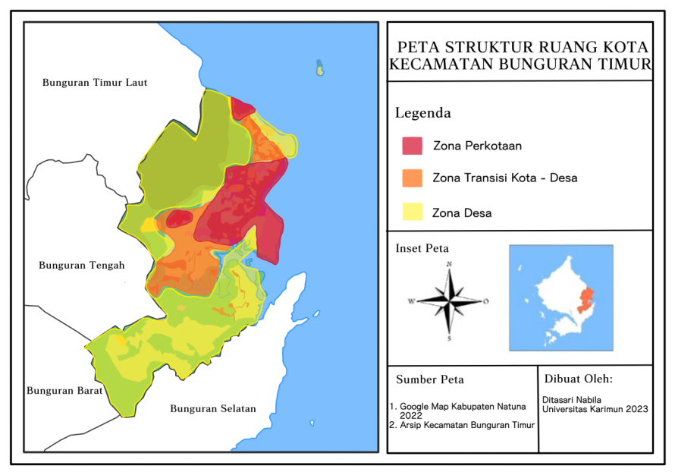

***Figure 7.*** *Ranai City**Structure from Morphology Approach*

Apart from the urban area zone, the city of Ranai also has a transition zone to the surrounding village town, namely in the villages of Sepempang and Sungai Ulu, as an effect of the widening and growth of the new city zone in the area and it is possible that this zone will also change over time to become an urban zone. The largest transition zone is in Sungai Ulu Village; this can be seen because the area of Sungai Ulu Village is still very large, and so is Batu Gajah Village in the southern part of Sungai Ulu Village. Apart from that, there is a quite large urban area of Cemaga in Bunguran Selatan District, which is approximately 27 km away and can be reached in approximately half an hour from Ranai. It is located in the southern part of Ranai City. So, the development of the city of Ranai is expected to grow more rapidly in the south and towards Cemaga. Meanwhile, the village zones are spread across Bandarsyah Village, Sepempang Village, a few in Ranai Kota Village, and Sungai Ulu Village, and most of them are in Batu Gajah in the southern part of East Bunguran District. Most of the land used in this village zone is still dominated by forests and community plantations, and the rest is used as a settlement for scattered and far-flung villagers and several local docks in coastal areas.

## **Ranai Sustainable Development Input.**

Ranai is a small-scale city with an area of ​​142.13 km2 and a population of around 23,036 people, making Ranai or East Bunguran District have a population density of 162.08 people per km2. However, what is unique is that based on data collected from the Natuna Regency Central Statistics Agency, there was a 10% decrease in population (Sahputra, 2022), but this did not stop people from converting undeveloped land into developed land. There are even filling up of wetlands and swamps to become residential areas for residents, and people also build houses illegally in river bodies, causing flooding in riverside areas in every northern or rainy season, namely from November to March. Apart from land conversion, drainage management is not suitable due to community behavior that does not heed the mutual cooperation program launched by the regional government so that drainage channels are buried in soil and overgrown with grass then the community also carries out bad practices such as throwing rubbish in drainage channels and blocking them. Drainage channels, thereby exacerbating the impact of flood disasters (Numan, 2024). The most severe flood that occurred in East Bunguran was first recorded in 1978, with a flood duration of around six days; then in 1984, the flood occurred again, and finally, the worst flood occurred in 2022 up to the height of an adult's neck; this is thought to be land conversion. From wet primary forests to built-up land for settlements, the main cause, besides drainage problems and littering behavior by the community, is the total loss of forest cover of around 16,400 from 2001 to 2019 (S Lehmann, 2019). Residents also carried out land conversion by burning plants on the land, so there was also an uncontrolled land fire that consumed one hectare of green land and was successfully extinguished by the Karimun Regency Disaster Management Agency, Natuna Fire Department, Village Development Officer, Bhayangkara Security and Public Order and personnel from Kodim 0813 Natuna (Putra et al., 2019). Due to various problems related to environmental exploitation and community practices that are not environmentally friendly and result in natural disasters such as floods and forest fires, it is necessary to apply sustainable city concepts not only to the city of Ranai but also to the upstream areas of Ranai which hold the key to sustainability. Society's life in the future. The concept of green urbanism can be a solution to overcome the problems that exist in Ranai City, especially the application of water and biodiversity pillars. In this pillar, urban water management, water recycling and irrigation, and waste management can be carried out using zero waste in a triple-zero framework to overcome flooding problems, especially in improving the quality of drainage channels and raising awareness of people's behavior in littering. Besides that, the application of urban landscape typologies by connecting the city with nature in eco-city theory can also stop and overcome the problem of raising awareness of environmentally unfriendly land conversion practices by the community as well as protecting green areas such as wet primary forests and wetlands such as swamps from being converted into built-up and denuded areas as a reservoir for rainwater runoff during the rainy season[17]. For an inner city with a high-density population, areas can implement green spaces as a solution to decrease individuality and raise the sense of community to protect and manage its environment, besides creating the identity of its people and cultures[18].

**4. Conclusion**

Based on the discussion above, research findings related to the form and structure of Ranai City as a small border island city in Natuna Regency can be seen as follows:

**Table 2.** Research Findings on the Form and Structure of Ranai City

|  |  |  |  |  |
| --- | --- | --- | --- | --- |
| Objective: To understand the shape and structure of the city of Ranai as a small border island city | | | | |
|  | Target 1 | Target 2 | Target 3 | Target 4 |
|  | Ranai City Road Network Pattern | Ranai City Form and Urban Sprawl | Ranai City Structure | Ranai City Environmental Sustainable Input |
| Research Findings | 1. Grid System 2. Concentric Radial System 3. Irregular system | 1. City Form    1. Ecological Approach       1. Sectoral Model       2. Plural Centers Model    2. Morphological Approach       1. Patternless Compact City/ Island City       2. Ribbon Compact City       3. Uncompact City Chain Model 2. Urban Sprawl    1. Ecological Approach       1. Elongated Spread       2. Elongated Leap Frog | 1. Urban Zone    1. Primary Urban Area: Ranai Kota, Ranai Dasar, Batu Hitam, Bandarsyah    2. North Urban Area: Sepempang    3. Southwest Urban Area: Sungai Ulu, Bandarsyah 2. Transition Urban-Village Zone    1. North Urban-Village Area: Ranai Kota, Sepempang    2. Southwest Urban-Village Area: Bandarsyah, Sungai Ulu 3. Village Zone    1. North-West Village Area: Sepempang, Ranai Kota, Ranai Darat, Bandarsyah, Sungai Ulu    2. South Village Area: Batu Gajah | 1. Green Urbanism: Water & Biodiversity Pillar    1. Urban Water Management    2. Water Recycling and Irrigation    3. Waste Management (zero waste)    4. Urban Landscape Typologies and Green Spaces |

The phenomenon of urban sprawl spreading along the island's coastal infrastructure path and spreading sprawl due to new growth centers in Ranai City could result in uncontrolled urban development, and changes in land uses could worsen the natural disaster that could happen in the future. This can be overcome with the concept of compact city development by limiting land conversion from undeveloped land to developed land, especially in wetland forests, swamps, mangrove forests, and coastal areas. Apart from that, the built-up land is optimized by constructing vertical buildings. Unproductive urban built-up land can also be converted into green land to optimize rainwater infiltration as a strategy to maintain the availability of groundwater and raw water sources for the people of Ranai City. This concept can also support the main concept of green urbanism above.

**Bibliography**

A, C. (2020). *Kecamatan Bunguran Timur Dalam Angka 2020 (East Bunguran in Number 2020)*. *112*.

Adams, J. S. (2005). Hoyt, H. 1939: The structure and growth of residential neighborhoods in American cities. Washington, DC: Federal Housing Administration. *Progress in Human Geography*, *29*(3), 321–325. https://doi.org/10.1191/0309132505ph552xx

Burgess, E. W. (2015). The growth of the city: an introduction to a research project. In *The city reader* (pp. 212–220). Routledge.

Fitrani, F., Hofman, B., & Kaiser*, K. (2005). Unity in diversity? The creation of new local governments in a decentralising Indonesia. *Bulletin of Indonesian Economic Studies*, *41*(1), 57–79.

Kustiwan, I. (2014). Pengertian Dasar dan Karakteristik Kota, Perkotaan, dan Perencanaan Kota. *Modul Perencanaan Kota*, 535. http://repository.ut.ac.id/3999/1/ADPU4433-M1.pdf

Lehmann, S. (2019). *Green Urbanism: a Series of Holistic Principles Sapiens*.

Lehmann, Steffen. (2019). Green Urbanism: a Series of Holistic Principles. *Sapiens*, *3*(October 2012).

Mandaka, M., Ikaputra, I., & Widyastuti, D. T. (2022). Tipologi dan Morfologi Kota Bersejarah Lasem. *Jurnal Arsitektur Pendapa*, *5*(1), 58–75.

Mardiansjah, F. H., & Rahayu, P. (2019). Urbanisasi dan pertumbuhan kota-kota di Indonesia: Suatu perbandingan antar-wilayah makro Indonesia. *Jurnal Pengembangan Kota*, *7*(1), 91–110.

Nasution, A. P. (2015). POTRET SEBARAN KEPENDUDUKAN DI PROPINSI KEPULAUAN RIAU. *BENING*, *2*(1).

Numan, M. (2024). *Natuna padamkan karhuta di Bunguran Timur (Natural Disaster Management Agency extinguishes forest and land fires in East Bunguran Timur)*.

Nurman, M. (2024, February). BPBD Natuna padamkan karhutla di Bunguran Selatan , tak ada korban jiwa. *BPBD Natuna*.

Putra, B. D., Horne, R., & Hurley, J. (2019). Place, space and identity through greening in Kampung Kota. *Journal of Regional and City Planning*, *30*(3), 211–223.

Sahputra, Y. (2022). *Kala Natuna Alami Banjir Parah, Apa Penyebabnya? (When Natuna Experiences Severe Flooding, What Causes It?)*.

Setiawan, B. (2020). Integrasi dan Nasionalisme di Natuna. *Jurnal Masyarakat Dan Budaya*.

Susilowati, E., & Masruroh, N. N. (2018). Merawat kebhinekaan menjaga keindonesiaan: Belajar keberagaman dan kebersatuan dari masyarakat pulau. *Jurnal Sejarah Citra Lekha*, *3*(1), 13–19.

Wan’s. (2019). *Banjir rendam Beberapa Kawasan di Bunguran Timur (Floods Submerge Several Areas in East Bunguran)*.

Yunus, H. S. (2005). *Manajemen kota: perspektif spasial*. Pustaka Pelajar. https://books.google.co.id/books?id=BLetNQAACAAJ