Settlement’s Function of Regional Development Corridor in Malaysia: A Case Study of South-East Pahang Development Authority (DARA)

M A A Masamuddin¹, M F Rashid²

Urban and Regional Planning Program, Faculty of Built Environment and Surveying, Universiti Teknologi Malaysia (UTM), 81310 UTM Johor Bahru, Johor, Malaysia¹
asyrafamirul@graduate.utm.my
Urban and Regional Planning Program, Faculty of Built Environment and Surveying, Universiti Teknologi Malaysia (UTM), 81310 UTM Johor Bahru, Johor, Malaysia²

Abstract
Frontier area development through Township development is one of strategy in the regional development corridors (RDC) that was formulated by the government. In line with the New Economic Policy (NEP) strategy, the development of RDC such as South-East Pahang Development Authority (DARA) in 1971 was focused on improving the living standards and productivity of the rural population through the process of modernizing rural and remote areas. The existence of DARA indirectly catalysed the development of new townships which drove the urbanization process in the South-East Pahang region. However, the dissolution of DARA in 2000 was occurred due to the successful in the development of DARA in South-East Pahang region. Nonetheless, a question emerges whether these new townships are fulfilling to the settlement’s function and performances today that was planned in early setup of DARA. Hence, this paper aims to evaluate the settlement’s function of the township development in the DARA in Malaysia as a case study of RDC. The methodology used is a qualitative method using a case study method on the 11-existing settlement centers located in the DARA area. The findings highlighted that the settlement’s function of these settlement centers have undergone significant changes from the main goal of its establishment with today’s functions and performances due to the factor of population decline and shrinkage of economic opportunity. Therefore, immediate measures are required by the relevance government agencies to ensure the existence of these settlement centers in the future.

1. Introduction
The construction of new cities in South-East Pahang has begun in the 1972s involving settlements development and provision of urban infrastructure facilities as one of initiatives under the Regional Development Corridor (RDC) known as South-East Pahang Development Authority (DARA) (Walton, 1976) (Yusoff et al., 2021a). Based on the DARA Master Plan, there are 36 towns designed to be built until 1990, but after taking into account the current situation in the South-East Pahang area there are only 30 cities proposed to be developed. Today, there are 17 remaining settlements were existed that was developed DARA (Administration Division, 1993). This settlement area was developed by the DARA since 1975 over 45 years of development that has undergone a variety of changes that begins with the opening of new settlements through the frontier development approach by opening forestry areas to the new settlements with socio-economic activities especially on agricultural activities such as oil palm plantation, logging and iron mining (Ngah, 2011) (Rompin District Council, 2010) (Asnarulhadi, 1997).
In 2000, the Malaysia government decided to dissolve DARA through DARA Act 569 (Dissolve) 1997 and was handed over the DARA’s administration responsibility to the private sector namely Teras Dara Konsortium (TDK) with the support from Pahang state government and local government. The main factor leading to the decision to dissolve and privatize DARA is due to the Malaysia government discovered that the basic roles of development especially in terms of reopening up the frontier and improving the well-being development of the people in DARA’s area have been successfully implemented. However, this decision was impacted hugely to the new privatisation administration on the ability and level of readiness in terms of finance and manpower to develop the area and take over the functions of DARA.
Over more than 20 years of dissolution, DARA area is not seen as it is from the original master plan’s vision in providing a conducive living for the peoples. Some of the issues have been identified that include changes in current development patterns from original concepts and strategies, instability of key economic activities, population rates decline and settlement hierarchy status (Walton, 1976) (Yusoff et al., 2021b) (Ngah, 2011). Thus, this paper aims to evaluate the settlement’s function of the township development in the DARA in Malaysia as a case study of RDC.

2. Literature Review

2.1 Background of Regional Development Corridor (RDC) in Malaysia
The establishment of the Regional Development Corridor (RDC) is a government-planned development strategy to accelerate the development of backward regions towards achieving the balance of development between territories (Ngah, 2011) (South-East Pahang Development Authority, 1997). Regional development is divided into two approaches, namely, the development of forest resource (frontier) and in-situ development (Higgins and Savoie, 2017). The establishment of the RDA is a government planned development strategy to accelerate the development of backward regions towards achieving the balance of development between territories.
Several RDA have been established to implement development strategies in major areas with natural resources such as virgin forests in less developing areas in Peninsular Malaysia such as southeast Pahang, southeast Johor, southern Kelantan, and in central Terengganu. The plan is intensified through certain bodies that are still active today such as the South-East Johor Regional Development Authority (KEJORA), the Central Terengganu Regional Development Authority (KETENGAH), the South Kelantan Regional Development Authority (KESEDAR), Kedah Regional Development Authority (KEDA) and the Penang Regional Development Authority (PERDA) which has always played a role in the development of regional development in Malaysia (Ngah, 2011).

2.2 South-East Pahang Development Authority (DARA)
The South-East Pahang Development Authority (DARA) was established under Act 68, the South-East Pahang Development Authority Act 1972 (Administration Division, 1993) (Mat, 1983) (Briefing Report, 1986). DARA was established to lead the integrated development strategy through the opening approach of the forest, exploiting resources, providing a network of connection and development centers of growth and cities complete and modern city. The DARA region covers four districts namely Rompin, Pekan, Bera and Maran. Official dissolution of virginity was implemented on November 1, 2000 under the South-East Pahang Development Authority Act 1997.

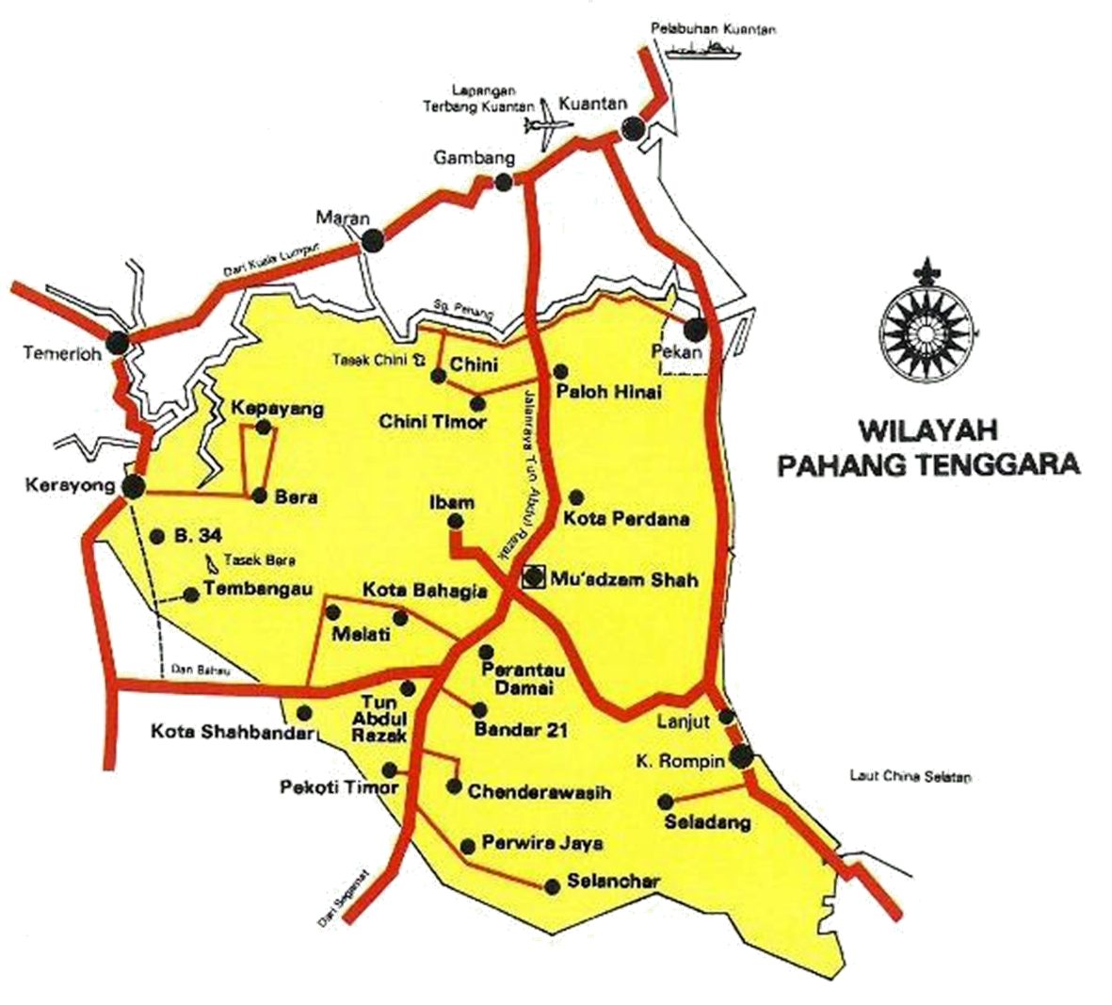
Figure 1. Regional Plan for DARA
Source: Administration Division, 1993

After the dissolution, the Ministry of Rural Development (KPLB) was given the role of developing a DARA area by pursuing existing activities and programs (South-East Pahang Development Authority, 1997). The new settlement area (city) is located in the administrative area of Pahang Tenggara Region which covers an area of 1,002,197 hectares. The Map of Pahang Tenggara Region which houses 17 settlement centers called 'cities' comprises of 3 level of settlement hierarchy namely Main Settlement Centre (PPU), Rural Settlement Centre (PPD) and Small Settlement Centre (PPK) that equipped with basic facilities and services to residents (Figure 1).
In examining the functions of settlements within the regional development area, the understanding of the foundation and definition of the region must first be understood, which refers to the definition of 'regional development' (Alden and Awang, 1985) territory can be defined as a group of areas developed continuously within the regional development area with Unexplained sources such as timber sources, iron seeds, gold and so on to carry out economic activities centrally in a major settlement area. The development of regional areas includes a large area located in the interior based on the principles of the region, which is to balance urban and rural development, which is a uniformity of development that was developed during the British administration from racial classification based on economy activities to a comprehensive physical development approach which focuses on socio-economic development (Rustiadi, 2018). Thus, the development of settlements within the regional development area is one of the ways to accelerate the overall development process involving rural areas in Malaysia (Rashid et al., 2019a) (Razali and Rashid, 2021a).

3. Methodology
The function of settlement in the DARA is based on four (4) settlement services indicators such as function, economy, public/social facilities and convenience infrastructure and utility (Ministry of Urban Wellbeing, Housing and Local Government, 2016). This study implements a qualitative method using primary data through a case study method by conducting a fieldwork and inventory audits of the settlement facilities and services schedule in determining the hierarchy and functions of settlements from previous and current related reports on DARA (Table 1).

Table 1: Method of Study for Settlement’s Function in the DARA.
Objective | Method of Data Collection | Method and Output of Analysis
To evaluate the settlement’s function of the township development in the DARA | - Conduct fieldwork and inventory audits of the settlement facilities and services schedule in determining the hierarchy and functions of settlements | - Use a qualitative method through case study method on 17 existing settlement centers  - Qualitative data analysis (Settlement function centrality index analysis)  - Analysis of aspects of the functional hierarchy (centralization index) of settlements

A fieldwork and inventory audit of settlement facility and service were conducted in determining the hierarchy and function of a settlement. The elements that play a role in determining the level and functionality of a settlement based on several facility indicators were based on four (4) settlement services such as function (administration), economy (business, industry, financial services), public/social facilities (education, health, recreation/culture/heritage, synagogue, security, rescuer, postal service) and convenience infrastructure and utility (sewerage services, road network, drainage system, solid waste, electricity, water, telecommunications, transportation services, terminal transportation) (Ministry of Urban Wellbeing, Housing and Local Government , 2016) (Krimi et al., 2010) (Latip and Yusoff, 2019).

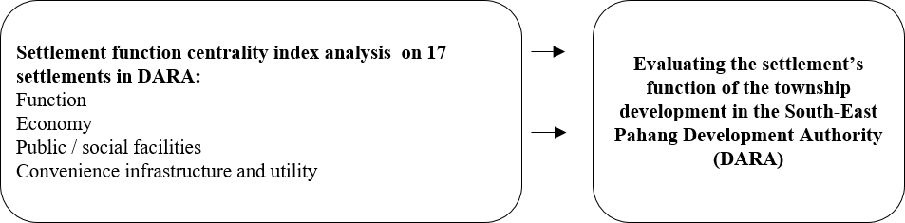
Figure 2. An Evaluation Framework of the Settlement’s Function in the DARA

The level of functionality of a settlement is influenced by the components of municipal facilities consisting of the availability of basic and public facilities in a settlement area that affect the socio-economic level of rural communities (Figure 2). The indicators evaluated consist of functionality, economy, facilities and infrastructure and utilities that are interrelated between facilities and levels of functionality and settlement hierarchy (Rashid et al., 2019a) (Rashid et al., 2020). Today, there are 17 remaining settlements developed by DARA which located in 4 (four) districts, namely Pekan, Muadzam Shah, Rompin and Bera. Bandar Muadzam Shah was selected as a Central City and Regional Administrative Center with the support of the surrounding Settlement Centers (Table 2).
Table 2: Settlements Hierarchy of the DARA’s Settlements.
District | No. | Settlement (City) | Original Proposal of The Settlement Hierarchy | Recent Status of Settlement Hierarchy
Pekan | 1. | Chini | Support City | Small Settlement Centre (PPK)
Pekan | 2. | Paloh Hinai | Settlement Center | Rural Settlement Centre (PPD)
Pekan | 3. | Kota Perdana | Settlement Center | Rural Settlement Centre (PPD)
Muadzam Shah | 4. | Bukit Ibam | Settlement Center | Rural Settlement Centre (PPD)
Muadzam Shah | 5. | Muadzam Shah | Central City and Regional Administrative Center | Main Settlement Centre (PPU)
Muadzam Shah | 6. | Kota Bahagia | Settlement Center | Rural Settlement Centre (PPD)
Muadzam Shah | 7. | Kota Shahbandar | Settlement Center | Rural Settlement Centre (PPD)
Muadzam Shah | 8. | Melati | Settlement Center | Rural Settlement Centre (PPD)
Muadzam Shah | 9. | Pekoti Timur | Settlement Center | Rural Settlement Centre (PPD)
Muadzam Shah | 10. | Chenderawasih | Settlement Center | Rural Settlement Centre (PPD)
Muadzam Shah | 11. | Perwira Jaya | Support City | Rural Settlement Centre (PPD)
Muadzam Shah | 12. | Perantau Damai | Settlement Center | Rural Settlement Centre (PPD)
Muadzam Shah | 13. | Chanis (Bandar 21) | Settlement Center | Rural Settlement Centre (PPD)
Muadzam Shah | 14. | Bandar Tun Razak | Support City | Small Settlement Centre (PPK)
Muadzam Shah | 15. | Selancar | Settlement Center | Rural Settlement Centre (PPD)
Rompin | 16. | Seladang (Selendang) | Settlement Center | Rural Settlement Centre (PPD)
Bera | 17. | Bandar Bera | Settlement Center | Small Settlement Centre (PPK)
Source: Administration Division, 1993; Rompin District Council, 2010; Briefing Report, 1986

4. Analysis and Findings
Highlighted in table 3 that the existing development of DARA urban areas involving 17 towns is classified in the settlement hierarchy of Rural Settlement Centre (PPD) and Small Settlement Centers (PPK) referring to the Rompin District Local Plan 2002-2015. This indicates that the settlement status is not clear in line with the existing physical development following the administrative transition from the Regional Development Authority which is DARA to the relevant government agency especially rural development agencies after the dissolution of DARA.

Table 3: Settlement Function Centrality Index Analysis of the DARA’s City.
No. | Function’s Components | Settlement (City)
No. | Function’s Components | Chini | Paloh Hinai | Bukit Ibam | Kota Perdana | Muadzam Shah | Melati | Kota Bahagia | Kota Shahbandar | Pekoti Timur | Chenderawasih | Perwira Jaya | Perantau Damai | Chanis (Bandar 21) | Bandar Tun Razak | Selancar | Seladang (Selendang) | Bandar Bera
1 | Primary School | 3 | 1 | 1 | 1 | 5 | - | 1 | - | - | 1 | 1 | 1 | 1 | 4 | 1 | - | 4
2 | High School | 1 | 1 | - | - | 1 | - | - | - | - | - | - | - | - | 1 | 1 | - | 1
3 | Police Station | 1 | 1 | 1 | - | 1 | 1 | 1 | 1 | - | 1 | - | - | - | 1 | - | - | 1
4 | Post Office | 1 | 1 | 1 | 1 | 1 | - | 1 | - | - | - | 1 | 1 | - | 1 | - | - | 1
5 | Health Clinic | 1 HC | 1 VC | 1 HC | 1 VC | 1 H | - | 1 VC | - | - | 1 HC | 1 HC | 1 HC | 1 HC | 1 HC | 1 VC | - | 1 HC
6 | Public Hall | - | - | - | - | 1 | - | 1 | - | - | - | - | - | - | - | - | - | -
7 | Telephone | 1 | - | 1 | - | 1 | - | 1 | - | - | - | - | - | - | - | - | - | -
8 | Highway Stop | - | - | - | - | 1 | - | - | - | - | - | - | - | - | - | - | - | -
9 | Mosque | - | - | 1 | - | 1 | - | 1 | - | 1 | - | 1 | - | - | 4 | 1 | - | 4
10 | Surau | 4 | 1 | - | 1 | 1 | 1 | 1 | - | - | 1 | 1 | 1 | 1 | 1 | - | - | 4
11 | Fire Station | - | - | - | - | 1 | - | - | - | - | - | - | - | - | - | - | - | -
12 | Playing Field | 1 | 1 | 1 | 1 | 1 | - | 1 | - | - | 1 | 1 | - | - | 1 | - | - | 1
13 | Tourism Centre | 1 | - | - | - | - | - | - | - | - | - | - | - | - | - | - | - | -
14 | Local Government Office | 1 | - | - | - | 1 | - | - | - | - | - | 1 | - | - | 1 | - | - | 1
Notes: VC: Village Clinic, HC : Health Clinic, H : Hospital

Therefore, the main issue that occurred in the settlement area in the Muadzam Sub-District as a result of DARA has caused the existing settlements to be not well managed due to the planning to open residential lots, businesses, etc. are not fully developed / sold. in line with the planning of the DARA urban development master plan which resulted in incomplete urban development status being fully developed as well as incomplete planning for the provision of basic and public facilities indirectly resulted in some underdeveloped and poorly maintained public facilities. Therefore, the focus of this study is to evaluate the level of achievement of the function of small towns in the development of rural areas in the Muadzam Shah which involves the remnant urban areas of the DARA which is the agency responsible for opening and developing rural areas to new settlement areas from 1970 until the closure / dissolution of the provincial development board by 2000.

5. Conclusion
The regional development approach is one of the mechanisms to accelerate rural development especially for the poor families to live in a newly built cities equipped with various facilities, environment quality, economic and social opportunities that will help settlers and their families to make the transition to a safer, more rewarding and diverse one (Yusoff et al., 2021a) (Razali and Rashid, 2021b). Therefore, it can be concluded that the provision of basic and public facilities affects the level of functionality of a rural settlement area in determining the level of settlement hierarchy.
It can be seen that 17 ‘urban’ settlements in the DARA administrative area are well planned with the provision of all basic and public facilities as well as the provision of socio-economic resources to the residents in a settlement in developing the functionality of the settlement as time progresses. In general, this study focuses on the achievement of the function of small towns in the development of rural areas in DARA based on the DARA development plan as a systematically planned city with various facilities for the living standards improvement of the people. The socio-economic aspect is one of the supports for a sustainable urban center development to focus on inclusive development between urban filling and community development in particular (Rashid et al., 2020)(Yusoff and Kalirajan, 2020)(Rashid et al., 2019b).

References
Administration Division. (1993). Annual Southeast Pahang Annual Report 1993. DARA.
Alden, J. D., and Awang, A. H. (1985). Regional Development Planning in Malaysia. Regional Studies, 6(19), 495-508.
Asnarulhadi, A. (1997). Malaysian Policies, New Economic Policy (NEP)-Regional Development Authority (1970–1990). Universiti Putra Malaysia.
Briefing Report. (1986). Regional Development Briefing Note. DARA.
Higgins, B., and Savoie, D. J. (2017). Regional Development Theories & Their Application. Routledge.
Krimi, M. S., Yusop, Z., and Hook, L. S. (2010). Regional Development Disparities in Malaysia. Journal of American Science, 3(6), 70-78.
Latip, A. R. A., and Yusoff, O. M. (2019). Regional Development In Malaysia: A Socio-Economic Impacts of Human Capital Development Programmes. Economic and Social Development: Book of Proceedings, 8-16.
Mat, J. (1983). Regional development in West Malaysia: A Comparative Effectiveness Study of JENGKA, DARA, KEJORA, and KETENGAH. Institut Tadbiran Awam Negara Malaysia.
Ministry of Urban Wellbeing, Housing and Local Government. (2016). Second National Urbanization Policy. PLANMalaysia.
Ngah, I. (2011). Challenges of Regional Development in Malaysia in the Globalization Context. In paper presented at International Conference on Regional Development, Vulnerability, Resilience, and Sustainability, Semarang (pp. 9-10).
Rompin District Council. (2010). Rompin District Local Plan Report 2002-2015. Rompin District Council.
Rustiadi, E. (2018). Regional planning and development. Jakarta: Yayasan Pustaka Obor Indonesia.
Rashid, M. F., Ngah, I., and Misnan, S. H. (2019a). Revitalizing Rural Areas in Malaysia: A Framework for Economic Revitalization. In IOP Conference Series: Earth and Environmental Science (Vol. 385, No. 1, p. 012004). IOP Publishing.
Rashid, M. F., Ngah, I., and Misnan, S. H. (2019b). Framework for Economic Performance of Rural Areas in Malaysia: A Territorial Approach. International Journal of Built Environment and Sustainability, 6(1-2), 1-6.
Rashid, M. F., Sulaiman, N. K., Misnan, S. H., Samsudin, N. A., and Ngah, I. (2020). Application of Rural
Web in Analyzing the Economic Performance of Rural Areas in Johor. In IOP Conference Series: Earth and Environmental Science (Vol. 447, No. 1, p. 012067). IOP Publishing.
Razali, N. M., and Rashid, M. F. (2021a). A Framework for Incorporating the Global Environment of Rural Community. In IOP Conference Series: Earth and Environmental Science (Vol. 881, No. 1, p. 012057). IOP Publishing.
Razali, N. M., and Rashid, M. F. (2021b). The Influence of Economic Capital Towards the Socioeconomic Background of the Rural Community. Environment, 6(26), 274-280.
South-East Pahang Development Authority. (1997). Dissolution Bill 1997 (Column 27), Official Statement of the Dewan Negara Parliament, Ninth Parliament, Third Term, First Meeting. DARA.
Walton, D. (1976). Report Planning and Development Town in Pahang Tenggara. Freeman Fox and Associates.
Yusoff, N. S., Rashid, M. F., and Halim, N. A. (2021a). The Impact of Regional Development Towards the Well-being of Rural Community. In IOP Conference Series: Earth and Environmental Science (Vol. 881, No. 1, p. 012056). IOP Publishing.
Yusoff, N. S., Rashid, M. F., and Halim, N. A. (2021b). The Indicators of Socioeconomic Well-Being of Rural Community. Management, 6(26), 253-261.
Yusof, Y., and Kalirajan, K. (2020). Variations in Economic Growth Across States in Malaysia: An Exploratory Analysis. Journal of Economic Studies, 3(48), 699-719.

