Traffic Solution and Improvement for the Area Surrounding Shubra Museum in Taif City, KSA

Supplementary Files

ABBREVIATIONS AND SYMBOLS

Symbol | Description
PHF | Peak Hourly Factor
AASHTO | American Association of State Highway Transportation Officials
HCM | Highway Capacity Manual
ASTM | American Society for Testing and Materials
LOS | Level of Service
PC | Passenger Car

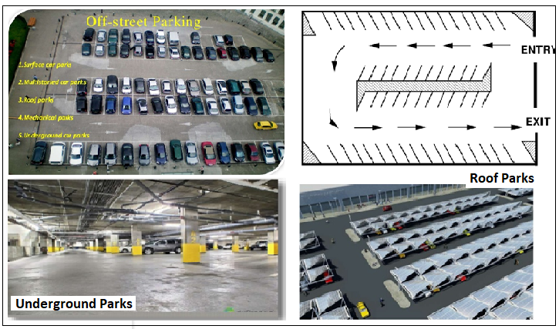
Illustration of off-street parking’s

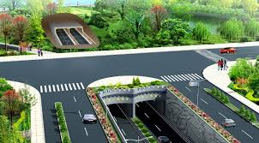
Tunnels - cut and cover
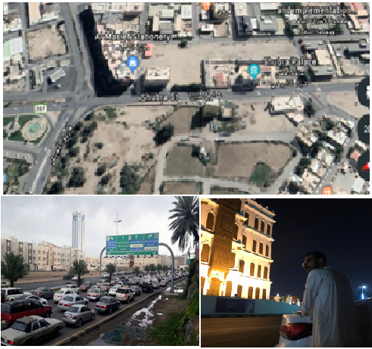
Location of the study- First Field visit

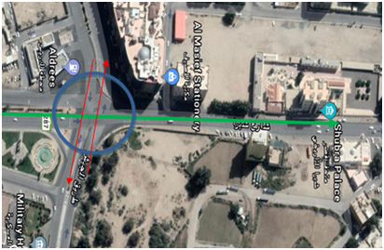

Tunnel location

Levels of Service:

Is the qualitative measurement of the impact of a number of factors such as operating speed, duration of travel, traffic failures, and freedom of maneuverability, transit, driving safety, comfort, road suitability and operating costs for the service provided by the road to its users.
The Levels of Service Properties table shows the type of road:

The Levels of Service Properties According to AASHTO Guide
Levels of Service | Features | Percentage of traffic to capacity (V/C) | Speed design  (mph) (v)
A | Free flow | V/C ≤ 0.1 | 80
B | Stable flow cytometry design | ≤ 0.3 | 80
C | Stable flow Cellular design | ≤ 0.5 | 80
D | The flow is approaching instability | ≤ 0.7 | 80
E | Unstable flow | ≤ 1.0 | 80
F | A turbulent flow stops and move | < 1.0 | 80

The Levels of Service type (on research paper)
Level of service | Features | Percentage of traffic to capacity (V/C) | Speed design  (mph) (v)
D | The flow is approaching instability | ≤ 0.7 | 80

Design Controls and Criteria - According to AASHTO Guide

Key controls in geometric highway design are the physical characteristics and the proportions of vehicles of various sizes using the highway tunnels.
Therefore, it is appropriate to examine all vehicle types, establish general class groupings, and select vehicles of representative size within each class for design use. These selected vehicles, with representative weight, dimensions, and operating characteristics, used to establish tunnel design controls for accommodating vehicles of designated classes, are known as design vehicles. For purposes of geometric design, each design vehicle has larger physical dimensions and a larger minimum turning radius than most vehicles in its class. The largest design vehicles are usually accommodated in freeway design.
Dimensions for 19 design vehicles representing vehicles within these general classes are given in Figure below.

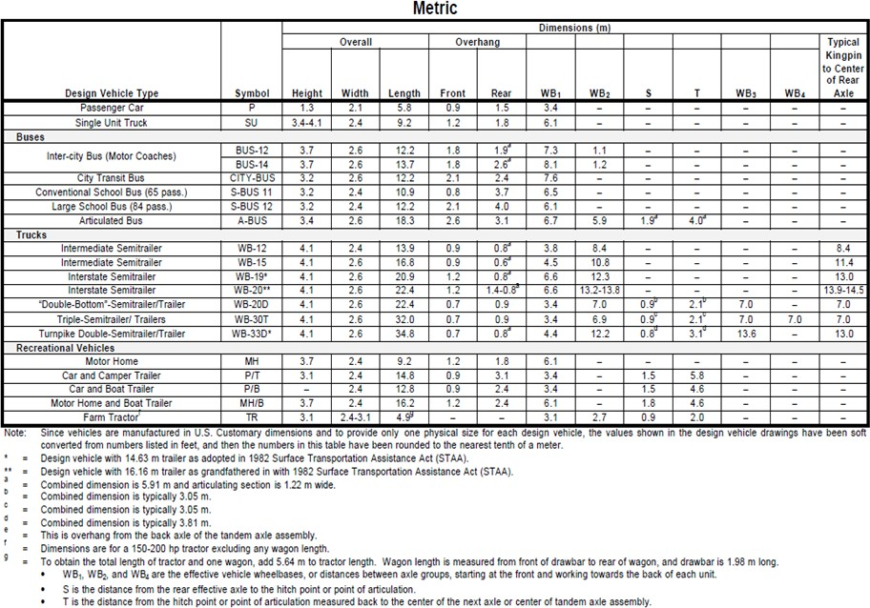
In the design of any highway facility, the designer should consider the largest design vehicle likely to use that facility with considerable frequency or a design vehicle with special characteristics appropriate to a particular intersection in determining the design of such critical features as radii at intersections and radii of turning roadways.
Design Vehicle Dimensions

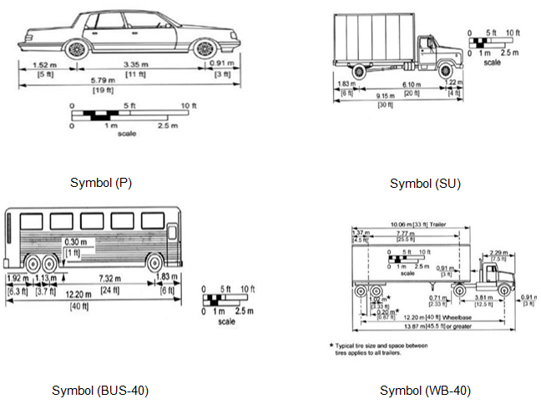
Design Vehicle

Suggest Solutions of Problem:

1- Bridge | 2- Underway Tunnel
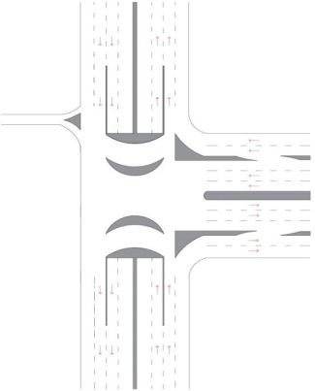 | 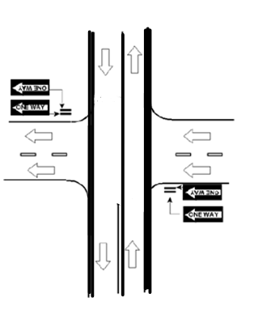

The Three Best of Suggest Solutions:

1- Tunnel (one road) | 2- Bridge
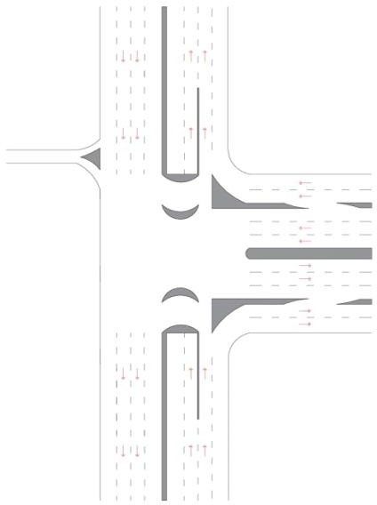 | 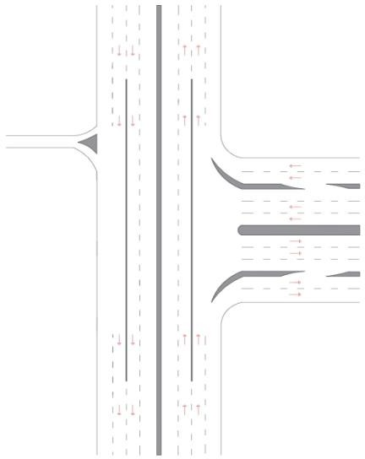
Advantages:  - Multi Service  - Half-streamlined road. | Advantages:  - Multi Service  - Less-streamlined road.
Disadvantages:  - Slow-implementation.  - Average cost. | Disadvantages:  - Very slow- implementation.  - Higher cost.

Chap
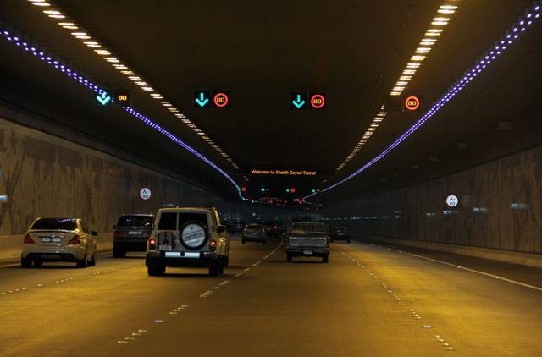

Tunnel with four lanes and traffic signs

APPENDIX A

(Traffic Survey’s Results)

Point: A

Point: B

Point: C

Point: D

Point E

