ATTACHMENT

1. Ethical Clearance KEPK Faculty of Medicine Universitas Diponegoro
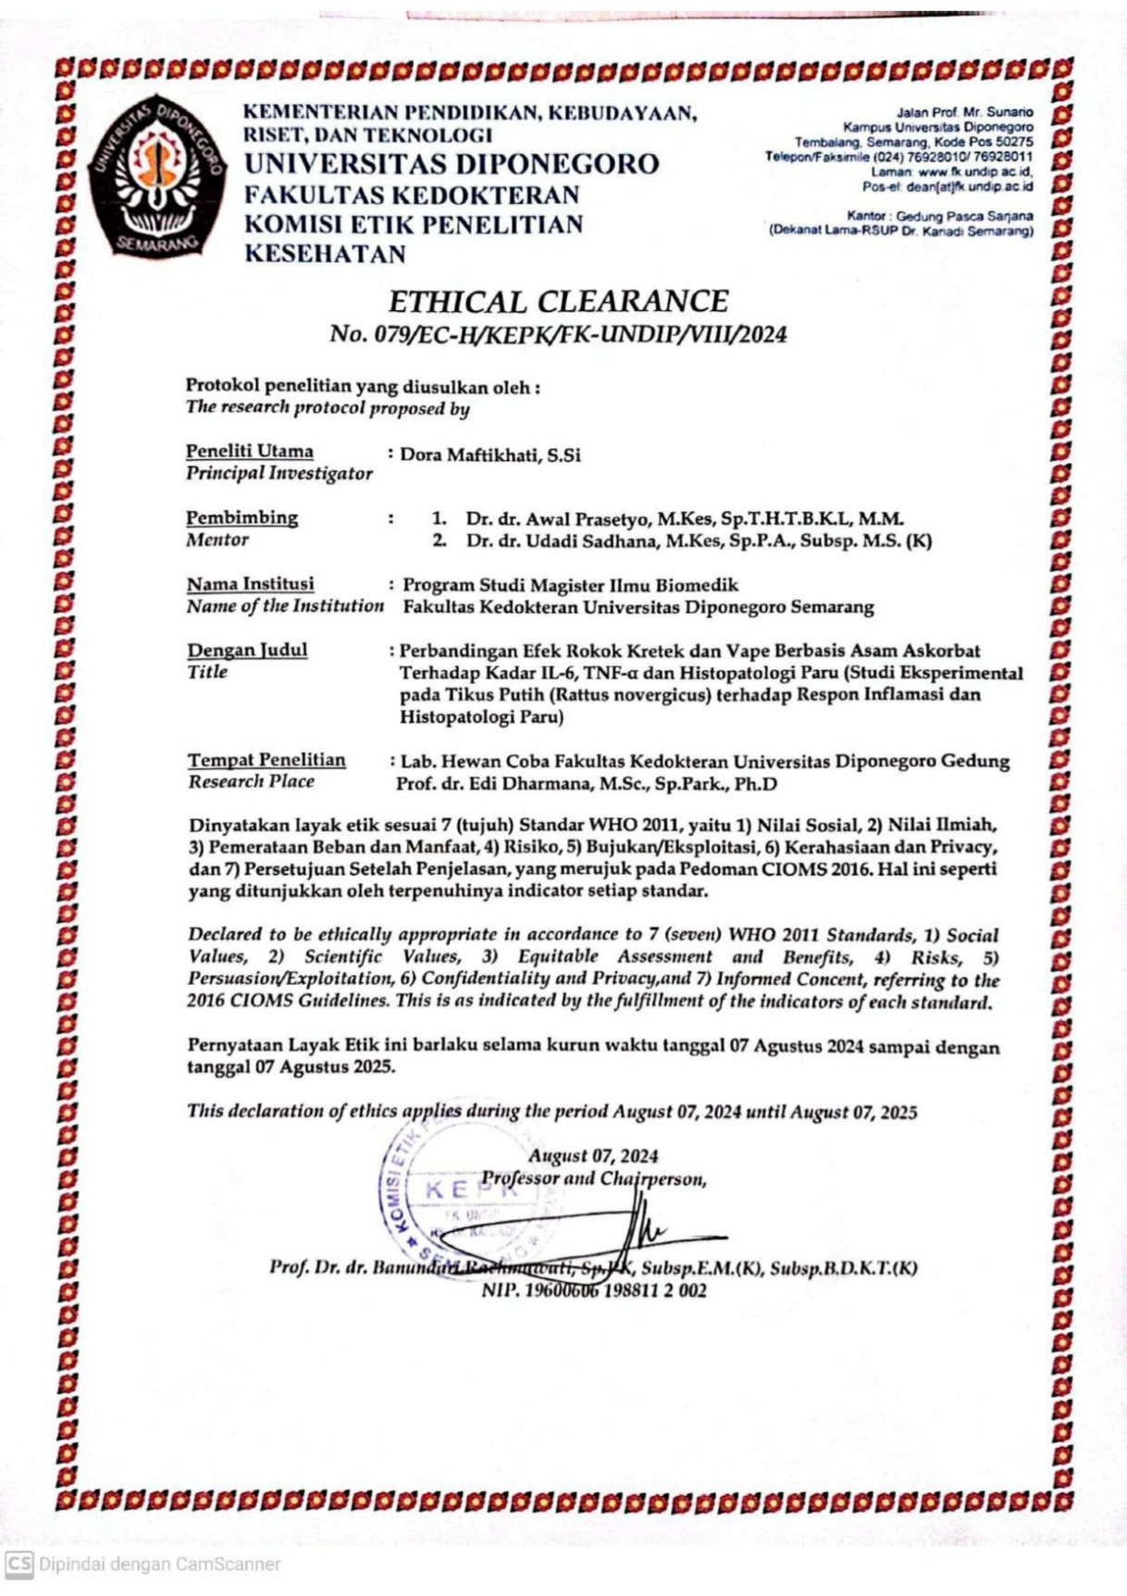

2. Letter of Research Approval
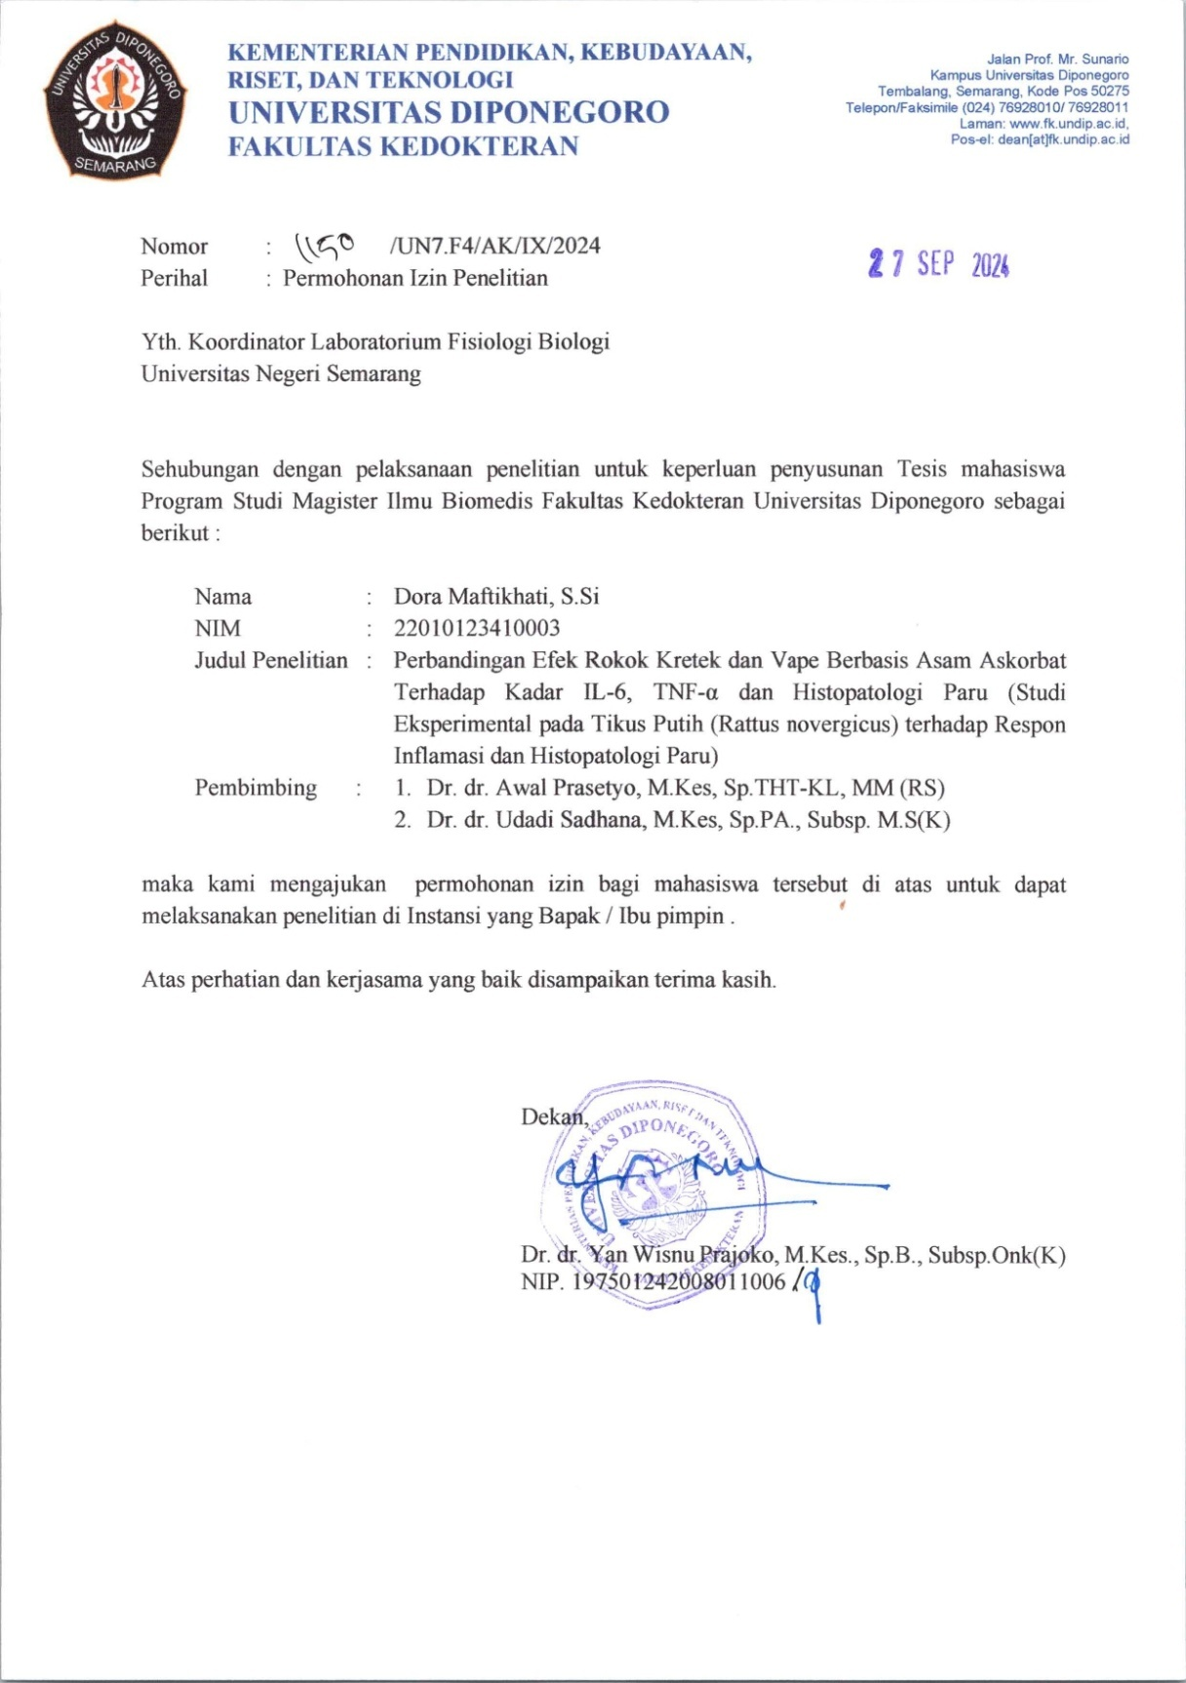

3. Dose Conversion Calculation
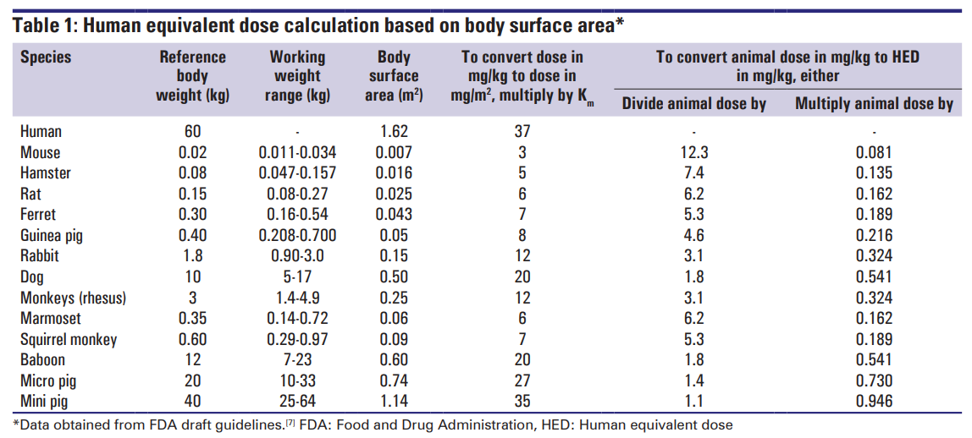
            - Dose of cigarette exposure
Heavy smoker = cigarette consumption ≥ 20 cigarettes per day.
- If a human weighs 60 kg, the cigarette dose per kilogram of body weight is calculated as 20/60 = 0.333 cigarette/kg BW.
- Conversion to the rat dose: 0.333 × 6.2 = 2.0666 cigarettes/day.
- If a rat weighs 200 grams, the cigarette dose for one rat is 0.2 × 2.0666 = 0.41 cigarette/rat/day.
- In one treatment group consisting of 7 rats, the total cigarette dose required per exposure is 0.41 × 7 = 2.8 ≈ 3 cigarettes/day
            - Dose of vape exposure
Heavy vape user = vape consumption of 3.3 mL or 500 puffs per day.
- If a human weighs 60 kg, the vape dose per kilogram body weight = 3.3 / 60 = 0.055 mL/kg/day.
- Conversion to the rat dose = 0.055 × 6.2 = 0.341 mL/day.
- If a rat weighs 200 g (0.2 kg), the vape dose per rat = 0.2 × 0.341 = 0.0682 mL/rat/day.
- In one treatment group of 7 rats, the total vape volume required per exposure = 0.0682 × 7 = 0.4774 mL/day ≈ 0.48 mL/day (rounded ≈ 0.5 mL/day).
- Administration: delivered as puffs with 4-second duration and 30-second interval (consistent with common usage).

4. Research Data Spreadsheet Results
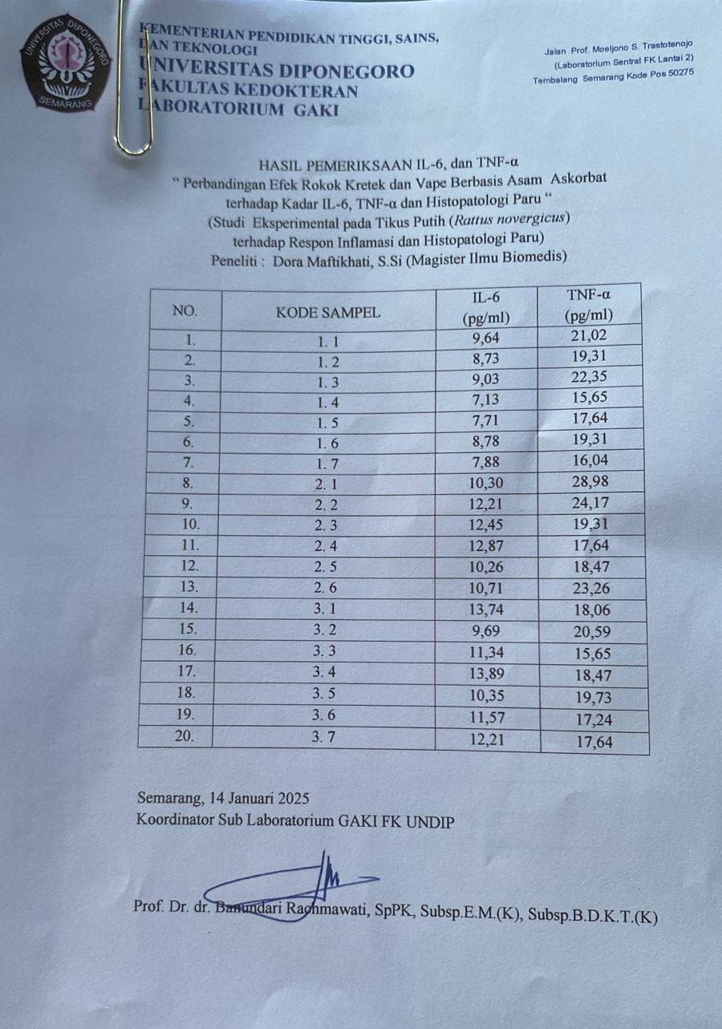

 | Keliling Alveolus (µm)
 | LP1 | LP2 | LP3 | LP4 | LP5 | Mean
K1.1 | 198,56 | 261,08 | 218,15 | 292,47 | 210,21 | 236,10
K1.2 | 221,17 | 328,22 | 224,44 | 172,68 | 182,42 | 225,79
K1.3 | 211,70 | 177,72 | 256,25 | 206,30 | 334,16 | 237,23
K1.4 | 332,40 | 219,43 | 272,06 | 338,29 | 232,44 | 278,92
K1.5 | 506,25 | 327,33 | 272,04 | 431,31 | 161,40 | 339,67
K1.6 | 434,85 | 302,41 | 334,25 | 275,08 | 289,88 | 327,29
K1.7 | 197,39 | 259,25 | 360,89 | 255,20 | 277,70 | 270,09
K2.1 | 223,17 | 182,84 | 327,93 | 144,04 | 194,87 | 214,57
K2.2 | 209,00 | 221,14 | 194,46 | 282,97 | 192,71 | 220,06
K2.3 | 187,20 | 263,95 | 264,20 | 272,66 | 313,44 | 260,29
K2.4 | 0,00 | 163,86 | 396,89 | 0,00 | 110,70 | 223,82
K2.5 | 285,58 | 201,25 | 305,66 | 178,65 | 180,90 | 230,41
K2.6 | 228,57 | 289,30 | 308,05 | 309,92 | 201,20 | 267,41
K3.1 | 375,78 | 143,14 | 215,88 | 435,32 | 315,86 | 297,20
K3.2 | 170,26 | 248,07 | 116,56 | 151,46 | 139,03 | 165,07
K3.3 | 141,50 | 233,40 | 177,73 | 241,40 | 183,87 | 195,58
K3.4 | 329,79 | 338,10 | 181,26 | 291,85 | 232,54 | 274,71
K3.5 | 433,76 | 280,54 | 429,25 | 203,42 | 273,98 | 324,19
K3.6 | 346,48 | 390,14 | 154,50 | 259,39 | 232,81 | 276,67
K3.7 | 334,76 | 349,79 | 232,11 | 283,45 | 289,03 | 297,83

 | Kerusakan Dinding Alveolus
 | LP1 | LP2 | LP3 | LP4 | LP5 | median
K1.1 | 0 | 0 | 1 | 0 | 1 | 0
K1.2 | 0 | 0 | 1 | 1 | 1 | 1
K1.3 | 1 | 1 | 0 | 0 | 0 | 0
K1.4 | 0 | 0 | 0 | 0 | 0 | 0
K1.5 | 1 | 1 | 0 | 0 | 1 | 1
K1.6 | 0 | 1 | 1 | 0 | 1 | 1
K1.7 | 0 | 0 | 0 | 0 | 1 | 0
K2.1 | 1 | 2 | 2 | 2 | 2 | 2
K2.2 | 3 | 3 | 2 | 2 | 2 | 2
K2.3 | 2 | 2 | 2 | 3 | 3 | 2
K2.4 | 3 | 2 | 2 | 3 | 3 | 3
K2.5 | 3 | 3 | 3 | 3 | 3 | 3
K2.6 | 3 | 3 | 3 | 2 | 3 | 3
K3.1 | 2 | 2 | 2 | 2 | 2 | 2
K3.2 | 3 | 2 | 2 | 2 | 2 | 2
K3.3 | 3 | 2 | 3 | 3 | 2 | 3
K3.4 | 2 | 2 | 2 | 2 | 2 | 2
K3.5 | 2 | 2 | 2 | 2 | 1 | 2
K3.6 | 1 | 2 | 1 | 2 | 2 | 2
K3.7 | 2 | 2 | 2 | 2 | 1 | 2

 | Jumlah Sel Radang Paru
 | LP1 | LP2 | LP3 | LP4 | LP5 | median
K1.1 | 0 | 0 | 0 | 0 | 0 | 0
K1.2 | 0 | 0 | 0 | 0 | 0 | 0
K1.3 | 0 | 0 | 1 | 1 | 1 | 1
K1.4 | 1 | 0 | 0 | 0 | 0 | 0
K1.5 | 0 | 1 | 0 | 0 | 0 | 0
K1.6 | 0 | 0 | 0 | 0 | 0 | 0
K1.7 | 0 | 0 | 1 | 1 | 1 | 1
K2.1 | 1 | 1 | 1 | 1 | 1 | 1
K2.2 | 1 | 1 | 1 | 1 | 1 | 1
K2.3 | 1 | 1 | 1 | 1 | 1 | 1
K2.4 | 2 | 2 | 3 | 2 | 1 | 2
K2.5 | 0 | 0 | 1 | 1 | 1 | 1
K2.6 | 1 | 1 | 1 | 1 | 1 | 1
K3.1 | 1 | 1 | 1 | 1 | 1 | 1
K3.2 | 1 | 1 | 1 | 1 | 1 | 1
K3.3 | 1 | 1 | 0 | 0 | 1 | 1
K3.4 | 1 | 1 | 1 | 1 | 1 | 1
K3.5 | 1 | 1 | 1 | 0 | 0 | 1
K3.6 | 0 | 0 | 0 | 0 | 1 | 0
K3.7 | 1 | 1 | 1 | 2 | 0 | 1

 | Berat Tikus (gram)
 | LP1 | LP2
K1.1 | 174 | 298
K1.2 | 156 | 365
K1.3 | 167 | 334
K1.4 | 150 | 285
K1.5 | 168 | 247
K1.6 | 143 | 324
K1.7 | 159 | 293
K2.1 | 166 | 360
K2.2 | 143 | 276
K2.3 | 165 | 306
K2.4 | 169 | 262
K2.5 | 144 | 310
K2.6 | 143 | 276
K3.1 | 162 | 295
K3.2 | 156 | 268
K3.3 | 160 | 274
K3.4 | 159 | 288
K3.5 | 141 | 299
K3.6 | 157 | 355
K3.7 | 171 | 322

5. Data Analysis Results
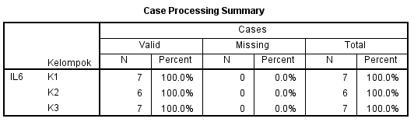
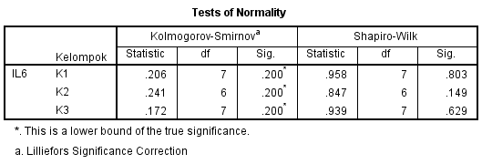
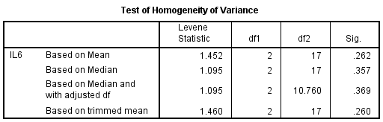

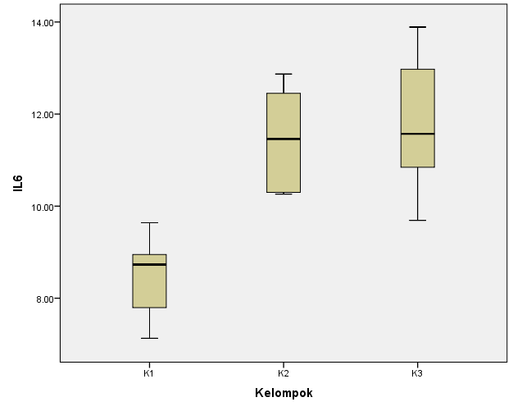
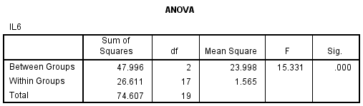

Post Hoc Tests
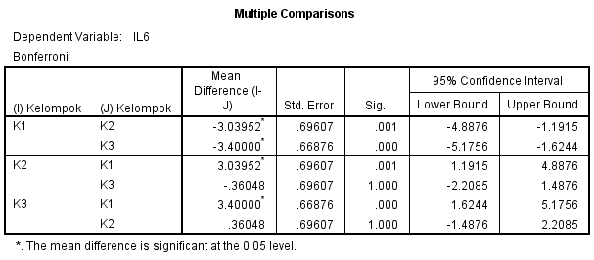

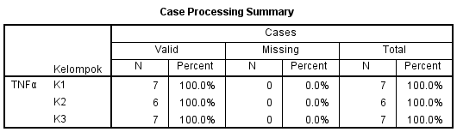
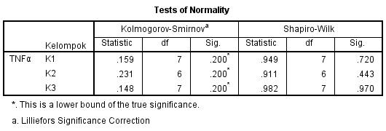
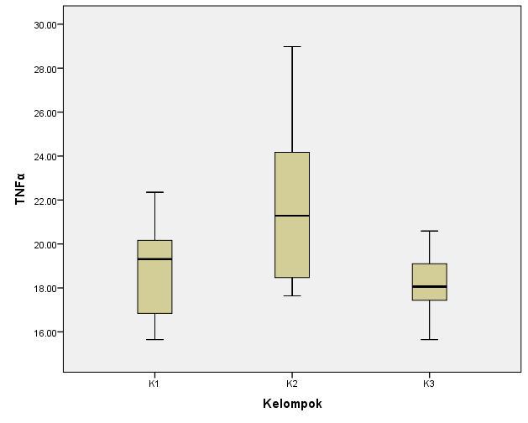
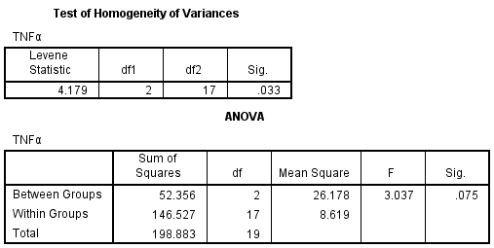

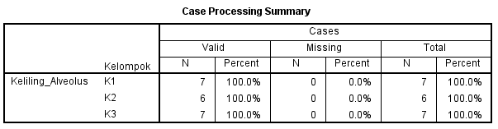
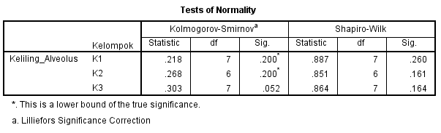
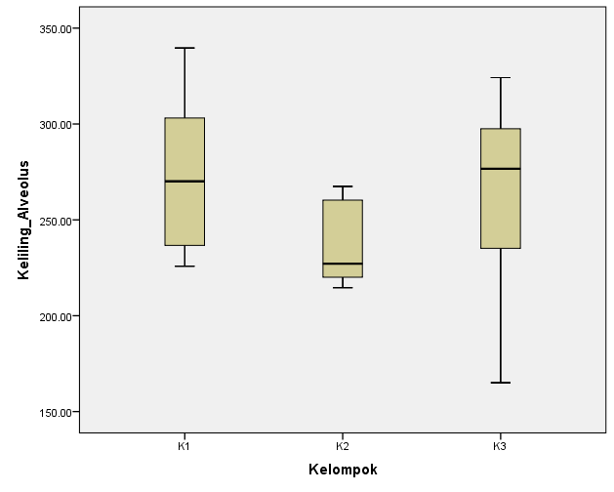
Oneway ANOVA

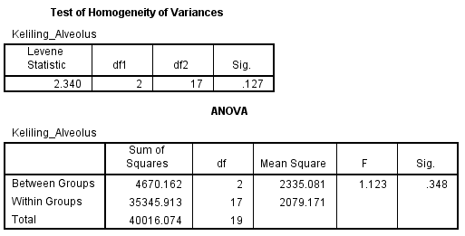

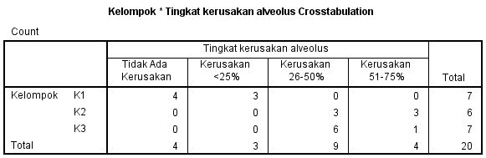
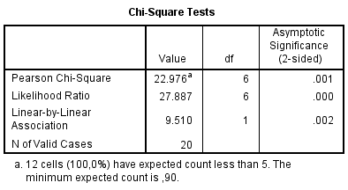

Kruskal-Wallis Test
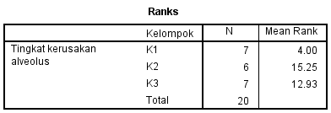
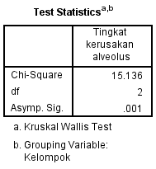

Mann-Whitney Test
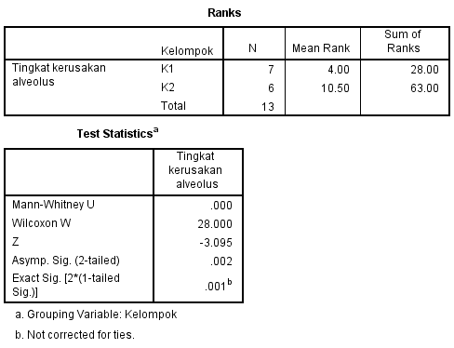

Mann-Whitney Test
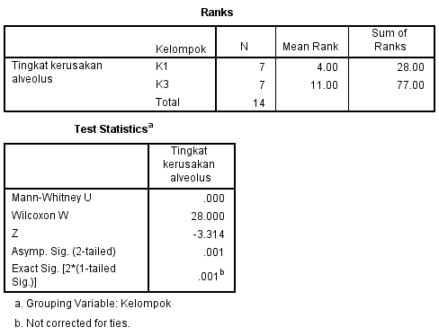

Mann-Whitney Test
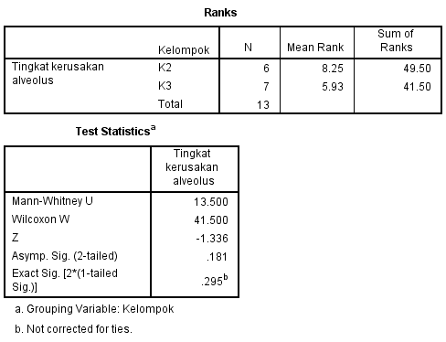

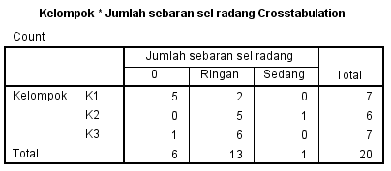
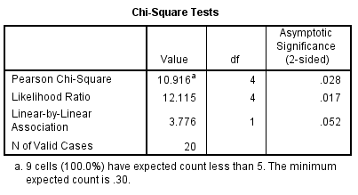

Kruskal-Wallis Test
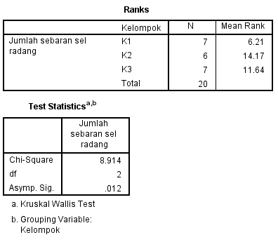
Mann-Whitney Test
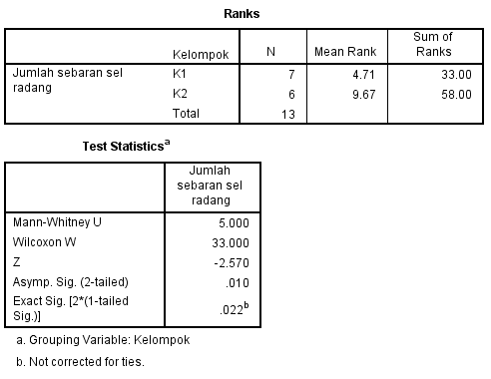

Mann-Whitney Test
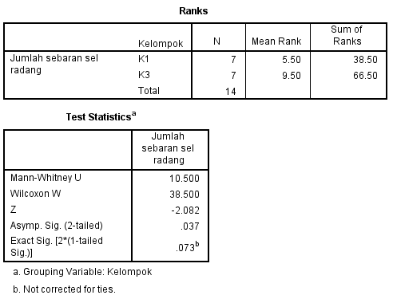

Mann-Whitney Test
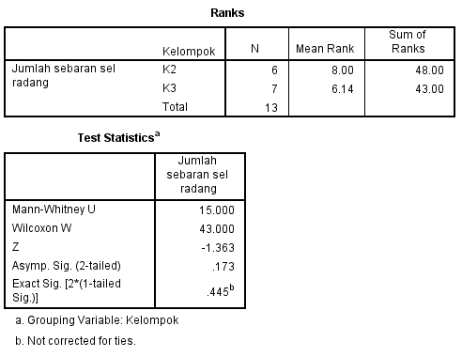

6. Research Documentation
              - Wistar rats were placed in the Animal Laboratory of the Biology Physiology Study Program, Universitas Negeri Semarang (UNNES).

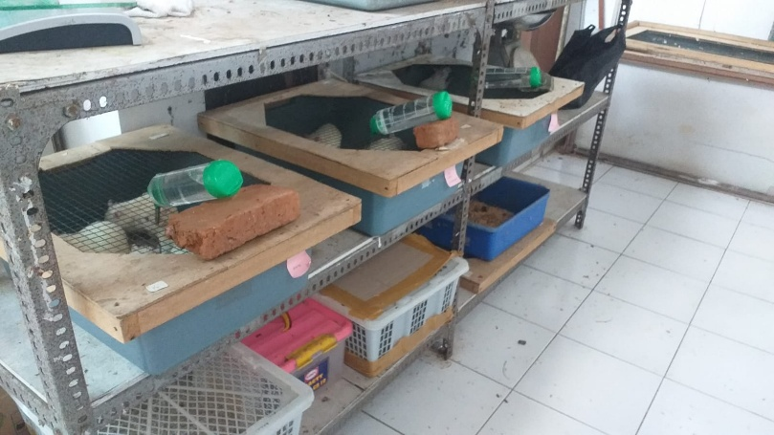

              - Exposure to cigarette smoke and vape aerosol.
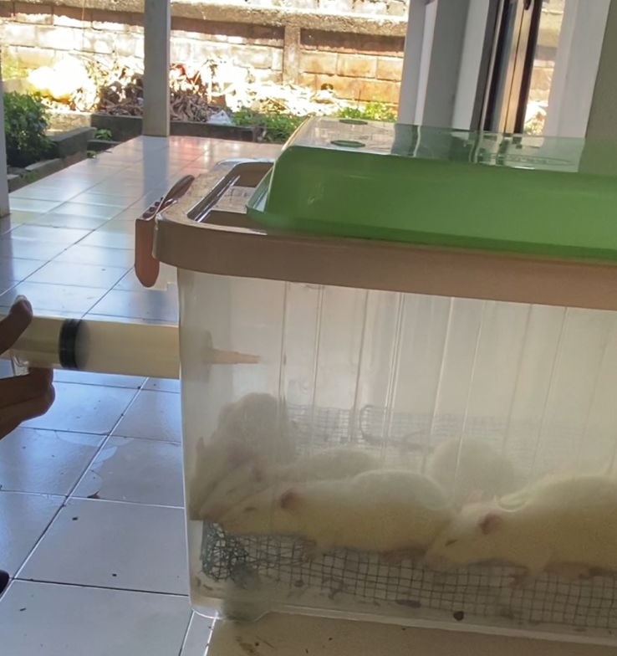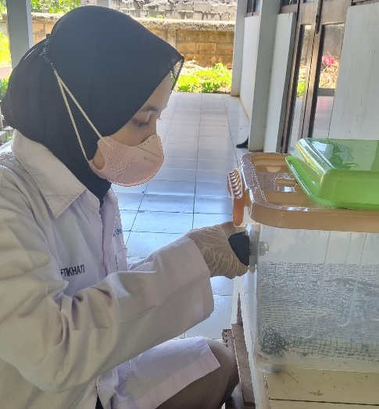
              - Rats that died (dropouts) after one week of cigarette smoke exposure.

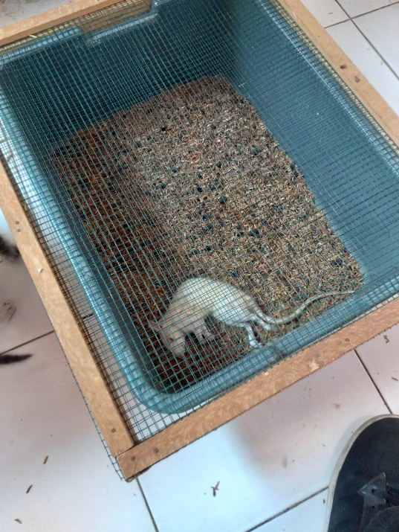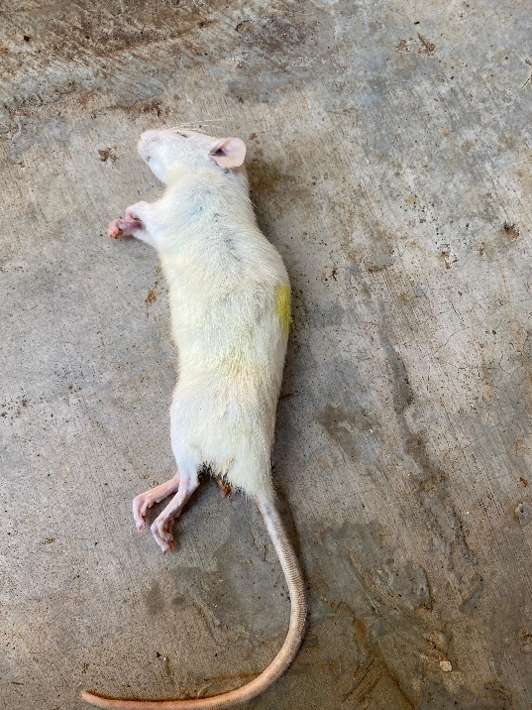

              - Weighing of rats after 12 weeks of treatment.

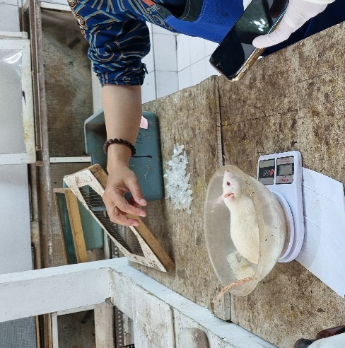

              - Collection of rat blood serum.

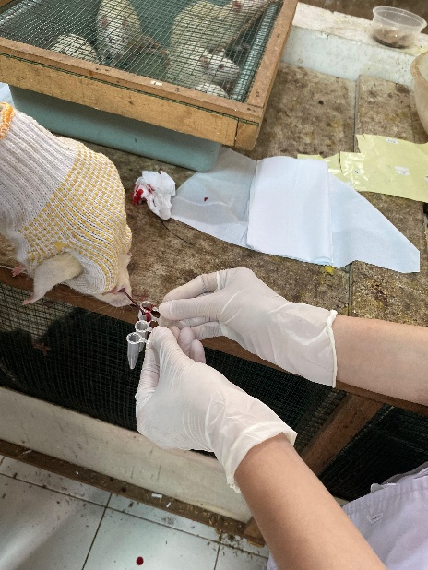
              - Centrifugation and results of rat blood serum centrifugation.
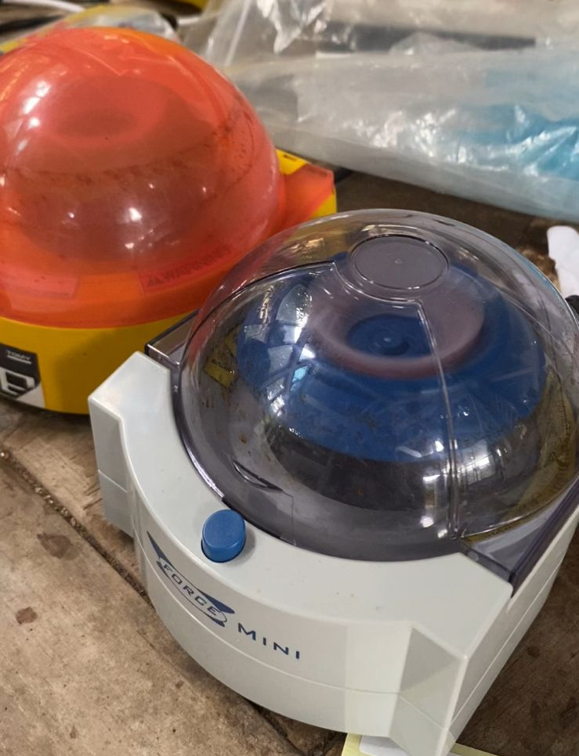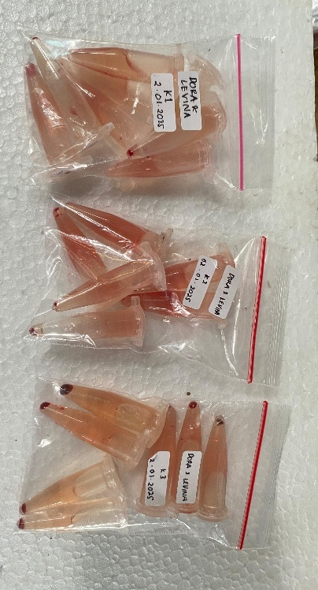

              - Lung organ collection process.

