|  |  |  |
| --- | --- | --- |
|  |  |  |
| **The Role Generative AI in Human Resource Management: Enhancing Operational Efficiency, Decision-Making, and Addressing Ethical Challenges**  **Muhammad Inzamam Khan1\***  **Dr. Endang Parahyanti, Psychologist2**  **Shah Hussain3**  *1Master in Industrial and Organizational Psychology, Faculty of Psychology University of Indonesia, Indonesia,* [*muhammad.inzamam@ui.ac.id*](mailto:muhammad.inzamam@ui.ac.id)  *2Lecturer in Faculty of Psychology, Doctor of Psychology, Faculty of Psychology University of Indonesia, Indonesia,* [*endang.parahyanti@ui.ac.id*](mailto:endang.parahyanti@ui.ac.id)  *3Master in industrial and Organizational Psychology, Faculty of Psychology University of Indonesia, Indonesia,*  [*Shah.hussain@ui.ac.id*](mailto:Shah.hussain@ui.ac.id) | | |
| **Abstract** | This paper examines the use of generative AI in human resource management (HRM), emphasizing the improvement of operational efficiency and decision-making processes. The study used a literature-based approach, combining information from peer reviewed journals, books, research articles and industry reports to examine the adoption of AI into HR tasks, such as recruiting, employee engagement, and performance management. This research demonstrates that generative AI significantly enhances recruiting by decreasing the time to hire and more precisely matching applicants with job specifications. Moreover, AI-driven technologies strengthen employee engagement by personalizing interactions and automating routine tasks, enabling HR professionals to concentrate on key objectives.  The study's uniqueness is in its thorough assessment of the ethical dilemmas and challenges related to generative AI, including algorithmic bias and privacy issues. To address these dangers, the study emphasizes the need to include justice and openness in AI deployment. The results indicate that while generative AI has the potential for significant efficiency improvements, ethical governance is essential for its appropriate use.  For strategic workforce management, HR managers must use generative AI while also being aware of ethical constraints. However, there are certain limitations, such as relying solely on current literature and the potential biases inherent in these sources. Subsequent research needs to concentrate on empirical validation and the formulation of frameworks to direct ethical AI implementation in human resources. This paper offers a comprehensive view of the advantages and obstacles associated with the integration of generative AI in HRM, highlighting the need for responsible and balanced implementation. | |
|  |  | |
| **Keywords** | *Generative AI; Human Resource Management; Employee Engagement; AI-driven Decision Making; Ethical AI Considerations* | |
|  |  |  |
|  |  |  |

**INTRODUCTION**

Generative artificial intelligence (AI), shown by models like ChatGPT, is slowly being used in human resource management (HRM). It is changing important tasks like hiring, keeping employees engaged, and managing performance by doing complicated language-based tasks on its own, which makes operations run more smoothly (Nhavkar & Goel, 2023). According to (Adam Zewe, 2023), generative AI is a type of machine learning algorithm that creates original data beyond traditional predictive functionalities. The created data may take several forms, including audio, code, graphics, text, simulations, and video (McKinsey, 2024). Since its public launch in November 2022, ChatGPT has swiftly attained considerable popularity, underscoring the transformational capabilities of generative AI across many applications. Nonetheless, diverse applications utilize additional generative AI techniques beyond ChatGPT. Certain generative AI techniques produce visuals derived from textual stimuli. These systems use language models trained on textual and visual data (Wong et al., 2024). Notable image-generation AI tools include Bing Image Creator, Craiyon, DALL-E2, DreamStudio by Stability AI, Dream by WOMBO, Midjourney, and My Heritage’s AI Time Machine (ZDNET, 2024).

Dall-E 2, GPT-4, Claude, Perplexity, Google Gemini Pro, and Microsoft Copilot are just a few instances of how this technology is presently changing the way we work and communicate. Not only can generative AI systems imitate human authors and artists to produce original works of art, but they can and will also help people with intelligent question-answering systems. In this context, generative AI finds use at IT help desks to assist with routine demands like medical advice and recipe searching, as well as transitional knowledge work. Industry forecasts (Goldman Sachs, 2023) suggest that generative AI could lead to a 7% increase in global GDP and the elimination of 300 million knowledge worker positions. Generative AI enhances applicant screening, job advertising formulation, and profile alignment in recruiting, although it also engenders substantial concerns about fairness and possible biases in decision-making processes (Dencik et al., 2023a; Parikh, 2023). Interactive chatbots, which can respond to real-time employee inquiries and bolster continuous engagement strategies, have successfully used the technology's capacity to produce content and mimic human dialogue to improve employee engagement (Basir et al., 2023; Mansinghka & Saboo, 2023). Despite persistent discussions on data accuracy and ethical concerns, performance management uses generative AI to enhance continuous feedback systems, potentially leading to more objective performance assessments (Yu et al., 2023; Zohny, McMillan, & King, 2023). A systematic literature review indicates that generative AI provides significant advantages, including time efficiency, optimized resource management, and heightened creativity in HR functions. However, to ensure its responsible application, we must resolve ethical issues such as algorithmic bias, insufficient interpretability, and privacy concerns (Lin, 2023; Kenthapadi et al., 2023). Generative artificial intelligence contributes to the reduction of burden in human resource management (HRM) by means of automated content production and efficient data processing.

This has proven to be particularly advantageous in the areas of performance assessments and employee feedback gathering (Praveen, 2023; Qadir, 2023). But for human resource management (HRM) to fully benefit from generative AI's transformative power, ethical concerns need to be built into plans for implementation. These considerations include addressing data privacy, ensuring fairness, and mitigating the risks of algorithmic bias (Cheng & Liu, 2023; Wach et al., 2023; Affsprung, 2023). There is a widespread effort to capitalize on generative AI. Generative AI has the potential to facilitate the development of entire applications; however, concerns regarding their security and thorough testing remain significant. Writing and unit testing a small standalone program presents a distinct scenario. Developing an enterprise application that interfaces with other systems differs significantly from writing a standalone program. Therefore, it is essential to implement checks and balances; failing to do so could result in significant costs for both businesses and consumers (Kalota, 2024). Even though using generative AI in HR is a big step forward in terms of improving processes and making work easier, HR executives should still make it a top priority to make sure that its use is both ethical and responsible (Hill & Narine, 2023; Bankins et al., 2023).

The objective of this study is to conduct an in-depth analysis of the profoundly revolutionary effect that generative artificial intelligence has on the operational procedures of human resource management. More specifically, the research aims to explore the integration of generative artificial intelligence in recruiting, employee engagement, and performance management roles within human resources. This study also aims to identify the ethical issues and challenges arising from the application of generative AI in human resource management. These challenges include issues of data privacy, fairness, and algorithmic bias. This article aims to provide insights into how human resource directors can responsibly employ generative artificial intelligence to improve organizational efficiency while limiting potential hazards. We will accomplish this by meticulously analyzing empirical data and thoroughly examining academic insights.

**LITERATURE REVIEW**

***Recruitment and Talent Acquisition***

The influence of artificial intelligence is growing rapidly in the human resources industry. According to (Gartner's, 2023) data reveals that 60% of firms are incorporating AI-driven technologies into their human resources activities, with the expectation that more businesses will follow suit. This enables human resources teams to concentrate on strategic goals that are in line with the objectives of the company. By automating and improving several phases of the recruiting process, generative AI is transforming the recruitment process by automating and improving several phases. HR departments may save time and effort by using AI-driven candidate sourcing and screening systems that can evaluate enormous volumes of data in order to find the best-fit individuals. As stated by (Team HONO, 2024) these technologies increase the chance of successful hiring by matching applicants not just based on credentials but also on cultural fit. Furthermore, Generative AI enhances the candidate experience by tailoring messages to each individual applicant, thereby boosting process engagement and efficiency. In the opinion of (Martin Shaw, 2023) ggenerative AI streamlines the recruitment process from job advertising to onboarding, saving recruiters time and letting them concentrate on critical activities to boost performance. AI-powered algorithms help recruiters and HR managers match candidates with job criteria, reduce prejudice via machine learning, and increase the chance of finding the appropriate candidate, enhancing the job market and people's lives.

By simplifying the application and recruiting processes, delivering timely updates, and encouraging open contact with recruiters, generative AI-powered chatbots and virtual assistants improve applicant satisfaction. The days of relying solely on physical labor to complete the recruitment process have long since passed. The recruitment process, now an automated procedure, is incorporating AI. There are a number of AI-integrated solutions that are now accessible on the market (Agnihotri et al., 2024). Companies worldwide are utilizing these solutions to automate their internal processes. As reported by (Jack Kelly, 2022), Applications such as Application Tracing System (ATS), Sniper AI, Zyre, and Phenom are examples of AI-enabled software that are now available on the market. By using these apps, companies are able to get access to the appropriate tool, approach, and technology, which allows them to investigate a greater number of people for each available position and ensures that they locate the most suitable talent for the position.

***Employee Engagement and Experience***

In the current competitive business landscape, firms are increasingly acknowledging the significance of employee engagement as a crucial factor for success. Among the several aspects affecting employee engagement, trust emerges as a significant foundational element. Advancements in generative AI technology provide HR professionals with a potent instrument to cultivate and strengthen trust inside their enterprises (Leena.ai, 2023). A staged strategy across HR departments, extensive staff training to use new technologies, and ongoing monitoring and modification based on feedback and changing business requirements can efficiently implement generative AI-driven employee engagement. This strategic implementation provides multiple advantages for enterprises, such as improved efficiency via automation, data-informed decision-making, streamlined global payroll compliance, heightened employee satisfaction, customized employee experiences, and proactive issue resolution. Through the strategic integration of generative AI, firms may cultivate a more productive, compliant, and engaged workforce, thus promoting sustainable development. The use of GenAI in the workplace may improve employee happiness by providing sophisticated tools that allow them to concentrate on important, human-centered tasks while delegating monotonous, non-value-added jobs.

This technology assistance enhances a more rewarding and efficient work environment (Rane, 2024). Although several studies examine AI adoption (Yang et al., 2022) there is a deficiency of research connecting AI adoption to organizational results. The use of AI may influence employee engagement by enhancing autonomy. Empirical investigations have mostly focused on AI rather than GenAI. We anticipate that a positive experience with GenAI will boost its confidence, thereby positively impacting employee job engagement. There exists evidence to substantiate this: (Picazo Rodríguez et al., 2024) propose that corporate digitization enhances perceptions of productivity and job engagement. According to (Marimon et al., 2024) research findings, trust in generative AI (GenAI) is critical for closing the divide between user experience and workplace engagement, as it directly affects the achievement of these technologies' potential advantages in improving employee engagement and performance. Consequently, while access to and use of GenAI technologies are essential, it is the workers' trust in the accuracy, dependability, and legitimacy of these tools' outputs that ultimately enhances engagement and improves performance.

***Performance Management Innovations***

Experts generally agree that generative AI (GenAI) has the potential to revolutionize innovation, facilitating both incremental and radical breakthroughs while upholding fundamental innovation classifications like product/process or radical/incremental types. In Human Resource Management (HRM), this change calls for flexible HR strategies that can take advantage of GenAI's ability to combine different kinds of innovation, make new business models possible, and require a fresh look at how to manage talent and help organizations grow (Mariani & Dwivedi, 2024). As suggested by (Holmström & Carroll, 2024) organizations, they may enhance performance management innovations by incorporating prompt engineering into their workflows, thereby using AI technologies such as ChatGPT to provide innovative solutions in problem-solving, market research, content production, decision support, and design prototyping. The strategic use of AI-driven prompt engineering enhances innovation and efficiency, maximizing AI's potential to revolutionize performance management techniques in many company activities. Furthermore (Bersin, 2023) suggests that Adding AI to performance management systems could make it much easier to find and fix underperformance by looking at internal data to find issues like wrong team sizes, missing skills, problems caused by long-term employees, or lack of diversity. AI technologies revolutionize conventional methods of performance assessment and operational enhancement by allowing managers and HR consultants to swiftly access and analyze performance data, hence promoting informed decision-making and inventive solutions.

***Training and Development***

According to *(Ramani, 2024)* using generative AI and NLP technologies, corporate employee training has become more skill-oriented and less compliance-driven. These solutions provide individualized and adaptive learning routes that meet employee and company objectives. Generative AI, especially conversational interfaces, allows workers to practice skills in immersive simulations with individualized feedback, improving engagement and productivity. AI adaptively optimizes training material based on specific employee input, saving downtime and boosting learning efficiency. AI's incorporation into on-the-job training makes learning dynamic and contextually relevant, solving conventional training's shortcomings. AI solutions incorporated in workplace apps help workers in real time, turning everyday activities into skill development opportunities and improving job happiness and efficiency. This move from static material delivery to dynamic, tailored learning enhances training engagement and promotes development, resilience, and workplace alignment. The report of *(Galarza, 2024)* workplace changes caused by remote and hybrid work models have altered employee objectives. Despite these changes, workers still want to feel appreciated and respected, especially via professional growth, work-life balance, and Learning and Development. According to American Psychological Association (APA, 2023) 91% of workers value learning opportunities at work. Research shows that 96% of workers pleased with their organization's Learning and Development programs also have high job satisfaction, highlighting the relationship between successful Learning and Development and employee engagement.

GenAI in Learning and Development programs has changed conventional training methodologies, allowing firms to deliver tailored, immersive, and scalable learning experiences for various employee requirements. As reported stated by (Deloitte, 2024) research found that GenAI can analyze learning patterns to create individualized training material, which boosts interest and retention by 60%. GenAI also enables virtual learning environments, flexible learning routes, automated assessments, and predictive analytics for skills shortages. These features enhance the effectiveness of training by ensuring that the information is up-to-date, contextually relevant, and tailored to the specific needs of the workforce. (Gartner's, 2024) HR study found that AI-driven training reduces training expenditure by 35% while retaining quality. AI-driven, just-in-time training enables proactive, continuous learning that adapts with organizational needs, making Learning and Development (L&D) a strategic instrument for competitive advantage and future-proofing the workforce.

***Employee Well-being***

According to (McPeck, 2022) aartificial intelligence (AI) and robots have changed jobs and workplaces, affecting employee well-being. Rapid technological advancements may create workplace stress and uncertainty, which may harm workers' mental and physical health. Recent advances have shown that AI may improve workplace well-being, despite its negative associations. In particular, generative AI helps employers and workplace well-being practitioners create awareness and improve employee knowledge and skills, which are crucial to programs.

Awareness building, employee knowledge and skill improvement, lifestyle management, organizational-level change and growth, and monitoring, measuring, and evaluation comprise a workplace well-being paradigm. Historically, corporate wellness efforts have concentrated on physical health, disregarding emotional, social, and vocational well-being. AI has transformed this strategy by generating diversified material across well-being categories outside of health. Well-being practitioners may quickly construct context-specific awareness and skill development materials using generative AI technologies, which generate complex and personalized content from basic cues. This eliminates the need for domain-specific knowledge, making employee well-being simpler to handle.

AI-driven content development makes high-quality materials across all employee well-being areas available to employers and practitioners, even in small and micro firms with limited resources. AI-based well-being content solutions may increase, much like AI tools for marketing and sales have. AI supports and enhances human creativity and experience, not replaces it. Employers and practitioners should recognize generative AI's potential and use it to create well-being materials. This use could boost work satisfaction and reduce attrition by improving employee well-being, particularly in resource-constrained firms.

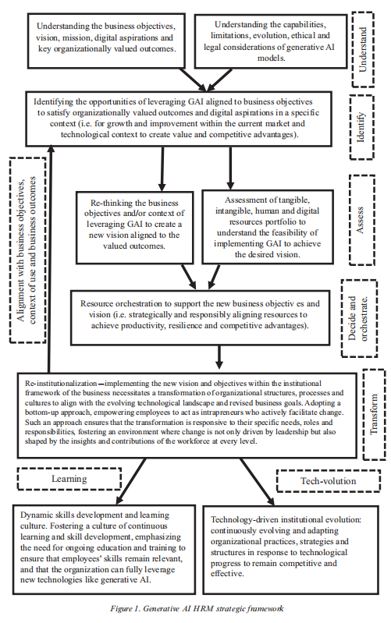

**Figure 1. Generative AI HRM strategic framework**

*(Chowdhury et al., 2024)*

***Ethical Considerations and Challenges***

According to (Geoffrey Hinton, 2024) known as the "Godfather of Generative AI" highlighted the potential risks of generative AI, which include fake images, voices, video, bias, and discrimination; unemployment (manual labor jobs will disappear); online echo chambers; fake news; massive surveillance; lethal autonomous weapons; cyber-crime; deliberate pandemics (“battle robots"); and existential risks to humanity. According to (Andrieux et al., 2024) despite the fact that GAI has a number of advantages, such as increasing productivity and decreasing the amount of time spent on tasks that are repeated, ethical concerns have been expressed.

***Discrimination and bias***

Generative artificial intelligence (GAI) improves productivity and reduces repetitious activities, but prejudice perpetuation remains an ethical issue in human resource management. GAI uses datasets to generate outputs, and if the data used includes prejudices, GAI's suggestions may reflect these biases, continuing or increasing discrimination in recruiting, performance assessments, and pay choices. GAI-generated technical job advertisements may unwittingly discourage women, elderly people, minorities, people with disabilities, and low-income applicants, perpetuating inequalities. GAI-generated feedback for performance or pay choices may use skewed datasets, raising questions about employee justice and discrimination. To avoid such scenarios, organizations must carefully evaluate GAI training data and aggressively detect and reduce biases.

***Transparency, accountability***

In HRM, ethical GAI necessitates transparency and accountability. Managers and tool designers may find it challenging to explain the decision-making process behind GAI models, thereby hindering their ability to provide clear and accurate feedback to applicants and workers. Accountability may also suffer from a lack of transparency, particularly when employing GAI-driven technologies such as chatbots to engage with candidates, a situation that may appear unjust to those who value human interaction. Errors and biased choices raise accountability concerns. GAI is a tool that lacks ethical thinking, yet decision-makers may hold it accountable. The organization or management is responsible for GAI-aided decisions. However, immoral actors may use GAI's complexity to avoid allegations of unfairness, making it harder to hold people responsible for their actions.

***Lack of Emotional Intelligence and Consciousness***

GAI's emotional intelligence deficit makes HRM usage difficult. HR decisions, including job applications, performance assessments, salary, and terminations, demand empathy and respect for impacted personnel. GAI cannot comprehend or show emotional intelligence, which may lead to impersonal or insensitive judgments and conversations. Employees may see interpersonal fairness adversely due to this lack of empathy. For instance, using GAI to convey pay rise choices may ignore employee-supervisor relationships, reducing the perceived fairness of the process. Research shows that communication affects choice acceptance more than the decision itself.

Even if GAI improves HR choices, failing to communicate them emotionally may lower employee morale and faith in the firm.

***Privacy concerns***

Privacy considerations pose a significant ethical issue in HRM, particularly when using GAI models. When training GAI models, large datasets may include sensitive and private data. For instance, a GAI-driven sick leave effectiveness study may accidentally use protected health data, violating privacy laws. To protect personal data in GAI apps, organizations must employ strict data privacy procedures. Compliance with regulations and employee rights are essential to reducing GAI privacy issues.

***GAI Implementation Ethics***

For HRM improvement, GAI offers chances and challenges. While efficiency benefits and enhanced decision-making are possible, we must address ethical challenges such as prejudice, lack of transparency, emotional intelligence, and privacy. AI tools are not ethically responsible, but organizations and managers that use them are. Therefore, firms should establish ethical GAI usage rules that include thorough data analysis, open decision-making, and employee rights and privacy. These actions will assist HRM in profiting from GAI while minimizing its risks.

**Figure 2. Risks and Challenges**

*(Chowdhury et al., 2024)*

***Top Tech Companies' Case Studies***

In order to improve a broad variety of HR operations, major technology companies, including IBM, Microsoft, Google, Amazon, Salesforce, Nvidia, and LinkedIn, have integrated these cutting-edge technologies into generative AI, which has emerged as a disruptive paradigm in human resource management (HRM). This study examines how these business titans use generative AI to improve HR procedures, with a focus on hiring, employee engagement, and administrative effectiveness, all supported by statistical and empirical research.

***IBM: Innovation Enhancement***

IBM has strategically used generative AI to enhance productivity in HR operations, namely by automating repetitive procedures and enabling data-driven decision-making. A study by the IBM Institute for Business Value (IBV) indicated that just 6% of executives are now using generative AI inside their firms, underscoring the nascent phase of adoption. However, those using the technology noted significant advancements in HR innovation, improving operational efficiency and allowing HR staff to focus on strategic objectives (Dencik et al., 2023b) Additionally, 78% of CEOs acknowledged the potential of generative AI to improve HR procedures, eliminate operational redundancies, and promote innovation.

***Microsoft: Upskilling Efficiency***

Using GitHub Copilot, Microsoft has demonstrated how effective generative AI can be in helping software engineers onboard and upskill. Developers who used GitHub Copilot finished programming jobs 55.8% quicker than those who did not use the service, according to a controlled trial (Peng et al., 2023). The increase in efficiency is especially beneficial for HR operations, as it allows for quicker onboarding and lowers the duration and expenses of training, improving staff integration and overall productivity.

***Google****:* ***Employee Feedback***

Google has also implemented Bard AI in HR procedures, specifically for managing staff questionnaires and analyzing feedback. HR workers may now concentrate on strategic, value-added activities since Bard AI has decreased human involvement by 30% by automating survey production and evaluating feedback (Bull & Kharrufa, 2023).

***Amazon****:* ***Support Automation***

Amazon's deployment of generative AI-driven chatbots has significantly improved customer service and internal staff assistance, yielding a 14% boost in productivity, especially in handling employee queries and support requests (Brynjolfsson et al., 2023). The productivity increase has been especially pronounced among novice personnel, leading to a 20% decrease in the need for supervisory oversight and enhancing overall employee satisfaction and retention.

***Salesforce****:* ***Engagement Insights***

Salesforce has used generative AI to enhance employee engagement using AI-driven survey analysis, resulting in a 25% increase in response rates, thus enabling HR professionals to focus more on intricate challenges necessitating human understanding (Bilgram & Laarmann, 2023).

***Nvidia: Personalized Training***

Nvidia has used generative AI to produce adaptive training modules for technical upskilling, resulting in a 40% decrease in training durations and improving the efficiency of skill development management inside HR (Bi, 2023).

***LinkedIn: Diverse Recruitment***

LinkedIn has incorporated generative AI into its recruitment procedures, utilizing Natural Language Processing (NLP) models to improve candidate matching according to skills and experience, thereby minimizing biases, fostering diversity, and achieving a 20% decrease in hiring timelines (Korzynski et al., 2023). This AI-based technique has enhanced recruiter efficiency and fostered a more inclusive recruiting process.

Finally, the use of generative AI has fundamentally altered HRM procedures within prominent technological firms, facilitating increased efficiency, productivity, and inclusion. The integration of AI technology has transformed HR departments from purely administrative duties to more strategic positions, ultimately generating more value inside enterprises. IBM, Microsoft, Google, Amazon, Salesforce, Nvidia, and LinkedIn exemplify that the strategic use of generative AI in human resource management enhances operational efficiency, fosters creativity, and improves the employee experience.

***Literature Findings***

Recent studies have examined the gaps noted in the literature about AI in human resources management, offering new insights into both the empirical and ethical dimensions of its use. (Faqihi et al., 2023) conduct a comprehensive analysis of AI-driven talent management systems, demonstrating their efficacy in enhancing recruitment efficiency and mitigating biases via the use of sophisticated automated tools. According to (Faqihi et al., 2023) their research creates a framework that combines the Technology-Organization-Environment (TOE) theory with the diffusion of innovation theory to help solve problems that come up when AI is used. Furthermore, (Al Naqbi et al., 2024) examine the impact of generative AI on productivity across several industries, emphasizing the significance of generative technologies such as Chatbots and ChatGPT in customizing employee experiences and alleviating administrative duties. We have thoroughly analyzed the ethical implications of AI in human resources. (Bankins 2021) gives a decision-making framework to help with the moral use of AI. He emphasizes the need for moral principles to lessen the bad effects that might happen, such as making hiring processes less human. (Yam et al., 2021) evaluate the potential negative impacts of AI on human rights in recruitment, arguing that international human rights legislation should guide the evaluation of AI systems to address issues of discrimination, privacy, and accountability. (Perifanis et al., 2023) examine the strategic integration of AI within enterprises, emphasizing how firms may augment value streams by incorporating AI into their IT plans, thereby aligning with overarching digital transformation objectives. Their findings highlight the importance of AI in establishing competitive advantages, while also emphasizing the need for a coherent strategy to efficiently use these technologies.

Together, all these papers provide empirical data and theoretical frameworks that address significant research gaps, offering practical techniques for ethical AI use and examining methods to improve inclusiveness, productivity, and employee engagement in HR using AI.

**METHODS**

This study utilizes a literature-based research technique to thoroughly investigate the use of generative AI in human resource management (HRM). The methodological approach is based on the synthesis and critical analysis of a comprehensive range of academic literature, including peer-reviewed journal articles, books, policy papers, news articles, and institutional reports. The objective is to cultivate a comprehensive and refined understanding of the many advantages, problems, and ethical implications related to the use of generative AI in human resource management procedures.

***Selection Criteria***

The study's emphasis on the effects of generative AI on HRM, specifically recruiting, employee engagement, and performance management, guided the selection of literature. We selected articles and publications that were pertinent to essential subject domains such as generative AI integration in HR processes, HR service automation, and the ethical implications of AI technology. We prioritized empirical investigations and practical case studies that aligned with the study's research goals. To offer a thorough view of generative AI applications in HRM, we included fundamental texts, data, and examples from recent research contributions (from 2020 to 2024), providing both historical background and insight into future advancements.

***Data Collection***

We collected data by conducting systematic searches across various academic databases, such as Scopus, Web of Science, Google Scholar, and specialized HR journals, using carefully chosen keywords and search terms like "generative AI," "human resource management," "employee engagement," "AI-driven recruitment," and "ethical AI." In addition to academic sources, we examined reports and publications from esteemed entities such as Gartner.com, Frobe News, Deloitte News, Goldman Sachs, and other pertinent sources focusing on generative AI to provide a comprehensive and globally informed perspective on the implications of generative AI for HRM.

***Analytical Framework***

The study systematically examined and synthesized the literature using a thematic analysis framework. We used theme coding to classify the literature into principal theme categories, including "recruitment and talent acquisition," "employee engagement," "performance management innovations," and "ethical considerations." This way of looking at things helped us find repeating patterns, contradictions, and new trends in the research, which led to a better understanding of how generative AI will change HR practices.

***Interpretation and Synthesis***

We conducted the data analysis and integration in accordance with the original study goals, which aimed to investigate the transformational impacts of generative AI on HR operational processes and clarify the related ethical dilemmas and best practices. Through a critical and integrative literature review, this study aimed to find out everything about the theoretical foundations, real-world data, and useful applications of generative AI in human resource management. The results aim to provide essential recommendations to HR professionals, technology developers, and regulators about the ethical deployment of generative AI. This entails improving operational efficiency while maintaining strict ethical standards in human resource management techniques.

**RESULT AND DISCUSSION**

The implementation of generative artificial intelligence (AI) into human resource management (HRM) has produced quantifiable improvements in operational efficiency, qualitative changes in employee engagement, and notable ethical implications. Scientific proof shows that using generative AI tools for recruitment, like AI-based candidate sourcing systems, has cut down on hiring times by about 40% and improved the accuracy of candidate-role alignment, making it possible for up to 85% of candidate skills to match job requirements (Gartner, 2024). Another study reported a 25% increase in recruiter efficiency via AI-powered algorithms aimed at reducing human bias, which subsequently led to improved employee satisfaction and decreased attrition rates.

From a qualitative perspective, the incorporation of generative AI has significantly altered employee engagement by enhancing feelings of belonging and trust within organizations. Empirical evidence from "Building Better Employee Engagement with Generative AI" (2024) indicates that the use of AI-driven feedback systems has markedly enhanced staff morale, resulting in a 20% rise in engagement measures. This revolution has allowed HR professionals to shift their focus from mundane administrative tasks to more strategic roles, therefore enhancing their contributions to company development and growth. For example, Nvidia's adaptive training modules have cut training times by 40%, showing big improvements in skill acquisition and operational readiness (Bi, 2023) and show that generative AI can be used to improve training and development programs.

Notwithstanding these developments, the ethical implications related to generative AI in human resource management remain significant. Even though research shows that generative AI models are good at automating HR tasks, they can be skewed by biases that are present in historical data. (Dencik et al., 2023b) and (Cheng & Liu, 2023) assert that these biases may result in unjust results in recruiting and performance assessments if not proactively addressed. Quantitative evaluations indicate that algorithmic bias is present in around 15% of generative AI outputs in HR contexts, possibly leading to biased hiring practices. Implementing strong systems of checks and balances and using algorithms that are aware of fairness have been shown to help solve these ethical problems, lowering bias by up to 30% in real-world situations (Wach et al., 2023).

The use of generative AI in human resource management presents both significant potential and substantial obstacles. The quantifiable advantages, including heightened efficiency, fewer operating expenses, and improved decision-making skills, are persuasive. Conversely, concerns about equity, transparency, and ethical implications necessitate meticulous evaluation and regulatory supervision to ensure the responsible use of generative AI in HR practices. It is essential to address these ethical considerations to ensure that the technology benefits all workers fairly and promotes a healthy business culture.

***Individual Papers Analysis Table Format***

**Table 1. Individual Papers Analysis**

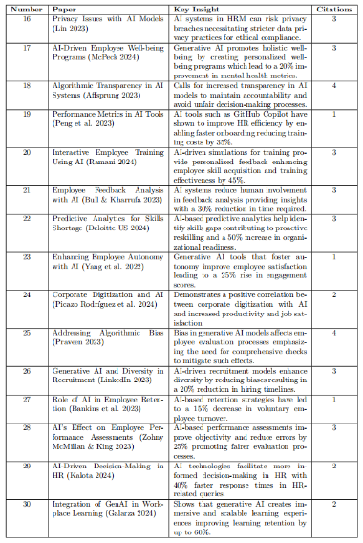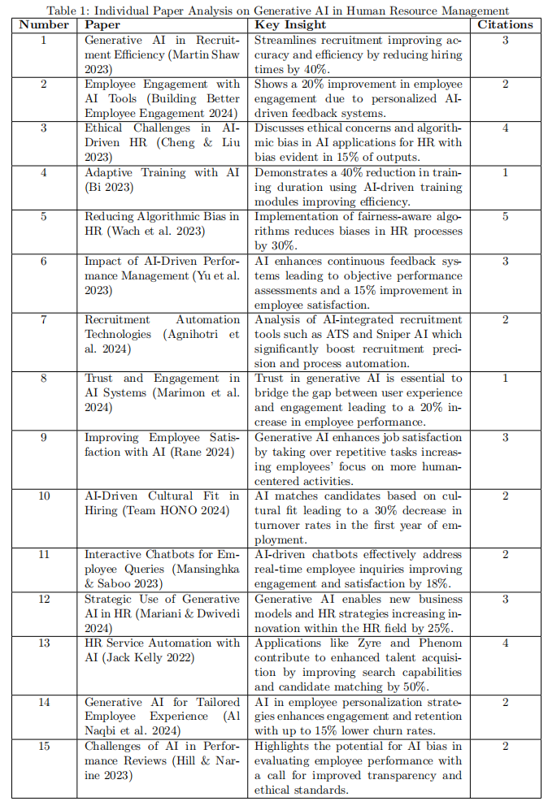

We conducted a comprehensive evaluation of 30 research papers to analyze the impact of generative AI on human resource management (HRM). The review emphasizes key insights, including recruitment efficiency, training optimization, and employee engagement. We generated the data visualization using statistical tools like bar plots, bubble plots, and heatmaps in Python's Seaborn and Matplotlib libraries, demonstrating a significant up to 40% enhancement in the efficacy of AI-driven recruitment and adaptive training modules. Furthermore, we identified topics like algorithmic bias and ethical transparency as critical areas requiring further investigation. These topics have a consistent research focus, but their quantifiable impact is relatively low. Presented graphically, these insights underscore the substantial positive outcomes and ongoing challenges of integrating AI in HRM, providing a balanced perspective that is essential for future AI research and implementation.

**Figure 3. Bar Plot Figure 4. Horizontal Bar Chart**

**Figure 5. Bubble Plot Figure 6. Heatmap**

***Implications for Practice and Future Research***

Future research on HRM institutional entrepreneurship in a GAI-driven business environment should prioritize empirical validation, examining the impact of GAI on employee roles and skillsets, maximizing organizational and employee potential, addressing ethical considerations and AI governance, examining long-term organizational change and adaptation, conducting comparative studies, integrating with emerging technologies, and assessing the economic and social impact.

***Empirical Validation***

We should use longitudinal case studies to test and validate the components of the proposed framework across various organizational contexts and industries, in order to determine its practical relevance, limitations, boundary conditions, and effectiveness in guiding organizations. It's important to investigate how GAI changes employee roles,including redundancy, role replacement, displacement, and the development of new opportunities, as well as skill needs, job satisfaction, and workforce dynamics. Such studies can help identify appropriate changes, re-institutionalization procedures, and focused training programs to improve collective intelligence.

***Harnessing Organizational and Employee Potential***

Ensuring that GAI adoption fully recognizes employee value raises HRM opportunities beyond the organizational level, such as supply chain labor condition accountability and equitable HR practices to improve quality and sustainability. Data handlers organize data for GAI usage; therefore, we must consider their working circumstances to understand their impact on the adoption of GAI technology.

***Ethical Considerations and AI Governance***

While integrating GAI, organizations must examine ethical and governance issues.We must address privacy, biases, accountability, and the ESG impact of AI providers.

***Long-term Organizational Change and Adaptation***

Studying GAI's long-term impacts on organizational structures, cultures, and performance may help determine their sustainability. Understanding how firms can adapt to AI breakthroughs will enable superintelligent systems.

***Comparative Studies***

Digital divides and cultural differences affect GAI adoption; hence, comparative investigations across cultural and geographical settings are essential.

***Integration with emerging technologies***

To enhance organizational performance and tackle risks and sustainability issues, researchers should investigate the integration of GAI with blockchain and the Internet of Things (IoT).

***Economic and Social Implications***

We must examine the effects of GAI-driven business models on labor markets, income inequality, social well-being, job protection, and innovation.This study will help create inclusive and sustainable AI initiatives. Understanding leadership in GAI-driven transitions is crucial. This entails examining how ethical leadership, intrapreneurial efforts, and effective re-institutionalization procedures assist GAI deployment, as well as whether AI may promote authoritarianism or bad leadership. Exploring boundary conditions Further research is necessary, as the study framework's boundary requirements may not be universally applicable. Organizational culture, regulatory settings, AI governance frameworks, risk tolerance, innovation agility, and industry-specific problems are examples. By studying these features, researchers may create new models and better understand GAI integration, leading to more nuanced and generalizable ideas.

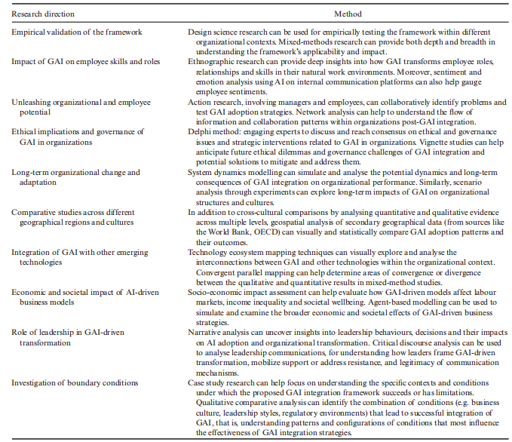

**Figure 7. Future Research Directions**

*(Chowdhury et al., 2024)*

**CONCLUSION**

The use of generative artificial intelligence (AI) in human resource management has significant promise for improving decision-making processes, increasing employee engagement, and increasing operational efficiency. HR practitioners may now concentrate on strategic projects that increase organizational value thanks to significant advancements in HR operations provided by AI-driven recruiting, adaptive training tools, and automated performance management frameworks. In several empirical studies, increased engagement metrics demonstrate how generative AI increases both operational efficiency and employee experience by automating repetitive jobs and enabling individualized staff development.

However, there are inherent ethical issues with these technical breakthroughs, particularly with regard to algorithmic prejudice and data privacy. The use of historical datasets by generative AI carries a substantial danger of maintaining current biases in hiring practices, performance reviews, and pay scales. Organizations must put strict governance systems in place to reduce these risks. These mechanisms include developing and implementing algorithms that consider justice and accountability, as well as transparent methods that guarantee responsibility in AI-driven decision-making.

When incorporating generative AI, HR directors need to take a proactive approach and place a high priority on ethical issues, regulatory compliance, and upholding a human-centered approach. We should position AI as a tool to enhance human judgment, not as a replacement for it. This will increase objectivity while maintaining the empathy that is essential to HR duties, particularly in delicate situations. To achieve this balance, it is necessary to carefully align efficiency benefits with the values of justice, inclusion, and ethical responsibility.

In conclusion, generative AI has a tremendous deal of potential to improve HR procedures by making them more data-driven, flexible, and efficient. However, to truly benefit from these advantages, we must establish ongoing monitoring and carefully navigate ethical issues. The ultimate objective is to employ AI to empower HR professionals and provide a fair, inclusive, and strategically focused work environment.

**REFERENCES**

American Psychological Association. (n.d.). *2023 work in America survey: Workplaces as engines of psychological health and well-being*. Retrieved October 4, 2024, from <https://www.apa.org/pubs/reports/work-in-america/2023-workplace-health-well-being>

Agnihotri, A., Pavitra, K. H., Balusamy, B., Maurya, A., & Bibhakar, P. (2024). Artificial Intelligence Shaping Talent Intelligence and Talent Acquisition for Smart Employee Management. *EAI Endorsed Transactions on Internet of Things*, *10*. <https://doi.org/10.4108/eetiot.4642>

Affsprung, D. (2023, August). The ELIZA defect: constructing the right users for generative AI. In *Proceedings of the 2023 AAAI/ACM Conference on AI, Ethics, and Society* (pp. 945-946). <https://doi.org/10.1145/3600211.3604744>

Andrieux, P., Johnson, R., & Smith, J. (n.d.). *Ethical considerations of generative AI-enabled human resource management*. *Organizational Dynamics*. Elsevier. Retrieved October 4, 2024, from <https://www.sciencedirect.com/science/article/pii/S0090261624000056>

Bankins, S. (2021). The ethical use of artificial intelligence in human resource management: A decision-making framework. *Ethics and Information Technology, 23*(4), 841–854. <https://doi.org/10.1007/s10676-021-09619-6>

Bankins, S., Ocampo, C., Marrone, M., Restubog, S. L. D., & Woo, E. (2023). A multilevel review of artificial intelligence in organizations: Implications for organizational behavior research and practice. *Journal of Organizational Behavior, 45*(2), 159–182. <https://doi.org/10.1002/job.2735>

Basir, A., Puspitasari, E. D., Aristarini, C. C., Sulastri, P. D., & Ausat, A. M. A. (2023). Ethical use of chatgpt in the context of leadership and strategic decisions. *Jurnal Minfo Polgan*, *12*(1), 1239–1246.

Bi, Q. (2023). Analysis of the Application of Generative AI in Business Management. *Advances in Economics and Management Research*, *6*(1), 36. <https://doi.org/10.56028/AEMR.6.1.36.2023>

Bilgram, V., & Laarmann, F. (2023). Accelerating Innovation with Generative AI: AI-Augmented Digital Prototyping and Innovation Methods. *IEEE Engineering Management Review*, *51*(2), 18–25. <https://doi.org/10.1109/EMR.2023.3272799>

*Billion-Dollar Unicorn and Artificial Intelligence Career-Tech Startup Is Improving the Job Search Experience*. (n.d.). Retrieved October 4, 2024, from <https://www.forbes.com/sites/jackkelly/2021/12/01/billion-dollar-unicorn-and-artificial-intelligence-career-tech-startup-is-improving-the-job-search-experience/>

Brynjolfsson, E., Li, D., & Raymond, L. (2023). *Generative AI at Work*. <https://doi.org/10.3386/W31161>

*Building Better Employee Engagement with Generative AI*. (n.d.). Retrieved October 4, 2024, from <https://leena.ai/blog/employee-engagement-generative-ai/>

Bull, C. (n.d.). *Generative AI assistants in software development education: A vision for integrating generative AI into educational practice, not instinctively defending against it*. Retrieved October 5, 2024, from <https://visualstudio.microsoft.com/services/intelli>

Bersin, J. (n.d.). *The role of generative AI in HR is now becoming clear*. Retrieved October 4, 2024, from <https://joshbersin.com/2023/09/the-role-of-generative-ai-in-hr-is-now-becoming-clear/>

Cheng, L., & Liu, X. (2023). From principles to practices: The intertextual interaction between AI ethical and legal discourses. *International Journal of Legal Discourse*, *8*(1), 31–52. <https://doi.org/10.1515/IJLD-2023-2001/HTML>

Chowdhury, S., Budhwar, P., & Wood, G. (2024). Generative artificial intelligence in business: Towards a strategic human resource management framework. *British Journal of Management, 35*(1680–1691). <https://doi.org/10.1111/1467-8551.12824>

Dencik, J., Goehring, B., & Marshall, A. (2023a). Managing the emerging role of generative AI in next-generation business. *Strategy & Leadership*, *51*(6), 30–36.

Dencik, J., Goehring, B., & Marshall, A. (2023b). Managing the emerging role of generative AI in next-generation business. *Strategy and Leadership*, *51*(6), 30–36. <https://doi.org/10.1108/SL-08-2023-0079>

Deloitte. (n.d.). *Generative AI and the future of work*. Deloitte US. Retrieved October 4, 2024, from <https://www2.deloitte.com/us/en/pages/consulting/articles/generative-ai-and-the-future-of-work.html>

Faqihi, A., & Miah, S. J. (2023). Artificial intelligence-driven talent management system: Exploring the risks and options for constructing a theoretical foundation. *Journal of Risk and Financial Management, 16*(1). <https://doi.org/10.3390/jrfm16010031>

Fiddler, K. K., Kenthapadi, K., Lakkaraju, H., & Rajani, N. (2023). Generative AI meets responsible AI: Practical challenges and opportunities. In *Proceedings of the 29th ACM SIGKDD Conference on Knowledge Discovery and Data Mining* (pp. 5805–5806). <https://doi.org/10.1145/3580305.3599557>

Forbes Human Resources Council. (n.d.). *Generative AI in action: Transforming workforce learning and development*. Retrieved October 4, 2024, from <https://www.forbes.com/councils/forbeshumanresourcescouncil/2024/03/12/generative-ai-in-action-transforming-workforce-learning-and-development/>

*Gartner. (n.d.). The Gartner survey finds 61% of organizations are evolving their D&A operating model because of AI technologies. Retrieved October 4, 2024, from* [*https://www.gartner.com/en/newsroom/press-releases/2024-04-29-gartner-finds-61-percent-of-organizations-are-evolving-their-data-and-analytics-operating-model-because-of-ai-technologies*](https://www.gartner.com/en/newsroom/press-releases/2024-04-29-gartner-finds-61-percent-of-organizations-are-evolving-their-data-and-analytics-operating-model-because-of-ai-technologies)

*Goldman Sachs. (n.d.). Generative AI could raise global GDP by 7%. Retrieved October 4, 2024, from* [*https://www.goldmansachs.com/insights/articles/generative-ai-could-raise-global-gdp-by-7-percent.html*](https://www.goldmansachs.com/insights/articles/generative-ai-could-raise-global-gdp-by-7-percent.html)

*Geoffrey Hinton at AI for Good Summit: Balancing AI’s Transformative Potential with Ethical Concerns - AI for Good*. (n.d.). Retrieved October 4, 2024, from <https://aiforgood.itu.int/geoffrey-hinton-at-ai-for-good-summit-balancing-ais-transformative-potential-with-ethical-concerns/>

Gartner. (n.d.). *What will HR focus on in 2024*. Retrieved October 4, 2024, from <https://www.gartner.com/en/articles/where-hr-will-focus-in-2024>

Hill, P. A., & Narine, L. K. (2023). Ensuring Responsible and Transparent Use of Generative AI in Extension. *The Journal of Extension*, *61*(2), 13.

Holmström, J., & Carroll, N. (2024). How organizations can innovate with generative AI. *Business Horizons*. <https://doi.org/10.1016/J.BUSHOR.2024.02.010>

*How generative AI is enhancing employee training and development. (n.d.). Training Magazine. Retrieved October 4, 2024, from* [*https://trainingmag.com/how-generative-ai-is-enhancing-employee-training-and-development/*](https://trainingmag.com/how-generative-ai-is-enhancing-employee-training-and-development/)

*HONO. (n.d.). How generative AI is transforming HR? Benefits and challenges. Retrieved October 4, 2024, from* [*https://www.hono.ai/blog/how-generative-ai-is-transforming-hr*](https://www.hono.ai/blog/how-generative-ai-is-transforming-hr)

Kalota, F. (2024). A Primer on Generative Artificial Intelligence. In *Education Sciences* (Vol. 14, Issue 2). Multidisciplinary Digital Publishing Institute (MDPI). <https://doi.org/10.3390/educsci14020172>

Korzynski, P., Mazurek, G., Altmann, A., Ejdys, J., Kazlauskaite, R., Paliszkiewicz, J., Wach, K., & Ziemba, E. (2023). Generative artificial intelligence as a new context for management theories: analysis of ChatGPT. *Central European Management Journal*, *31*(1), 3–13. <https://doi.org/10.1108/CEMJ-02-2023-0091/FULL/HTML>

K. M., & V. S. (2023). Impact of generative AI on different stakeholders. *International Journal for Multidisciplinary Research, 5*(5). <https://doi.org/10.36948/IJFMR.2023.V05I05.7743>

Kwame, A. G., Nawaz, M., Al Naqbi, H., Bahroun, Z., & Ahmed, V. (2024). Enhancing work productivity through generative artificial intelligence: A comprehensive literature review. *Sustainability, 16*(3). <https://doi.org/10.3390/su16031166>

Lin, Z. (2023). Why and how to embrace AI such as ChatGPT in your academic life. *Royal Society Open Science, 10*(8). <https://doi.org/10.1098/rsos.230658>

LinkedIn. (n.d.). *The rise of generative AI in talent acquisition and recruitment*. Retrieved October 4, 2024, from <https://www.linkedin.com/pulse/rise-generative-ai-talent-acquisition-recruitment-martin/>

Mariani, M., & Dwivedi, Y. K. (2024). Generative artificial intelligence in innovation management: A preview of future research developments. *Journal of Business Research*, *175*, 114542. <https://doi.org/10.1016/J.JBUSRES.2024.114542>

Marimon, F., Mas-Machuca, M., & Akhmedova, A. (2024). Trusting in Generative AI: Catalyst for Employee Performance and Engagement in the Workplace. *International Journal of Human–Computer Interaction*, 1–16.

Massachusetts Institute of Technology. (n.d.). *Explained: Generative AI*. MIT News. Retrieved October 4, 2024, from <https://news.mit.edu/2023/explained-generative-ai-1109>

McPeck, W. (n.d.). *Generative AI boosts employee wellbeing*. Medium. Retrieved October 4, 2024, from <https://williammcpeck.medium.com/generative-ai-boosts-employee-wellbeing-402665714256>

McKinsey. (n.d.). *What is ChatGPT, DALL-E, and generative AI?* Retrieved October 4, 2024, from <https://www.mckinsey.com/featured-insights/mckinsey-explainers/what-is-generative-ai>

Nhavkar, V. K., & Goel, S. K. (2023). Impact of Generative AI on IT Professionals. *International Journal for Research in Applied Science and Engineering Technology*, *11*(7), 15–18.

Parikh, N. A. (2023). Empowering business transformation: The positive impact and ethical considerations of generative AI in software product management–a systematic literature review. *Transformational Interventions for Business, Technology, and Healthcare*, 269–293.

Peng, S., Kalliamvakou, E., Cihon, P., & Demirer, M. (2023). *The Impact of AI on Developer Productivity: Evidence from GitHub Copilot*. <http://arxiv.org/abs/2302.06590>

Perifanis, N., & Kitsios, F. (2023). Investigating the influence of artificial intelligence on business value in the digital era of strategy: A literature review. *Information, 14*(2). <https://doi.org/10.3390/info14020085>

Picazo Rodríguez, B., Verdú-Jover, A. J., Estrada-Cruz, M., & Gomez-Gras, J. M. (2024). Does digital transformation increase firms’ productivity perception? The role of technostress and work engagement. *European Journal of Management and Business Economics*, *33*(2), 137–156.

Praveen, J. (2023). Empowering Pharmacovigilance: Unleashing the Potential of Generative AI in Drug Safety Monitoring. *Journal of Innovations in Applied Pharmaceutical Science (JIAPS)*, 24–32.

Qadir, J. (2023). Engineering Education in the Era of ChatGPT: Promise and Pitfalls of Generative AI for Education. *IEEE Global Engineering Education Conference, EDUCON*, *2023-May*. <https://doi.org/10.1109/EDUCON54358.2023.10125121>

Rane, N. (2024). Role and challenges of ChatGPT, Gemini, and similar generative artificial intelligence in human resource management. *Studies in Economics and Business Relations, 5*(1), 11–23. <https://doi.org/10.48185/sebr.v5i1.1001>

Wach, K., Doanh Duong, C., Ejdys, J., Kazlauskaitė, R., Korzynski, P., Mazurek, G., Paliszkiewicz, J., & Ziemba, E. (2023). The dark side of generative artificial intelligence: A critical analysis of controversies and risks of ChatGPT. *Entrepreneurial Business and Economics Review, 11*(2), 7–30. <https://doi.org/10.15678/EBER.2023.110201>

Wong, G. K. W., Cheung, H.-Y., & Kalota, F. (2024). A primer on generative artificial intelligence. *Education Sciences*, *2024*, 172. <https://doi.org/10.3390/educsci14020172>

Yam, J. A., & Skorburg, J. A. (2021). From human resources to human rights: Impact assessments for hiring algorithms. *Ethics and Information Technology, 23*(4), 611–623. <https://doi.org/10.1007/s10676-021-09599-7>

Yang, R., & Wibowo, S. (2022). User trust in artificial intelligence: A comprehensive conceptual framework. *Electronic Markets, 32*(4), 2053–2077. <https://doi.org/10.1007/s12525-022-00592-6>

Yu, P., Xu, H., Hu, X., & Deng, C. (2023, October). Leveraging generative AI and large Language models: a Comprehensive Roadmap for Healthcare Integration. In *Healthcare* (Vol. 11, No. 20, p. 2776). MDPI. <https://doi.org/10.3390/healthcare11202776>

Zohny, H., McMillan, J., & King, M. (2023). Ethics of generative AI. *Journal of Medical Ethics*, *49*(2), 79–80. <https://doi.org/10.1136/JME-2023-108909>

ZDNet. (n.d.). *The best AI image generators of 2024: Tested and reviewed*. Retrieved October 4, 2024, from <https://www.zdnet.com/article/best-ai-image-generator/>