|  |  |  |
| --- | --- | --- |
|  |  |  |
| **ANALYSIS OF DELAYS IN DELIVERY OF EXPORTED GOODS AT FREIGHT FORWARDER PT ARINDO JAYA MANDIRI SEMARANG**  **Esti Ayu Anugraheni1*, Nurul Imani Kurniawati2**  *1Bachelor of Applied Logistics Management and Administration, Vocational School, Diponegoro University, Indonesia,* [*estiayuanugraheni@students.undip.ac.id*](mailto:estiayuanugraheni@students.undip.ac.id)  *2Bachelor of Applied Logistics Management and Administration, Vocational School, Diponegoro University, Indonesia,* [nurulimanikurniawati@lecturer.undip.ac.id](mailto:nurulimanikurniawati@lecturer.undip.ac.id)  *\*Correspondent author* | | |
| **Abstract** | PT. Arindo Jaya Mandiri is a freight forwarder company. PT. Arindo Jaya Mandiri must provide the best service to meet customer needs. However, the process of sending export goods often experiences delays so that consumers complain. This research was carried out with the aim of knowing the flow of export goods delivery and the critical points that cause delays, knowing the supporting and inhibiting factors, and knowing the Fault Tree Analysis method. The method uses a qualitative descriptive approach. The research results show that the export goods delivery flow starts from the stuffing flow to the payment flow. However, obstacles that influence such as human error, document discrepancies, natural disasters, and the fleet. The Fault Tree Analysis method is used to analyze the causes of delays in delivery of the highest priority goods, namely the fleet. The conclusion is that PT. Arindo Jaya Mandiri sends export goods without any reference so the company only carries out work according to custom. Delivery of export goods is carried out by creating Standard Operating Procedures. | |
|  |  | |
| **Keywords** | *Delay; delivery of Goods; export; factors; freight forwarder* | |
|  |  |  |
|  |  |  |

**INTRODUCTION**

Initially, the buying and selling network was only carried out in one area, but after technological advances, buying and selling can be done in all regions. Foreign trade is an essential part of supporting trade in the region and export-import activities are an aspect that determines the flow of the economy, especially Indonesia. International trade has had a positive impact by increasing the sales volume of export and import commodities. The natural potential that each country has is different, encouraging the desire of other countries to obtain it. Economic factors are one aspect of ongoing international trade, namely when certain groups try to obtain results that exceed their capacity. This will make consumers try to meet their needs so that the business can run optimally. Developments in the business world have resulted in increasingly tight competition between companies. So to face this competition, every company must make efforts to be superior to other companies. So many people compete to produce products that can be exported. This is what causes exports to grow and become more widespread among the general public.

PT. Arindo Jaya Mandiri is a company that focuses on freight forwarders who help send goods using sea transportation. As a freight forwarder service company, this company must provide the best service to meet customer needs, one of which is timely delivery of goods that reach their destination safely. Freight forwarder companies that assist in managing export activities to send and receive products via land, sea and air. Companies need to provide the best service to consumers so that export delivery operations meet consumer expectations. However, companies often have problems such as limited staff in inputting data, lack of truck availability, sloppy packaging of goods, and Occupational Health Safety (K3) which has not been implemented optimally. These obstacles resulted in delays in the delivery of goods. Therefore, companies respond to consumer complaints to resolve problems by finding the cause of delays in delivery of goods. PT. Arindo Jaya Mandiri was founded to have an ever-increasing number of consumers, resulting in the company becoming known and growing. However, the company's performance was less than optimal, especially with limited human resources, so the number of consumers decreased and the company's performance decreased.

Tabel 1.1 Consumer Data PT. Arindo Jaya Mandiri 2021-2023

Source: Secondary Data Processed by the Author, 2023

Based on the results of interviews with PT. Arindo Jaya Mandiri in Figure 1.1 shows that the company's consumers have experienced a very significant decline. The company has the most consumers in 2021 with 24 consumers. The number of consumers has decreased because they often experience delays in delivery caused by several factors, such as the fleet they own often experiences problems, the company's costs are limited because customers make payments after the goods have been processed so the company has to deliver goods in turns, mismatches in goods data and resources. Humans are less responsive when carrying out the process of sending export goods. Therefore, consumers who still use the freight forwarder services of PT. Arindo Jaya Mandiri experienced a decline from initially 24 consumers, now only a few, such as PT. Hanil Indonesia, PT. Cirebon Furniture, PT. Prima Parquet Indonesia, PT. Asia Pacific Indonesia, CV. Majawana, and PT. SIK. This is because customers who will export goods in large quantities and need time quickly prefer to use other freight forwarder services because they feel that the service provided is optimal compared.

Tabel 1.2 Export Goods Delivery Rate PT. Arindo Jaya Mandiri 2021-2023

Source: Secondary Data Processed by the Author, 2023

Based on the results of interviews with PT. Arindo Jaya Mandiri in table 1.2 shows that the volume of export shipments has decreased every year. In 2021, the shipping volume will be 2417 containers. This results in the company's operations decreasing so that the company's income decreases. Many consumers want to export large quantities but companies cannot fulfill them because problems often occur which result in delays in the delivery of exported goods. This often happens due to export goods piling up but the data attached does not match the existing goods so it takes time to check, the company has limited costs so the company can only send goods according to capital, human resources lack coordination between staff. in offices and depots so there are often misunderstandings, and the limited fleet owned by the company but no maintenance is carried out so that it often disrupts the process of sending goods or picking up goods. This resulted in the delivery volume not being able to meet the company's target. The obstacle that often occurs in delays in sending export goods is the company's limited fleet of only 30 units. Sometimes the process of sending goods from the depot to the warehouse and then to the port takes a long time. The fleet often experiences damage and requires repairs before taking the goods to the warehouse.

Tabel 1.3 Complaint Items for PT. Export Goods Delivery. Arindo Jaya Mandiri

|  |  |
| --- | --- |
| No. | Complaint Items about Delays in Delivery of Export Goods |
| 1. | Human resources are not responsive enough in the distribution process |
| 2. | The fleet often has problems |
| 3. | Incompatibility of goods data with existing goods |
| 4. | Transportation and cost limitations |

Source: Secondary Data Processed by the Author, 2023

Based on the results of interviews with PT. Arindo Jaya Mandiri in table 1.3 states that complaints in sending export goods include resources that are not responsive enough in the distribution process, fleets that often have problems, limited transportation and fleet, and incompatibility of goods data with existing goods. This is a complaint felt by consumers. These complaints are a factor in consumers choosing to use other freight forwarders.

Tabel 1.4 Complaint Items for PT. Export Goods Delivery. Arindo Jaya Mandiri (Consumer)

|  |  |  |  |  |
| --- | --- | --- | --- | --- |
| No | Complaint Items | 2021 | 2022 | 2023 |
| 1. | Human Resources | 3 | 4 | 3 |
| 2. | Transportation | 10 | 9 | 4 |
| 3. | Inventory | 6 | 2 | 3 |
| 4. | Cost | 5 | 3 | 1 |
| TOTAL | | 24 Consumer | 18 Consumer | 11 Consumer |

Source: Secondary Data Processed by the Author, 2023

Based on the results of interviews with PT. Arindo Jaya Mandiri in table 1.4 shows that the level of complaint most frequently felt by consumers is the problematic fleet factor or fleet limitations because the fleet is the most important, especially in the delivery of goods, the second factor is inappropriate goods data, the third factor is insufficient human resources responsiveness, and the final factor is limited costs. Method of solving this problem, the author uses Fault Tree Analysis to find out the roots that cause a problem. FTA is carried out using a top down approach which starts from determining the top to bottom problems which are used to identify problems. So that it can facilitate decision making and process improvements caused

**LITERATURE REVIEW**

***Operational Management***

Jumadi (2021), operational management is an activity that creates products or services with the stages of planning, organizing, implementing and supervising in order to achieve effective and efficient goals

***Delivery of Goods***

Pinantun (2020), goods delivery is a service of delivering goods to consumers that can be seen for consumer satisfaction.

***Delay in Delivery of Goods***

Rahman (2020), delay is the time when activities are implemented that are not carried out in accordance with the initial concept which can result in activities not being completed on time according to previous plans.

***Export***

Reza (2020), exports are the activity of selling products owned to other countries using foreign exchange transactions and using a foreign language.

***Freight Forwarder***

Oktavianti (2022), a freight forwarder is a company whose aim is to assist in providing services for activities needed by consumers who will send, transport and receive goods using land, sea and air fleets.

***Problem Solving Methods***

According to Shodiqin (2020), problem solving methods are not only methods but are also used in thinking about solving problems starting from searching for data to concluding results.

**METHODS**

***Research Approach***

The research uses a qualitative method with a descriptive approach that focuses on analyzing the inductive thinking process to get answers to the problem of analyzing delays in export goods delivery at freight forwarder PT. Arindo Jaya Mandiri Semarang.

***Research Focus and Location***

Focus on the causes of delays in sending export goods to PT Arindo Jaya Mandiri Semarang. Location at PT. Arindo Jaya Mandiri Semarang

***Research Phenomenon***

The phenomenon used in the research is the flow of export goods delivery at PT. Arindo Jaya Mandiri Semarang critical points cause delays related to procedures, documents and critical points. Supporting factors and inhibiting factors that influence the timeliness of delivery of export goods. Fault Tree Analysis method for analyzing the causes of delays in sending export goods to PT. Arindo Jaya Mandiri Semarang.

***Research Data Source***

The research data sources used are primary sources through interviews with employees and secondary sources through handbooks, profiles, reports, etc.

***Determination of Research Informants***

The method of determining research informants using the purpose sampling method is a method used to collect data samples from related parties who are considered to understand and be permanent employees so that it is hoped that it will make it easier to conduct research.

***Research Instrument***

The research instruments used in conducting interviews with informants were cellphones and notepads.

***Data Collection Technique***

Data collection used in this research was structured interviews, participatory observation, and documentation.

***Data Analysis Techniques***

Data analysis used in this research is data reduction, data tabulation, and drawing conclusions.

***Data Triangulation***

Data triangulation used in this research is source triangulation carried out through interviews with 3 informants using the same questions in order to obtain the same and clearer answers.

**RESULT AND DISCUSSION**

**The Flow of Export Goods Delivery and Critical Points that have the Potential to Cause Lateness**

1. Stuffing Flow

Stuffing is the activity of preparing goods for loading into containers and for shipping by ship. Consumers email the company to make the delivery. Documents sent by the shipper via email include shipping instructions contain the SI number, shipper's name, consignee's name, port of loading and unloading, goods to be sent, delivery schedule, and delivery conditions, delivery orders include the ships used, estimated ships arriving and ships leaving, conditions used, and others, v-legal includes certain documents regarding goods to be exported, especially wood from the Forestry Service, packing list includes the number of goods to be exported, gross weight, net weight, and packaging, and invoice includes the price of the goods to be exported. The critical point in the stuffing flow is the document and fleet.

1. Export Declaration (PEB)

Export Declaration based on invoice documents, packing lists and files support sent by consumers. PEB creation will be done online. Documents sent by the shipper will be processed by company staff to create the PEB. The PEB creation will be done online via the application provided by customs in creating the PEB draft. The critical point in the PEB flow is human resources and document.

1. Export Service Note (NPE)

Creation of NPE only for special items like wood. checks will be carried out by customs. Customs will do it sending Notification of Document Requirements (NPPD). NPE will be issued after payment. The critical point in the NPE flow is human resources and container.

1. Certificate of Origin

Certificate of Origin is a supporting certificate required by the consignee as a statement authenticity of goods exported from the country of origin. The company will create this document if requested by the party consignee. The critical point in the COO flow is resources people and documents.

1. Bill of lading

Bill of lading is the file that will be sent to consignee as an important document for picking up goods at the port of unloading. PT. Arindo Jaya Mandiri asked the shipping company for help in making the B/L. The finished B/L will be notified to PT. Arindo Jaya Mandiri to pick up Original B/L and will be sent to the sender. The critical points in the bill of lading flow are human resources and documents.

1. Verified Gross Mass (VGM)

Regulation requires containers to be weighed. weighing results appear, the document will be sent to the shipper to revise the gross mass and net mass if it is overloaded. If it is already revisions are made, requests for VGM. The critical point in the VGM flow is the container and human resources

1. Payment Flow

After the shipper receives the documents sent, The shipper will confirm the bank chosen by PT. Arindo Jaya Mandiri to make payments for shipping goods. If the exporter has made payment, then the exporter will send proof of payment and the finance division will check transactions. Critical points in the payment flow namely the consumer.

**Supporting Factors And Inhibiting Factors That Influence The Timeliness Of Delivery Of Export Goods To PT. Arindo Jaya Mandiri Semarang**

1. **Supporting Factors**
2. Adequate transportation

In export shipping activities, the factor that really supports the success of export activities is reliable transportation because it is used to prepare and transport goods that will be sent from the exporter to the importer. PT. Arindo Jaya Mandiri as a freight forwarder has a supporting function and is responsible for transporting export cargo. This, the company always tries to prepare and use adequate transportation for deliveries in order to maintain the condition of exported goods and consumer satisfaction. This is done to reduce complaints from consumers.

1. Capital/Cost

Capital is used to support the delivery of goods because the shipper makes shipping payments after the goods are delivered. So, the company must meet the required payments. Apart from that, capital is used to purchase transportation, warehouses, trucking, and pay employees. Capital is an important aspect so that a company can maintain its goods delivery performance.

1. Human resources

Human resources as implementers of company performance to achieve the desired goals. This company focuses on freight forwarders, the majority of whose human resources are graduates who are competent in the field of import and export. This is done to support the running of the company because all employees know the import and export sector. So it makes it easier to do work.

1. Company profiles

Company profiles are used for company branding to attract consumer attention. As in PT. Arindo Jaya Mandiri which has a complete company profile and work experience. Work experience is a consideration as a promotion to gain recognition from other people or consumers. Work experience owned by PT. Arindo Jaya Mandiri is almost 30 years old and has been able to spread company branding by having approximately 10 regular customers who use freight forwarder services. This is one of the supporting factors for the company's delivery of goods to survive to date.

1. **Inhibiting Factors**
2. Human Eror

Hampering the delivery of goods due to human error, namely lack of employee discipline experiencing descriptions in filling, retrieval containers, document checking, and others.

1. Document is incomplete

Difference documents between goods and data in a document interferes with the processing of other documents. So, the company must confirm the documents to the shipper regarding the correctness of the documents listed for the smooth delivery of goods.

1. Natural Disasters

Natural disasters are events caused by nature which can cause loss of life, loss and damage environment. Natural disasters that are often experienced when shipping goods are bad weather, rain and floods

1. Damage to fleet and containers.

Goods delivery activities are interconnected on the other hand, if there is a problem with a part, it will disrupt the delivery of goods and result in problems lateness. Frequent damage to fleets is trucking and container tires with holes

**Fault Tree Analysis Method For Analyzing The Causes Of Delays In The Delivery Of Export Goods**

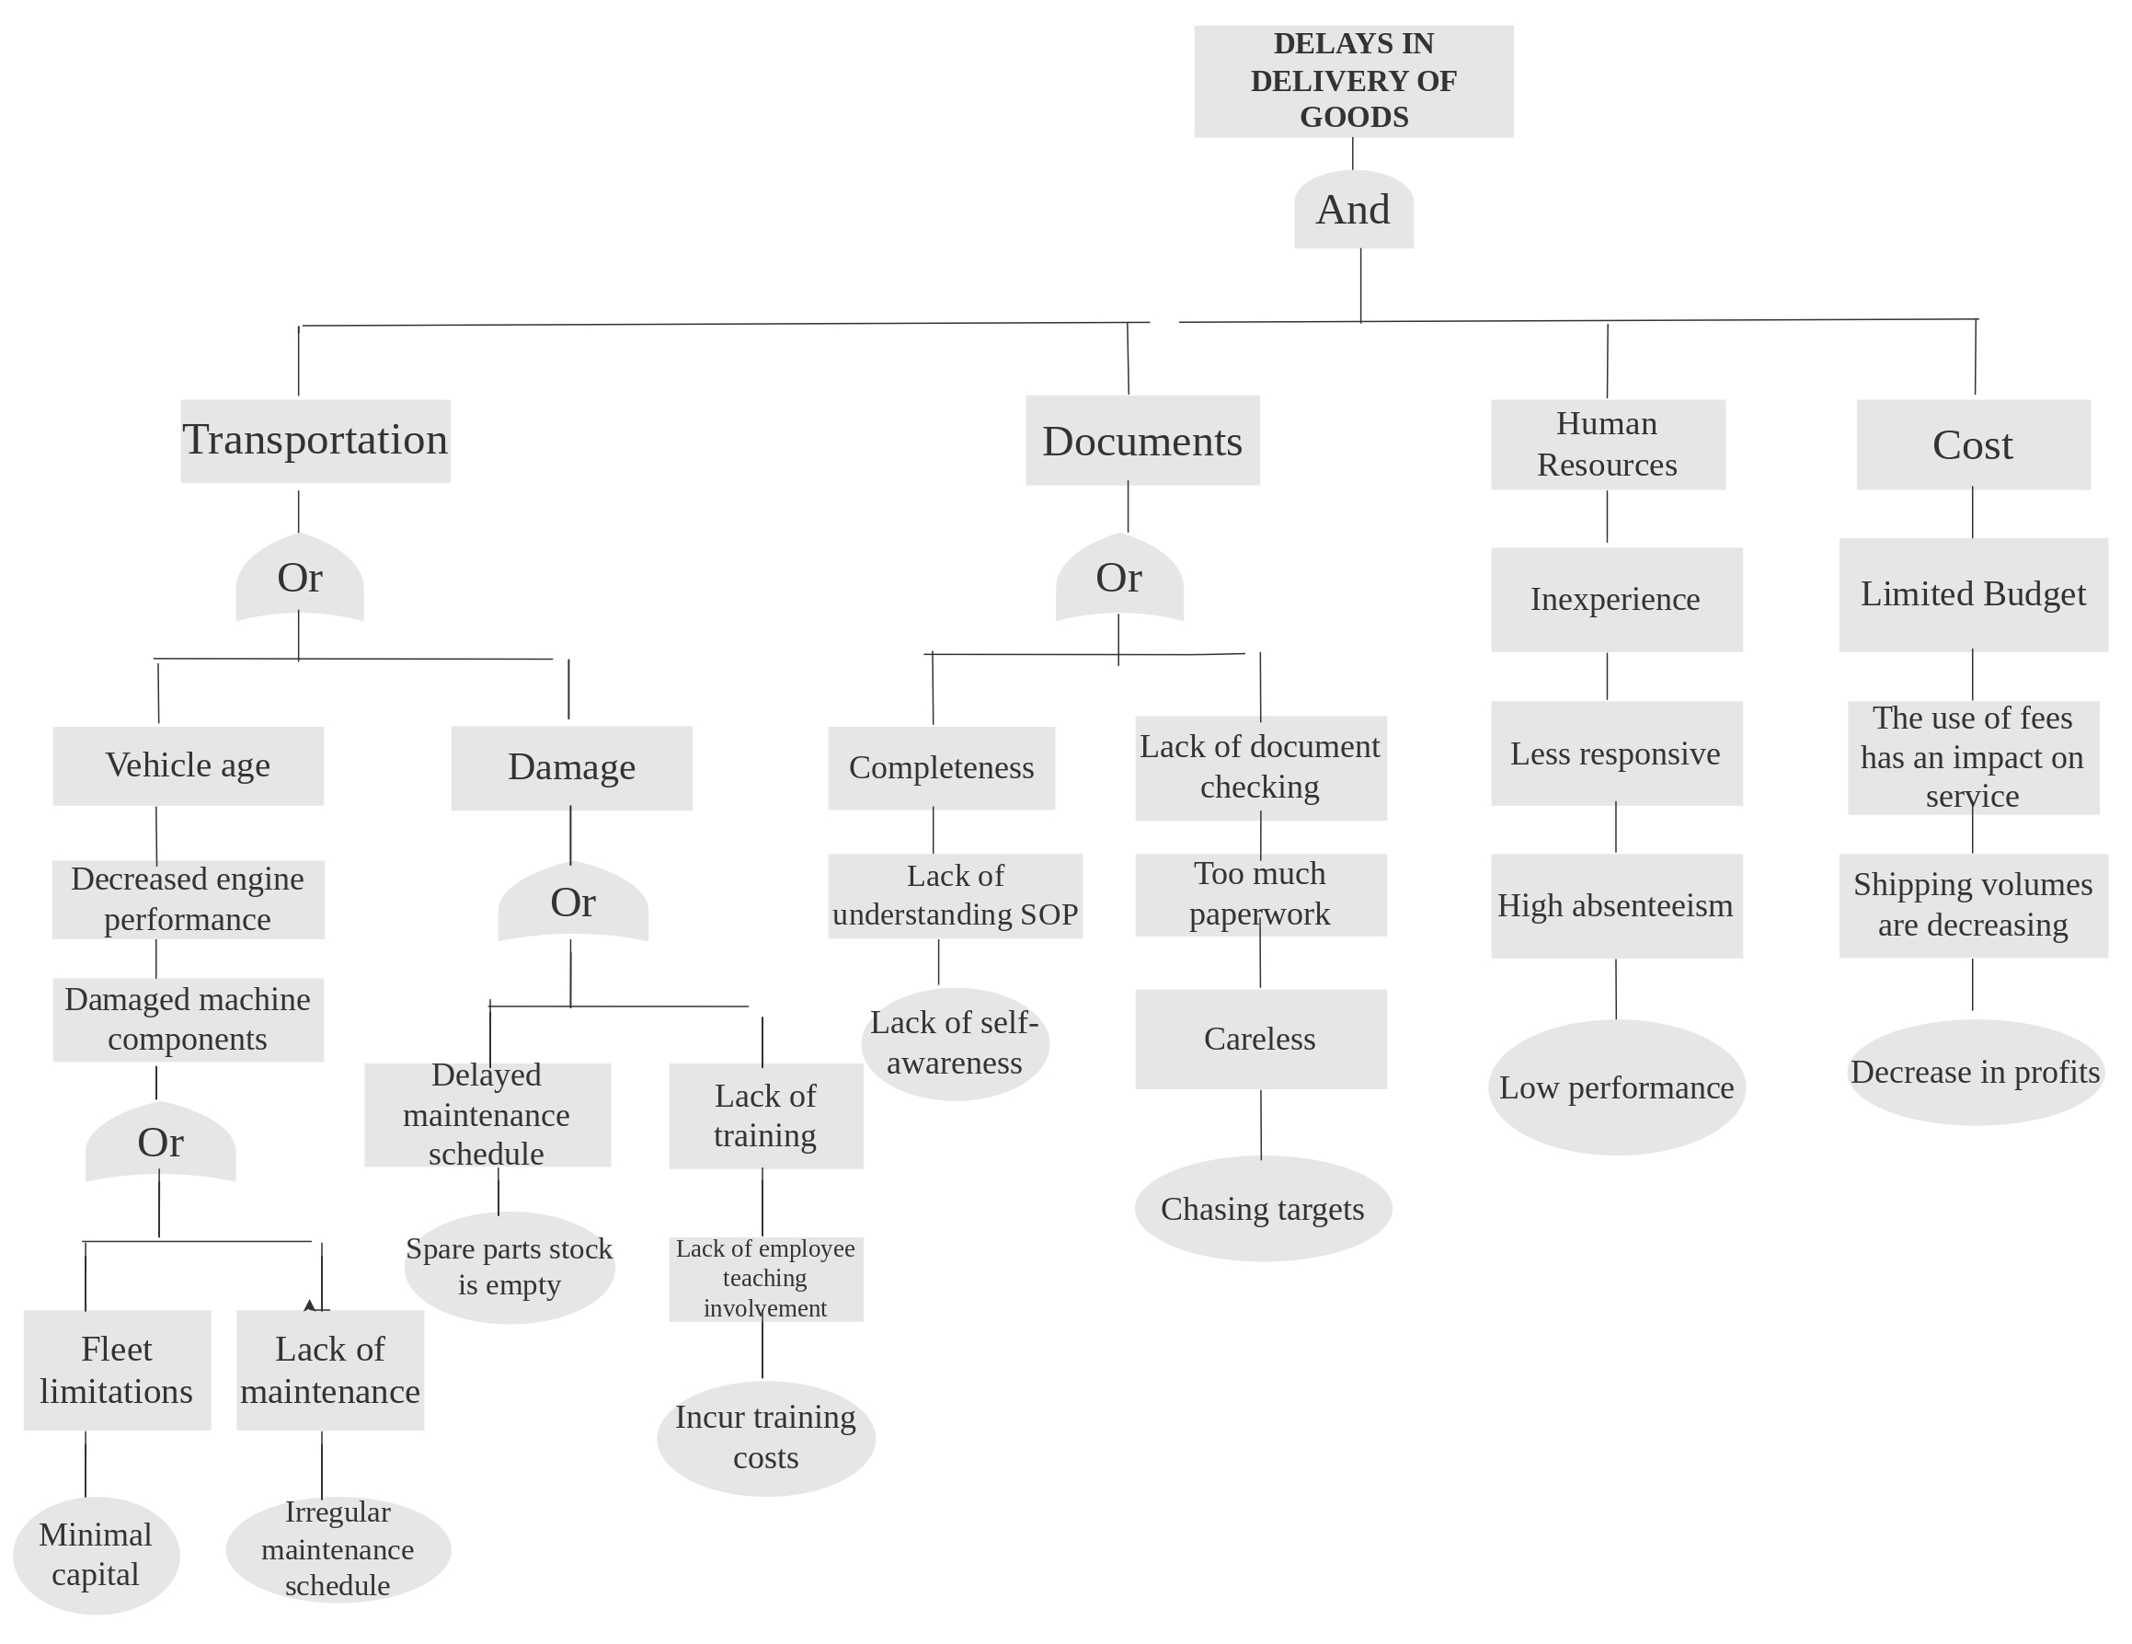

Gambar 4.1 Fault Tree Analysis Flow

Source : Secondary Data Processed by the Author, 2024

Based on the picture in 4.1, explain the causes of delays using a tree diagram. Causes of delays at PT. Arindo Jaya Mandiri has four causes, namely fleet. Documents, human resources, and costs. This is an obstacle to delays in the delivery of goods which results in a decrease in the number of consumers. Analysis of the causes of delays in the delivery of export goods using the fault tree analysis method, as follows:

1. Determining Treatment Priorities

Tabel 4.1 Items for determining priority for handling delays

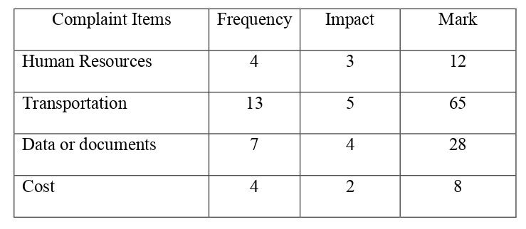

Source : Secondary Data Processed by the Author, 2024

Priority determination is used to determine the highest priority of delays in each process. This is done to facilitate identification and improvement of solutions. The most significant priority cause is the fleet. The order of causes of delays is fleet, data or documents, human resources, and costs.

1. Solution Development And Mitigation
2. Transportation

Companies often experience problems with their fleet, such as frequent damage, not being able to use it during delivery, fleet limitations, and others. The company checks when it will be used or looks for other vendors to make deliveries

1. Data or Documents

PT. Arindo Jaya Mandiri often experiences discrepancies between documents and the goods to be sent, which hampers the processing of other documents. The development of solutions and mitigations carried out sends the documents back to the shipper so that they can be checked again

1. Human Resources

Human resources owned by PT. Arindo Jaya Mandiri is less responsive in carrying out company performance, employees do work outside the company's job desk, and employees are less experienced

1. Cost

PT. Arindo Jaya Mandiri has insufficient or unsuitable capital to carry out deliveries. Limited costs will affect the company's services. Usually able to make deliveries to reach the target due to cost limitations, we are only able to make deliveries according to the capital we have

1. Implement Solutions And Monitor Evaluation
2. Transportation

The solution implemented is having a workshop and workshop employees to carry out fleet maintenance and repairs, the company has GPS installed on its fleet, has good security, and partners with truck vendors

1. Data Or Documents

Implementation of the solution and monitoring evaluation is carried out by checking when the shipper sends an email and the company will confirm via email if within 1x24 hours the shipper does not send the documents back

1. Human Resources

Implementing solutions and monitoring evaluations is carried out by employees helping each other and leaders coordinating with each employee to find out the performance and condition of the company.

1. Cost

Implementing solutions and monitoring evaluations carried out is minimizing shipments with large loads if capital is limited.

**CONCLUSION**

Based on research results regarding Delays in Delivery of Export Goods to Freight Forwarder PT. Arindo Jaya Mandiri Semarang, the author concludes. In the flow of sending export goods to PT. Arindo Jaya Mandiri Semarang does not have Standard Operating Procedures as a standard reference so the company carries out work based on company habits. Therefore, the delivery of export goods is still not operating optimally and needs improvement. The document processing process starts from the stuffing flow, making an Export Goods Notification, making an Export Service Note, making a Certificate of Origin, making a Bill of lading, making Verified Gross Mass, and payment flow. Critical points causing delays in goods delivery occur in all goods delivery flows. This disrupts the delivery of exported goods, resulting in delays in the delivery of goods if an evaluation is not carried out immediately.

PT. Arindo Jaya Mandiri Semarang in sending export goods has supporting and inhibiting factors. Supporting factors for sending export goods include adequate transportation, capital, human resources, and company profile. Meanwhile, factors inhibiting the delivery of export goods include human error and paperwork incomplete, natural disasters and fleet damage. This inhibiting factor is an obstacle faced by the company so that its implementation is not optimal.

In the Fault Tree Analysis Method which is used to analyze what causes delays in the delivery of goods to PT. Arindo Jaya Mandiri Semarang, namely fleet, human resources, costs and documents. The obstacles to the fleet are due to the age of the vehicles which are vulnerable to damage and the fleet often experiences damage because there is no scheduling in carrying out maintenance and a lack of training for workshop employees. Document barriers due to incomplete documents sent by shippers or employees which require time to process and lack of inspection of the documents created or sent. Barriers to costs due to limited capital owned by the company. Barriers to human resources due to lack of responsiveness and lack of training.

**REFERENCES**

Alif, Febri Triyawan. 2020. “Management of Dextrose Monohydrate Import Documents at PT PPJK and FF Units. Esa Zona Express Surabaya”. Written Paper, Amni Maritime University.

Ambarwati. 2021. "Operational Management and Implementation in Industry". Magelang: Love House Library

Andang, Bagus Pratomo. 2021. “Handling Imports Less Than PT. Textile Dyestuff Container Load. Sri Rejeki Isman Tbk At CFS Warehouse Tanjung Emas Port Semarang By PT. Indonesian Team”. Written Paper, Amni Maritime University.

Arindo Jaya Mandiri. 2023. “PT Company Profile. Arindo Jaya Mandiri”. Semarang

Central Bureau of Statistics. 2023. "December 2022 exports reached US$23.83 billion, down 1.10 percent compared to November 2022 and December 2022 imports worth US$19.94 billion, up 5.16 percent compared to November 2022." Accessed from <https://www.bps.go.id/id/pressrelease/2023/01/16/1961>

Baldah. 2020. “Defect Level Analysis Using the Six Sigma Method on the TGSW Line”. Journal of Business Management Economics, 1(1).

Dewi, Desilia Purnama. 2020. “Administration Procedures for Goods Delivery Services at PT. Citra Van Titipan Kilat Tangerang. Scientific Journal of Secretarial/Office Administration Science, 7(7).

Ikhsanuddin, Muhammad. 2022. “Analysis of the Causes of Delays in Delivery of Export Goods at PT. Solo Kawistara Garmindo”. Final Project, Vocational School. Solo: Sebelas Maret University.

Imawati, Pegy Prastiti. 2021. "Planning for more economical raw material inventory control using economic order quantity (Eoq) and just in time (Jit) methods at UD. Sukri Ponorogo Endowment Fund”. Thesis, Muhammadiyah University of Ponorogo.

Jumadi. 2021. “Operations Management”. Journal of Economics and Business

Kamalia. 2020. "Analysis of Factors Affecting Indonesian Rubber Exports to the United States". Jiep: Journal of Economics and Development, 5 (2): 687-705

Karno. 2020. “Factors that cause delays in regular delivery of goods from the central warehouse to the consignee at domestic courier services PT. Caraka Yasa Jakarta 2020”. Management Journal, 1-4.

Manus, Tasya., Agustinus B. Pati 2, & Franky Rengkung. 2022. "North Sulawesi Government's Efforts to Increase Exports During the Covid 19 Pandemic". Journal of Politics.

Mulya, Nabila Zahra. 2023. “Analysis of Fertilizer Distribution at PT. BGR Logistics Indonesia Semarang Regional Division”. Final Project, Vocational School. Semarang: Diponegoro University.

Muthmainah, Rodiatul. 2019. "Evaluation of Export Activity Procedures at PT. Asia Enterprise Star”. Journal Of Applied Business Administration, 3(2).

Nova, Terra Terry .2021. “Analysis of Delays in Delivery of Export Goods at PT. Covemore International”. Final Project, Vocational School. Solo: Sebelas Maret University.

Oktavianti, Poppy. 2020. “Import Administration Procedures at PT. Multi Terminal Indonesia Tanjung Priok, North Jakarta.” Thesis, Jakarta: Indonesian College of Economics.

Pahlephi, Rully D. 2022. "Getting to Know Fishbone Diagrams: Functions and How to Make Them." <https://www.detik.com/bali/berita/d-6471592/mengenal-fishbone-diagramfunction-dan-cara-> buatnya, accessed on 15 February 2024.

Parura, Irwanty. 2021. "Analysis of Factors Affecting the Delay in Financial Reporting of Operational Health Assistance (Bok) at the Community Health Center in Jayawijaya District = Analysis of Factors Affecting the Delay in Financial Reporting of Operational Health Assistance (Bok) at the Community Health Center in Jayawijaya District." Thesis, Hasanuddin University.

Pinantun, Mimbar. 2020. “Administrative Governance of Express Goods Delivery at PT. Angkasa Pura Logistics”. Thesis, Indonesian College of Economics.

Rahma, Anida. 2023. "Various Goods Delivery Methods". <Https://Shipdeo.Com/Blog/Macam-Macam-> Metode-pengiriman-Barang/, accessed 25 November 2023

Rahman, Rahman. 2020. "Analysis of Factors Affecting Delays in the Arrival Time of the Trans Jateng BRT at Each Shelter on the Tawang Station-Bawen Terminal Route. Thesis, Amni Maritime University.

Rahmat. 2021. “Application of Six Sigma to Improve Packing Quality in PT. Pouch Cooking Oil. XYZ in Gresik Regency”. National Journal of Industrial Engineering.

Rahmawati, Andira Dwi Juana. 2023. “Quality Control of Spot Defects in Half-Finished Plastic Roll Products from HDPE Using the PDCA (Plan-Do-Check-Action) Method at PT. Rapindo Plastama Mojokerto”. Thesis, Polytechnic Academy of Leather Technology.

Rahmayanti, Reny. 2020. "Analysis of Supplier Selection Using the Analytical Hierarchy Process (AHP) Case Study Method at PT. Cazikhal”. Thesis, Faculty of Economics. Solo: Sebelas Maret University.

Reza, Nuur Fauzi. 2020. “Handling of Export Documents for Shortening Goods Belonging to Pt Bonanza Megah by the EMKL Company PT. Samudera Perdana Aligned Semarang Branch”. Written Paper, Amni Maritime University.

Riadi, Muchlisin. 2023. "Fault Tree Analysis (FTA) - Functions, Methods, Symbols and Creation Steps". <https://www.kajianpustaka.com/2023/06/Fault-Tree-AnalysisFta.Html> , accessed on February 13.

Safira, Silvia Dhea. 2022. "Product Defect Analysis Using FMEA and FTA Methods to Reduce Product Defects (Case Study: Garment 2 and Garment 3 PT. Sri Rejeki Isman Tbk)". IDEC National Seminar and Conference Journal

Shodiqina, Ali B. 2020. "Problem Solving Profile According to Krulik and Rudnick in View of Wolfram Mathematica Capabilities." National Postgraduate Journal

Somadi. 2020. "Evaluation of Goods Delivery Delays Using the Six Sigma Method". Indonesian Logistics Journal, 4 (2): 81-93

Sugiyono. 2022. "Qualitative Research Methods". Alphabet: Bandung

Suryani, Ayu. 2020. "Analysis of the Role of Freight Forwarders in the Process of Sending Export Goods Via Sea Transportation PT. Deros Indah Prima”. Thesis, Surabaya: College of Port Administration and Management

Suyono. 2020. "Shipping Intermodal Freight Export Import by Sea". Jakarta : PPM.

Wijaya, Andi. 2020. Production Management and Operational Management. Management Journal