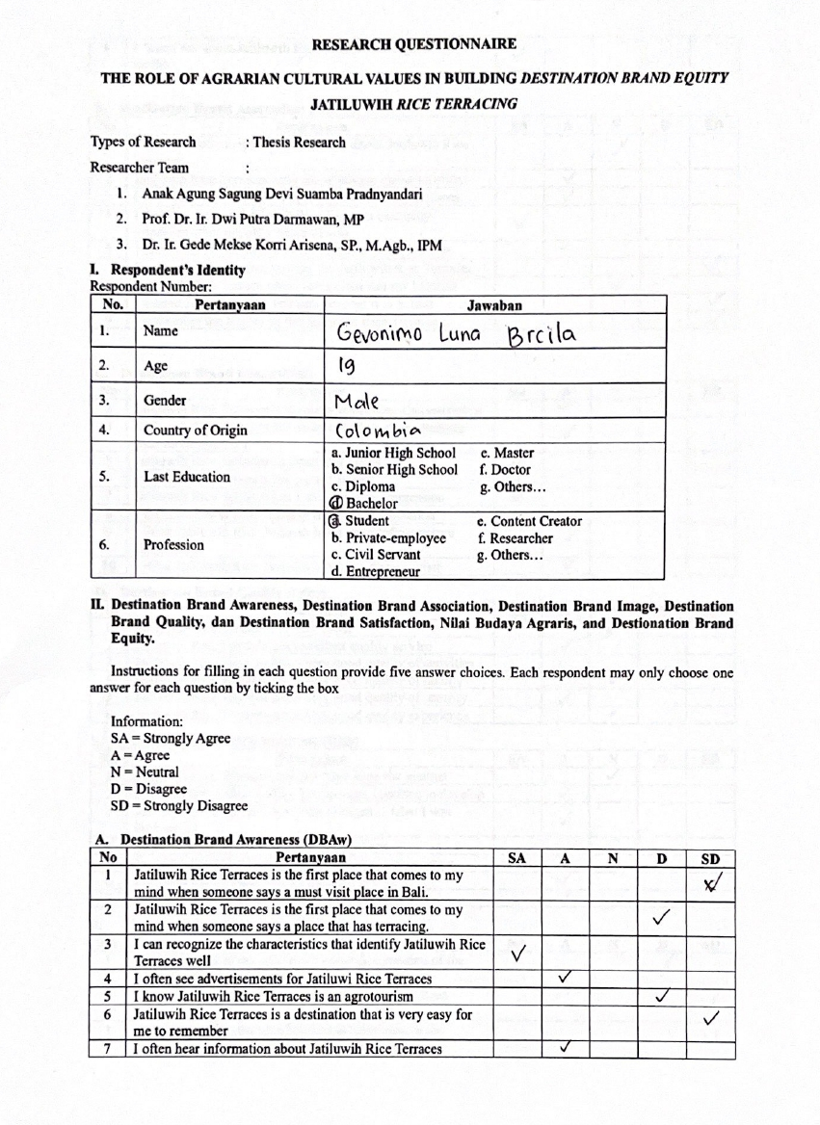
Attachment 1. Research Questionnaire
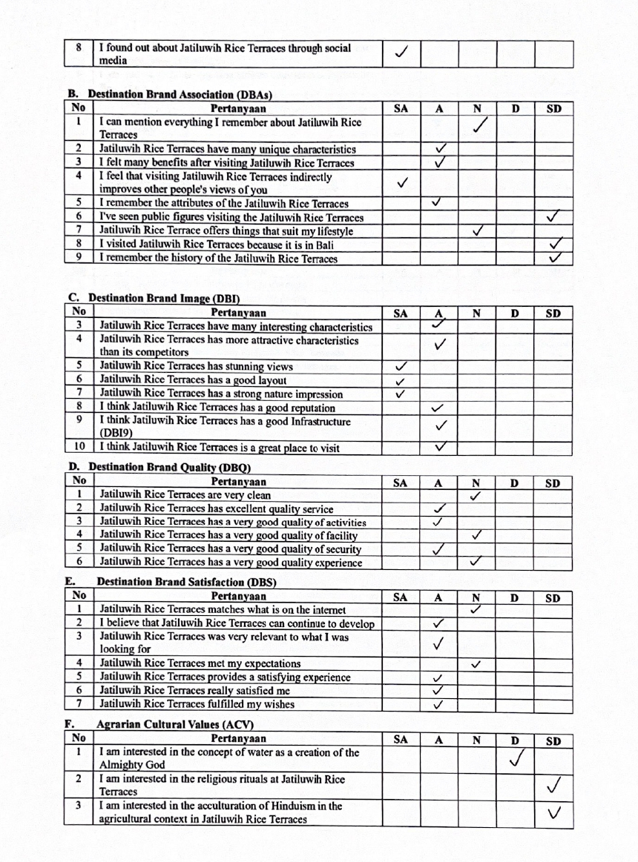

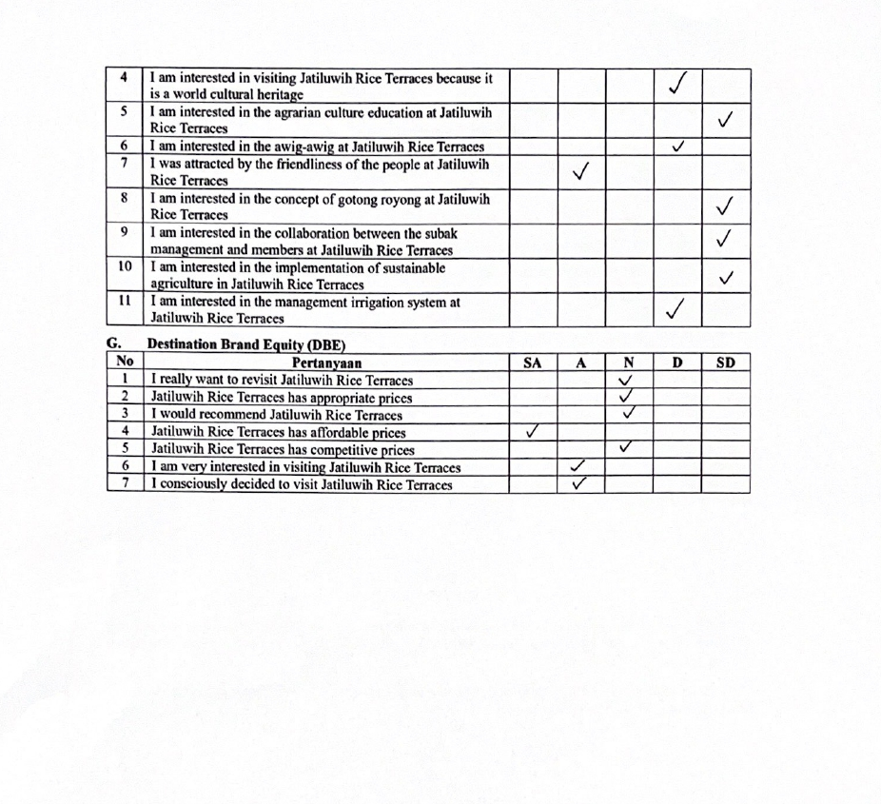

Attachment 2. Research Certificate
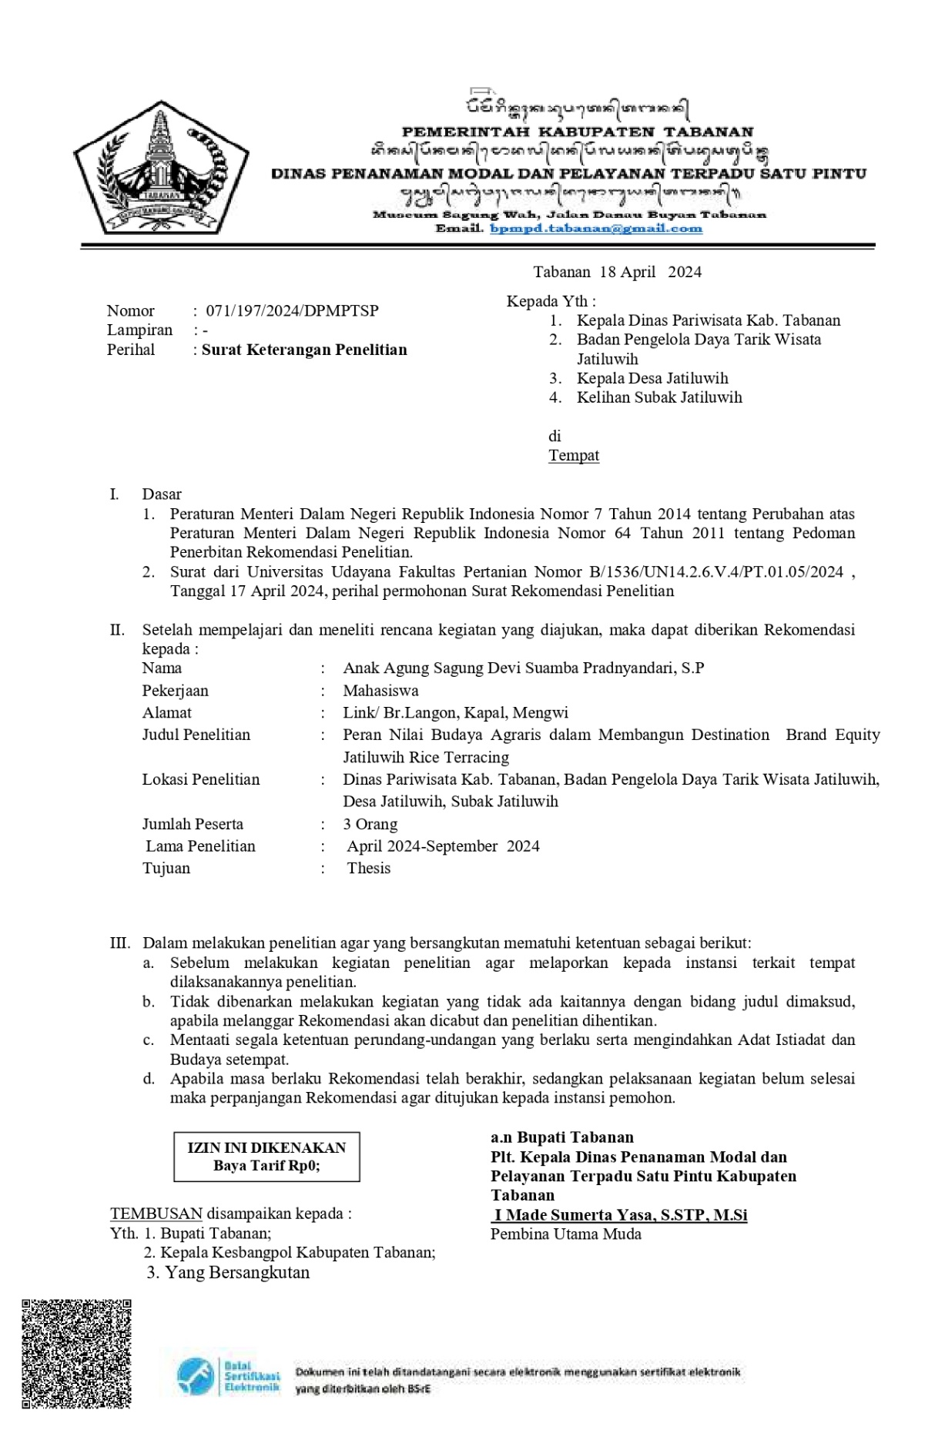
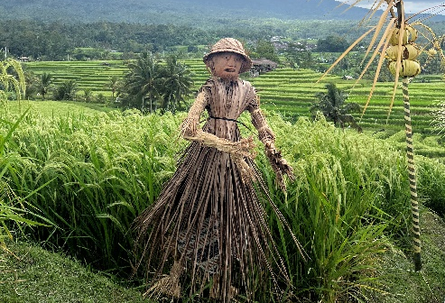
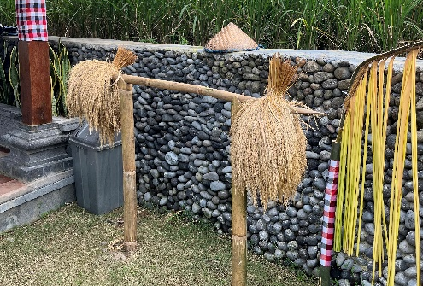
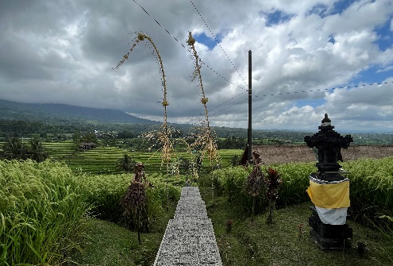
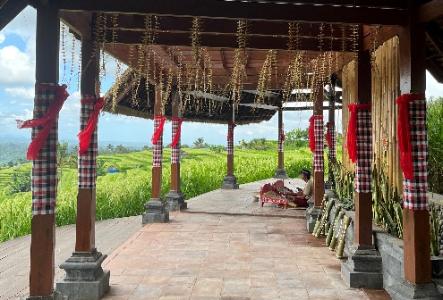
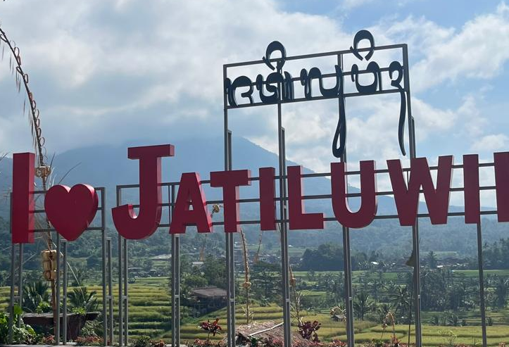
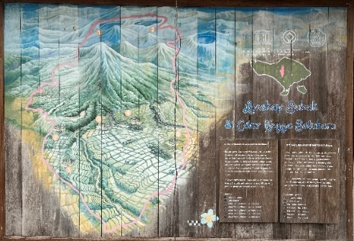
Attachment 3. Documentation of the Condition of Jatiluwih Rice Terraces
I Love Jatiluwih sign as a photo spot for tourists
Gazebo as a place to rest and enjoy views of the rice fields.
Jatiluwih Village area information board
Props for taking photos include capil hats and dry rice lifting equipment
Lelakut or scarecrows are used to ward off birds and as photo props
Road access to the gazebo
Papan informasi wilayah Desa Jatiluwih

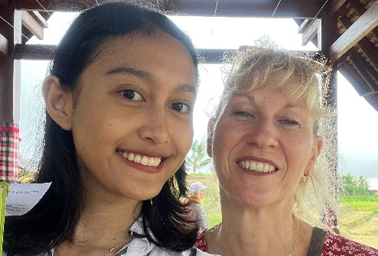
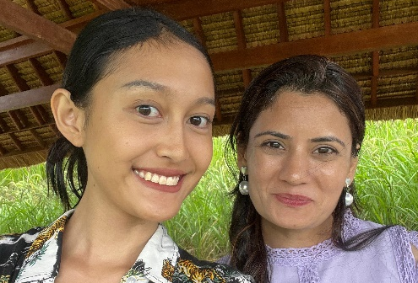
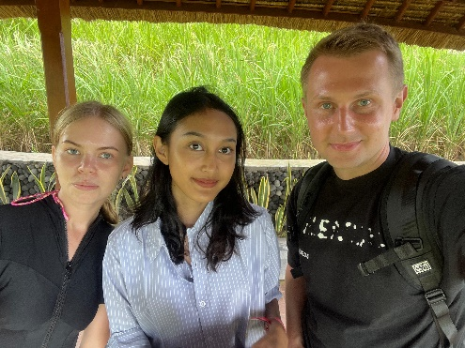
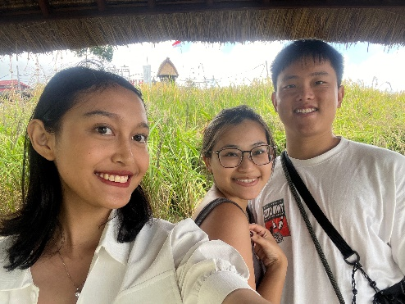
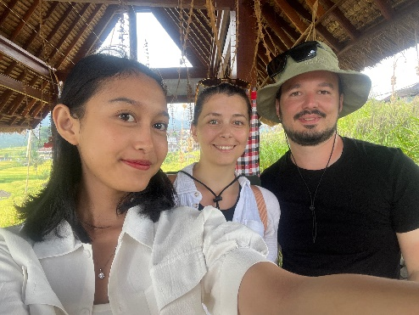
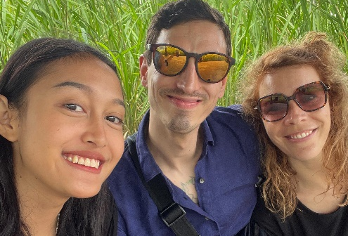
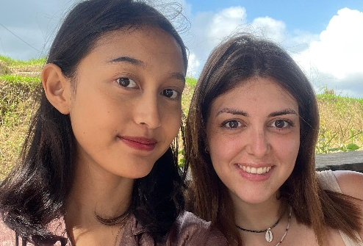
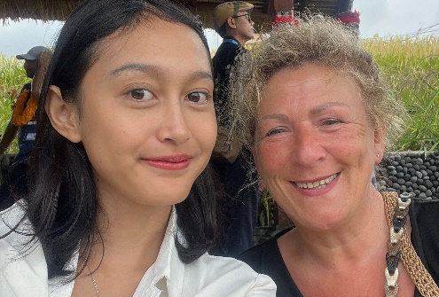
Interview with Balazs dan Edina
Tourist from Hungaria
Interview with Khoknlov
Tourist from Russia
Interview with Poonam
Tourist from India
Interview with Ling dan Nen Hao
Tourist from Singapura
Interview with Evelien dan Jonas
Tourist from Belgia
Interview with Julia
Tourist from Prancis
Interview with Nicole
Tourist from Belanda
Interview with Gayle
Tourist from Australia
Attachment 4. Documentation of Several Respondents
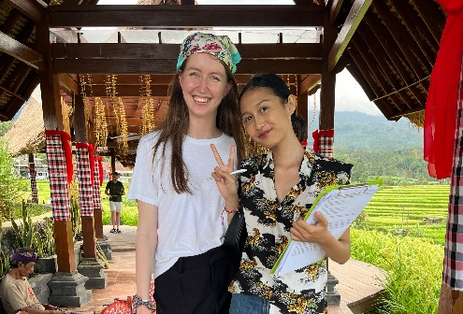
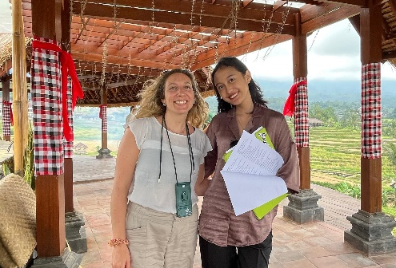
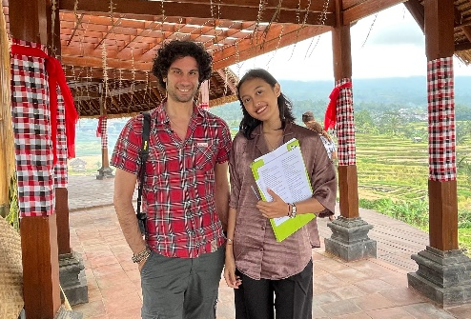
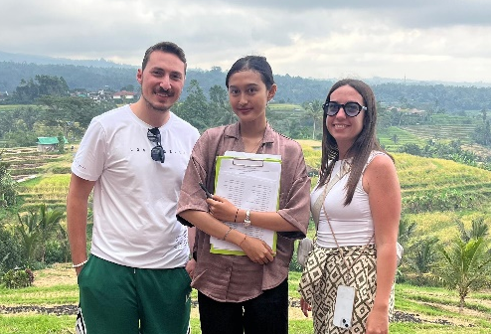
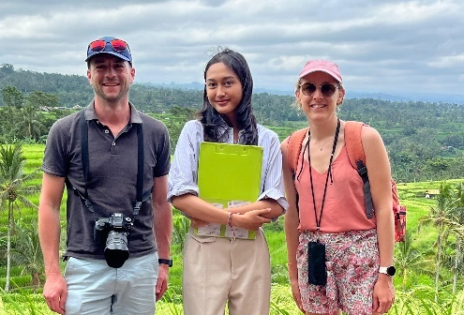
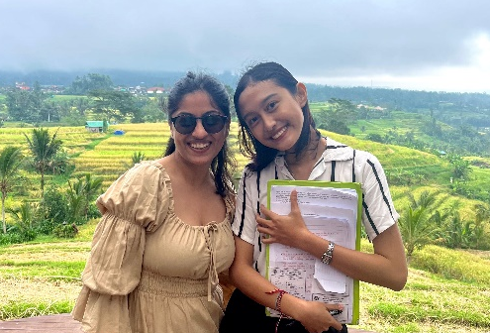
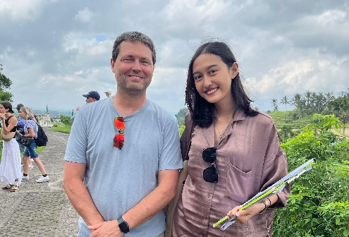
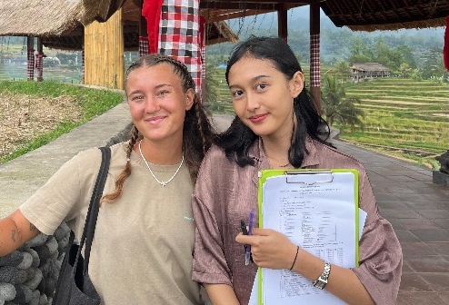
Interview with Chiara
Tourist from Spanyol
Interview with Bernard
Tourist from Prancis
Interview with Tertrain
Tourist from Prancis
Interview with Stefano dan Chiara
Tourist from Russia
Interview with Priyanka
Tourist from India
Interview with Sarah
Tourist from Jerman
Interview with Rebecca
Tourist from Italia
Interview with Luca
Tourist from Italia
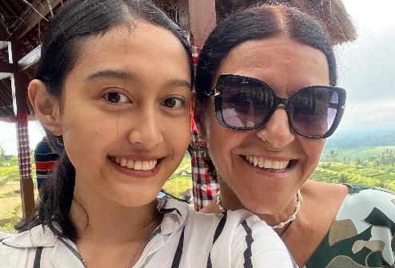
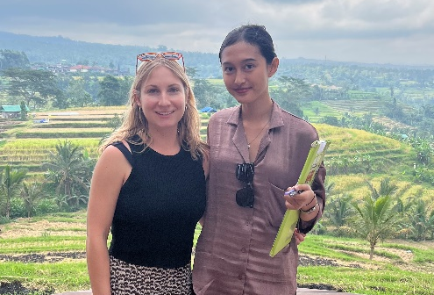
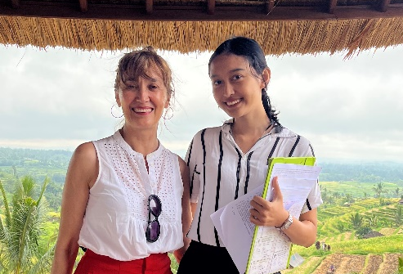
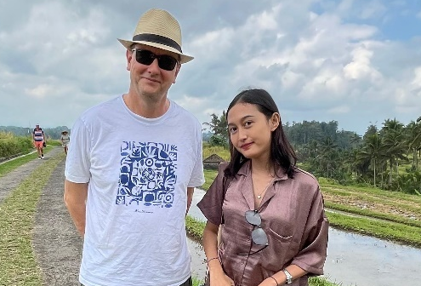
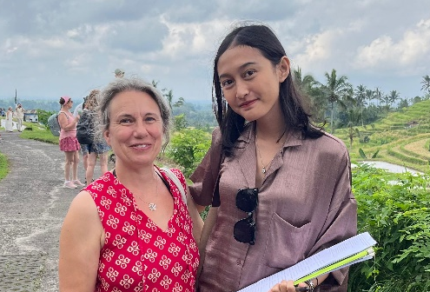

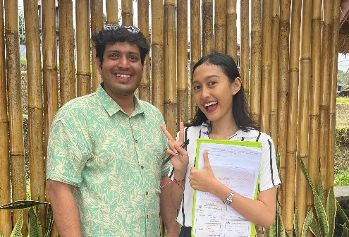
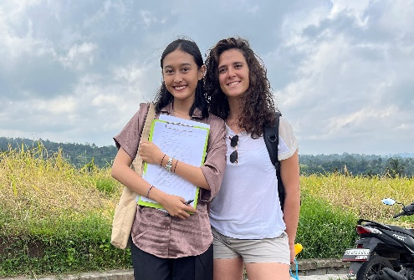
Interview with Federica
Tourist from Italia
Interview with Alvin
Tourist from India
Interview with Nathalie
Tourist from Prancis
Interview with Anthony
Tourist from Australia
Interview with Hyujin
Tourist from Korea Selatan
Interview with Amabili
Tourist from Jerman
Interview with Melissa
Tourist from New Zealand
Interview with Susana
Tourist from Spanyol
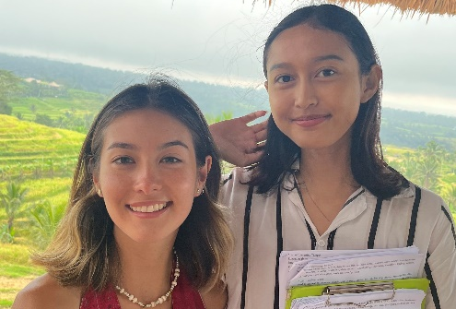
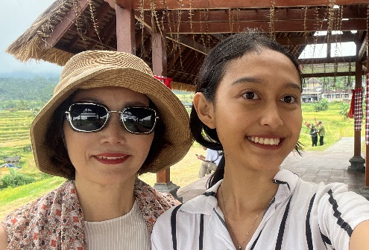
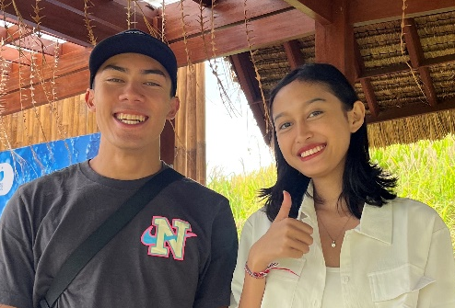
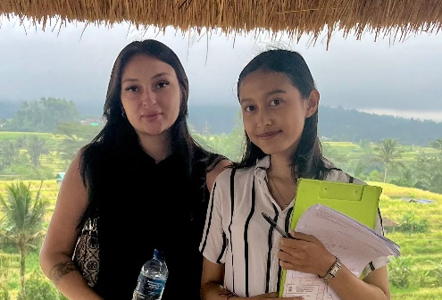
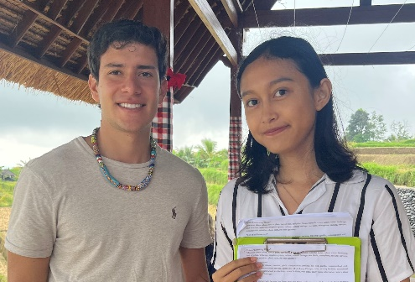
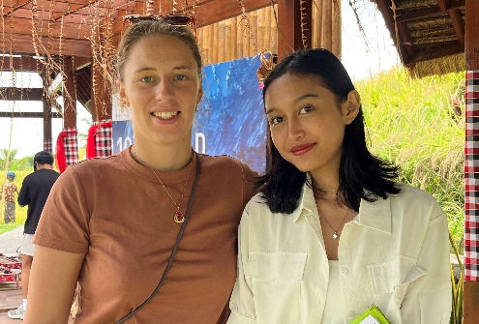
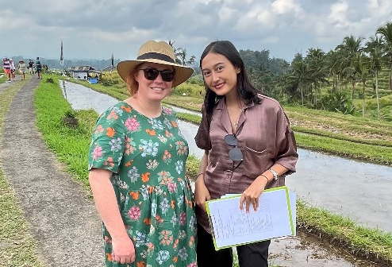

Interview with Kim
Tourist from Korea Selatan
Interview with Roze
Tourist from Kazakstan
Interview with Katie
Tourist from Australia
Interview with Gevonimo
Tourist from Colombia
Interview with Valeriia
Tourist from Australia
Interview with Soliane
Tourist from Prancis
Interview with Isabella
Tourist from Colombia
Interview with Hugo
Tourist from Prancis
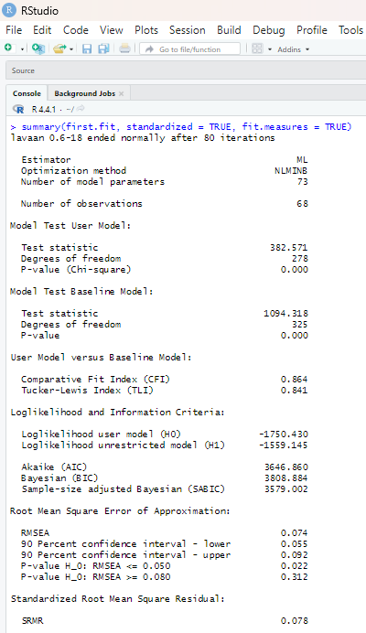
- Model Fit Measurement (CFI, TLI, RMSEA, dan SRMR)
Attachment 5. Lavaan Results

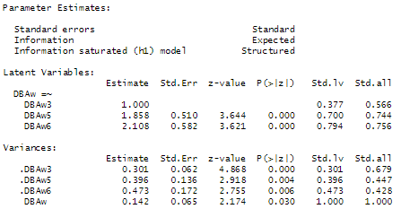
- Loadings Factor
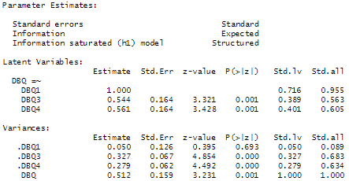
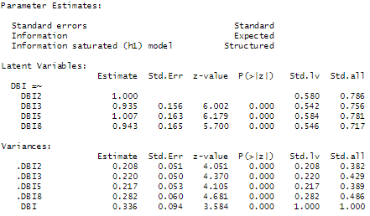
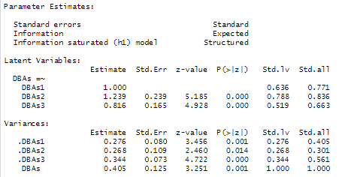

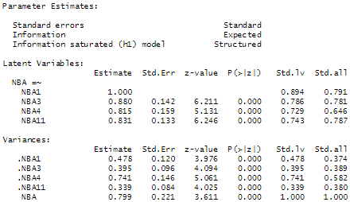
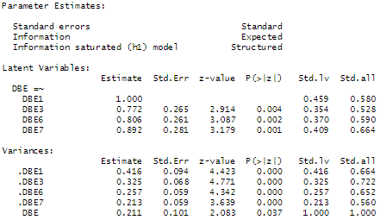
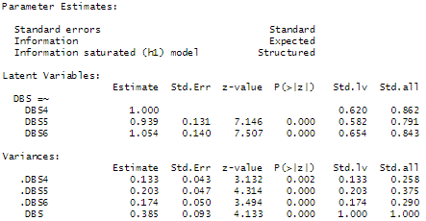
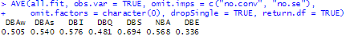
- Average Variance Extracted (AVE)

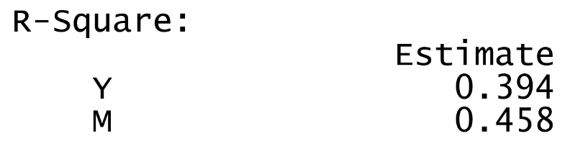
- R²

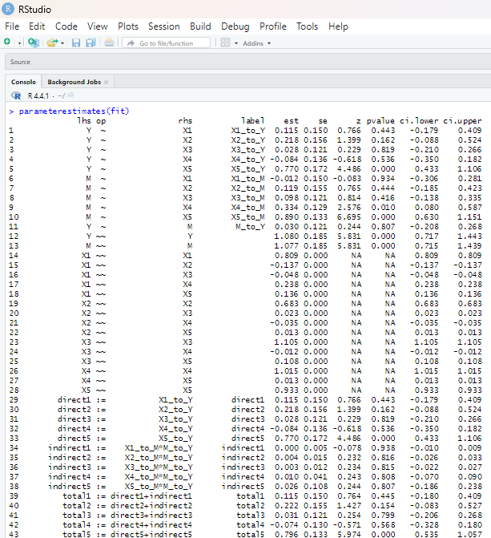
- Path Coefficient

